MCP Filesystem Agent

Overview
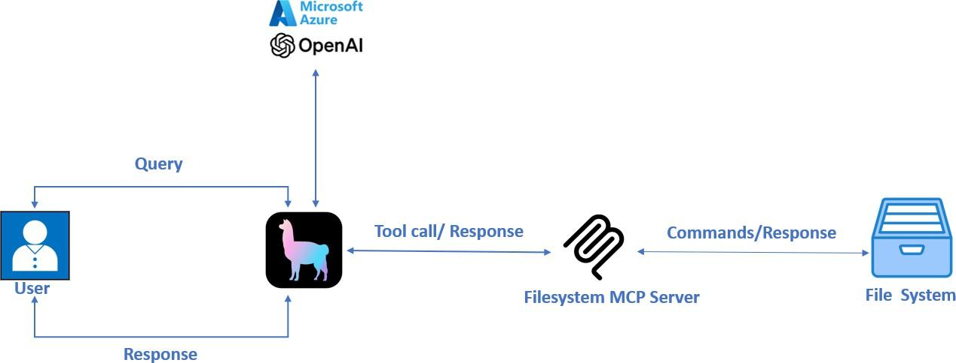

The application provides an interactive interface where users can:
- Navigate local directories using natural language commands.
- List directories and files
- Read file contents
- Perform basic file operations

Prerequisites
Before you begin, ensure you have the following installed:
  - Python 3.8 or higher
  - Node.js and npx (for the MCP filesystem server)
  - Azure OpenAI API access
  - uv package manager (faster alternative to pip)

Project Setup

Installing uv Package Manager
If you don't have uv installed yet:
pip install uv

Creating a Project Environment
Create a new project environment using uv:
uv init llamaMCP_project cd llamaMCP_project

Installing Required Packages
Install all required packages using uv:
uv add python-dotenv llama-index-llms-azure-openai==0.4.2 llama-index-core==0.14.8 llama-index-tools-mcp==0.4.3 "mcp[cli]>=1.6.0"

Environment Configuration
Create a .env file in your project directory with the following Azure OpenAI configuration:
AZURE_OPENAI_API_KEY=your_azure_openai_api_key_here AZURE_OPENAI_ENDPOINT=your_azure_endpoint_here AZURE_OPENAI_API_VERSION=your_api_version_here

Running the Application
- Place the llamaMCP.py file in your project directory
- Update the path in the StdioServerParameters to match your desired root directory:
server_params = StdioServerParameters( command="npx",
args=[
"-y",
"@modelcontextprotocol/server-filesystem", "D:/YourDesiredDirectory"
],)
- Run the application:
python llamaMCP.py
- Enter your queries when prompted

Example Queries
  - "List all files in the current directory"
  - "Navigate to Documents/Reports"
  - "Read config.json"
  - "Show me the contents of readme.txt"
  - "What files are in the images folder?"

Understanding the Code
Let's break down the main components of the llamaMCP.py script:

Imports and Configuration
import asyncio import os
from dotenv import load_dotenv
from llama_index.llms.azure_openai import AzureOpenAI # ... more imports
This section imports necessary libraries and loads environment variables from your .env file.

Azure OpenAI Setup
llm = AzureOpenAI( api_key=AZURE_OPENAI_API_KEY, azure_endpoint=AZURE_OPENAI_ENDPOINT, deployment_name=AZURE_OPENAI_DEPLOYMENT, api_version=AZURE_OPENAI_API_VERSION,
)
This section initializes the Azure OpenAI LLM using your API credentials.

MCP Filesystem Server
server_params = StdioServerParameters( command="npx",
args=["-y", "@modelcontextprotocol/server-filesystem", "allowed directory"],
)
This configures the Model Context Protocol (MCP) server for filesystem access. The server allows the application to interact with files on your system.

Chat Memory
memory = ChatMemoryBuffer.from_defaults(token_limit=1500)
This creates a memory buffer for the agent to maintain conversation context.

Main Application Loop
The main() function establishes connections and handles user interaction:
async def main():
# ... implementation details
This function:
  - Sets up tools for file system by connecting to the MCP server
  - Creates a ReActAgent with those tools
  - Manages the chat loop, handling user input and displaying responses

Technical Details

MCP Tools
The application uses the Model Context Protocol (MCP) to interact with the filesystem. Available tools include:
- read_file: Read complete file contents
- read_multiple_files: Read multiple files at once
- write_file: Create or overwrite files
- edit_file: Make selective text edits
- create_directory: Create new directories
- list_directory: Show directory contents
- move_file: Move or rename files
- search_files: Find files with patterns
- get_file_info: Get file metadata details
- list_allowed_directories: Show accessible directories

ReAct Agent
The application uses a ReAct (Reasoning and Acting) agent that:
- Interprets natural language commands
- Plans appropriate actions using the available tools
- Executes those actions
- Provides responses based on the results

