Project Report
Smart Driver Monitoring & Collision Alert System

Project Title | Smart Driver Monitoring & Collision Alert System
Mentor | Mr. Bharat Baviskar
Team Members | - Manmit Habib  - Vidish Mujumdar  - Pranavkumar Kumbhar

1. System Overview
1.1 Project Objective
The primary objective is to develop a real-time, embedded driver safety system capable of detecting driver’s drowsiness, identify collision risk and abnormal driving patterns using low-cost sensors interfaced to the STM32 Nucleo-F446RE microcontroller. The system generates binary alert flags corresponding to each detected hazard, which can serve as inputs to an external alert system, CAN bus or telemetry.
The specific engineering objectives of the system are:
- Detect driver drowsiness by monitoring eye blink frequency using an IR sensor and timer.
- Measure the distance of obstacle from vehicle using an HC-SR04 ultrasonic sensor and compute a dynamic safe stopping distance based on vehicle speed.
- To acquire real-time vehicle inertial data using the MPU6050 IMU to detect harsh braking, harsh acceleration, oversteer or any abnormal driving pattern.
- Receive and parse GPS NMEA data to determine vehicle position and speed.
- Generate six independent status flags: Drowsy, Obstacle, Overspeed, Harsh Braking, Harsh Acceleration, and Harsh Turning.
1.2 Overall System Architecture
The system is built around a single STM32 Nucleo-F446RE microcontroller that connects to four sensor’s modules. It continuously collects data from each device and processes it to determine the vehicle's safety status. Figure below shows the overall system block diagram and how the different components are connected.
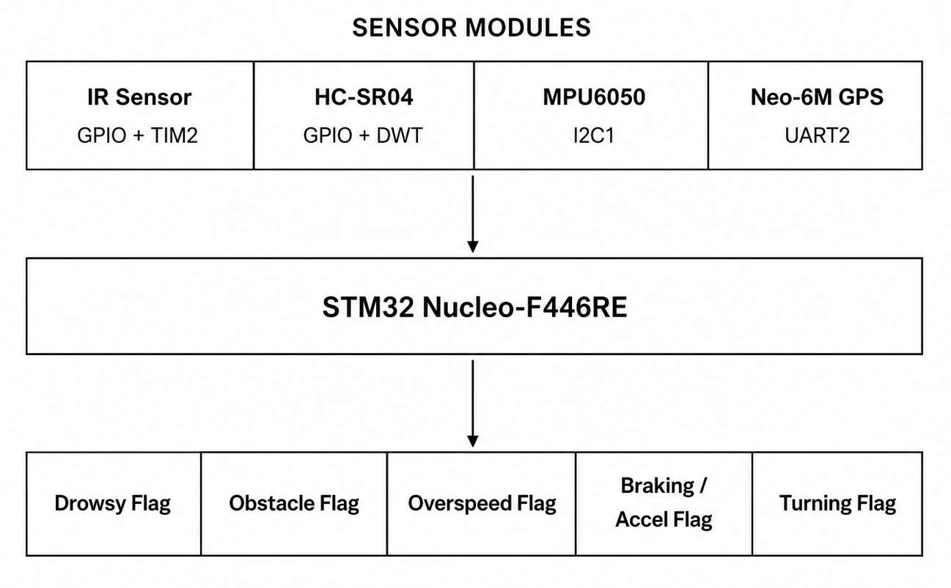
1.3 System Operation Summary
During each cycle, system performs the following tasks:
- Reads the IR sensor to monitor the driver's eye status.
- Measures the distance to obstacles using the HC-SR04 ultrasonic sensor.
- Collects acceleration and gyroscope data from the MPU6050.
- Updates the latest GPS location and speed whenever new data is available.
- Compares the sensor values with predefined limits and updates the required safety flags. A timer is used to detect if the driver's eyes remain closed for 5 seconds, while GPS data is received in the background through UART without interrupting the main program.

2. Hardware Components and Interfacing
2.1 STM32 Nucleo-F446RE
The STM32 Nucleo-F446RE is the central processing unit of the system. It is based on the ARM Cortex-M4 core with an FPU, operating at up to 180 MHz. Key capabilities required in this project include:
- Multiple hardware timers (TIM2 used for 5-second drowsiness timeout).
- I2C peripheral for IMU communication.
- UART peripheral for GPS NMEA reception via interrupt.
- GPIO for IR sensor input and HC-SR04 trigger/echo.
- DWT cycle counter for microsecond-resolution timing.
Specification | Value
Microcontroller | STM32F446RE
Core | ARM Cortex-M4 with FPU
Clock Speed | Up to 180 MHz
Flash Memory | 512 KB
SRAM | 128 KB
Communication | UART, I2C, SPI, CAN, USB
Timers | TIM1–TIM14; TIM2 used for drowsiness (32-bit)
Operating Voltage | 3.3 V

2.2 HC-SR04 Ultrasonic Distance Sensor
Purpose
The HC-SR04 measures the time of flight of an ultrasonic pulse to determine the distance between the vehicle and obstacle. The computed distance is compared against a dynamically calculated safe stopping distance to generate the Obstacle Flag.

Working Principle
A 10 µs HIGH pulse on the TRIG pin causes the sensor to emit eight cycles of 40 kHz ultrasonic sound. The ECHO pin is held HIGH for the duration of the round-trip travel time of the acoustic wave. Measuring this HIGH duration and applying the speed-of-sound formula yields the one-way distance.

Distance Formula: distance_cm = (pulse_width_µs × 0.0343) / 2
where 0.0343 cm/µs is the speed of sound, and division by 2 accounts for the round-trip path.

STM32 Pin Assignment and Protocol
Sensor Pin | STM32 Pin | Direction | Protocol
TRIG | PC7 | Output | GPIO
ECHO | PB6 | Input | GPIO + DWT
VCC | 5 V | Power | -
GND | GND | Power | -

The DWT cycle counter (incrementing at 180 MHz) gives microsecond resolution, far superior to SysTick or HAL_Delay-based timing.
2.3 MPU6050 IMU (Accelerometer + Gyroscope)
Purpose
The MPU6050 provides 3-axis linear acceleration and 3-axis angular velocity measurements. These values are used to compute the following safety flags: Harsh Braking, Harsh Acceleration, and Harsh Turning.

Working Principle
The MPU6050 contains MEMS based capacitive accelerometers and MEMS gyroscopes. Internal ADCs digitize the analog sensor outputs at up to 1 kHz. The results are stored in 16-bit registers starting at address 0x3B. A burst I2C read of 14 consecutive bytes retrieves all six sensor axes plus temperature in a single transaction.

Sensitivity and Scaling
Sensor | Full-Scale Range | Sensitivity | Output Unit
Accelerometer | ±2 g (default) | 16384 LSB/g | g
Gyroscope | ±250°/s (default) | 131 LSB/(°/s) | °/s

STM32 Pin Assignment and Protocol
Signal | STM32 Pin | I2C Role | I2C Address
SDA | PB7 | Data | 0x68 (AD0=GND)
SCL | PB6 | Clock | —

2.4 Neo-6M GPS Module
Purpose
The Neo-6M provides GNSS-derived geographic position (latitude and longitude) and spee. Speed is used in the Overspeed flag and in the dynamic safe stopping distance calculation for the Obstacle Flag.
Working Principle
The Neo-6M receives signals from GPS satellites and outputs standard NMEA sentences over a serial UART interface at baud rate 9600. The firmware receives these sentences via UART interrupt and parses sentence to extract latitude, longitude, and speed. The parsed decimal degrees are stored in global variables updated on every new GPS fix.
STM32 Pin Assignment and Protocol
Signal | STM32 Pin | UART Instance | Baud Rate
TX (GPS) | PA3 (UART2_RX) | USART2 | 9600
RX (GPS) | PA2 (UART2_TX) | USART2 | 9600

Interrupt-driven reception is used so that GPS data is buffered without blocking the main processing loop. A newFixAvailable flag is set in the UART callback to signal the main loop that fresh GPS data is ready to be latched.
2.5 IR Sensor (Drowsiness Detection)
Purpose
The IR sensor detects eye blinks by sensing the reflection of infrared light from the driver's eye. When we blink, the reflected IR signal changes causing the sensor output to transition to a LOW state. This transition is used to reset a 5-second countdown timer.
Working Principle
IR sensor module emits infrared light and monitors the reflected intensity. When the driver's eye is open, the cornea reflects IR light back to the photodetector, holding the output HIGH. During a blink, the reflected signal drops, pulling the output LOW. The STM32 reads this pin every loop iteration and detects the HIGH-to-LOW transition (falling edge) as a blink event.
STM32 Pin Assignment
Signal | STM32 Pin | Logic Level
IR OUT | PB5 | (GPIO_PIN_SET = blink)

TIM2 is used as a hardware timer to monitor the driver's eye activity. It is configured for a 5-second interval. If no blink is detected within this time, the timer generates an interrupt and sets a flag. The main program checks this flag and declares the driver drowsy if the condition is met.
3. Software Design and Implementation
3.1 System and Peripheral Initialization
The startup sequence configures all peripherals before entering the main loop.
- HAL & Clock: The system clock is configured to 180 MHz using the PLL, providing the required clock for all peripherals.
- GPIO: GPIO pins are initialized for the IR sensor, ultrasonic sensor.
- USART2: USART2 is configured at 9600 baud for GPS communication, with interrupt-based data reception enabled.
- I2C1: I2C1 is initialized in Fast Mode (400 kHz) to communicate with the MPU6050 sensor.
- TIM2: TIM2 is configured with a 5-second interval and is started only when required for drowsiness monitoring.
- DWT Counter: The DWT cycle counter is enabled to provide accurate timing for ultrasonic distance measurement.
- MPU6050: The MPU6050 is initialized by clearing its sleep mode, making it ready to provide accelerometer and gyroscope data.
3.2 Main Loop Execution Flow
The while(1) loop executes all sensor reads and flag computations sequentially shows the simplified main loop flowchart.

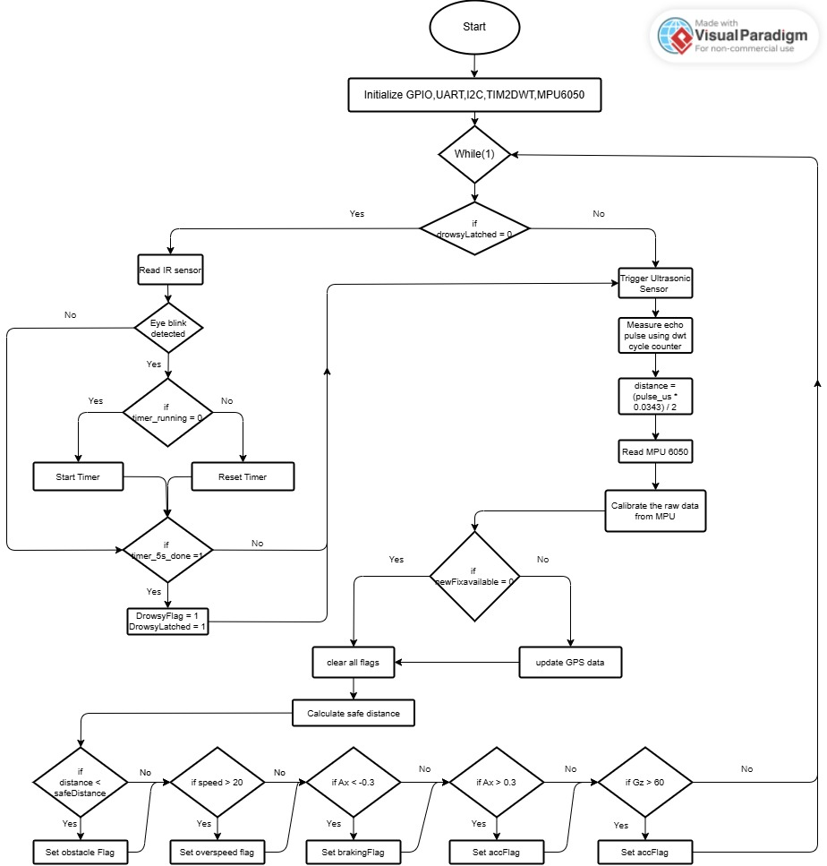

3.3 Drowsiness Detection Module
The drowsiness detection module continuously monitors the driver's eye status using the IR sensor. Every time a blink is detected, the system resets a 5-second timer. If no blink is detected within this time, the driver is considered drowsy and the drowsiness flag is generated.
Blink Detection
The system compares the current IR sensor reading with the previous reading to detect a new blink. This ensures that each blink is counted only once, even if the eye remains closed for a short time.
Timer Reset
Whenever a blink is detected, the 5-second timer is reset. If the timer is not already running, it is started. If it is already active, only the timer count is reset, allowing the monitoring process to continue smoothly.
Drowsiness Flag
If the timer reaches 5 seconds without detecting another blink, the timer interrupt sets a flag. The main program then marks the driver as drowsy and stops further eye monitoring until the system is restarted. This prevents the drowsiness status from being cleared accidentally.

Pseudo-code – Drowsiness Module:
if (!drowsyLatched)
{
ir_detected = readIR();
if (newBlinkDetected)
{
resetTimer();
startTimerIfNeeded();
}
if (timer_5s_done)
{
stopTimer();
drowsyFlag = 1;
drowsyLatched = 1;
}
}

3.4 HC-SR04 Distance Measurement
The ultrasonic sensor measures the distance to an obstacle by sending an ultrasonic pulse and measuring the time taken for the echo to return. The measurement process is as follows:
- Set the TRIG pin LOW for a short time.
- Generate a 10 µs pulse on the TRIG pin to start the measurement.
- The sensor transmits an ultrasonic wave.
- Wait for the ECHO pin to become HIGH.
- Record the start time.
- Wait for the ECHO pin to become LOW.
- Record the end time.
- Calculate the time taken by the echo pulse.
- Calculate the distance using the speed of sound.
The measured distance is calculated using the following equation:
$$\text{Distance (cm)}=\frac{\text{Echo Time}×0.0343}{2}$$
A high-resolution counter is used to measure the echo pulse duration accurately. This provides precise distance measurements and improves the reliability of obstacle detection.

3.5 MPU6050 Data Acquisition Module
The module reads all six motion axes in a single 14-byte I2C burst transaction. The MPU6050 register map places the ACCEL_XOUT_H register at address 0x3B, followed contiguously by ACCEL_Y, ACCEL_Z, TEMP, GYRO_X, GYRO_Y, GYRO_Z two bytes each.

After the I2C read, each 16-bit value is reconstructed by bit-shifting and OR-ing the high and low bytes, then cast to int16_t to correctly handle negative values (two's complement). The scaled physical values are computed as:

Ax = AccX / 16384.0f (g units, ±2 g range)
Gx = GyroX / 131.0f (°/s units, ±250°/s range)
Bytes 6–7 (TEMP_OUT) are read but discarded.

3.6 GPS Reception and Parsing
The GPS module continuously sends location data to the STM32 through UART2. The data is received one character at a time using UART interrupts. When a complete GPS message is received, it is processed by the program.
From the received $GPRMC message, the system extracts the following information:
- Latitude
- Longitude
- Vehicle speed
The latitude and longitude are converted into decimal format, and the speed is converted from knots to km/h for further calculations.
Whenever a valid GPS message is received, a flag is set to indicate that new data is available. During the next iteration of the main loop, the latest location and speed values are updated, and the flag is cleared. This ensures that the system always uses complete and valid GPS data for monitoring and decision making.

4. Threshold Values and Flag Generation Logic
All safety flags are binary outputs (0 or 1). They are evaluated once per main loop iteration, with the exception of drowsyFlag, which is generated by the TIM2 hardware interrupt and permanently latched once asserted. Table below provides a consolidated reference for all six flags.

Flag | Sensor | Parameter | Threshold | Equation | Purpose
drowsyFlag | IR Sensor | Eye blink frequency | No blink for > 5 s | timer_5s_done = 1 | Detects driver drowsiness
obstacleFlag | HC-SR04 | Distance to obstacle | distance_cm < safeDistance | safeDistance = (v·t_r + v²/2a)×100 | Alerts when vehicle is inside dynamic safe stopping distance
overspeedFlag | GPS | Speed over ground | speed > 20 km/h | speed > 20 | Flags limit exceedance
brakingFlag | MPU6050 | Longitudinal deceleration. | Ax < −0.3 g | Ax < −0.3 | Detects harsh braking
accFlag | MPU6050 | Longitudinal acceleration. | Ax > +0.3 g | Ax > 0.3 | Detects aggressive acceleration
turningFlag | MPU6050 | Yaw angular rate | |Gz| > 60°/s | fabsf(Gz) > 60.0 | Detects abnormal driving and oversteering

4.1 Drowsiness Flag
A normal person blinks around 15–20 times per minute. System considers the driver to be drowsy if no blink is detected for 5 seconds. This threshold was selected to provide timely detection of possible driver fatigue while avoiding frequent false alarms.
Once drowsiness is detected, the drowsyFlag is set and remains active until the system is restarted. This ensures that the warning is not cleared automatically if the driver blinks afterward, making the system more reliable for safety applications.

4.2 Obstacle Flag – Dynamic Safe Stopping Distance
Unlike a fixed-distance threshold, this system implements a physics based dynamic safe distance model accounting for driver reaction time and vehicle kinematics. The calculation proceeds as follows,

Step 1 – Convert speed: speedMS = speed / 3.6 (km/h → m/s)
Step 2 – Reaction distance: d_reaction = speedMS × 1.0 (1 s reaction time)
Step 3 – Braking distance: d_braking = speedMS² / (2×6)
Step 4 – Safe distance: safeDistance = (d_reaction + d_braking) × 100[cm]

4.3 Overspeed Flag
Overspeed limit is set to 20 km/h, which is suitable for testing in indoor or campus environments. If the vehicle speed exceeds this value, the overspeed flag is activated.
In a real vehicle, this speed limit could be changed automatically based on the driving location or road conditions. The system uses the speed provided by the GPS module to compare with the predefined speed limit.

4.4 Harsh Braking and Acceleration Flags
In this project, a threshold of ±0.3 g is used to detect harsh braking and sudden acceleration. If the acceleration along the X-axis exceeds this limit in either direction, the corresponding safety flag is activated. This threshold helps identify sudden vehicle movements while reducing false alarms caused by normal driving conditions.
The X-axis of the MPU6050 is assumed to be aligned with the direction of vehicle movement. Therefore, correct sensor mounting is important to ensure accurate detection of braking and acceleration events.

4.5 Harsh Turning Flag
In this project, the harsh turning threshold is set to 60°/s. The system uses the Z-axis gyroscope of the MPU6050 to measure the vehicle's turning rate. The absolute value of the measured yaw rate is compared with the threshold so that sharp turns are detected in both left and right directions. If the turning rate exceeds 60°/s, the harsh turning flag is activated. This value provides reliable detection of aggressive turning during normal vehicle operation.

5. Experimental Results
5.1 Hardware Setup
The prototype was assembled on a zero PCB and connected to the STM32 Nucleo-F446RE board.
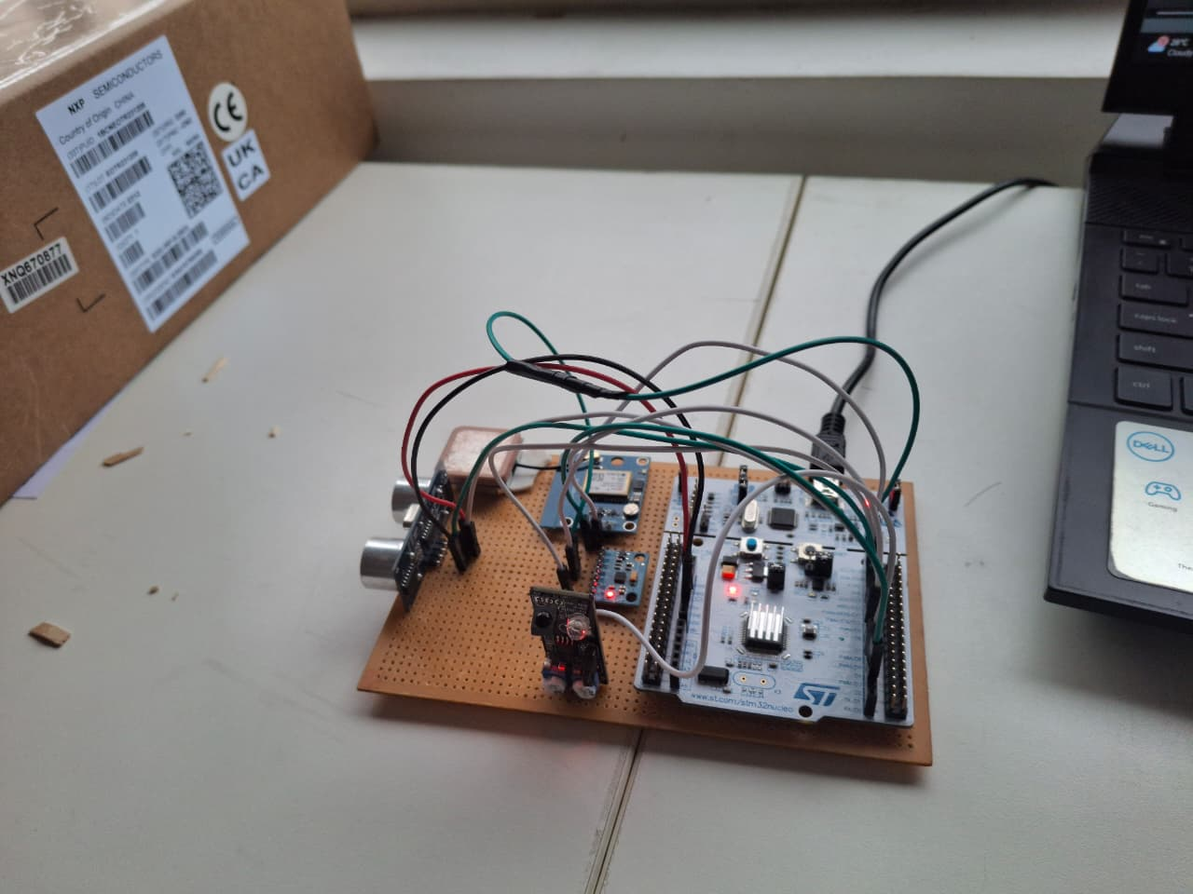
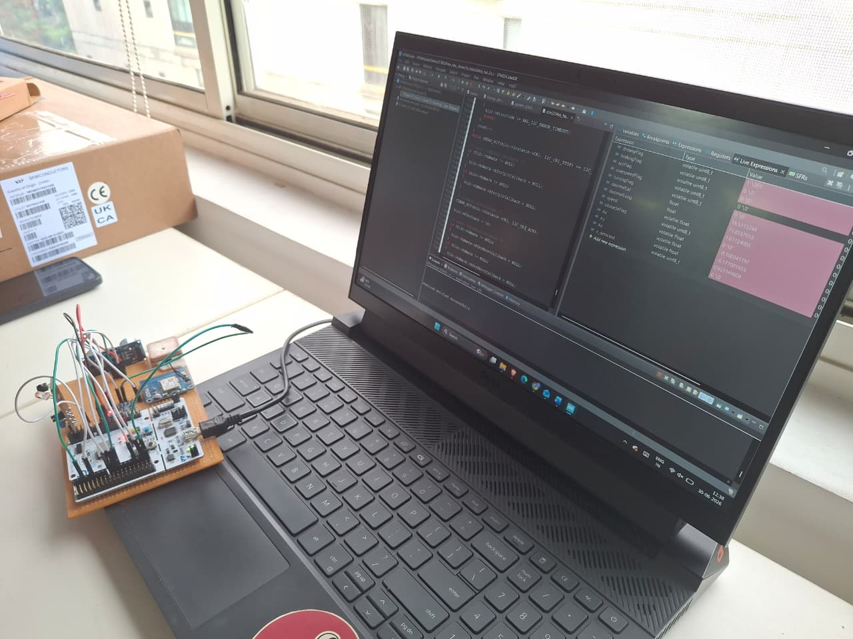
5.2 Observation and Discussion
All eight test cases produced the expected flag outputs. The following observations were noted during testing:
- Drowsiness latching: The latch mechanism functioned correctly in all trials. Once drowsyFlag was set, no subsequent blink or sensor event was able to clear it, confirming the permanent latch design.
- Dynamic safe distance: The obstacle detection model correctly scales with speed. At standstill, safeDistance evaluates to near-zero and no false obstacle flags were raised.
- GPS cold start delay: The Neo-6M required approximately 45–60 seconds for a first fix in an open environment. During the fix acquisition period, GPS-dependent flags (overspeed, obstacle safe distance) remain at their default values.
- Ultrasonic blind zone: The HC-SR04 has a minimum range of approximately 2 cm. Objects closer than 2 cm produce unreliable echo pulses.

6. Conclusion
This project successfully developed a Smart Driver Monitoring and Collision Alert System using the STM32 Nucleo-F446RE. The system achieved all the intended objectives and successfully detected six important safety conditions during testing.

- The IR sensor successfully detected driver drowsiness by monitoring eye blinks and generated a warning when no blink was detected for 5 seconds.
- The HC-SR04 ultrasonic sensor measured the distance to nearby obstacles and provided obstacle warnings based on the calculated safe stopping distance.
- The MPU6050 accurately measured acceleration and turning motion, allowing the system to detect harsh braking, sudden acceleration, and sharp turns.
- The Neo-6M GPS module provided location and vehicle speed, which was used for overspeed detection and obstacle detection.
- All six safety flags drowsiness, obstacle detection, overspeed, harsh braking, harsh acceleration, and harsh turning worked correctly and independently during testing.

The project shows that an effective real time driver safety system can be developed using an STM32 microcontroller and commonly used embedded peripherals such as GPIO, UART, I2C, and timers. The modular design makes the system easy to expand by adding features such as a buzzer, CAN communication, or cloud connectivity in the future. This project provides a strong foundation for developing more advanced driver assistance and vehicle safety systems.

