***1st Step:***

**pip install fastapi[all]**

**pip install uvicorn[standard]**

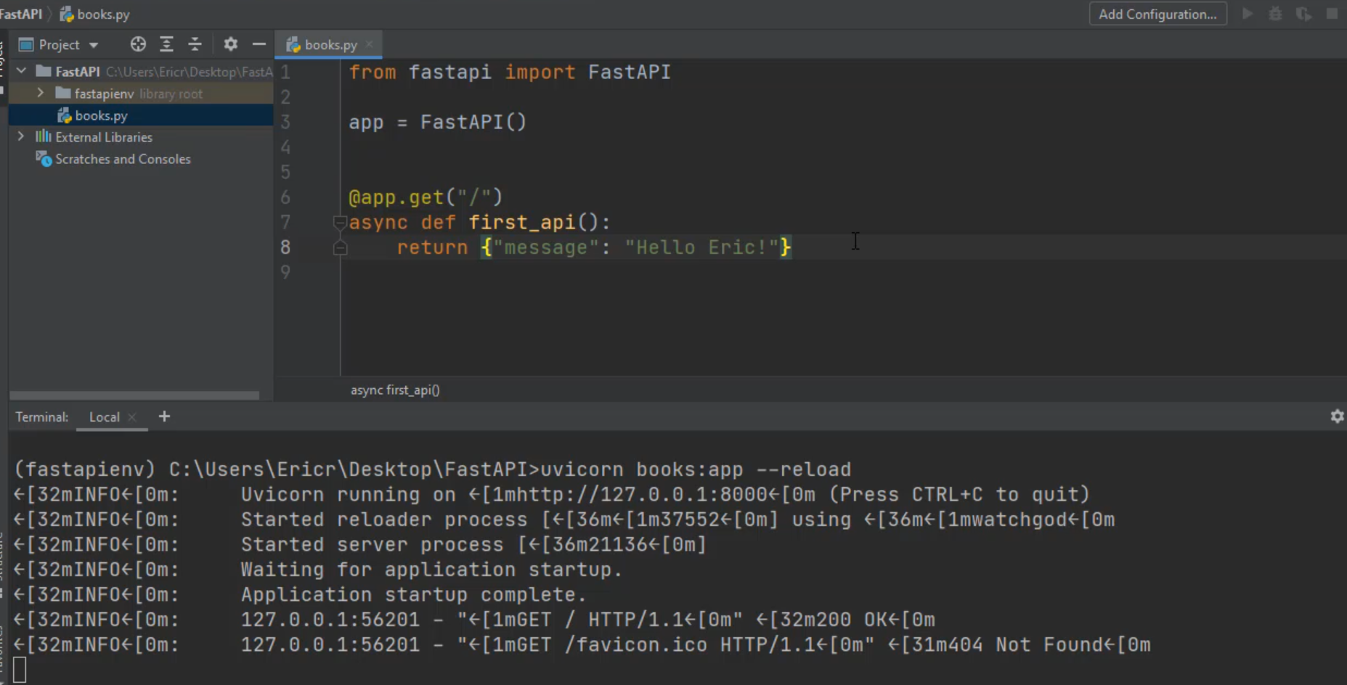

***Run uvicorn:***

E:\PycharmProjects\FastAPI> uvicorn books:app --reload



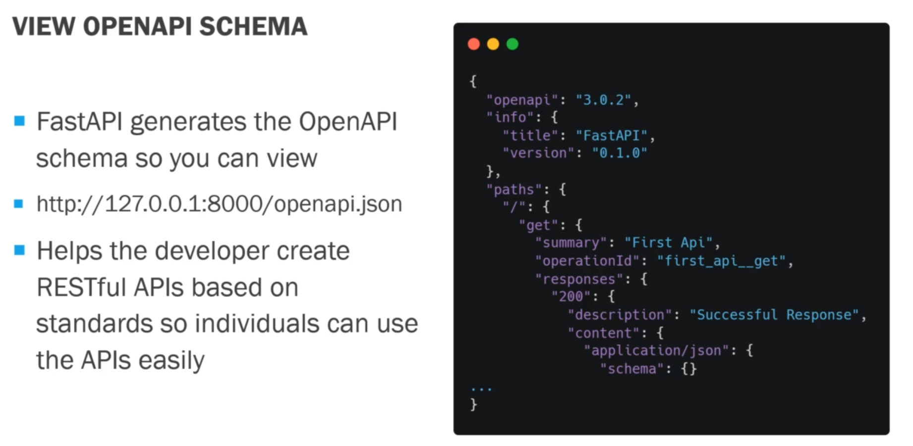

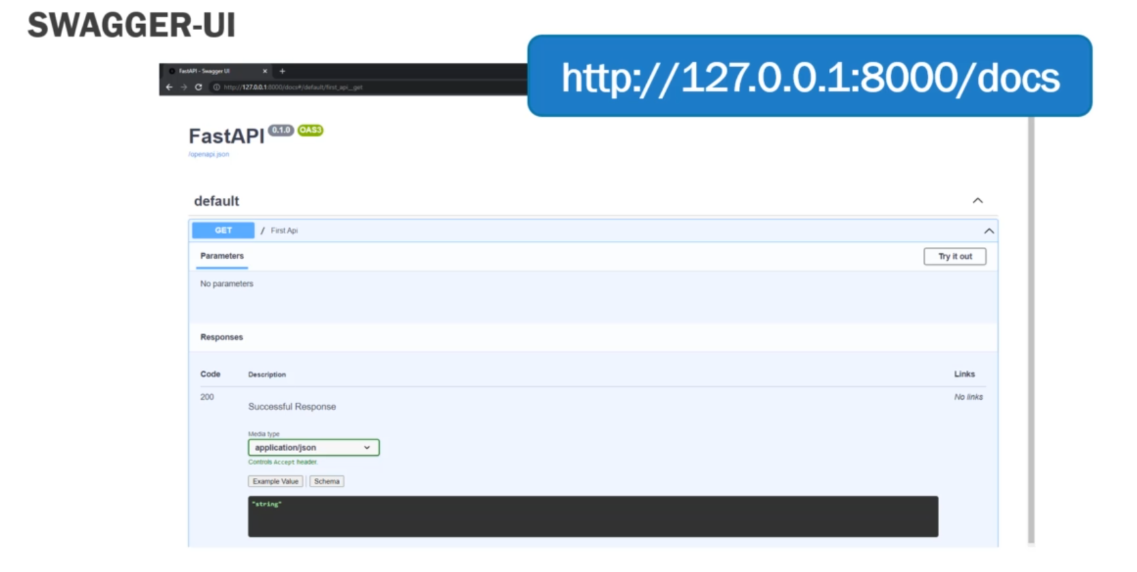

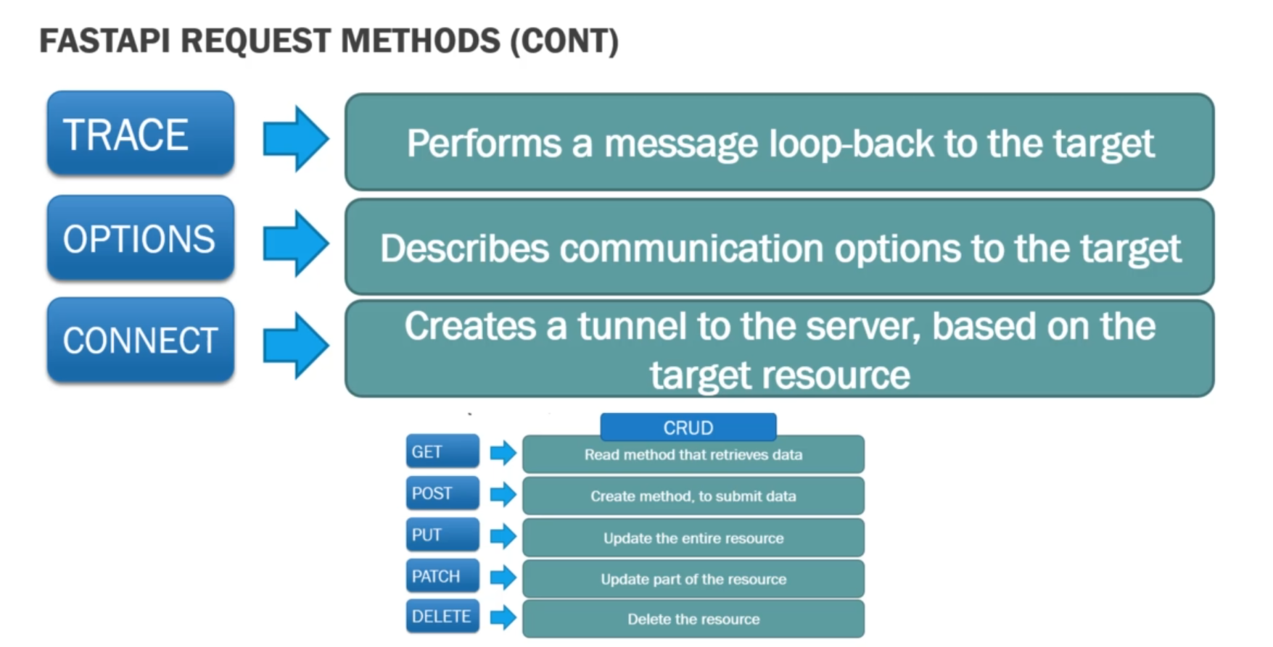

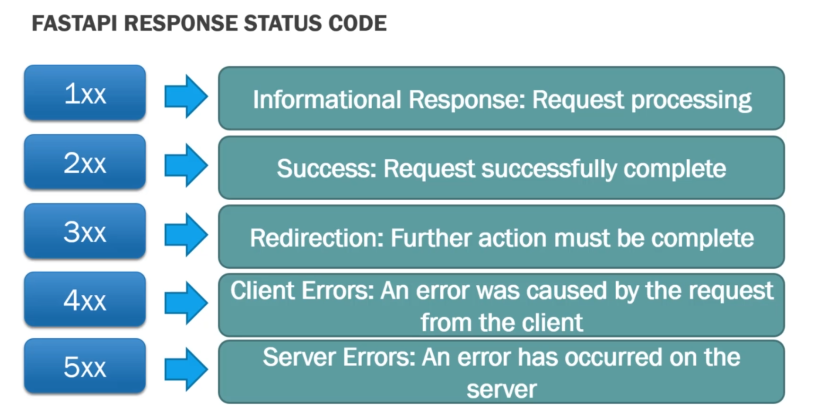

***Project Books:***

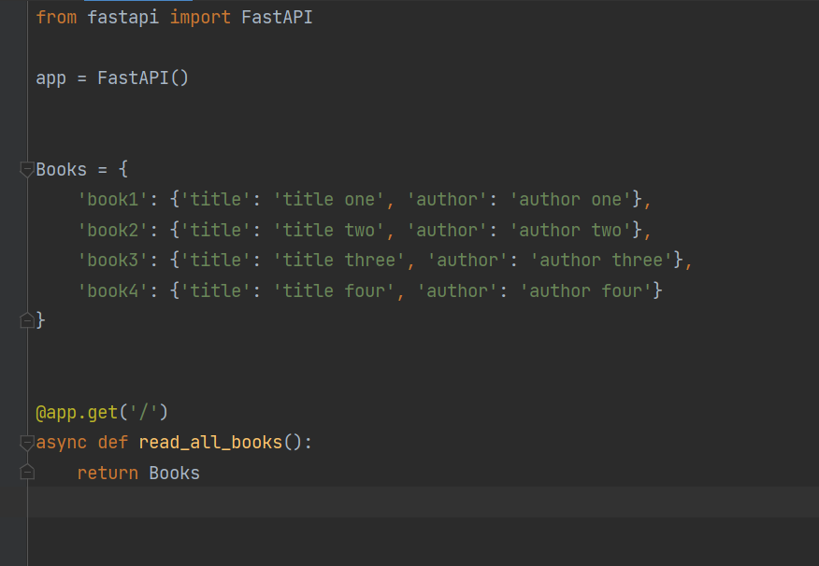

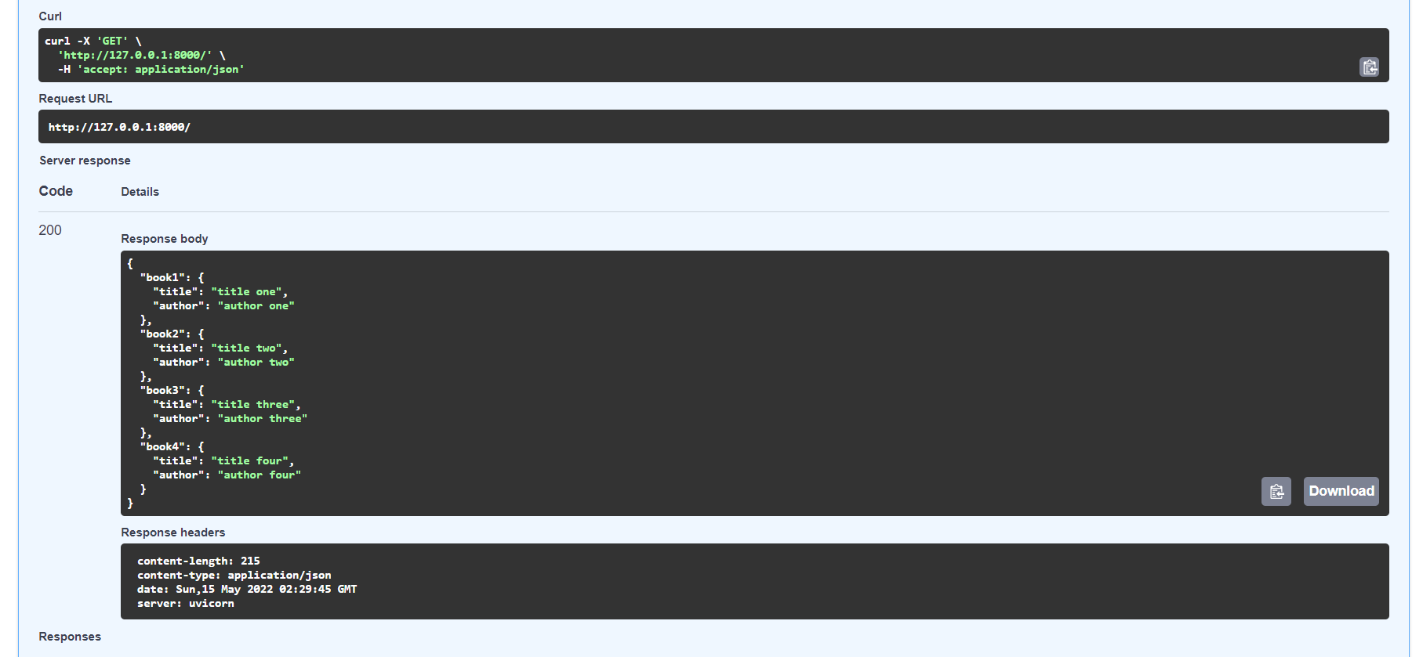

***To get required data type only***

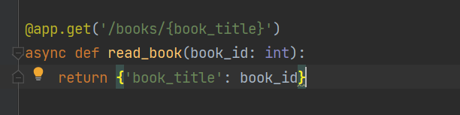

* ***The order of @app.get() matters.***

***Some Terms:***

* ***Query Parameters***
* ***Path Parameters***

