***Step 1 :***

**pip install fastapi[all]**

**pip install uvicorn[standard]**

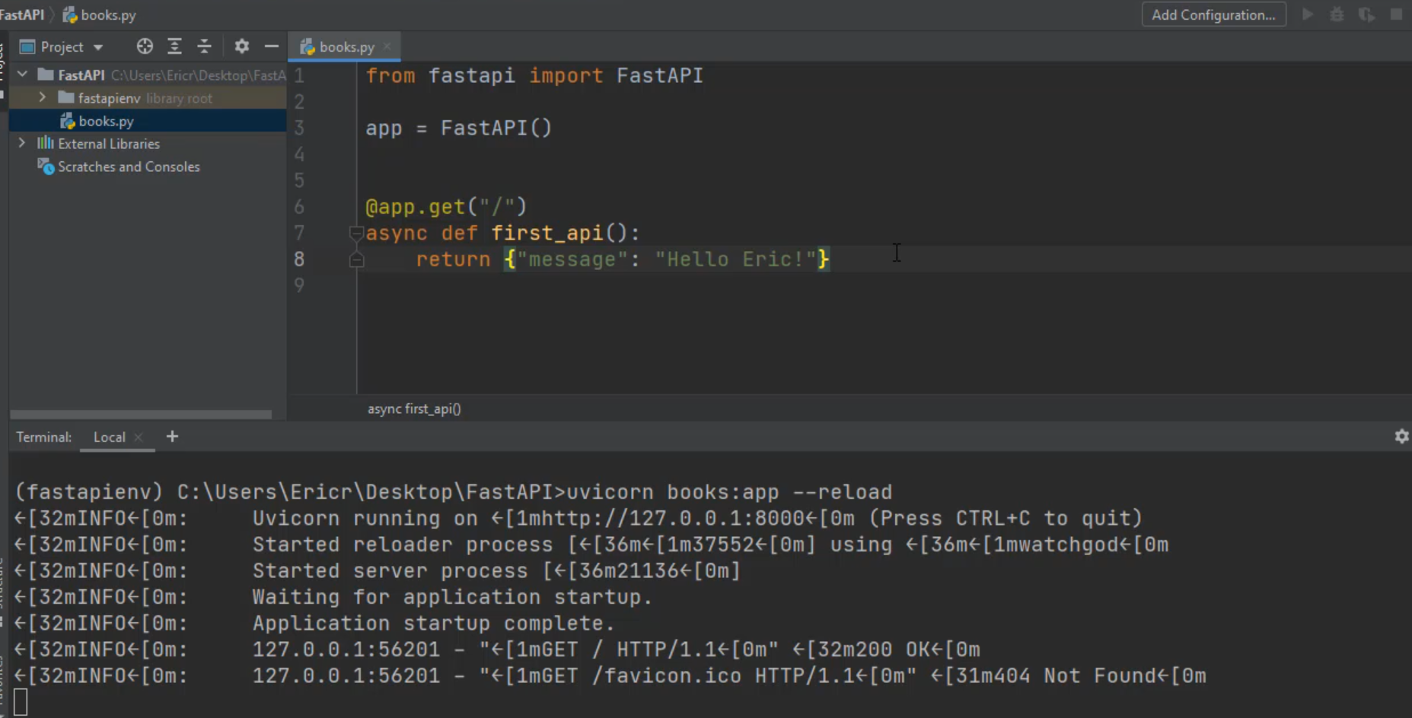

***Run uvicorn:***

E:\PycharmProjects\FastAPI> uvicorn books:app --reload