CASE STUDY



A leading B2B customer support software provider in the US approached VR Business Solution to convert marketing opportunities into real sales value. The client wanted to learn about the requirements of B2B customer support software in several industries

# BACKGROUND

VR Business Solution designed a comprehensive outbound sales development program to generate strong leads that would result in higher sales opportunities and forge a long-term relationship. We approached targeted accounts and helped our client build and scale demand by offering relevant assets associated with B2B customer support software targeting multiple job titles

VR Business Solution reached out to the following industries :



Media & Entertainment



BFSI



BFSI



Food & Beverages



Healthcare



Telecommunications



Information & Technology

Our prime focus was to boost campaign efficiency by:

* Creating ideal personas to leverage distinctive email nurturing campaigns
* Formulating a robust content syndication program with measurable KPIs

C Level

IT Directors+

LOB Managers+

**Targeted Job Titles**

IT Staff+



VR Business Solution, implemented a lead generation strategy that helped the client identify and prioritize the best-fit accounts based on intent, technographic, engagement data, and engaging those accounts across content syndication. We reached out to professionals and made pertinent assets available to them, based on which VR Business Solution help its client target technology and business challenges.



accounts, audience, and top-tier management of various companies

# RESULT

* + High Lead Volume Delivered
  + 58% increase in leads from 2019-20

Leads Delivered

92K



**2019 2020**

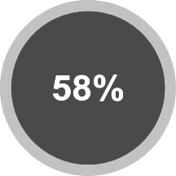

**Total Leads Delivered Lead Growth, 2019-20**

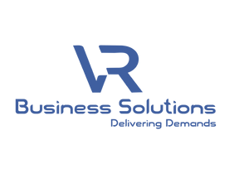

## About VR Business Solution

VR Business Solution is a global technology media company helping B2B brands engage with Enterprise IT and business audiences. We drive brand awareness and demand generation programs for B2B technology brands leveraging our media properties enhanced through the use of our propriety technology stack. VR Business Solution is headquartered in the USA and has a delivery center in Pune, India.

## Headquarters –

66 West Flagler Street - Suite 900

Miami, FL 33130

+1 786 406 6061

## Delivery Center –

Platinum Square, Office No. 713, 7th Floor, Near Hyatt Hotel,

Viman Nagar, .

Pune 411014, India

+91 782 383 1216

[contact@vr-bs.com](mailto:contact@vr-bs.com)

© 2022 All Rights Reserved VR Business Solutions.