

**American International University- Bangladesh**

**CSC 3215: Web Technologies**

**Project Report**

**Project Title: Resort Management System**

**Section: D**

|  |  |
| --- | --- |
| Student Name | Student Id |
| Abu Ubayda Tanvir | 18-36404-1 |
| Kakon Paul Avi | 19-39695-1 |

**Project Description:**

This project aims at creating a Resort Management System which can be used by customers to reserve rooms and other facilities online. Users can check the availability of rooms and other facilities. The users can register and log into the system. The administrator will know the details of reservations. This system can manage and keep records of the resort online. Admin will also manage all the things for the resort. This system is very secure and user friendly.

**Database schema:**

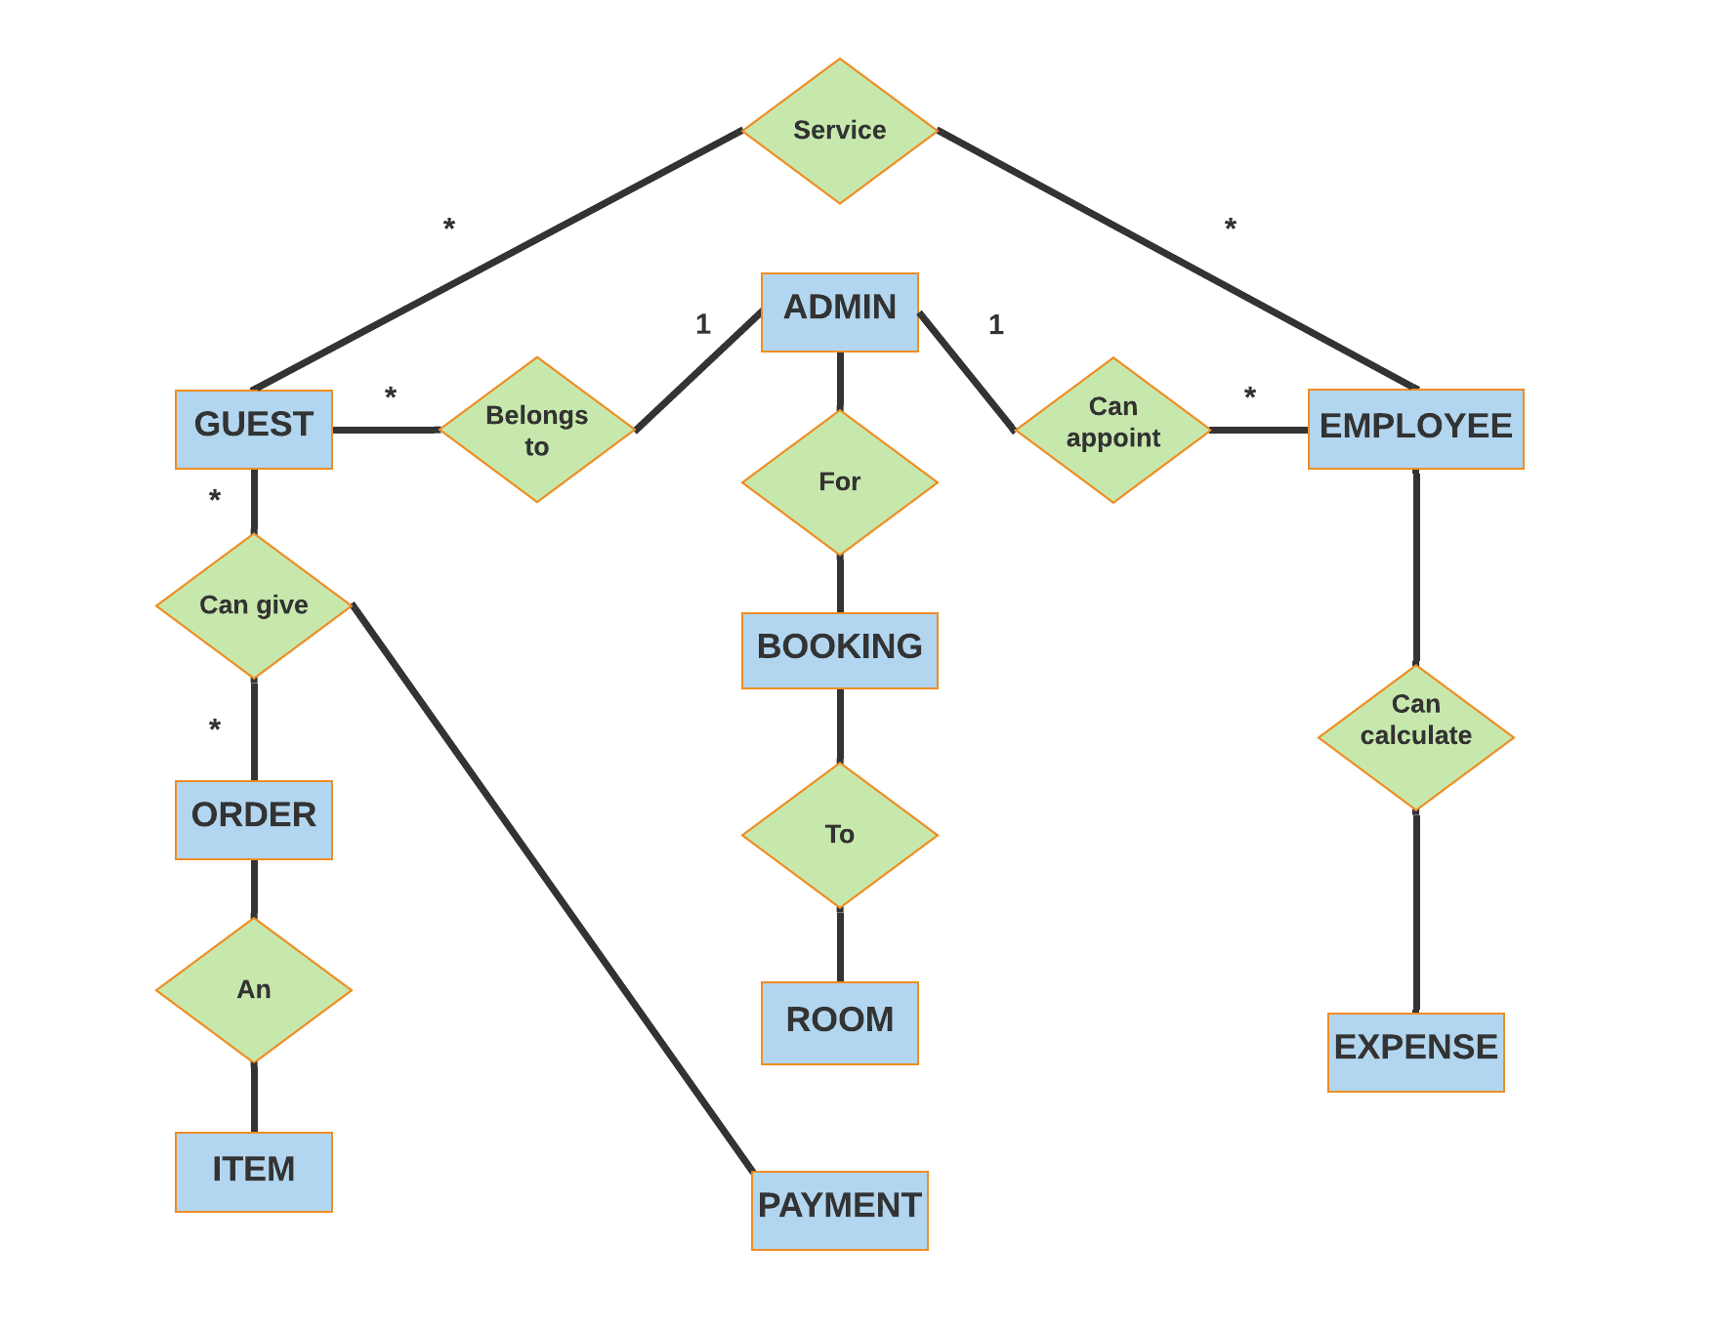

**Core Modules of the Project:**

**Login.php**

<?php

include 'controllers/SignIn.php';

?>

<html>

<head>

<link rel="stylesheet" href="https://maxcdn.bootstrapcdn.com/bootstrap/3.3.7/css/bootstrap.min.css" integrity="sha384-BVYiiSIFeK1dGmJRAkycuHAHRg32OmUcww7on3RYdg4Va+PmSTsz/K68vbdEjh4u" crossorigin="anonymous">

<link rel="stylesheet" href="styles/MyStyles.css">

</head>

<body>

<form action="" method="post">

<br><br>

<br><br>

<br><br>

<br><br>

<br><br>

<br><br>

<table align = "center">

<tr>

<td align="right">Username</td>

<td>:<input name="uname" type="text" value="<?php echo $uname;?>"><br>

<span><?php echo $err_uname;?></span></td>

</tr>

<tr>

<td align="right">Password</td>

<td>:<input name="pass" type="password" value="<?php echo $pass;?>">

<br><span><?php echo $err_pass;?></span></td>

</tr>

<tr>

<td></td>

<td align="left"><input type="submit" value="Log In"></td>

</tr>

</table>

</form>

</body>

</html>

<?php include 'Footer.php';?>

**CustomerRegister.php**

<?php

include 'controllers/UserController.php';

?>

<html>

<head>

<link rel="stylesheet" href="https://maxcdn.bootstrapcdn.com/bootstrap/3.3.7/css/bootstrap.min.css" integrity="sha384-BVYiiSIFeK1dGmJRAkycuHAHRg32OmUcww7on3RYdg4Va+PmSTsz/K68vbdEjh4u" crossorigin="anonymous">

<link rel="stylesheet" href="styles/MyStyles.css">

</head>

<body>

<body style = "background: url(https://i.pinimg.com/originals/08/f0/19/08f019f2c19f91cf1484d1a699851662.png); background-size: 100% 100%" ></body>

<form action="" method="post">

<h3 align = "center"><font color = 'red'>Customer Registration Form</font></h3>

<table align = "center">

<tr>

<td align='right'><b>First Name<font color = 'red'>*</font></b> </td><td><input type="text" value="<?php echo $name ?>" name="name" id="name">

</td>

<td>

<?php echo $err_name ?>

</td>

</tr>

<tr>

<td align='right'><b>Last Name<font color = 'red'>*</font> </b></td><td><input type="text" name="lname" id="lastname" value="<?php echo $lname ?>">

</td>

<td>

<?php echo $err_lname ?>

</td>

</tr>

<tr>

<td align='right'><b>Address<font color = 'red'>*</font> </b></td><td><input type="text" name="address" id="address" value="<?php echo $address ?>">

</td>

<td>

<?php echo $err_address ?>

</td>

</tr>

<tr>

<td> </td><td><input type='text'>

</td>

</tr>

<tr>

<td align='right'><b>Phone <font color = 'red'>*</font></b></td><td><input type="text" name="telephone" id="phone" value="<?php echo $telephone ?>">

</td>

<td>

<?php echo $err_telephone ?>

</td>

</tr>

<tr>

<td align='right'><b>Email<font color = 'red'>*</font> </b></td><td><input type="text" name="email" id="email" value="<?php echo $email ?>">

</td>

<td>

<?php echo $err_email ?>

</td>

</tr>

<tr>

<td align="right"><b>Gender<font color = 'red'>*</font></b></td>

<td><input type="radio" name="gender" value="male" <?php if($gender=='male') echo "checked"; ?>>

<label>Male</label>

<input type="radio" name="gender" value="female" <?php if($gender=='female') echo "checked"; ?>>

<label>Female</label>

</td>

<td>

<?php echo $err_gender ?>

</td>

</tr>

<tr>

<td align='right'><b>Blood Group </b></td><td><input type="text">

</td>

</tr>

<tr>

<td align="right"><b>Marital Status<font color = 'red'>*</font></b></td>

<td><input type="radio" name="marital" value="married" <?php if($marital=='married') echo "checked"; ?>>

<label>Married</label>

<input type="radio" name="marital" value="unmarried" <?php if($marital=='unmarried') echo "checked"; ?>>

<label>Unmarried</label>

</td>

<td>

<?php echo $err_marital ?>

</td>

</tr>

<tr>

<td colspan='2'align='center'><input type='submit' value='Register'>

</td>

</tr>

</table>

</form>

</body>

</html>

**AdminLogin.php**

**<?php include 'admin_header.php';**

**include 'Usercontroller.php';**

**?>**

**<html>**

**<div class="center-login">**

**<h1 class="text text-center">Login</h1>**

**<form action="" method="post" class="form-horizontal form-material">**

**<div class="form-group">**

**<h3 class="text text-center">Username</h3>**

**<input type="text" name="uname" value="<?php echo $uname;?>" class="form-control">**

**<span class="text-danger"><?php echo $err_uname;?></span>**

**</div>**

**<div class="form-group">**

**<h3 class="text text-center">Password</h3>**

**<input type="password" name="pass" value="<?php echo $pass;?>" class="form-control">**

**<span class="text-danger"><?php echo $err_pass;?></span>**

**</div>**

**<div class="form-group text-center">**

**<input type="submit" name="btn_login" class="btn btn-danger" value="Login" class="form-control">**

**</div>**

**<div class="form-group text-center">**

**<a href="signup.php" class="btn btn-primary" >Sign Up</a>**

**</div>**

**</form>**

**</div>**

**</html>**

|  |  |  |  |  |  |
| --- | --- | --- | --- | --- | --- |
| **CO2 and CO4 Evaluation: Project Report Evaluation** | | | | | |
| **Completeness**  **(5)** | **Validation**  **(5)** | **Feature Implementation**  **(5)** | **Concept Understanding**  **(5)** | **Promptness (5)** | **Total (25)** |
|  |  |  |  |  |  |
|  | | | | | |