Pranav Karra

ENGR 108 Project

Prof. Koscinski

06/23/17

Electrical Engineering: DC circuit analysis

Introduction:

For this project, we were supposed to develop a system of linear equations and try to re-create the problem to solve it using MATLAB. The problem I chose involves a circuit with a couple of resistors and the overall system being powered by a 9V battery. The main objective is to find the current through each component in the given system, and check to make sure that the solution will verify if the current in the top loop is less than or more than 0.5mA.

To analyze a circuit, one must think about some ways to use Kirchhoff’s voltage and current rules to construct these systems of equations. To begin with we need to label each component and assume a direction of current that passes through the system. It can be hard to pick the correct direction for the current travelling around a loop, which can be avoided by simply picking a direction in which you want the current to travel. If you end up with a negative value it just means that the direction you picked was the opposite of the actual direction of current travelling in the loop. While choosing a direction for the current to travel, one should make sure that direction is being consistent around all the loops involved in the circuit, as inconsistency can cause a slight error in the results. After this is done, use Kirchhoff’s second rule to write down the loop equations for as many loops it takes to cover almost every component involved in the circuit. Before we go ahead we need to know what exactly Kirchhoff’s second rule means. The second rule, also known as the loop rule, tells us that the voltage around a circuit must be zero. To come up with these equations, one must choose a starting point and go around the loop noting down the change in voltage going across resistors. Also, make sure to add voltage instead of subtracting when you’re going around in the direction opposite to the current through a resistor.

The given problem consists of the following as shown in the figure:

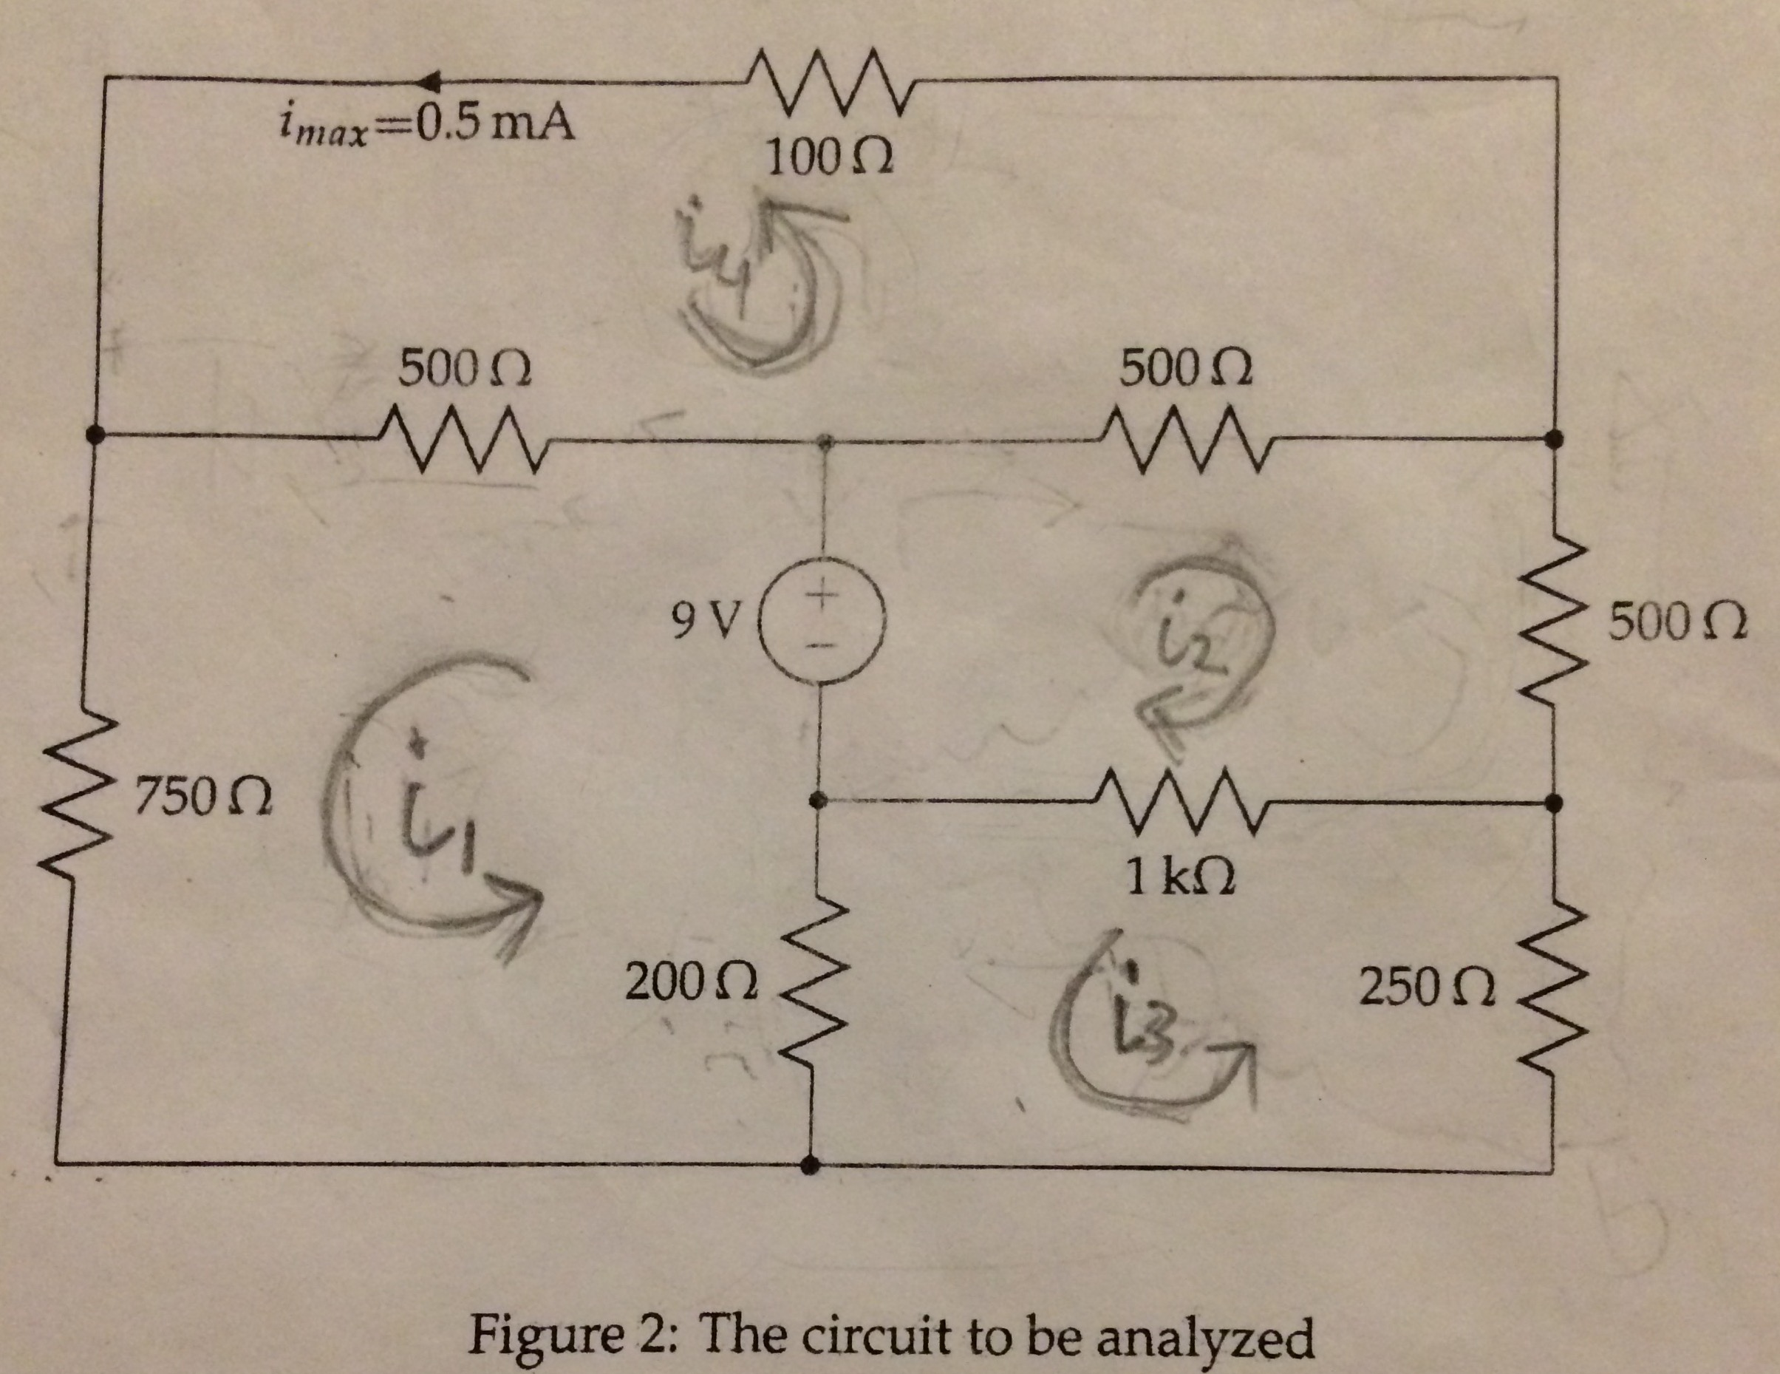

Procedure:

As we can see the direction of current has already been assumed and is consistent all along. We see that there contains a single voltage source and eighth resistors. We can analyze this circuit by dividing it up into four smaller loops and using the current rules to come up with four separate equations.

For the lower-left hand loop we get the following equation:

For the loop with current i2 we have:

For the lower right hand loop, we get the following equation:

And the top most equation gives us the following:

Now it’s just a matter of rearranging these equations so that they are in form to which we can apply a matrix operation. This we require us to expand on the above equations and rewrite them:

Now it’s time to create a MATLAB program to solve these equations using Gaussian elimination method:

1. State the Problem: Find the current through each component and verify that the current at the top loop is less than the maximum through the loop (i.e. 0.5mA)
2. Describe the input and output:
   1. Input: Eight resistors with varying values and a 9V battery.
   2. Output: Four current values and to verify that the current through the top loop is less than or is equal to the maximum current around it.
3. Develop a MATLAB solution: The MATLAB code 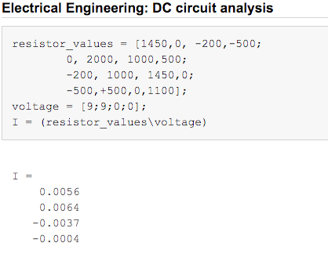
4. Test the solution: In order to make sure that the above solution is right we need to test this solution by using a loop or a node that wasn’t used in the above system of equations to generate the output. To do this, we consider the outer loop for the entire circuit going around with a current i5. This results in the following equation for the entire circuit:

When we include this in the MATLAB solution the answer for the outermost loop should be zero as there is no applied voltage around, there can be no current, so even if we enter any value for the resistors the answer should be zero which would hence prove that the above steps that were taken to develop these equations were right.

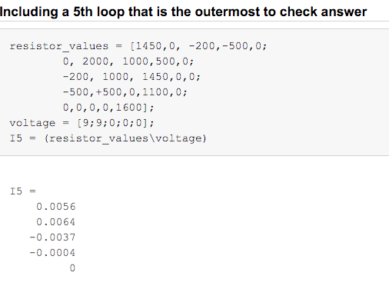

Results: Now that we got the current values for all the loops and have verified that those are correct, we need to now find the current through each component in the system. This would require us to plug back the current values i1, i2, i3, i4 to each of above equations to get the current travelling through each resistor. For example, for the 750-ohm resistor in the i1 loop, to get the current passing through it we would refer to its corresponding system of equation, where we see that it is nothing but, 750 Similarly the below figure gives us the current values through each component.

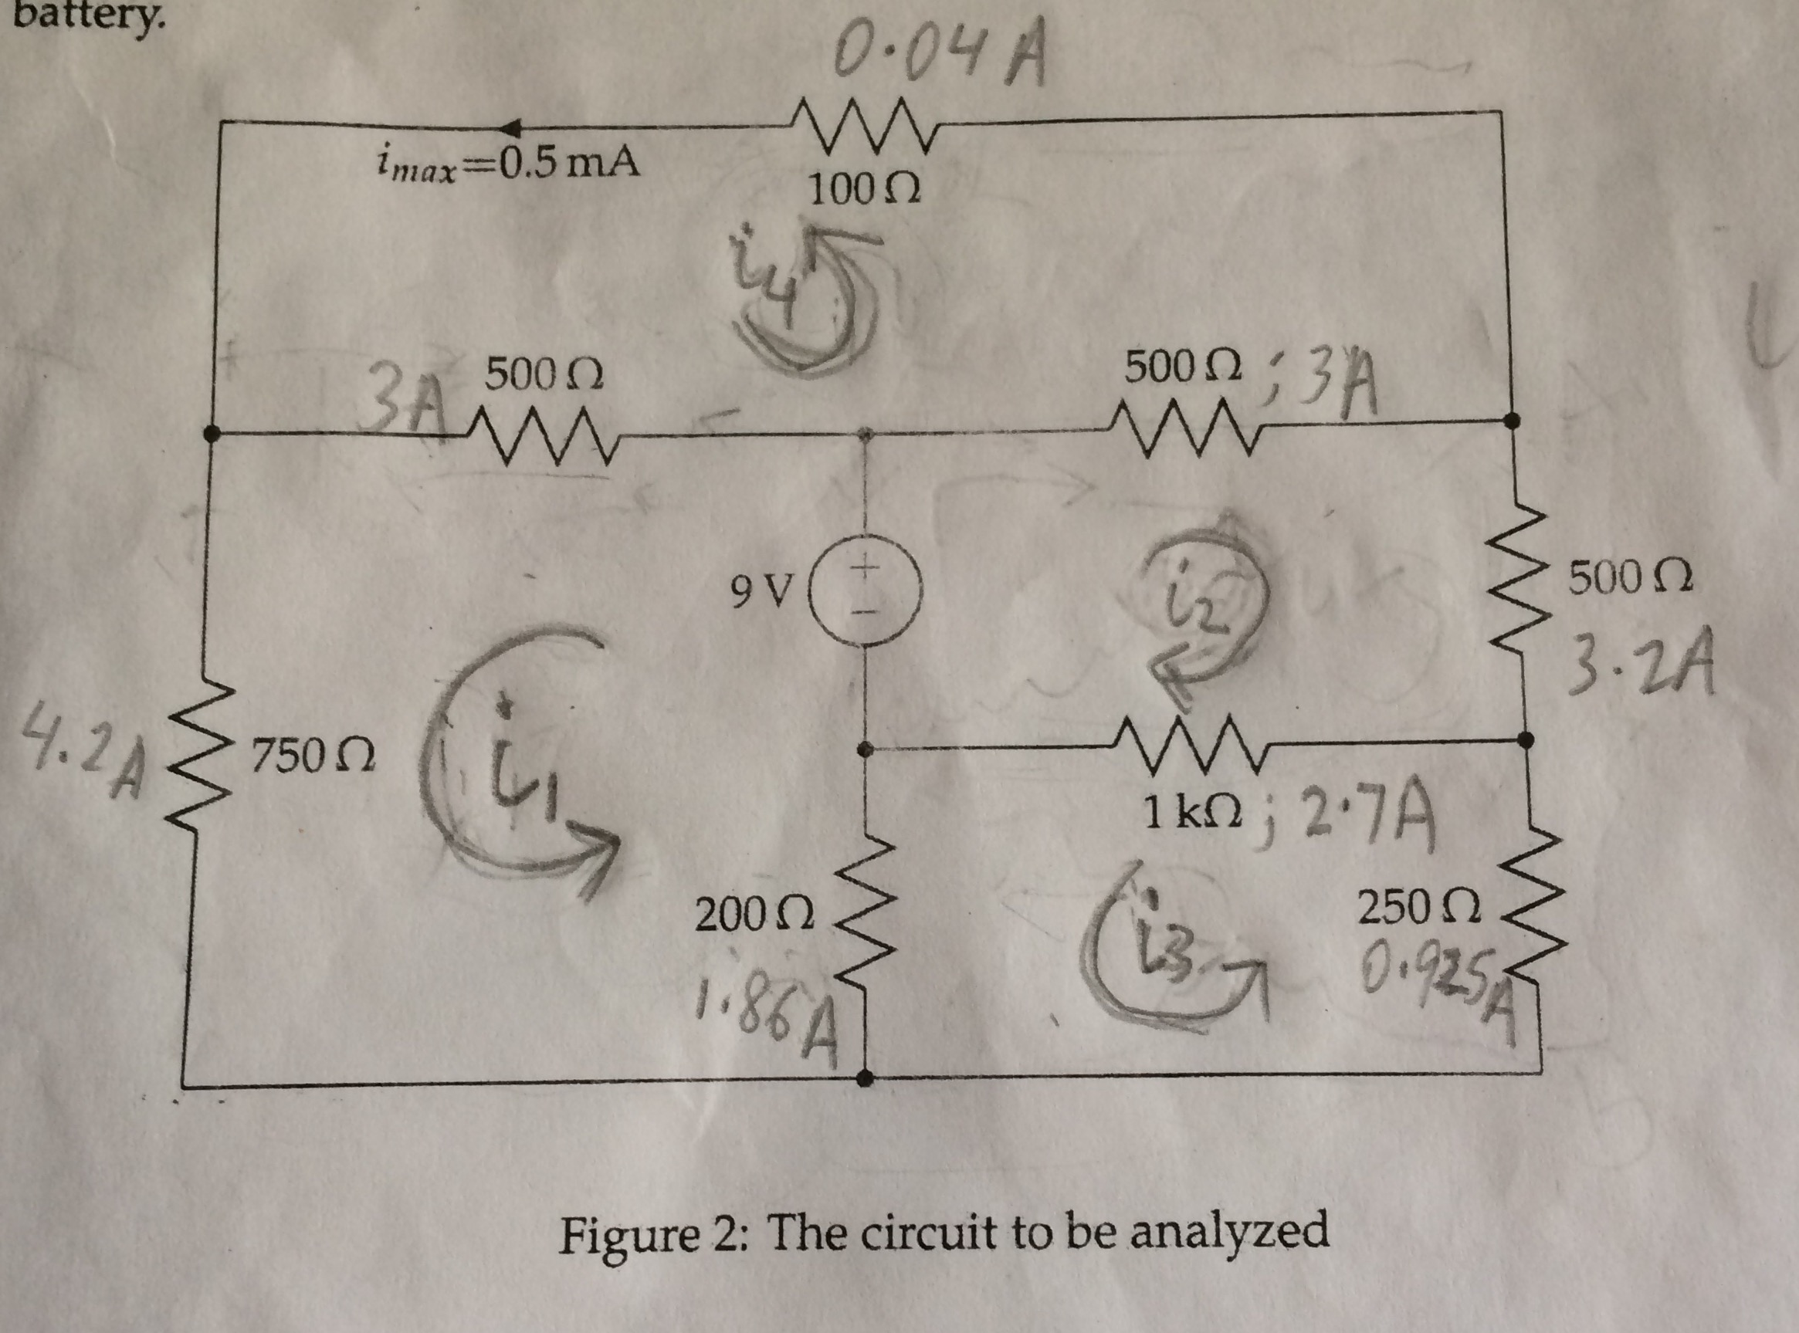

Thus, these results suggest that different resistors take up varying amount of current based on their values, with higher one taking up more current compared to a lower resistor value. We also see that even though we ended up with a negative value for the current through the loop, it just suggests that we predicted the current to be flowing in the wrong direction. Our solution also verifies that the current in the top loop is less than the maximum (i.e. 0.5mA) that can pass through the 100-ohm resistor safely before failing.