Level Design Document

Version 1.0

Peter khromov

Yurgen177@gmail.com

Contents

1. Overview 2

2. Environment 6

2.1 Level Atmosphere/Mood 6

2.2 Map Objectives 9

2.3 Challenge Highlights 9

2.4 Actors 10

3. User Interface 12

4. Gameplay 13

4.1 Gameplay Mechanics 13

4.2 Level Progression Chart 14

4.3 Level Flow Chart 15

4.4 Level Beat Chart 16

4.5 Level Layout 17

# 1. Overview

#### 1.1 Campaign

* Dawn of War: a civil country invaded by military forces
* Single Campaign

#### 1.2 Mission Location

* Baltic city, Port
* Outdoors/Indoors
* Industrial set in a dark realism atmosphere

#### 1.3 Mission Difficulty

|  |  |  |  |  |
| --- | --- | --- | --- | --- |
| **№** | **OCR** | **Challenge** | **Quantity** | **Difficulty** |
| **1** | Turn off the Alarm | Rifleman 1 | 2 | 4 |
| Eazy Puzzle | 1 | 1 |
|  | **Total** | **5** |
| **2** | Get the Key | Officer | 1 | 1 |
| Sniper 1 | 2 | 6 |
|  | **Total** | **7** |
| **3** | Open the Gate | Rifleman 1 | 2 | 4 |
| Medium Puzzle | 1 | 2 |
|  | **Total** | **6** |
| **4** | Destroy the APC | Sniper 2 | 1 | 4 |
| Hard puzzle | 1 | 3 |
|  | **Total** | **7** |
| **5** | Disarm the Missiles | Rifleman 1 | 3 | 6 |
| Rifleman 2 | 1 | 3 |
|  | **Total** | **9** |

* General: the mission difficulty curve slowly progresses from medium to difficult as the player moves through the map. On the way, he is introduced both to old and new mechanics.
* Turn off the Alarm: this section is both challenging and familiar to the players. They must pass or kill two general guards and switch off the alarm that calls enemy’s reinforcements.
* Get the Key: the player must kill two snipers and the enemy officer to get his keycard. The difficulty level raises but objective isn’t too hard because both types of AI are already familiar to the player.
* Open the Gate: this section is a bit easier than the previous one. The player must defeat two enemy soldiers and solve a puzzle to hack the gate control panel.
* Destroy the APC: the difficulty level raises quite significantly. The objective here is to kill a new enemy — an advanced sniper — and plant explosives on an enemy armored vehicle which can’t be defeated any other way.
* Disarm the Missiles: this is the main and the most difficult objective. The player finds himself in an open-spaced building with four enemy soldiers and one advanced soldier. The latter one is not familiar to the player yet.

#### 1.4 Mission Metrics

The total mission time is 41 minutes.

|  |  |  |  |  |
| --- | --- | --- | --- | --- |
| OCR | Activity | Quantity | Time | Total time |
| Start | Movement | 1 | 1 | 1 |
| Total | | | 1 |
| Switch off the Alarm | Rifleman 1 | 2 | 2 | 4 |
| Eazy Puzzle | 1 | 1 | 1 |
| Total | | | 5 |
| Transition | Movement | 1 | 2 | 2 |
| Total | | | 2 |
| Get the Key | Officer 1 | 1 | 1 | 1 |
| Sniper 1 | 2 | 2 | 4 |
| Total | | | 5 |
| Transition | Movement | 1 | 2 | 2 |
| Total | | | 2 |
| Open the Gate | Rifleman 1 | 2 | 2 | 4 |
| Med Puzzle | 1 | 2 | 2 |
| Total | | | 6 |
| Destroy the APC | Sniper 2 | 1 | 3 | 3 |
| Hard Puzzle | 1 | 3 | 3 |
| Total | | | 6 |
| Transition | Movement | 1 | 2 | 2 |
| Total | | | 2 |
| Disarm the Missiles | Rifleman 1 | 4 | 2 | 8 |
| Rifleman 2 | 1 | 3 | 3 |
| Total | | | 11 |
| End | Action, movement | 1 | 1 | 1 |
|  |  |  | Total | 1 |
|  |  |  | Grand Total | 41 |

* The dimensions of the map are 38 by 70 units. This is the total physical size.
* There are 2 new enemies that the player is introduced to: Sniper 2 and Rifleman 2.
* Hard puzzle is a new mechanic that will be used later as well.
* The boiler pipe is the main dominant of the scene. Another dominant is the sea with the sun setting in it.

# 2. Environment

### 2.1 Level Atmosphere/Mood

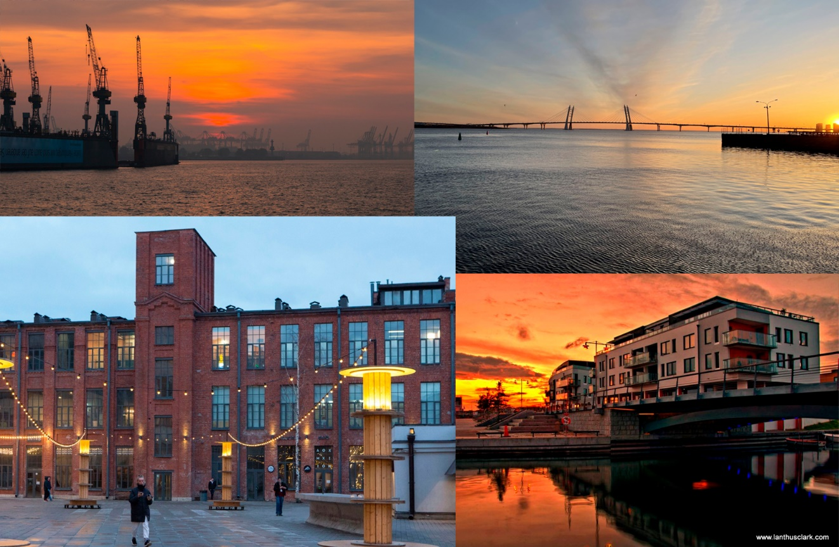

* The overall look of the level is rather relaxing and peaceful, and the general mood is a counterpoint to the fact the port has been captured by terrorists who are about to destroy some peaceful city. On the other hand, the setting sun produces lots of shadowy spots that play a key gameplay role allowing the player to hide from the guards’ eyes.

#### 2.1.1 Story

Northern Europe, Baltic Sea. A group of armed ex-military rebels lead by an PMC veteran I. Yerasov captured an old local port. According to the satellite intelligence, they have tactical missiles stored in a warehouse.

The player is a SEAL operative. His current mission called Silent Dusk is to enter the port, find the missiles and disarm them before they are launched.

#### 2.1.2 Major Areas/Visual Themes

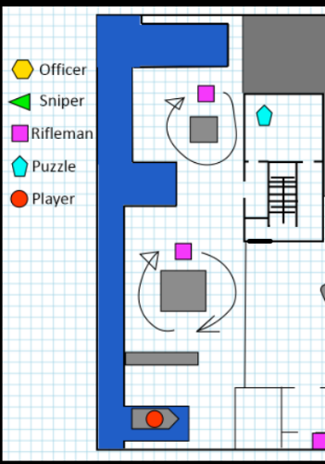**Switch off the Alarm:** the first OCR. You leave the boat and move along the pier. The pier has been transformed into a sea view promenade but retained some elements (e. g. a port crane). However, there are some military objects brought by Yerasov's soldiers: ammo crates, barrels etc. It is patrolled by two enemy riflemen armed with AK's. They are not very tough but if they see you, they raise the alarm, and then the mission is lost. To switch the alarm off, you must pass or kill the riflemen, enter the building and disarm the alarm controller — it's the first puzzle.

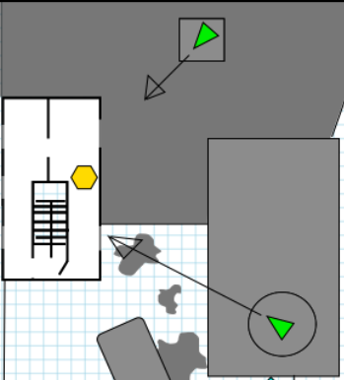**Get the key:**This OCR is within an old administrative house. It has old wallpapers; the lighting is quite dim. Its reconstruction started right before the port was captured.The exit is locked, and to proceed further you have to retrieve the key from an enemy officer who's sitting on the second floor. The officer is armed only with a PM pistol and is hardly a challenge. But there are two snipers with SVDs outside the building (one on the watchtower, another one on the boiler house pipe). Their shots are precise and take 1/2 hp. To get to the officer's body you have to deal with them first.

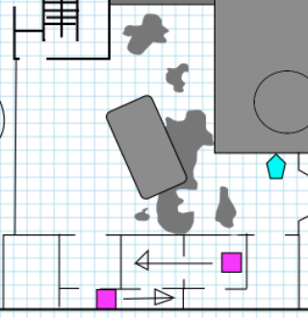**Open the Gate** this OCR takes place in an ex-food court: there is a long building that used to have various cafes and burger shops. Also, there is an old food truck in the yard. Piles of junk block the road, and you haves to get to the gate through the cafe building.

It is patrolled by two riflemen. They still aren't quite challenging but are quite close to each other. If they spot you, they attack you almost simultaneously. In the end, you have to breach the gate opening mechanism — that's the second puzzle.

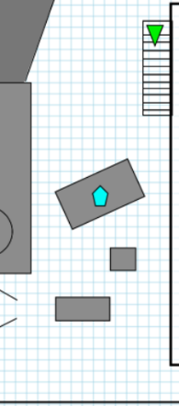**Destroy the APC:** right after the gate you get under a burst of the Cadillac Gage APC machinegun (it misses but you better hide: next time it takes all your HP) — destroying it is the third puzzle. You have to use covers, get to its hull and plant C4. But watch out for a sniper: he is armed with a .50 Bushmaster rifle and can kill you with a single shot. However, his reaction is not quite good so you have a chance to look out of the cover and shoot him.  
As for the territory, it's another yard with industrial and military objects. It's located between a boiler building and a warehouse.

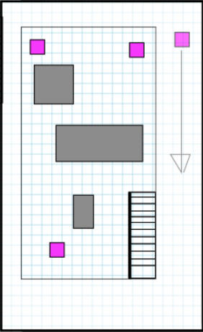**Disarm the Missiles:** the last OCR in the mission. The missiles are in an old warehouse which has been rebuilt into a concert hall. The missiles are located on a stage, in the other side there's a bar. Between them there are different obstacles and covers. Also, there's a balcony upstairs.

The main entrance is blocked, and you have to use the fire stairs where the sniper had his position and get through the window on the balcony. Inside, you have to deal with four riflemen. Three of them are simple AK guys but the last one (in the upper left corner) wears a kevlar vest and is armed with a PKP Pecheneg which deals more damage. You can try to kill them stealthily or engage and use covers to hide from their shots. As the PKP guy is killed, you retrieve his key and disarm the missiles. And with that, the mission is complete.

### 2.2 Map Objectives

* The main objective of the mission is to disarm the tactical missiles without getting caught.
  + **Switch off the Alarm**: completing this objective the player prevents the enemy from calling the reinforcements. Without it, if the player is spotted, the mission is failed.
  + **Get the Key**: an enemy officer has the key that opens the back door of the administrative house and allows the player to proceed further.
  + **Open the Gate**: the gate that leads to the warehouse yard is closed. To open it, the player must hack the gate control panel.
  + **Destroy the APC**: an armored vehicle is blocking the road. The player must plant a C4 charge on it without being killed by its machinegun.
  + **Disarm the Missiles**: this is the main objective of the mission. The player must defeat the guards and disarm tactical missiles stored in the warehouse.

### 2.3 Challenge Highlights

* The level has both enemies to defeat and puzzles to solve.
* Each OCR will introduce some mix match of these elements.

### 2.4 Actors

##### 2.4.1 Player

* The player is armed with a silenced MP5 small machinegun and a silenced MK 14 EBR sniper rifle. His third weapon is a knife.
* OCR 1 is the start of the mission where the player leaves the boat and starts his way.
* The main objective for this character (player) is to disarm the tactical missiles without being caught along the way.

##### 2.4.2 NME List

###### Special Forces Soldier, S Favorite Weapon Of Terrorists, AK-47, Isolated On White Stock Photo - Image of protection, killer: 307294962.4.2.1 Rifleman 1

* Armed with an AK 47
* Objectives: defend the territory, kill intruders
* The lowest Tier of the Rifleman enemies
* They are in OCR 1, 3, 5

###### 1/35 Russian Special Forces Soldier with PKP Pecheneg Mechine Gun Resin Scale Figure - Jorromodels2.4.2.2 Rifleman 2

* Armed with a PKP Pecheneg, has body armor
* Objectives: defend the territory, kill intruders
* The top Tier of the Rifleman enemies
* He is in OCR 5

###### Military Soldier (outfit) | Hitman Wiki | Fandom2.4.2.3 Officer 1

* Armed with a PM pistol
* Objectives: defend the territory, kill intruders
* The weakest enemy on the level
* He is in OCR 2

###### Sniper Svd Sniper Rifle Isolated White Background ⬇ Stock Photo, Image by © zim90 #1882803322.4.2.4 Sniper 1

* Armed with a SVD rifle
* Objectives: defend the territory, kill intruders
* The lowest tier of Sniper enemies
* They are is in OCR 2

###### Download Soldier sniper Wallpaper by aliforchrist - d3 - Free on ZEDGE™ now. Browse millions of popular army Wallpaper… | Sniper, Military wallpaper, Army wallpaper2.4.2.5 Sniper 2

* Armed with a .50 Bushmaster rifle
* Objectives: defend the territory, kill intruders
* The top tier of Sniper enemies
* He is in OCR 4

# 3. User Interface

* In – Game Information:
  + Objective menu at the beginning of the level
  + OCR list will be shown as they progress
  + Map on the top right corner of the screen
* HUD Elements
  + Health / Armor / Weapons

# 4. Gameplay

### 4.1 Gameplay Mechanics

* Main Mechanics:
  + Fighting
  + Solving puzzles
* Fighting:
  + The player will encounter 3 types of enemies
    - Rifleman
      * Is a middle-range enemy but can hit at any distance
      * Most effective at distances 5-20m
      * Deals medium damage but shoots auto rifles
      * Can activate the alarm unless it’s not turned off
    - Sniper
      * Is a long-range enemy but can hit at any distance
      * Most effective at distances 10-50m
      * Deals significant damage with each shot
    - Officer
      * Is a close-combat enemy
      * Can deal damage only at distances below 15 m
      * Deals small damage

### 4.2 Level Progression Chart

|  |  |  |  |
| --- | --- | --- | --- |
| **Activity** | **Quantity** | **Difficulty** | **Total Difficulty** |
| Easy Puzzle | 1 | 1 | 1 |
| Medium Puzzle | 1 | 2 | 2 |
| Hard Puzzle | 1 | 3 | 3 |
| Officer | 1 | 1 | 1 |
| Rifleman 1 | 7 | 2 | 14 |
| Rifleman 2 | 1 | 3 | 3 |
| Sniper 1 | 2 | 3 | 6 |
| Sniper 2 | 1 | 4 | 4 |
|  |  | **Total** | **34** |

### 4.3 Level Flow Chart

The following is the flow chart for both overall and individual OCR.

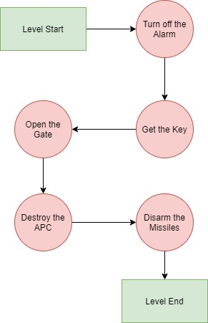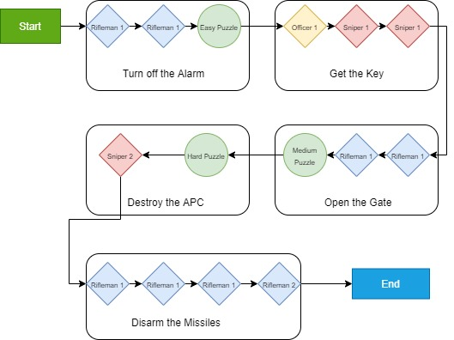

### 4.4 Level Beat Chart

* The following is the list of all game activities and their respective difficulty values

|  |  |  |
| --- | --- | --- |
| **Activity** | **Description** | **Difficulty** |
| Easy Puzzle | Takes less than 1 min | 1 |
| Medium Puzzle | Takes less than 2 min | 2 |
| Hard Puzzle | Takes less than 3 min | 3 |
|  |  |  |
| Rifleman 1 | Takes less than 2 min to defeat | 2 |
| Rifleman 2 | Takes less than 3 min to defeat | 3 |
| Rifleman 3 | Takes less than 3 min to defeat | 4 |
| Rifleman 4 | Takes less than 5 min to defeat | 6 |
|  |  |  |
| Sniper 1 | Takes less than 2 min to defeat | 3 |
| Sniper 2 | Takes less than 3 min to defeat | 4 |
| Sniper 3 | Takes less than 5 min to defeat | 6 |
|  |  |  |
| Specops Soldier 1 | Takes less than 3 min to defeat | 4 |
| Specops Soldier 2 | Takes less than 4 min to defeat | 5 |
| Specops Soldier 3 | Takes less than 4 min to defeat | 6 |
|  |  |  |
| Officer 1 | Takes less than 1 min to defeat | 1 |
| Officer 2 | Takes less than 2 min to defeat | 3 |
| Officer 3 | Takes less than 2 min to defeat | 4 |

### 4.5 Level Layout

This is the overall level layout for the map

