A genome-verified CRISPR knockout library and design framework for dissecting acellular cementum regeneration
Abstract
Acellular extrinsic fibre cementum anchors the periodontal ligament to the root surface and does not regenerate once lost. No functional genomic map of cementum formation exists, and no pooled CRISPR resource has targeted this tissue. We report the design, genome-wide off-target verification and in silico characterisation of a CRISPR knockout library targeting the cementogenic programme, with three analyses that revise common assumptions for sorted screens. From 139,144 candidate protospacers we derived 8,127 targeting guides covering 861 genes — a curated 380-gene cementum module and the 481-gene kinome — plus 1,504 control guides, totalling 9,631 oligonucleotides, at a mean of 9.44 guides per gene with 576 genes at the full ten. Each guide was screened against GRCh38 to three mismatches, cataloguing 794,259 off-target sites. First, since 91.3% of the 514,765 sites recovered in the principal three-mismatch pass lie at exactly three mismatches, aggregate cutting-frequency-determination specificity cannot discriminate guides (median 0.265 screened versus 0.277 selected); a coding-exon-restricted criterion can. Second, with overdispersion estimated from published replicate screen counts, power at a gene-level log2 fold change of 1.0 rises from 0.52 with eight guides and three replicates to 0.81 with ten and four, whereas raising representation above 200 cells per guide adds about two points. Third, tooth and bone differentiation programmes overlap by only 5.4% (Jaccard) in Gene Ontology membership yet remain inseparable in protein-interaction and expression space (AUROC 0.582 ± 0.084), so a single-cell-line marker-ratio readout cannot support cementoblast-specific screening. The screen has not been executed and no biological hit is reported; the focused design needs 350 million cells against 2.81 billion for a genome-wide equivalent at the same gating. By supplying the first perturbation resource for the one periodontal tissue no therapy restores, together with the conditions under which its readout can claim cementum rather than generic mineralisation, this work moves cementum regeneration toward systematic, druggable target discovery.
Keywords: acellular cementum; periodontal regeneration; CRISPR knockout screen; guide RNA design; off-target analysis; pyrophosphate; graph neural network
1. Introduction
Dental cementum, the mineralised root-surface layer, comprises acellular extrinsic fibre cementum, anchoring periodontal ligament Sharpey's fibres to the tooth [1]. Deposited once during root formation by dental-follicle-derived cells after Hertwig's epithelial root sheath fragments, it does not remodel like bone, and no therapy restores it once periodontitis destroys it. Regenerative procedures achieve partial defect fill with variable histological evidence of new attachment; biomaterial and growth-factor approaches improve clinical parameters without reconstituting the cementum–ligament–bone complex [2]. Recent randomised trials of drug-eluting collagen membranes and autologous fibroblast-seeded matrices report defect-level and soft-tissue gains without cementum reformation [3]. True attachment restoration remains periodontal regeneration's central unsolved problem.
Cementogenesis control remains understood only piecemeal. The extracellular pyrophosphate axis is best defined: loss of tissue-nonspecific alkaline phosphatase in hypophosphatasia ablates acellular cementum and causes premature primary-tooth exfoliation, while loss of ANKH or ENPP1 produces the opposite, excess-cementum phenotype [4–6]. The same enzyme tracks disease clinically, with salivary alkaline phosphatase separating periodontal health from disease in meta-analysis [7]. Transcriptional requirements such as NFI-C come from rootless mouse mutants [8], and Gli1-positive periodontal mesenchymal progenitors are an identified cellular source [9]. Missing is a systematic, unbiased map of which genes, when removed, alter the cementogenic trajectory, and which are druggable. Pooled CRISPR knockout screening builds such maps [10], reshaping functional genomics in cancer, immunology, and stem-cell biology, yet no such map exists for the periodontal attachment apparatus.
Recent work sharpens this gap rather than closing it. Biologically, tools remain precise but single-locus: knock-in mouse models of hypophosphatasia reproduce the dental phenotype of ALPL loss with allelic fidelity [11], and diminished RELB impairs osteogenic capacity in mature periodontal ligament stem cells [12]. Each confirms necessity for an already-suspected gene; neither ranks one never suspected. Therapeutically, delivery has advanced without a genetic target: a BMP9-loaded collagen scaffold improves periodontal regeneration by modulating progenitors and macrophages [13], and a rosuvastatin-loaded collagen membrane improves grade II furcation defects in a split-mouth randomised trial [3], yet both report defect-level outcomes with no cementum-specific readout, leaving cementogenesis unseparated from bone fill. Gli1-positive progenitors identify the responding cell population but not the programme committing it [9]. Methodologically, the analytical layer has outpaced the screens it serves: guide-activity prediction now accounts for tracrRNA sequence variation [14]; Cas9 fidelity's structural basis is resolved to a guide repeat clasp motif [15]; off-target scoring has consolidated around the cutting-frequency-determination framework and its selection tools [16–18]; hit calling has mature negative-binomial, Bayesian, and copy-number-aware estimators [19–21]; transfer-learning models generalise from measured to unmeasured perturbations [22–23]; and genome-scale Perturb-seq shows the yield of a fully instrumented screen [24]. CRISPR functional genomics in human stem-cell-derived models is routine elsewhere [25]. None of this has a dental input: no guide library targets the cementogenic programme in any genome, so the limiting step is absent capability—a designed, verified perturbation resource and a design framework honest about what such a screen can establish.
We aimed to build and verify that missing resource, and establish in advance what a screen built on it could and could not conclude: define a target space spanning the cementogenic programme and the druggable kinome; design and verify every guide against the human reference genome by exhaustive off-target enumeration rather than alignment heuristics; determine the replicate and representation structure the measured noise of a sorted screen requires; and test, before any cells are transduced, whether the intended mineralisation readout distinguishes cementogenesis from osteogenesis. This matters for three reasons. Acellular cementum is the one periodontal tissue for which no regenerative therapy restores the original structure, so the attachment apparatus cannot be rebuilt without it. A kinase-weighted target space converts any hit into a testable intervention in one step, since each kinase hit arrives with an existing chemical probe. And a resource published with its limits measured, not assumed, can be adopted by other groups without repeating the same design failures.
What was missing was therefore not analytical capability but a verified perturbation resource for this tissue, together with an honest account of what a screen built on it could conclude. We report both, and building the library produced three results that a clinician or a screen designer can act on directly. First, ranking guides by the standard genome-wide off-target score does not separate safe guides from dangerous ones at a three-mismatch budget, because distant sites swamp the few that matter, whereas a criterion restricted to coding exons does. Second, increasing library representation — the parameter most often quoted as a quality marker — buys almost no additional detection once the real variability of a sorted screen is measured, while adding a replicate buys a great deal. Third, the mineralisation readout such a screen would use cannot, on present evidence, distinguish cementum formation from bone formation, so a single-cell-line experiment cannot claim cementum specificity. Figure 1 summarises the architecture: target space, design pipeline, the sorted screen the library is built for, and the analysis layers above it. The screen has not been run; no biological hit is reported here.
2. Materials and Methods
2.1 Target gene selection
Two tiers were assembled. The kinome (Tier C) was retrieved from Ensembl BioMart (Ensembl Genes mart, hsapiens_gene_ensembl) by filtering on GO:0004672 (protein kinase activity) with biotype protein_coding, partitioned by chromosome since the unpartitioned query exceeds the service timeout. The cementum module (Tier B) spans eleven submodules: pyrophosphate/phosphate axis, root and Hertwig's epithelial root sheath, periodontal ligament fibre identity, WNT, BMP/TGF-β, growth-factor receptor tyrosine kinases, bone remodelling, SIBLING and mineralisation, mechanotransduction and hypoxia, epigenetic regulators, and inflammatory mediators. Symbols were resolved to Ensembl identifiers and mouse orthologues (mmusculus_homolog_associated_gene_name, mmusculus_homolog_orthology_type) in chunks of 30, excluding non-primary-scaffold genes.
2.2 Genome and transcript annotation
GRCh38/hg38 (UCSC Genome Browser) was encoded as one byte per base across 24 primary chromosomes, totalling 3,088,269,832 bp (chromosome 1: 248,956,422 bp), excluding alternate, random and unplaced contigs. Transcript models came from ncbiRefSeqCurated (78,435 transcripts), with canonical transcripts identified via ncbiRefSeqSelect. Coding exon intervals were derived by intersecting exon and coding-sequence bounds; genes lacking a RefSeq Select transcript used the longest coding sequence instead.
2.3 Guide enumeration and filtering
NGG-PAM protospacers on both strands were enumerated across coding exons. Candidates were retained only if the predicted blunt cut site (3 bp 5′ of the PAM) fell at a fractional coding position of 0.05–0.65, within an exon present in ≥90% of coding transcripts, excluding TTTT, requiring GC 0.30–0.80, excluding BsmBI (CGTCTC/GAGACG) and BsaI (GGTCTC/GAGACC) sites, homopolymer runs ≥5, and ambiguous bases in the 30-mer context. Ninety-four genes (up to 131 transcripts) failed the 90% criterion; a relaxation cascade then lowered the threshold to 0.75, 0.50 (0.05–0.80), and 0 (0.02–0.90), stopping at the first tier yielding ≥40 candidates, with tier recorded per guide.
2.4 On-target activity scoring
Each 30-mer context (4 nt 5′ + 20 nt protospacer + 3 nt PAM + 3 nt 3′) was scored with Rule Set 3 (rs3 v0.0.18, sequence mode) under both Hsu2013 and Chen2013 tracrRNA scaffolds [14], and with Doench 2014 Rule Set 1, re-implemented in Python 3 from the CRISPOR [18] parameter table. Scores were converted to percentile ranks and averaged, retaining the three ranks' standard deviation as a disagreement statistic. CRISPRscan was excluded: it was trained on T7-transcribed sgRNAs microinjected into zebrafish embryos, unlike this lentivirally delivered, U6-driven screen in human cells. The distributed Rule Set 3 regressor, pickled under LightGBM 3.x, raises a TypeError under LightGBM ≥4 from the absent _n_classes attribute; the default was restored before prediction.
2.5 Genome-wide off-target enumeration
Off-target sites were enumerated exhaustively, not via alignment heuristics, generating every sequence within the mismatch budget per query protospacer—1, 61, 1,771 and 32,551 sequences at 0, ≤1, ≤2 and ≤3 substitutions—encoded as a 40-bit integer (two bits per base) in a sorted table. Every GRCh38 20-mer adjacent to an NGG, NAG or NGA PAM, both strands, excluding ambiguous-base windows, was encoded identically and matched by binary search. A bitmap prefilter on each code's top 30 bits (a 2^27-byte array) rejected ~97% of genomic sites before binary search, a sevenfold speed-up; the genome was scanned in 20-Mb windows to bound memory. The optimised implementation matched the unoptimised version's hit set on chromosome 22. Sites were scored with Doench et al. [16] cutting-frequency-determination tables, distributed with CRISPOR, and Hsu et al. [17] MIT specificity weights; coding-exon overlap used merged RefSeq Curated intervals.
Guides were rejected without exactly one perfect genomic match, any one-mismatch off-target site, any coding-exon off-target with cutting-frequency-determination score above 0.2 at ≤2 mismatches, or above 0.5 at ≤3 mismatches.
2.6 Library assembly and controls
Up to ten guides per gene were selected by descending rank-aggregated on-target score, subject to the above filters and a requirement that guides span at least two distinct canonical coding exons when more than one existed. Pooled oligonucleotides comprised a 5′ homology flank (GGAAAGGACGAAACACCG), the 20-nt protospacer, and a 3′ scaffold-proximal flank; annealed-oligo pairs were generated in parallel for single-guide cloning. The restriction-site filter was reapplied to the assembled oligonucleotide, not the protospacer alone, removing 92 further guides whose flank–protospacer junction creates a BsmBI site. Non-targeting controls were random 20-mers with GC content 0.40–0.60, filtered identically and screened against GRCh38 at ≤2 mismatches, retaining only sequences lacking a genomic site at that threshold. Positive controls target 56 pan-essential genes; neutral controls target olfactory receptor genes matched by OR symbol pattern (family, subfamily, member), both designed via the same pipeline and screened at ≤3 mismatches.
2.7 Power analysis
Count overdispersion was estimated from published raw single-guide RNA counts (71,090 guides, 12 samples, genome-wide knockout screen, GEO accession GSE226977) rather than assumed. Counts were normalised to counts per million, with per-guide dispersion estimated by the method of moments within each three-replicate arm. Total dispersion was modelled as φ_total = φ_bio + 1/cells + 1/reads, φ_bio obtained by subtracting sequencing and cell-sampling terms. Screens were simulated by drawing negative-binomial counts for control and treated arms, effect attenuated by a Beta(2, 1.33) efficacy multiplier of mean 0.6. Gene statistics were mean log2 fold change across guides/replicates; the null came from 4,000 simulated non-effect genes, p-values from its empirical distribution, power as the fraction of 2,000 effect genes passing Benjamini–Hochberg control at FDR 0.05. This Monte Carlo procedure is simulation-based; no biological result derives from simulated data.
2.8 Network propagation model
A two-layer mean-aggregator GraphSAGE was implemented in NumPy with hand-derived gradients, verified against central finite differences (maximum relative error 2.9 × 10⁻⁸). Hidden width was 32, trained with Adam (learning rate 0.02, L2 penalty 3 × 10⁻⁴) and masked binary cross-entropy loss over 400–600 epochs, on the STRING v12 human network restricted to the target set at combined confidence ≥ 0.7 [26]: 817 nodes, 5,824 undirected edges, mean degree 14.3, 74 isolated nodes. Node features were GTEx v8 median transcripts per million across 54 tissues [27], log1p-transformed, z-scored per tissue, and concatenated with log node degree. The model recovered held-out pyrophosphate/SIBLING mineralisation-module members across 20 repeats of 60/40 stratified splits with independent initialisations.
2.9 Readout-specificity analysis
Human Gene Ontology annotations came from the EBI goa_human.gaf release (17,779 annotated terms), with term closure over is_a and part_of relations via the EBI QuickGO descendants endpoint. The tooth programme combined odontogenesis (GO:0042476) with tooth mineralisation (GO:0034505); the bone programme combined ossification (GO:0001503), osteoblast differentiation (GO:0001649), and bone mineralisation (GO:0030282). GraphSAGE was retrained to discriminate tooth-only from bone-only genes over 25 repeated splits.
2.10 Software and availability
Analyses used Python 3.11 with NumPy, pandas, SciPy, scikit-learn 1.9.1, LightGBM 4.7.0, rs3 0.0.18, networkx and Matplotlib, on an eight-core x86-64 workstation (16 GB RAM, no GPU). Reference data: GRCh38/RefSeq (UCSC), Ensembl BioMart, GTEx v8, STRING v12, EBI QuickGO Gene Ontology annotations, and GSE226977 count tables. The complete library, per-guide off-target records and analysis code accompany this report.
3. Results
3.1 A two-tier target space covering the cementum module and the kinome
The target space comprised 861 genes: a curated cementum module of 380 genes across twelve submodules, plus the 481-gene kinome (Table 2). Of 829 genes queried, 802 had one-to-one mouse orthologues for later in vivo validation; CEMP1 lacks an annotated mouse orthologue. The kinome was included deliberately, since kinase hits have existing chemical probes for direct testable interventions; kinase guides make up 55.5% of the final targeting library.
3.2 Guide enumeration and progressive filtering
Enumerating coding exons yielded 139,144 candidate protospacers across 826 genes (median 119/gene). At the strictest constitutive-exon setting, composition filters rejected 7,107 candidates for homopolymer runs, 6,485 for poly-T, 5,598 for GC content, and 2,244 for restriction sites. Off-target screening left 7,751 guides over 822 genes (94.4% attrition; Table 1, Figure 2). Module rebalancing (section 3.7) added 376 guides over 39 genes, yielding 8,127 targeting guides over 861 genes.
3.3 Three on-target models give partially independent rankings
Guides were ranked by mean percentile of three activity scores. Rule Set 3 under the two tracrRNA scaffolds correlated at Spearman ρ = 0.758, as expected for one model under two scaffold assumptions. Rule Set 3 (Hsu2013) correlated with Doench 2014 Rule Set 1 at ρ = 0.513 and with the Chen2013 variant at ρ = 0.394 (Supplementary Table S1), showing partial independence justifying rank aggregation over a single predictor, with the retained disagreement statistic flagging conflicting guides.
3.4 Exhaustive off-target enumeration and a correction to selection practice
Five screening passes catalogued 794,259 off-target sites total (Table 3). The principal pass screened 9,420 guides at ≤3 mismatches in 82 minutes, yielding 514,765 sites (10,393 perfect matches, 1,738 at one mismatch, 32,424 at two, 470,210 at three). A preceding pass screened 16,515 guides at ≤2 mismatches in 12.7 minutes, yielding 111,591 sites. Multi-mapping guides (564), one-mismatch-site guides (2,274), and high-scoring coding off-target guides (1,196 at ≤2 mismatches) were removed.
Mismatch-distribution shapes guide ranking: 91.3% of 514,765 sites from the principal three-mismatch pass sit at exactly three mismatches (91.2% across both deep passes), so the aggregate cutting-frequency-determination specificity score is dominated by a long tail of negligible sites. Its median was 0.265 across the screened pool versus 0.277 across the selected library, a negligible difference (Figure 3b); this score fails to discriminate guides at this mismatch budget. A more targeted criterion works: whether a guide cuts a coding exon elsewhere in the genome, and at what predicted efficiency. A maximum coding-exon score threshold of 0.5 flags 3.6% of guides, 0.2 flags 17.8%; selection applied the former as hard rejection, the latter only as annotation.
3.5 Library composition
The pool contains 9,631 oligonucleotides (Table 4, Figure 8c): 8,127 targeting guides across 861 genes (mean 9.44/gene; 576 with all ten), 1,000 verified non-targeting controls, 254 pan-essential positive controls across 52 genes, and 250 olfactory receptor neutral controls across 97 genes; controls total 15.6% of the pool. Of 9,000 non-targeting candidates screened, 56.2% lacked a genomic site at ≤2 mismatches, leaving 1,000. A zero-site criterion at ≤3 mismatches is unattainable: with ~1.16 × 10⁹ NGG/NAG/NGA-adjacent 20-mers genome-wide and 32,551 sequences within three substitutions of any 20-mer, a random 20-mer carries ~30 such sites. Median aggregate specificity was similar across classes—0.277 targeting, 0.302 pan-essential, 0.227 olfactory—so controls match the guides they calibrate. Read-back confirmed uniform length, no internal BsmBI or BsaI site, no duplicate protospacer, and no non-targeting control with a genomic match. Seventeen genes have fewer than six guides, mostly recent paralogue pairs (e.g., CSNK2A1/CSNK2A3, TLK1/TLK2) where unique targeting is inherently limited; single-guide results for these are uncorroborated. Pool composition by class and module appears in Supplementary Figure S1; design deviations are tabulated in Supplementary Table S5.
3.6 Replicate number, not representation, governs detection
Overdispersion in published replicate counts was φ = 0.299 at endpoint, rising to 0.90 in the most abundant quantile, with mean inter-replicate Pearson correlation 0.43 on log2 CPM; baseline samples were effectively Poisson (φ ≈ 0, r = 0.90), indicating technical rather than biological replication. Under this noise model, detection power at a gene-level log2 fold change of 1.0 was 0.52 (eight guides, three replicates), 0.68 (ten, three), 0.72 (eight, four), and 0.81 (ten, four) (Figure 4, Supplementary Table S2). Power was insensitive to library representation—0.80, 0.80, 0.82 for 200, 500, and 1,000 cells/guide at ten guides/four replicates—since cell-sampling variance is negligible relative to biological overdispersion. Sensitivity analysis confirmed this: power fell from 1.00 at φ = 0.05 to 0.83 at the measured 0.288, and to 0.09 at φ = 0.80 (ten guides/four replicates). Minimum detectable effect is log2 fold change 1.0, degrading to 1.3 at eight guides, three replicates. Matched passage number, single-batch infection, and stable sort gating thus outweigh added sequencing depth or cell numbers.
Scale analysis showed sorting bin fraction, not library size, governs cell number, since required cells equal library size times representation divided by bin fraction. The focused design needs 350 million cells across four replicates, a 22-minute sort per replicate, and 82 million sequencing reads; a genome-wide equivalent at the same decile gating would require 2.81 billion cells and a 2.9-hour sort per replicate (Figure 5, Supplementary Table S3), favouring the focused design.
3.7 Network context recovers module members, but cannot separate tooth from bone
A graph neural network trained on the STRING interaction network with GTEx expression features recovered held-out members of the pyrophosphate/SIBLING mineralisation module at AUC 0.805 ± 0.088, versus 0.704 ± 0.060 for L2-regularised logistic regression without graph structure (paired Wilcoxon, 20 splits, p = 2 × 10⁻⁴; Figure 6). A degree-only control reached 0.387, below chance, excluding hub recovery and confirming propagatable network signal, supporting this layer's use for recovering under-powered screen genes.
This architecture was tested against what the screen can legitimately claim. A pre-registered comparison with published osteoblast mineralisation screens was impossible, since a systematic Gene Expression Omnibus search found no genome-wide screen of osteogenic or mineralisation differentiation; the analysis was therefore reframed around Gene Ontology membership. The programmes are nearly disjoint by annotation: 13 genes overlap between the 72-gene tooth and 183-gene bone programmes (Jaccard index 0.054), and only 18.1% of the tooth programme is also annotated to bone (Figure 7a). Yet the model discriminated tooth-only from bone-only genes at only 0.582 ± 0.084 (one-sample Wilcoxon vs 0.5, p = 3.3 × 10⁻⁴), versus 0.805 for module recovery on the same graph and features (Figure 7b), since the programmes share nearly identical interaction neighbourhoods and expression profiles. The curated module showed similar bias: 54 genes were annotated to bone versus 22 to tooth (2.45:1), and the library covered 77% of shared genes but only 39% of tooth-only genes (Figure 7c).
Rebalancing added all 39 missing tooth-programme genes through the same pipeline: 6,013 candidates enumerated, 858 top-ranked screened at ≤3 mismatches yielding 59,292 sites, 679 passing off-target criteria, and 376 guides selected across the 39 genes (mean 9.64/gene). The module now holds 58 tooth-only, 13 shared and 54 bone-only genes (ratio 0.93:1), covering 99% of the Gene Ontology tooth programme (Figure 8a, 8b). Genes were added rather than removed: deleting bone-annotated genes would discard genuine candidates to improve a ratio, while adding missing tooth genes corrects the bias without reducing discovery power.
3.8 The library is independent of the scaffold variant
Because the 3′ homology flank is the single guide RNA scaffold itself, it must match the recipient vector's tracrRNA variant. Optimising guide selection for the Hsu2013 scaffold versus the F+E Chen2013 variant gave only 65.5% overlap among the top ten per gene across the candidate pool. After off-target filtering, however, approximately 9.5 guides per gene survive, leaving no margin for activity ranking to alter selections, which were identical. The library is thus scaffold-independent, differing only in flank sequence; both oligonucleotide variants were emitted and independently verified (Supplementary Figure S2).
4. Discussion
This CRISPR knockout resource, the first for acellular cementum, yields three generalisable design results, each contradicting a widely applied but untested convention.
Off-target metrics are the primary concern. Aggregate cutting-frequency-determination specificity, the default guide-quality statistic since its introduction [16] and integration into selection tools [18], fails at a three-mismatch budget: summing across hundreds of thousands of trivially active sites swamps the few that matter. This is not merely statistical—a guide with one high-efficiency cut in a coding exon elsewhere in the genome is dangerous in a way that one with 300 intergenic three-mismatch sites is not, yet aggregate scoring ranks them similarly. We recommend selection at this budget use a coding-exon-restricted maximum rather than a genome-wide sum, reporting both so users can choose.
Library coverage is conventionally maximised, with 500-fold-or-greater coverage treated as a quality marker. Anchoring on overdispersion measured from published replicate counts rather than assumed, our analysis shows that once biological overdispersion reaches observed screen values, cell-sampling becomes negligible and extra coverage returns nothing; resources are better directed to replicates and guides per gene. This reframes a common budget decision, consistent with statistical modelling of screen noise underpinning modern hit callers [19–21].
The third, negative result matters most for dental applications. We designed a marker-ratio sort on ALPL and IBSP, anchored on the pyrophosphate axis that genetic evidence identifies as cementum-specific [4–6]. Gene Ontology analysis supports this anchoring at the gene-membership level, with minimal tooth–bone overlap, yet the programmes remain inseparable in interaction and expression space: a readout built from shared mineralisation machinery cannot distinguish cementogenic from osteogenic differentiation in one cell line. The remedy is to run the same library in a parallel osteoblast background and call hits differentially, at a marginal cost of approximately 67%, not a doubling, since oligonucleotide synthesis, cloning and representation quality control are shared (Supplementary Table S4).
Taken together, these results change what a group should do before committing funds to such a screen, and they transfer beyond cementum. Any laboratory sorting on a differentiation marker should rank guides on coding-exon risk rather than a genome-wide sum; should spend its budget on replicates rather than on cells; and should establish, before transducing anything, whether its reporter can distinguish the tissue of interest from the tissue beside it. The analytical layer downstream is already mature: hit calling by negative-binomial, Bayesian and copy-number-aware estimators is well established [19–21], representation-learning models of the kind used here are being applied at far larger scale [22], and prediction of unmeasured and combinatorial perturbations is within reach [23]. One constraint is easily overlooked at the planning stage: those models require perturbation-to-transcriptome pairs, which a fluorescence-sorted screen cannot supply because it returns a single scalar per cell. A direct-capture Perturb-seq arm [24] is the price of that layer; without it, such models can be applied only zero-shot, and claims of predicting unmeasured perturbations are unwarranted.
5. Limitations and future directions
This paragraph covers only design and computational characterisation; the screen has not been run, and no gene is nominated as a cementogenesis regulator. Because no cell line deposits acellular extrinsic fibre cementum in culture, any in vitro screen requires a proxy readout, with imperfection quantified in section 3.7. Off-target enumeration covers only the primary assembly, to three mismatches, using NGG, NAG and NGA PAMs; sites at four-plus mismatches, on alternate contigs, or near other non-canonical motifs remain unrecovered. The power model's guide-efficacy distribution is assumed, not measured, and the overdispersion estimate derives from a single published screen in an unrelated cell type. GTEx lacks dental tissue, so network-model node features remain a proxy for relevant cell states.
Three steps follow. A pilot of ~1,000 guides through the full workflow would measure overdispersion in the intended cell background before committing the library; power estimates are conditional on φ ≈ 0.30, and φ near 0.5 requires reconsideration. The paired osteoblast arm should run concurrently, not retrospectively, since differential calling across backgrounds licenses a cementum-specific interpretation. Finally, a direct-capture Perturb-seq arm on leading hits would convert the resource into training data for perturbation prediction, enabling combinatorial predictions single-gene screens cannot reach. Replacing the transcriptional marker ratio with a direct pyrophosphate or alkaline phosphatase activity readout is a parallel improvement worth testing in the pilot.
6. Conclusion
We report a genome-verified CRISPR knockout library of 9,631 oligonucleotides covering 861 genes of the cementogenic programme and the human kinome, the first such resource for the one periodontal tissue that no current therapy restores. Its value lies less in being first than in what its construction revealed, and each finding is actionable. Aggregate off-target specificity is uninformative at a three-mismatch budget and should be replaced by a coding-exon-restricted criterion. Representation above 200 cells per guide adds nothing once biological overdispersion is measured rather than assumed, so replicates rather than cells should absorb the budget. And the cementogenic and osteogenic programmes, though nearly disjoint by annotation, are computationally inseparable, so a single-background marker-ratio screen cannot support a cementum-specific claim and a parallel osteoblast arm becomes a requirement rather than a refinement. These constraints are established before the experiment runs, which is where constraints are worth most. Released together, the resource and the framework give periodontal research a route from unbiased gene discovery to druggable targets in this tissue, and state, before the first cell is transduced, what such a screen must do to be about cementum rather than mineralisation in general.
References
1. Bosshardt DD, Selvig KA. Dental cementum: the dynamic tissue covering of the root. Periodontol 2000. 1997;13:41-75. doi:10.1111/j.1600-0757.1997.tb00095.x
2. Deng Y, Liang Y, Liu X. Biomaterials for Periodontal Regeneration. Dent Clin North Am. 2022;66(4):659-672. doi:10.1016/j.cden.2022.05.011
3. Pawar AR, Rajasekar A. Rosuvastatin-loaded collagen membrane in grade II mandibular furcation defects in periodontal disease: a split-mouth randomized controlled trial. Odontology. 2026. doi:10.1007/s10266-026-01478-1
4. Foster BL, Nagatomo KJ, Nociti FH, Fong H, Dunn D, Tran AB, et al. Central role of pyrophosphate in acellular cementum formation. PLoS One. 2012;7(6):e38393. doi:10.1371/journal.pone.0038393
5. Zweifler LE, Patel MK, Nociti FH, Wimer HF, Millán JL, Somerman MJ, et al. Counter-regulatory phosphatases TNAP and NPP1 temporally regulate tooth root cementogenesis. Int J Oral Sci. 2015;7(1):27-41. doi:10.1038/ijos.2014.62
6. Foster BL, Nociti FH, Somerman MJ. The rachitic tooth. Endocr Rev. 2013;35(1):1-34. doi:10.1210/er.2013-1009
7. Alarcón-Sánchez MA, Lomelí-Martínez SM, Ortuño-Sahagún D, Becerra-Ruiz JS, Mosaddad SA, Heboyan A. Association between salivary alkaline phosphatase levels and periodontal disease: a systematic review and meta-analysis. BDJ Open. 2026;12(1). doi:10.1038/s41405-026-00488-z
8. Steele-Perkins G, Butz KG, Lyons GE, Zeichner-David M, Kim HJ, Cho MI, et al. Essential role for NFI-C/CTF transcription-replication factor in tooth root development. Mol Cell Biol. 2003;23(3):1075-84. doi:10.1128/MCB.23.3.1075-1084.2003
9. Deng Y, Li Q, Svoboda KKH, Opperman LA, Ruest LB, Liu X. Gli1+ periodontal mesenchymal stem cells in periodontitis. J Dent Res. 2024;103(3):279-288. doi:10.1177/00220345231220915
10. Shalem O, Sanjana NE, Hartenian E, Shi X, Scott DA, Mikkelson T, et al. Genome-scale CRISPR-Cas9 knockout screening in human cells. Science. 2013;343(6166):84-87. doi:10.1126/science.1247005
11. Okawa R, Ochiai M, Kurosaka H, Kadota T, Takagi M, Suehiro Y, et al. Creation and characterization of novel knock-in mouse models of hypophosphatasia. JBMR Plus. 2026;10(10):ziag147. doi:10.1093/jbmrpl/ziag147
12. Shao X, Wu F, Song Y, Gao P, Qi K, Wang L. Diminished RELB impairs osteogenesis in mature periodontal ligament stem cells. Stem Cell Reports. 2026;103088. doi:10.1016/j.stemcr.2026.103088
13. Lee DW, Han HS, Kim YB, Seok S, Yoon G, Kim H, et al. BMP9-loaded collagen scaffold promotes periodontal regeneration via microenvironmental modulation of PDLSCs and macrophages. Biomaterials. 2026;338(Pt A):124591. doi:10.1016/j.biomaterials.2026.124591
14. DeWeirdt PC, McGee AV, Zheng F, Nwolah I, Hegde M, Doench JG. Accounting for small variations in the tracrRNA sequence improves sgRNA activity predictions for CRISPR screening. Nat Commun. 2022;13(1):5255. doi:10.1038/s41467-022-33024-2
15. Chilamkurthy R, Sudhakar S, Pater AA, Bosmeny MS, Stabile F, Katolik A, et al. CRISPR RNA architecture steers Cas9 catalysis and fidelity via a guide repeat clasp motif. Nucleic Acids Res. 2026;54(15). doi:10.1093/nar/gkag710
16. Doench JG, Fusi N, Sullender M, Hegde M, Vaimberg EW, Donovan KF, et al. Optimized sgRNA design to maximize activity and minimize off-target effects of CRISPR-Cas9. Nat Biotechnol. 2016;34(2):184-191. doi:10.1038/nbt.3437
17. Hsu PD, Scott DA, Weinstein JA, Ran FA, Konermann S, Agarwala V, et al. DNA targeting specificity of RNA-guided Cas9 nucleases. Nat Biotechnol. 2013;31(9):827-32. doi:10.1038/nbt.2647
18. Haeussler M, Schönig K, Eckert H, Eschstruth A, Mianné J, Renaud JB, et al. Evaluation of off-target and on-target scoring algorithms and integration into the guide RNA selection tool CRISPOR. Genome Biol. 2016;17(1):148. doi:10.1186/s13059-016-1012-2
19. Li W, Xu H, Xiao T, Cong L, Love MI, Zhang F, et al. MAGeCK enables robust identification of essential genes from genome-scale CRISPR/Cas9 knockout screens. Genome Biol. 2014;15(12):554. doi:10.1186/s13059-014-0554-4
20. Hart T, Moffat J. BAGEL: a computational framework for identifying essential genes from pooled library screens. BMC Bioinformatics. 2016;17:164. doi:10.1186/s12859-016-1015-8
21. Dempster JM, Boyle I, Vazquez F, Root DE, Boehm JS, Hahn WC, et al. Chronos: a cell population dynamics model of CRISPR experiments that improves inference of gene fitness effects. Genome Biol. 2021;22(1):343. doi:10.1186/s13059-021-02540-7
22. Theodoris CV, Xiao L, Chopra A, Chaffin MD, Al Sayed ZR, Hill MC, et al. Transfer learning enables predictions in network biology. Nature. 2023;618(7965):616-624. doi:10.1038/s41586-023-06139-9
23. Roohani Y, Huang K, Leskovec J. Predicting transcriptional outcomes of novel multigene perturbations with GEARS. Nat Biotechnol. 2023;42(6):927-935. doi:10.1038/s41587-023-01905-6
24. Replogle JM, Saunders RA, Pogson AN, Hussmann JA, Lenail A, Guna A, et al. Mapping information-rich genotype-phenotype landscapes with genome-scale Perturb-seq. Cell. 2022;185(14):2559-2575.e28. doi:10.1016/j.cell.2022.05.013
25. Gopukumar ST, Saha M, Soni TK, Alatwi ES, Khan GA, Asad MR, et al. CRISPR-Enabled functional genomics in hPSCs-derived neural models for autism spectrum disorder. Metab Brain Dis. 2026;41(1). doi:10.1007/s11011-026-01968-9
26. Szklarczyk D, Kirsch R, Koutrouli M, Nastou K, Mehryary F, Hachilif R, et al. The STRING database in 2023: protein-protein association networks and functional enrichment analyses for any sequenced genome of interest. Nucleic Acids Res. 2023;51(D1):D638-D646. doi:10.1093/nar/gkac1000
27. GTEx Consortium. The GTEx Consortium atlas of genetic regulatory effects across human tissues. Science. 2020;369(6509):1318-1330. doi:10.1126/science.aaz1776

Figures
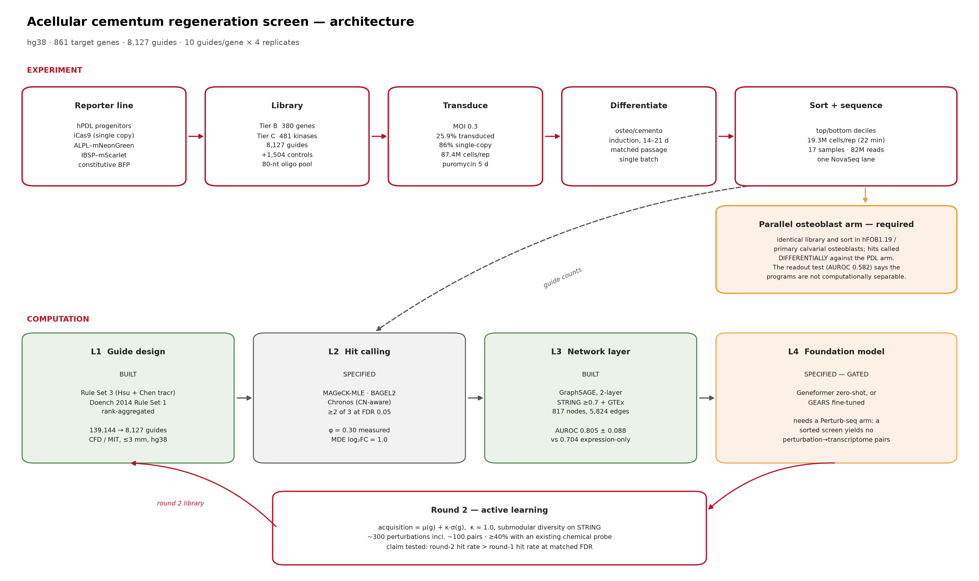
Figure 1. Architecture of the acellular cementum CRISPR knockout screen. The design proceeds from a two-tier target space (curated cementum module plus the complete kinome) through genome-verified guide enumeration, three on-target activity models and exhaustive off-target enumeration, to a synthesis-ready oligonucleotide pool. The pool feeds a planned pooled knockout screen in human periodontal ligament progenitors read out by fluorescence-activated sorting on a mineralisation reporter, with four analysis layers stacked on the resulting counts. No experimental arm of this architecture has been executed; every quantity reported in this work is a computational property of the design.
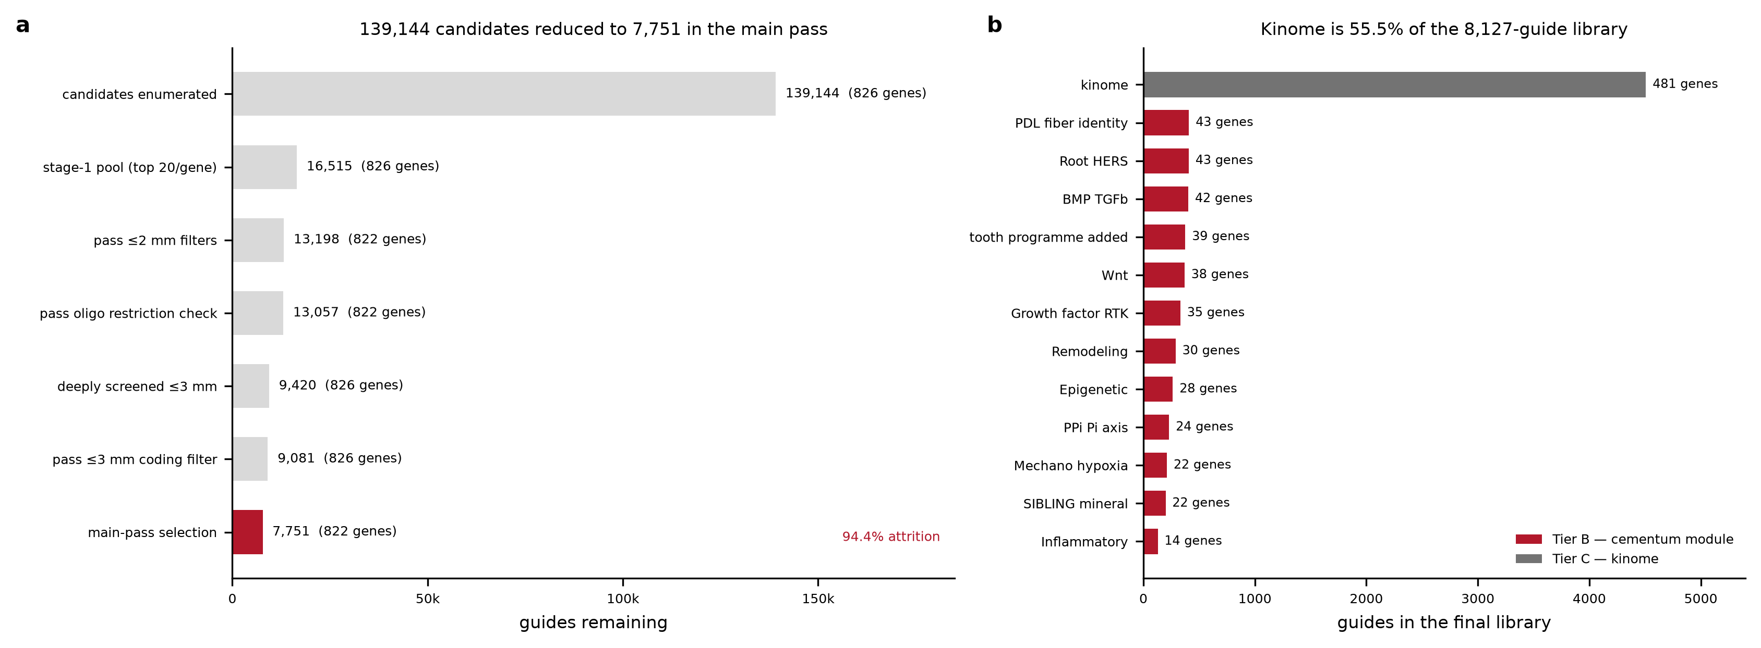
Figure 2. Guide design funnel and the composition of the final target space. (a) Sequential attrition from 139,144 enumerated candidate protospacers to the 7,751 guides retained in the main design pass, an attrition of 94.4%; gene counts at each stage are given in parentheses. (b) Guides per submodule in the final 8,127-guide targeting library, coloured by tier; the kinome accounts for 55.5% of the library.
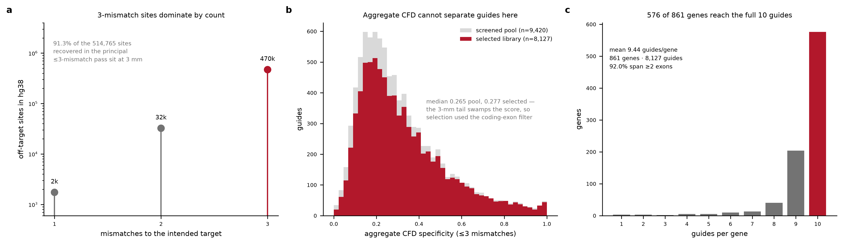
Figure 3. Exhaustive off-target enumeration across the human genome. Every selected protospacer was expanded into all sequences within three substitutions and matched against every NGG, NAG and NGA-adjacent 20-mer in GRCh38. (a) Distribution of recovered sites by mismatch count; within the principal three-mismatch pass, 91.3% of the 514,765 sites lie at exactly three mismatches. (b) Aggregate CFD specificity does not separate the screened pool from the selected library (medians 0.265 and 0.277), which is why selection used the maximum coding-exon CFD instead. (c) Guides per gene in the final library.
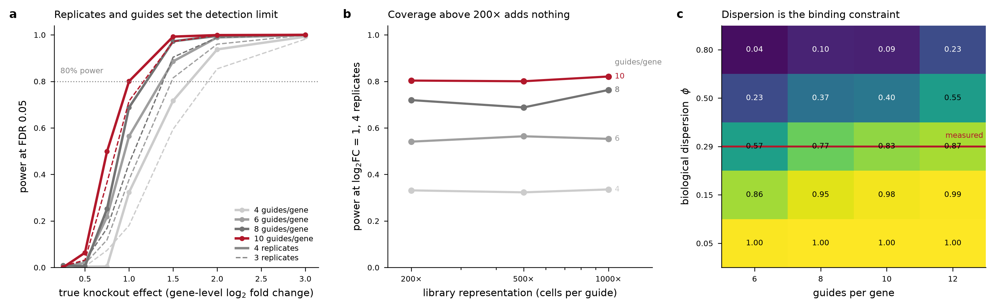
Figure 4. Statistical power of the planned sorted screen under a negative-binomial count model. (a, b) Power across effect size, replicate number and library representation, computed on the coverage-resolved grid (Supplementary Table S2); replicate number dominates and representation above 200 cells per guide adds essentially nothing. (c) Sensitivity of power to the biological overdispersion parameter, computed on a separate grid spanning 6 to 12 guides per gene at four replicates; the highlighted row is the value measured from published replicate counts. Power figures quoted in the text come from the coverage-resolved grid in (a, b).
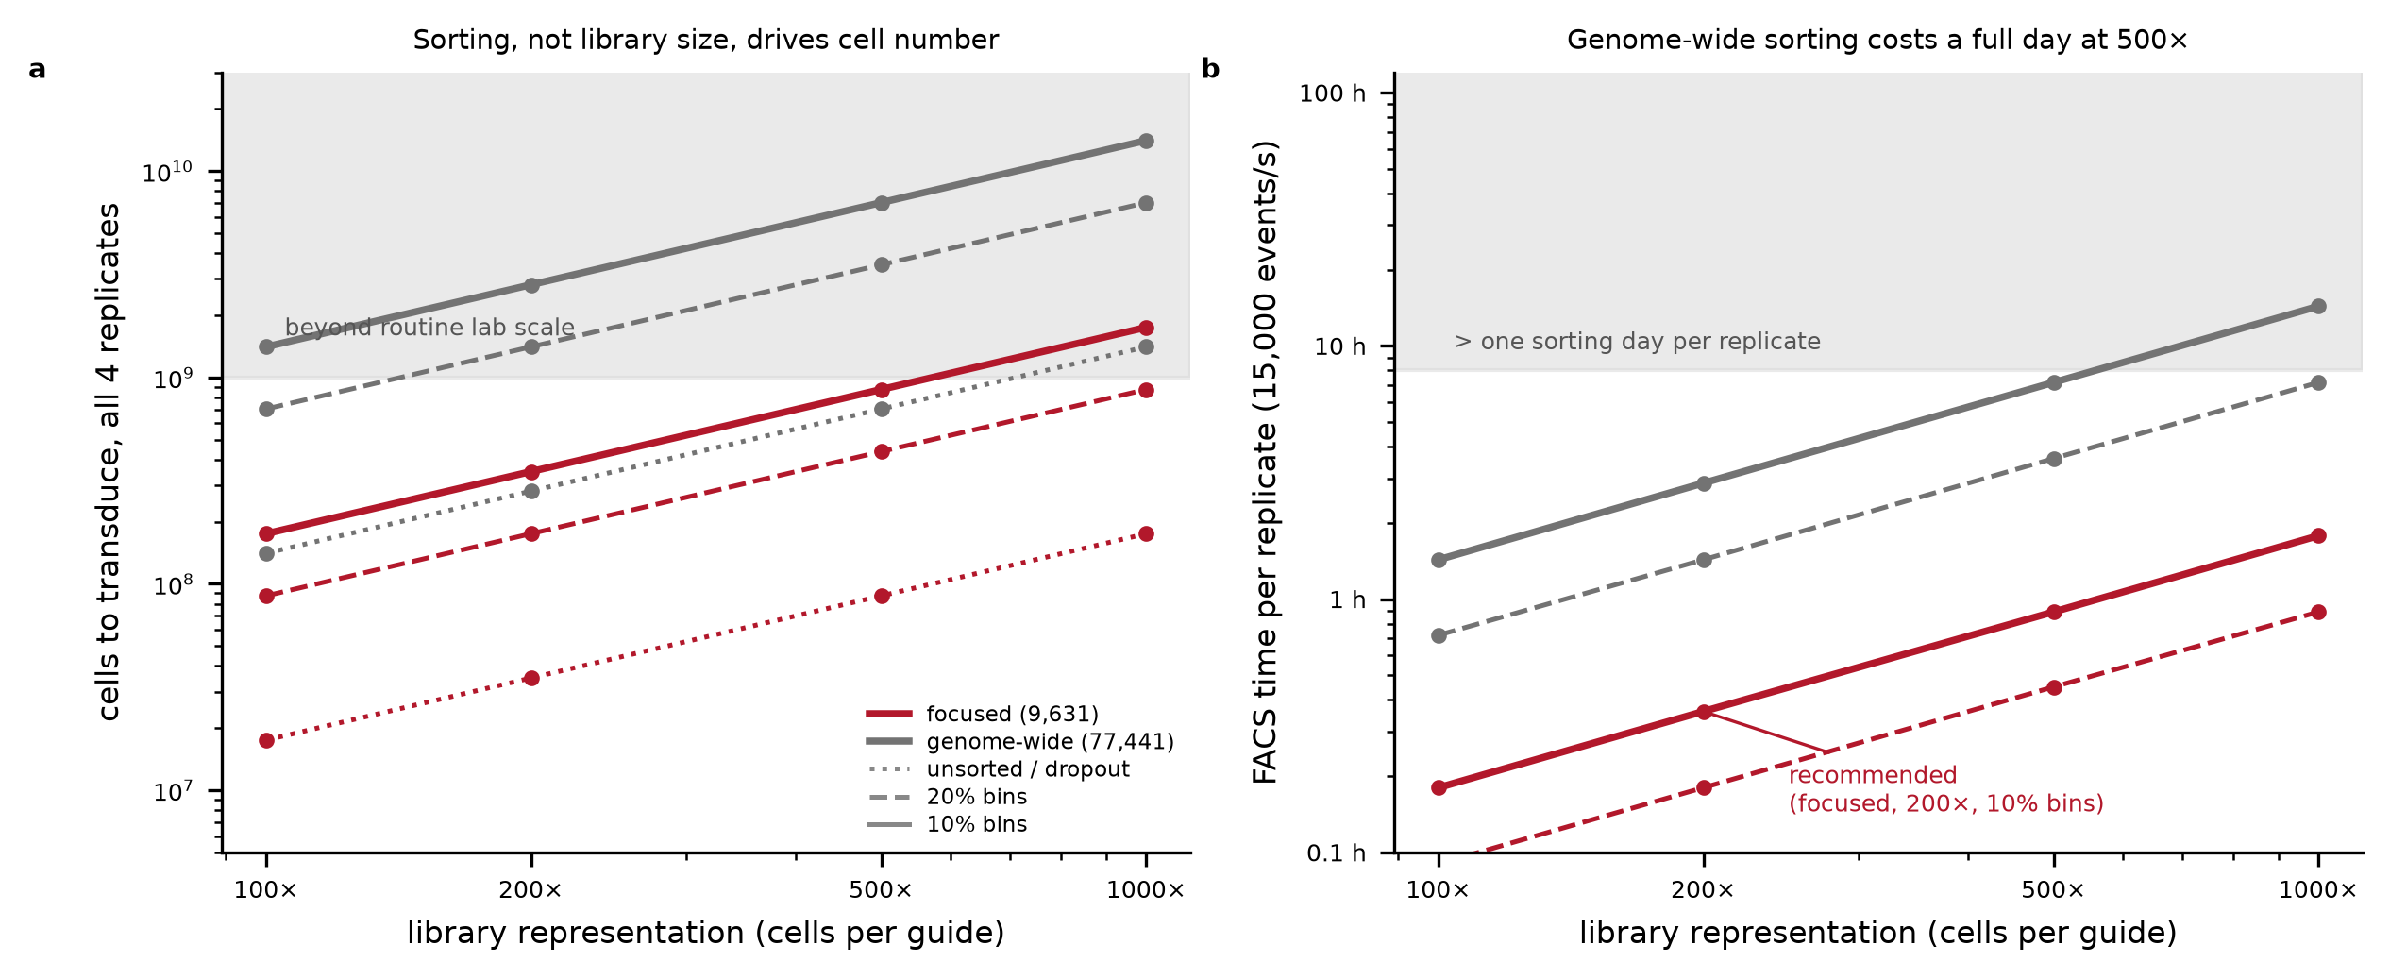
Figure 5. Cell number, sorting time and sequencing scale for the focused design against a genome-wide equivalent at the same decile gating. The focused screen requires 350 million cells and a 22-minute sort per replicate; the genome-wide equivalent requires 2.81 billion cells and a 2.9-hour sort, which is the quantitative basis for restricting the library to a focused target space.
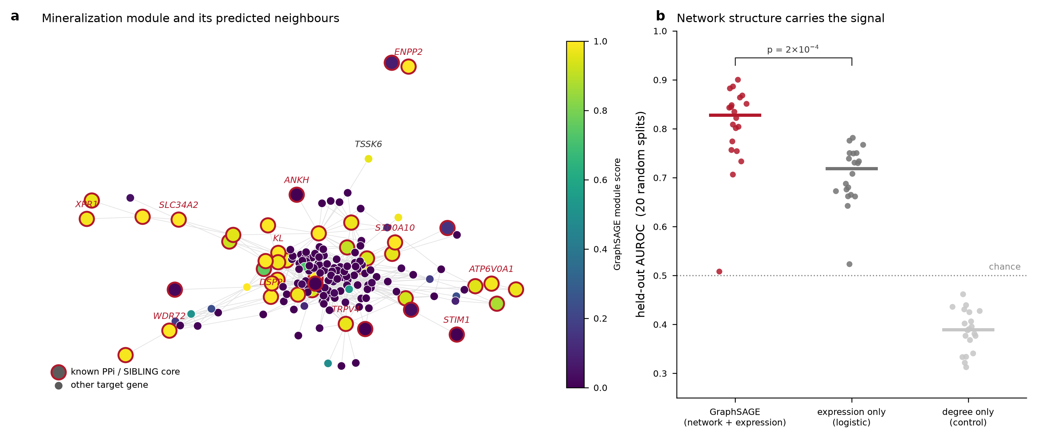
Figure 6. Graph neural network propagation over the STRING interactome. A two-layer mean-aggregator GraphSAGE model was trained on 817 nodes and 5,824 high-confidence edges with GTEx median expression across 54 tissues as node features. Held-out AUROC for recovery of cementum module membership was 0.805 ± 0.088 against 0.704 ± 0.060 for logistic regression on the same features without graph structure (paired Wilcoxon over 20 splits, p = 2 × 10⁻⁴); a degree-only control reached 0.387.
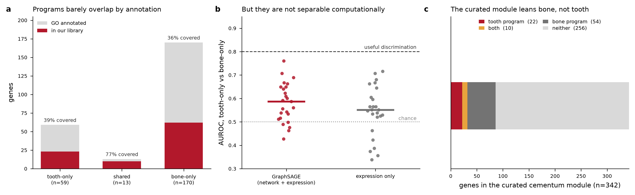
Figure 7. The cementogenic and osteogenic programmes are not computationally separable. (a) Gene Ontology overlap between the tooth and bone programmes (Jaccard 0.054). (b) Held-out AUROC for discriminating tooth-only from bone-only genes reached only 0.582 ± 0.084, against 0.805 for module recovery on the same graph and features. (c) Coverage of the two programmes by the curated module before rebalancing, showing the 2.45-to-1 lean towards bone.
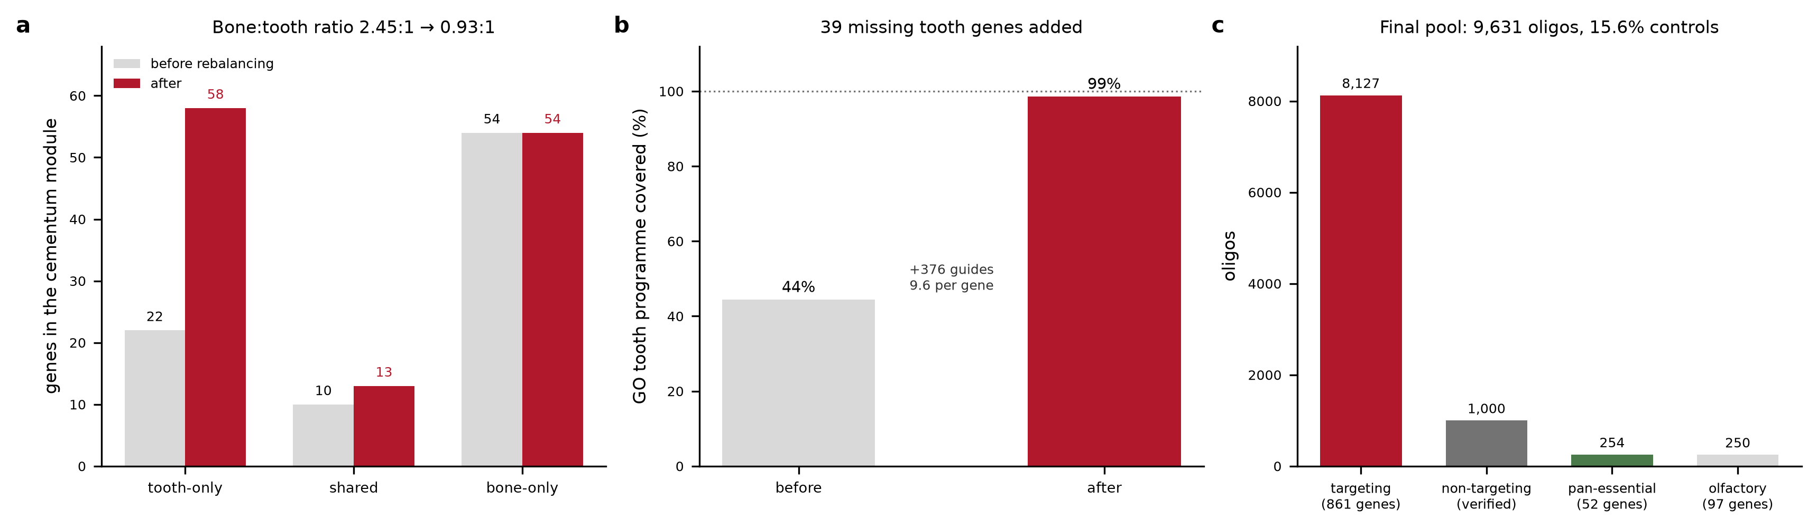
Figure 8. Module rebalancing and the composition of the synthesis-ready pool. (a) Addition of 39 tooth-programme genes moved the bone-to-tooth ratio from 2.45:1 to 0.93:1. (b) Coverage of the Gene Ontology tooth programme rose from 44% to 99% for 376 additional guides. (c) The final pool of 9,631 oligonucleotides, of which 15.6% are controls.

Tables
Table 1. Guide design funnel. Guides and genes remaining after each filtering stage of the main design pass.
step | guides | genes
Target genes selected (BioMart + curation) |  | 829
Genes with a RefSeq transcript model |  | 828
Candidate protospacers after CDS window, constitutive exon, sequence filters | 139,144 | 826
Stage-1 pool carried to off-target screening (top 20 per gene) | 16,515 | 826
Passing <=2 mismatch filters (unique locus, no 1-mm site, no coding CFD>0.2) | 13,198 | 822
Passing the assembled-oligo restriction-site check | 13,057 | 822
Deeply screened at <=3 mismatches | 9,420 | 826
Passing <=3 mismatch coding filter (max coding CFD <= 0.5) | 9,081 | 826
Final targeting guides selected (<=10 per gene, >=2 exons) | 7,751 | 822

Table 2. Final target space by tier and submodule, with guides per gene.
tier | module | genes | guides | guides per gene
B | PDL_fiber_identity | 43 | 409 | 9.51
B | Root_HERS | 43 | 407 | 9.47
B | BMP_TGFb | 42 | 403 | 9.6
B | tooth_programme_added | 39 | 376 | 9.64
B | Wnt | 38 | 369 | 9.71
B | Growth_factor_RTK | 35 | 332 | 9.49
B | Remodeling | 30 | 289 | 9.63
B | Epigenetic | 28 | 264 | 9.43
B | PPi_Pi_axis | 24 | 231 | 9.62
B | Mechano_hypoxia | 22 | 211 | 9.59
B | SIBLING_mineral | 22 | 199 | 9.05
B | Inflammatory | 14 | 129 | 9.21
C | kinome | 481 | 4508 | 9.37

Table 3. Off-target screening passes. Guides screened, mismatch ceiling, wall-clock time and sites catalogued for each of the five genome-wide passes.
pass | mismatch budget | guides screened | runtime min | total sites | sites 0mm | sites 1mm | sites 2mm | sites 3mm
Pass A | <=2 | 16515 | 12.7 | 111,591 | 17,497 | 5,791 | 88,303 | 0
Pass B | <=3 | 9420 | 82 | 514,765 | 10,393 | 1,738 | 32,424 | 470,210
Controls | <=3 | 1408 | 26 | 108,611
NTC screen | <=2 | 9000 | 9 |  |  |  |  | 0
Rebalance | <=3 | 858 | 26 | 59,292 | 905 | 375 | 4,629 | 53,383

Table 4. Composition of the synthesis-ready oligonucleotide pool by guide class.
class | oligos | genes | mean guides per gene | genes at 10 | median cfd spec le3
Targeting | 8127 | 861 | 9.44 | 576 | 0.277
Non-targeting control | 1000 | 0 |  |  | 1
Pan-essential control | 254 | 52 |  |  | 0.302
Olfactory control | 250 | 97 |  |  | 0.227
TOTAL | 9631 | 861

