Supplementary Information
A genome-verified CRISPR knockout library and design framework for dissecting acellular cementum regeneration
Supplementary Figures
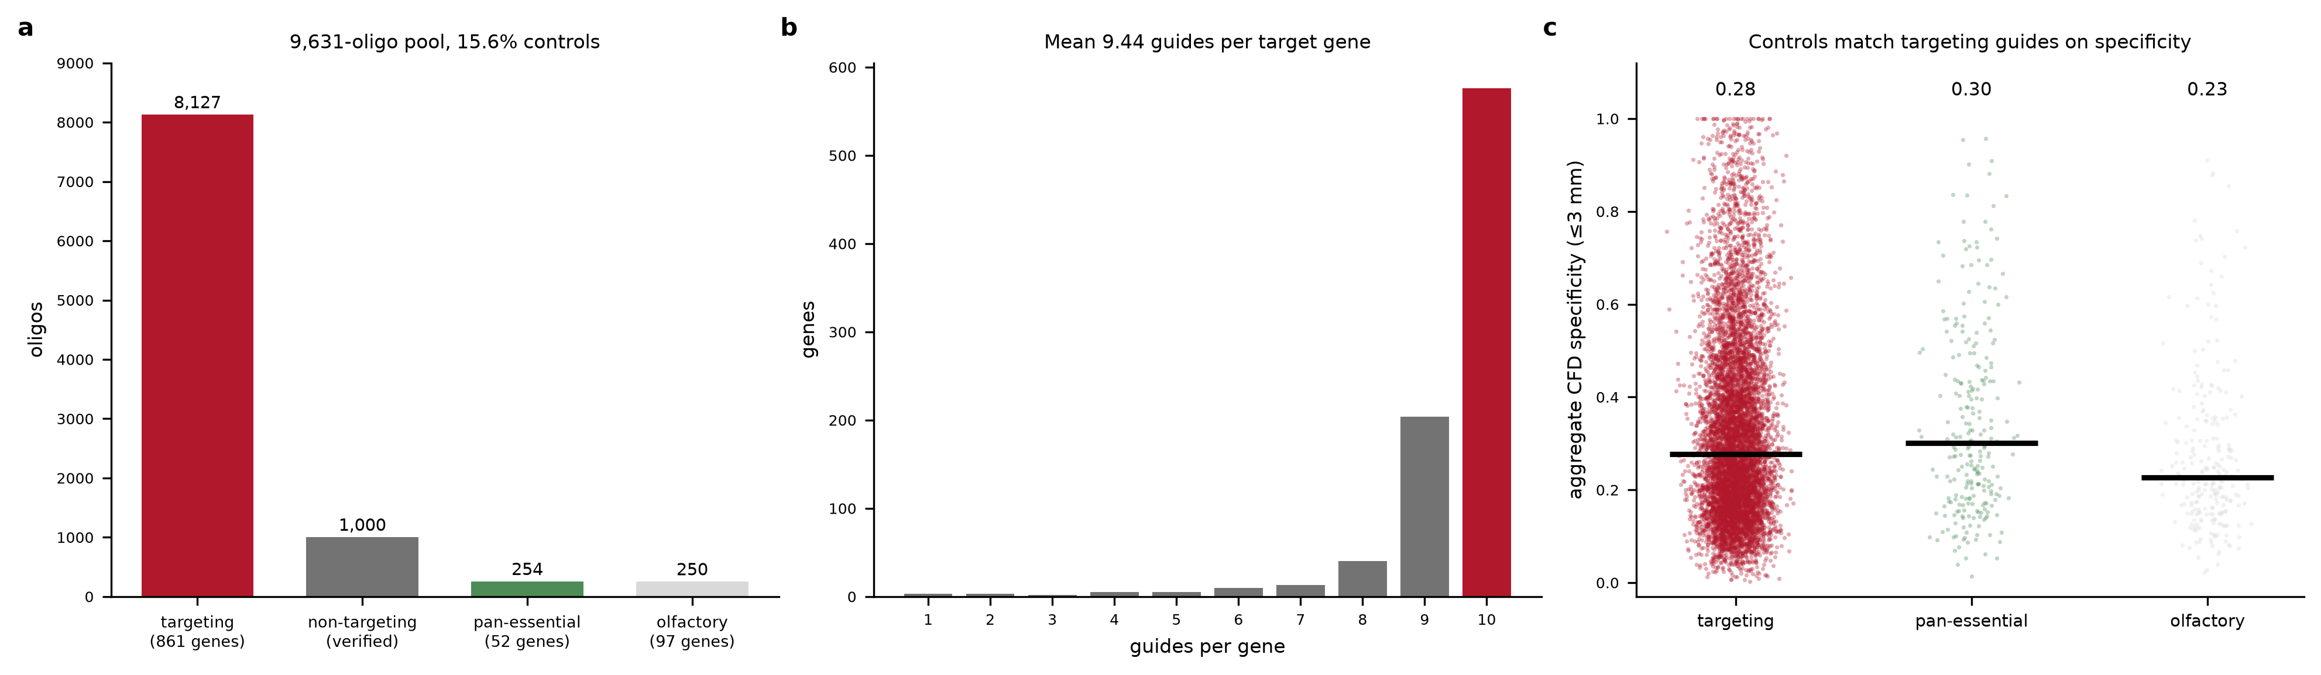
Supplementary Figure S1. Composition of the final library. (a) Oligonucleotides by class. (b) Guides per target gene. (c) Aggregate CFD specificity of targeting guides against the two control classes, confirming that controls are neither systematically cleaner nor dirtier than the guides they calibrate.
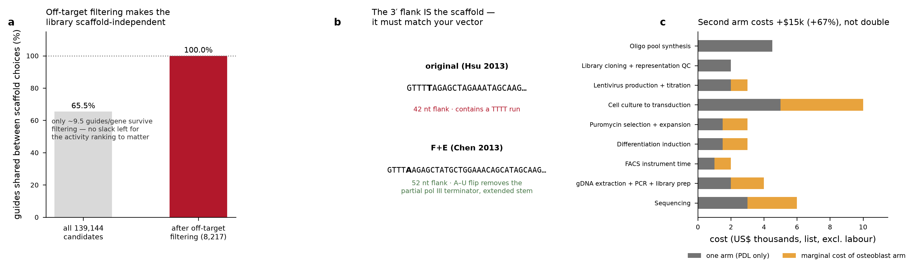
Supplementary Figure S2. Oligonucleotide architecture and cost. (a, b) The 3′ homology flank is the sgRNA scaffold itself, so the original Hsu 2013 and F+E Chen 2013 constant regions give different oligonucleotide strings; after off-target filtering the selected guide set is identical under either scaffold. (c) Incremental cost of the parallel osteoblast arm.

Supplementary Tables
Supplementary Table S1. Rank concordance (Spearman ρ) between the three on-target activity models applied to the selected guides.
model | family | median score | spearman vs RS3 Hsu
Rule Set 3 (Hsu2013 tracr) | gradient-boosted, transcript-aware | 0.114 | 1
Rule Set 3 (Chen2013 tracr) | same model, improved scaffold | 0.044 | 0.758
Doench 2014 Rule Set 1 | logistic, independent training set | 12.77 | 0.513

Supplementary Table S2. Monte Carlo power grid across effect size, guides per gene, replicate number and library representation. Power is the fraction of simulated genes called at a 5% false discovery rate; the final column averages the three coverage levels. Values quoted in the Results are taken from this grid.
log2FC | guides per gene | replicates | 200× coverage | 500× coverage | 1000× coverage | mean power
0.25 | 4 | 2 | 0.001 | 0.001 | 0 | 0.001
0.25 | 4 | 3 | 0.002 | 0.004 | 0.002 | 0.003
0.25 | 4 | 4 | 0.002 | 0 | 0 | 0.001
0.25 | 6 | 2 | 0.002 | 0 | 0 | 0.001
0.25 | 6 | 3 | 0.004 | 0.002 | 0.002 | 0.003
0.25 | 6 | 4 | 0.002 | 0.002 | 0.002 | 0.002
0.25 | 8 | 2 | 0 | 0 | 0 | 0
0.25 | 8 | 3 | 0.001 | 0.001 | 0.008 | 0.003
0.25 | 8 | 4 | 0 | 0.009 | 0.002 | 0.004
0.25 | 10 | 2 | 0.003 | 0 | 0.004 | 0.002
0.25 | 10 | 3 | 0 | 0.006 | 0.001 | 0.002
0.25 | 10 | 4 | 0.01 | 0 | 0.003 | 0.004
0.5 | 4 | 2 | 0.001 | 0.003 | 0 | 0.001
0.5 | 4 | 3 | 0.004 | 0.004 | 0 | 0.003
0.5 | 4 | 4 | 0.006 | 0.004 | 0 | 0.003
0.5 | 6 | 2 | 0 | 0.003 | 0.002 | 0.002
0.5 | 6 | 3 | 0 | 0.016 | 0.024 | 0.013
0.5 | 6 | 4 | 0.046 | 0.02 | 0.044 | 0.037
0.5 | 8 | 2 | 0.01 | 0.001 | 0.027 | 0.013
0.5 | 8 | 3 | 0.004 | 0.029 | 0.034 | 0.022
0.5 | 8 | 4 | 0.046 | 0.006 | 0.058 | 0.037
0.5 | 10 | 2 | 0.001 | 0.004 | 0.003 | 0.003
0.5 | 10 | 3 | 0.02 | 0.032 | 0.01 | 0.021
0.5 | 10 | 4 | 0.096 | 0.064 | 0.09 | 0.083
0.75 | 4 | 2 | 0.017 | 0.006 | 0.003 | 0.009
0.75 | 4 | 3 | 0.06 | 0.074 | 0.018 | 0.051
0.75 | 4 | 4 | 0.118 | 0.004 | 0.044 | 0.055
0.75 | 6 | 2 | 0.036 | 0.044 | 0.098 | 0.059
0.75 | 6 | 3 | 0.13 | 0.118 | 0.062 | 0.103
0.75 | 6 | 4 | 0.175 | 0.218 | 0.185 | 0.193
0.75 | 8 | 2 | 0.058 | 0.002 | 0.05 | 0.037
0.75 | 8 | 3 | 0.22 | 0.168 | 0.208 | 0.199
0.75 | 8 | 4 | 0.436 | 0.252 | 0.358 | 0.349
0.75 | 10 | 2 | 0.192 | 0.162 | 0.214 | 0.189
0.75 | 10 | 3 | 0.341 | 0.366 | 0.372 | 0.36
0.75 | 10 | 4 | 0.452 | 0.498 | 0.528 | 0.493
1 | 4 | 2 | 0.064 | 0.128 | 0.049 | 0.08
1 | 4 | 3 | 0.176 | 0.18 | 0.18 | 0.179
1 | 4 | 4 | 0.332 | 0.323 | 0.336 | 0.33
1 | 6 | 2 | 0.19 | 0.132 | 0.206 | 0.176
1 | 6 | 3 | 0.321 | 0.378 | 0.355 | 0.351
1 | 6 | 4 | 0.541 | 0.564 | 0.553 | 0.553
1 | 8 | 2 | 0.352 | 0.206 | 0.369 | 0.309
1 | 8 | 3 | 0.543 | 0.447 | 0.582 | 0.524
1 | 8 | 4 | 0.72 | 0.688 | 0.763 | 0.724
1 | 10 | 2 | 0.391 | 0.394 | 0.396 | 0.394
1 | 10 | 3 | 0.673 | 0.716 | 0.648 | 0.679
1 | 10 | 4 | 0.804 | 0.8 | 0.821 | 0.808
1.5 | 4 | 2 | 0.362 | 0.322 | 0.399 | 0.361
1.5 | 4 | 3 | 0.61 | 0.594 | 0.661 | 0.622
1.5 | 4 | 4 | 0.762 | 0.717 | 0.778 | 0.752
1.5 | 6 | 2 | 0.589 | 0.629 | 0.626 | 0.615
1.5 | 6 | 3 | 0.804 | 0.815 | 0.848 | 0.822
1.5 | 6 | 4 | 0.907 | 0.886 | 0.917 | 0.903
1.5 | 8 | 2 | 0.714 | 0.726 | 0.764 | 0.735
1.5 | 8 | 3 | 0.904 | 0.904 | 0.914 | 0.907
1.5 | 8 | 4 | 0.96 | 0.972 | 0.966 | 0.966
1.5 | 10 | 2 | 0.833 | 0.856 | 0.841 | 0.843
1.5 | 10 | 3 | 0.958 | 0.972 | 0.952 | 0.961
1.5 | 10 | 4 | 0.986 | 0.992 | 0.988 | 0.989
2 | 4 | 2 | 0.722 | 0.697 | 0.74 | 0.72
2 | 4 | 3 | 0.838 | 0.854 | 0.867 | 0.853
2 | 4 | 4 | 0.928 | 0.938 | 0.944 | 0.937
2 | 6 | 2 | 0.872 | 0.864 | 0.846 | 0.861
2 | 6 | 3 | 0.96 | 0.96 | 0.964 | 0.961
2 | 6 | 4 | 0.98 | 0.989 | 0.985 | 0.985
2 | 8 | 2 | 0.944 | 0.952 | 0.962 | 0.953
2 | 8 | 3 | 0.988 | 0.988 | 0.992 | 0.989
2 | 8 | 4 | 0.997 | 0.996 | 0.998 | 0.997
2 | 10 | 2 | 0.974 | 0.98 | 0.985 | 0.98
2 | 10 | 3 | 0.996 | 0.998 | 0.998 | 0.997
2 | 10 | 4 | 1 | 0.999 | 1 | 1
3 | 4 | 2 | 0.952 | 0.944 | 0.95 | 0.949
3 | 4 | 3 | 0.982 | 0.982 | 0.982 | 0.982
3 | 4 | 4 | 0.996 | 0.992 | 0.994 | 0.994
3 | 6 | 2 | 0.99 | 0.99 | 0.992 | 0.991
3 | 6 | 3 | 0.998 | 0.999 | 0.998 | 0.998
3 | 6 | 4 | 1 | 0.998 | 0.999 | 0.999
3 | 8 | 2 | 0.999 | 1 | 0.998 | 0.999
3 | 8 | 3 | 1 | 1 | 1 | 1
3 | 8 | 4 | 1 | 1 | 1 | 1
3 | 10 | 2 | 1 | 0.999 | 1 | 1
3 | 10 | 3 | 1 | 1 | 1 | 1
3 | 10 | 4 | 1 | 1 | 1 | 1

Supplementary Table S3. Cell number, sorting time, sample count and sequencing depth for the focused and genome-wide designs.
metric | focused (Tier B+C) | 200×, 4 reps, 10% bins | focused (Tier B+C) | 500×, 4 reps, 10% bins | focused (Tier B+C) | 1000×, 4 reps, 10% bins | genome-wide | 200×, 4 reps, 10% bins | genome-wide | 500×, 4 reps, 10% bins | genome-wide, 20% bins | 200×, 4 reps, 20% bins | genome-wide, 3 reps | 200×, 3 reps, 10% bins
guides | 9,631 | 9,631 | 9,631 | 77,441 | 77,441 | 77,441 | 77,441
frac_transduced | 0.259 | 0.259 | 0.259 | 0.259 | 0.259 | 0.259 | 0.259
frac_single_copy | 0.857 | 0.857 | 0.857 | 0.857 | 0.857 | 0.857 | 0.857
cells_per_bin | 1,926,200 | 4,815,500 | 9,631,000 | 15,488,200 | 38,720,500 | 15,488,200 | 15,488,200
cells_through_sorter | 19,262,000 | 48,155,000 | 96,310,000 | 154,882,000 | 387,205,000 | 77,441,000 | 154,882,000
cells_to_infect_per_rep | 87,433,525 | 218,583,811 | 437,167,623 | 703,035,986 | 1,757,589,964 | 351,517,993 | 703,035,986
total_cells_to_infect | 349,734,098 | 874,335,246 | 1,748,670,491 | 2,812,143,942 | 7,030,359,855 | 1,406,071,971 | 2,109,107,957
sort_hours_per_rep | 0.36 | 0.89 | 1.78 | 2.87 | 7.17 | 1.43 | 2.87
gdna_ug_per_sample | 12.7 | 31.8 | 63.5 | 102.2 | 255.6 | 102.2 | 102.2
pcr_rxn_per_sample | 2 | 4 | 7 | 11 | 26 | 11 | 11
n_samples | 17 | 17 | 17 | 17 | 17 | 17 | 13
reads_per_sample | 4,815,500 | 4,815,500 | 4,815,500 | 38,720,500 | 38,720,500 | 38,720,500 | 38,720,500
total_reads | 81,863,500 | 81,863,500 | 81,863,500 | 658,248,500 | 658,248,500 | 658,248,500 | 503,366,500

Supplementary Table S4. Itemised budget for the core screen and the incremental cost of the parallel osteoblast arm.
line item | one arm usd | two arm usd | note | marginal usd
Oligo pool synthesis (9,631 oligos) | 4500 | 4500 | one pool serves both arms | 0
Library cloning + representation QC | 2000 | 2000 | one cloning, shared | 0
Lentivirus production + titration | 2000 | 3000 | more virus for 2 backgrounds | 1000
Cell culture to transduction | 5000 | 10000 | 350M cells per arm | 5000
Puromycin selection + expansion | 1500 | 3000 |  | 1500
Differentiation induction (14-21 d) | 1500 | 3000 |  | 1500
FACS instrument time | 1000 | 2000 | ~22 min/rep/arm | 1000
gDNA extraction + PCR + library prep | 2000 | 4000 | 17 vs 34 samples | 2000
Sequencing | 3000 | 6000 | 82M vs 164M reads | 3000
TOTAL | 22500 | 37500 |  | 15000

Supplementary Table S5. The screen as originally specified against the design delivered, with the analysis that motivated each change.
design element | initially proposed | final design | why it changed
Readout | ALPL/IBSP ratio sort, single PDL line | same sort + parallel osteoblast arm, differential calling | tooth vs bone AUROC 0.582 — not separable in one line
Primary anchor | transcriptional marker ratio | PPi/Pi axis (ALPL activity / extracellular PPi) | matrix markers are shared with bone
Library scope | genome-wide primary + focused secondary | focused only, 9,255 oligos | genome-wide decile sort needs 2.8B cells
Guides per gene | 8 | 10 (mean 9.4 realised) | 8x3 gives 57% power; 10x4 gives 80%
Replicates | 3 | 4 | same
Representation | 500-1000x | 200x | 1/cells negligible against phi=0.30
Controls | 1,000 NTC + 500 assorted | 1,000 verified NTC + 254 essential + 250 olfactory | NTC must be verified at <=2 mm; <=3 mm is unattainable
Total reads | ~500M (genome-wide) | 83M per arm | smaller library
On-target models | RS3 + DeepSpCas9 + DeepHF | RS3 (2 scaffolds) + Doench 2014 | deep models need R/basilisk, unavailable on this host
Off-target budget | <=3 mm, NGG/NAG/NGA | <=3 mm, NGG/NAG/NGA (delivered) | unchanged
Hit selection metric | aggregate CFD specificity | max coding-exon CFD | 93% of sites sit at 3 mm; aggregate CFD does not discriminate
L4 foundation model | fine-tuned GEARS/scGPT on screen output | gated on adding a Perturb-seq arm | sorted screens yield no perturbation-transcriptome pairs

