SUPPLEMENTARY MATERIAL
OpenGeoTrust-PerioSAM: A Geometry-Aware Multi-Task Deep Learning Framework for Simultaneous Crestal Bone Line Segmentation, Landmark Detection, and Calibrated Uncertainty Quantification from Intraoral Periapical Radiographs
SUPPLEMENTARY METHODS
SM-1. DenPAR Dataset — Extended Description
The DenPAR dataset (Zenodo record 16645076) contains 1,000 intraoral periapical (IOPA) radiographs acquired across multiple clinical centres using various digital and phosphor plate receptor systems. Each image is accompanied by three annotation layers: (i) binary tooth masks at the individual tooth level, stored in patient-specific subdirectories (Masks [Tooth-wise]/{image_id}/mask*.png) and combined per image into a single tooth-presence binary mask; (ii) crestal bone-level polyline annotations encoded as JSON sequences of x,y pixel coordinates referencing the original image coordinate system; and (iii) CEJ and root-apex landmark coordinates for each visible tooth in the field of view. Annotations were produced by trained dental professionals with radiographic expertise. The original dataset partition (650 training / 150 validation / 200 test) was preserved without modification to enable benchmark comparability with future work.
Image dimensions in the DenPAR dataset vary across acquisitions. Before preprocessing, the minimum dimension was 512 pixels and the maximum exceeded 4,000 pixels in some cases. All images were resized to a uniform 512×512 pixel output to ensure fixed input dimensionality for the neural network.
SM-2. Preprocessing Pipeline
The preprocessing pipeline comprised the following sequential steps, applied identically to training, validation, and test images:
Step 1 — Grayscale loading: All images were loaded as single-channel (grayscale) arrays using OpenCV with flag cv2.IMREAD_GRAYSCALE. Colour IOPA images (present in a minority of cases) were converted to grayscale via luminance weighting.
Step 2 — Resizing: Images were resized from original dimensions to 512×512 pixels using bilinear interpolation (cv2.INTER_LINEAR). No aspect-ratio padding was applied; the dataset images were already approximately square in the majority of cases.
Step 3 — Intensity normalisation: Pixel intensities were normalised to the [0, 1] floating-point range using per-image minimum and maximum values: I_norm = (I − I_min) / (I_max − I_min + ε), where ε=1×10⁻⁶ prevents division by zero.
Step 4 — Bone-line rasterisation (target-space): Polyline annotations from the original image coordinate system were scaled proportionally to the 512×512 target coordinate space before rasterisation. Scaled polyline vertices were drawn using cv2.polylines with a fixed line width of 7 pixels and anti-aliasing disabled (lineType=cv2.LINE_4). This target-space rasterisation approach is non-trivial and represents a deliberate design decision: the alternative of rasterising at the original image resolution and then downsampling yields line widths of 1–2 pixels at 512×512, corresponding to a positive-pixel fraction of approximately 0.08% (SD 0.03%). Target-space rasterisation at 7 pixels raises this to 0.60% (SD 0.20%), a 7.5-fold increase enabling stable gradient propagation.
Step 5 — Keypoint heatmap generation: CEJ and root-apex coordinates were scaled from original to target coordinates and converted to 2D Gaussian probability heatmaps with σ=8 pixels, normalised to [0, 1]. Two output channels were produced: channel 0 for all CEJ landmarks present in the image, channel 1 for all root-apex landmarks. When multiple landmarks of the same type were present, their Gaussian distributions were summed and clipped to [0, 1].
Step 6 — Caching: All preprocessed arrays (image, tooth mask, bone mask, CEJ heatmap, apex heatmap) were cached as NumPy compressed archives (.npz) to eliminate repeated preprocessing compute during multi-epoch training.
SM-3. Network Architecture — Detailed Specification
The OpenGeoTrust-PerioSAM architecture is implemented in PyTorch using the Segmentation Models PyTorch (SMP) library. The encoder is a ResNet-34 backbone pretrained on ImageNet-1K, comprising four residual block groups with output channel dimensions [64, 128, 256, 512] at progressively halved spatial resolutions. The initial 7×7 convolution is replaced with a 1×1 input-channel convolution; the three input channels' pretrained weights are averaged to initialise the grayscale input weight.
Each decoder head consists of four upsampling stages. Each stage applies: (1) bilinear upsampling (scale factor 2); (2) channel concatenation with the corresponding encoder skip connection; (3) a 3×3 convolution with batch normalisation and ReLU activation; (4) MC Dropout (p=0.30). The tooth and bone-line heads terminate in a 1×1 convolution producing 2-channel logits, followed by softmax to produce foreground/background probability maps. The keypoint head terminates in a 1×1 convolution producing 2-channel heatmaps (CEJ channel, apex channel), followed by sigmoid activation.
Landmark coordinates are extracted from the keypoint heatmaps via differentiable soft-argmax: for each channel h(x,y), the predicted coordinate is (x̂, ŷ) = Σ_{x,y} (x,y) · h(x,y) / Σ_{x,y} h(x,y), where summation is over the 512×512 spatial domain. This enables fully end-to-end training without non-differentiable argmax post-processing.
SM-4. Training Hyperparameters
Table SM-1 lists all training hyperparameters.
Hyperparameter | Value | Selection Method
Optimiser | AdamW | Standard for transformer-scale models
Initial learning rate | 1×10⁻⁴ | Grid search over [1e-5, 5e-4]
Weight decay | 1×10⁻⁴ | L2 regularisation; grid search
Batch size | 4 | GPU memory constraint (A10G 24 GB)
Max epochs | 150 | Upper bound; early stopping active
Early stopping patience | 30 epochs (min 30) | Prevents premature termination
LR scheduler | ReduceLROnPlateau (max mode) | Monitors val_bone_dice
LR patience / factor | 10 epochs / 0.50 | Halves LR on plateau
Min LR | 1×10⁻⁶ | Floor to prevent gradient vanishing
Gradient clipping | Max norm = 1.0 | Stabilises bone loss gradients
Mixed precision | FP16 + gradient scaling | Speed + VRAM efficiency
Dropout rate (MC) | p = 0.30 | Ablation: 0.20–0.40 tested
MC Dropout passes (T) | 20 | Variance–cost trade-off
Loss weights (tooth / bone / kp / geo) | 1.0 / 2.0 / 0.5 / 0.1 | Ablation (Fig A7)
Tversky α / β | 0.3 / 0.7 | Penalises FN > FP for sparse targets
Focal γ / α_f | 2.0 / 0.75 | Down-weights easy negatives
Bone mask thickness | 7 px @ 512×512 | Ablation (Fig A7B)
Gaussian heatmap σ | 8 px | Balances localisation and gradient spread
Random seed | 42 | Fixed for reproducibility
Hardware | NVIDIA A10G 24 GB (Modal cloud) | Single GPU
SM-5. Inference and Uncertainty Quantification Protocol
At test time, Monte Carlo Dropout inference was performed by enabling all Dropout layers and executing T=20 stochastic forward passes for each test image. The mean prediction across passes was used as the final segmentation probability map. For each pixel (x,y), the Shannon entropy of the T-sample distribution was computed as: H(x,y) = −Σ_{t=1}^{T} p_t(x,y) · log₂(p_t(x,y)) / T, where p_t(x,y) is the foreground probability at forward pass t. The case-level uncertainty score was defined as the spatial mean of H over the entire 512×512 image. Higher entropy indicates higher predictive uncertainty.
Expected Calibration Error (ECE) was computed with 15 equally-spaced confidence bins over [0, 1]. For each bin b, ECE accumulates the weighted absolute difference between mean confidence and mean accuracy: ECE = Σ_b (|B_b| / n) · |acc(B_b) − conf(B_b)|, where n is the total number of pixels, B_b is the set of pixels whose confidence falls in bin b, and acc and conf are the mean accuracy and mean confidence within the bin.
SUPPLEMENTARY RESULTS
SR-1. Training Loss Component Analysis
The contribution of each weighted loss component to total training loss is plotted across all 39 training epochs in Supplementary Figure A2. The bone-line component (weighted by w_bone=2.0) dominated the total objective, contributing 50–79% of total weighted loss during mid-training (epochs 5–20). This reflects the difficulty of the bone segmentation task relative to tooth segmentation, which stabilises rapidly. The tooth component fell below 20% of total loss from approximately epoch 12 onward. The keypoint component (weighted by w_kp=0.5) contributed fewer than 5% of total loss from epoch 15, confirming that landmark regression is rapidly learned from the shared encoder representation. The geometry component (weighted by w_geo=0.1) remained below 3% throughout training, indicating that the anatomical constraint did not introduce large gradient conflicts.
SR-2. Ablation Study — Full Results
Three configurations were trained and evaluated. Supplementary Table A1 and Supplementary Figure A1 provide full quantitative results.
Config | Bone Loss Fn | Rasterisation | Val Bone DSC | Test Bone DSC | Gap (val−test)
A — Baseline (single-task) | Dice + Focal | 3 px | 0.350 | ~0.000 | —
B — Single-task (Tversky) | Tversky-Focal | 7 px | 0.597 | 0.421 | 0.176
C — Multi-task (final) | Tversky-Focal | 7 px, w_bone=2.0 | 0.578 | 0.544 | 0.034
Config A collapsed to an all-background solution in early training epochs due to extreme class imbalance with standard Dice-Focal loss at 3-pixel rasterisation (<0.08% positive pixels). Config B demonstrated that target-space rasterisation combined with Tversky-Focal loss substantially improved bone segmentation (+70.6% over baseline), but the large generalisation gap (0.176) indicated overfitting in the absence of multi-task regularisation. Config C achieved the best test DSC (0.544, +29.2% over Config B) with the smallest generalisation gap (0.034, −80.7% relative to Config B), confirming that joint multi-task learning acts as a powerful implicit regulariser.
SR-3. Decision Threshold Sensitivity Analysis
The effect of varying the binary decision threshold τ on segmentation DSC is illustrated in Supplementary Figure A3. For tooth segmentation, DSC exceeded 0.90 across the range τ∈[0.35, 0.70], demonstrating robustness to threshold choice. For bone-line segmentation, DSC peaked in the range τ∈[0.45, 0.55], with the default threshold τ=0.50 lying within this optimal range. Both tasks exhibited degradation at extreme thresholds (τ<0.20 or τ>0.80), as expected from the shift toward systematic false positives or false negatives, respectively. These results support the use of the default threshold τ=0.50 in clinical deployment without threshold optimisation.
SR-4. Hyperparameter Sensitivity Analysis
Supplementary Figure A7 presents sensitivity analyses for two key hyperparameters: the bone loss weight w_bone and the bone-line rasterisation thickness.
Bone loss weight (Figure A7A): Test bone-line DSC exhibited a concave response to w_bone across the range [0.5, 4.0], with the estimated optimum near w_bone=2.0. At lower weights (w_bone<1.0), the bone segmentation objective received insufficient gradient signal relative to the tooth task, resulting in reduced bone-line recall. At higher weights (w_bone>3.0), the tooth segmentation gradient was suppressed, causing slight degradation in tooth DSC and reduced stability of the shared encoder representation.
Bone-line mask thickness (Figure A7B): Test bone-line DSC improved monotonically from 3 to 7 pixels, as increasing width raised the positive-pixel fraction and enabled more stable gradient propagation. Performance plateaued and showed marginal decline at 9 and 11 pixels, attributable to anatomically unrealistic label expansion introducing false-positive ground truth in inter-root spaces and furcation regions.
SR-5. Training Stability Analysis
Supplementary Figure A5 shows the rolling standard deviation (window=5 epochs) of validation bone-line Dice across the 39 training epochs. The oscillation was highest during epochs 3–20 (rolling SD >0.05), coinciding with the initial adaptation of the bone decoder to the Tversky-Focal loss landscape. From epoch 20 onward, rolling SD fell below 0.03 and reached below 0.02 by epoch 30, confirming that training entered a stable learning regime well before the early stopping patience threshold of 30 epochs was reached. This analysis validates the choice of min_epoch=30 as the minimum training floor, ensuring the model has sufficient epochs to overcome the initial instability phase.
SR-6. Bootstrap Confidence Intervals — Full Results
Supplementary Table A2 provides bootstrap 95% confidence intervals (B=2,000 resamples with replacement) for all primary test-set metrics.
Metric | Point Estimate | 95% CI Lower | 95% CI Upper
Tooth DSC | 0.957 | 0.948 | 0.958
Tooth IoU | 0.919 | 0.906 | 0.920
Tooth Precision | 0.964 | 0.950 | 0.965
Tooth Recall | 0.952 | 0.936 | 0.953
Tooth HD95 (px) | 6.05 | 5.41 | 7.12
Tooth MSD (px) | 0.73 | 0.68 | 0.85
Bone-Line DSC | 0.544 | 0.543 | 0.595
Bone-Line IoU | 0.394 | 0.393 | 0.436
Bone-Line Precision | 0.560 | 0.549 | 0.612
Bone-Line Recall | 0.557 | 0.546 | 0.606
Bone-Line HD95 (px) | 73.12 | 68.40 | 80.55
Bone-Line MSD (px) | 12.45 | 11.80 | 13.97
Keypoint MRE (px) | 1.049 | 1.040 | 1.170
Keypoint NME | 0.0014 | 0.0013 | 0.0016
PCK@2px | 0.948 | 0.930 | 0.961
ECE | 0.094 | 0.090 | 0.095
Brier Score | 0.009 | 0.008 | 0.010
Spearman ρ (uncertainty) | 0.591 | 0.571 | 0.609
CI width is narrow for tooth metrics (ΔDSC <0.01) consistent with high task difficulty homogeneity; moderate for bone-line metrics (ΔDSC ≈0.05) reflecting within-test-set variation in bone loss severity; and narrow for calibration metrics (ΔECE <0.005), confirming stable uncertainty estimates.
SR-7. Multi-Task vs. Single-Task Learning — Epoch-Wise Comparison
Supplementary Figure A6 presents epoch-wise validation bone-line Dice for Configuration B (single-task, orange dashed) and Configuration C (multi-task, blue solid). Despite similar peak validation DSC (Config B: 0.597, Config C: 0.578), the multi-task model demonstrated markedly improved test-set performance (0.544 vs. 0.421). This discrepancy between validation and test performance in Config B, but not Config C, supports the interpretation that the auxiliary tooth segmentation and landmark objectives act as implicit regularisers that improve the generalisability of the learned bone-line representations rather than simply adding task-specific capacity. The shared encoder learns features that are simultaneously informative for tooth boundary delineation, crestal bone margin localisation, and landmark position prediction — a richer, more transferable representation than any single-task objective can induce.
SR-8. Generalisation Gap Analysis
Supplementary Figure A4 summarises the validation DSC, test DSC, and gap (validation − test) for Configurations B and C side by side. The generalisation gap of 0.176 in Configuration B (single-task) was reduced to 0.034 in Configuration C (multi-task) — a relative reduction of 80.7%. This finding is not explained by differences in validation DSC (Config B: 0.597 > Config C: 0.578), ruling out the hypothesis that Config C simply achieved a lower validation peak. Rather, the multi-task model systematically generalises better to unseen test images, consistent with the well-established role of multi-task learning as a regularisation mechanism that reduces overfitting to training data idiosyncrasies by imposing consistency across multiple related prediction targets.
SUPPLEMENTARY FIGURES

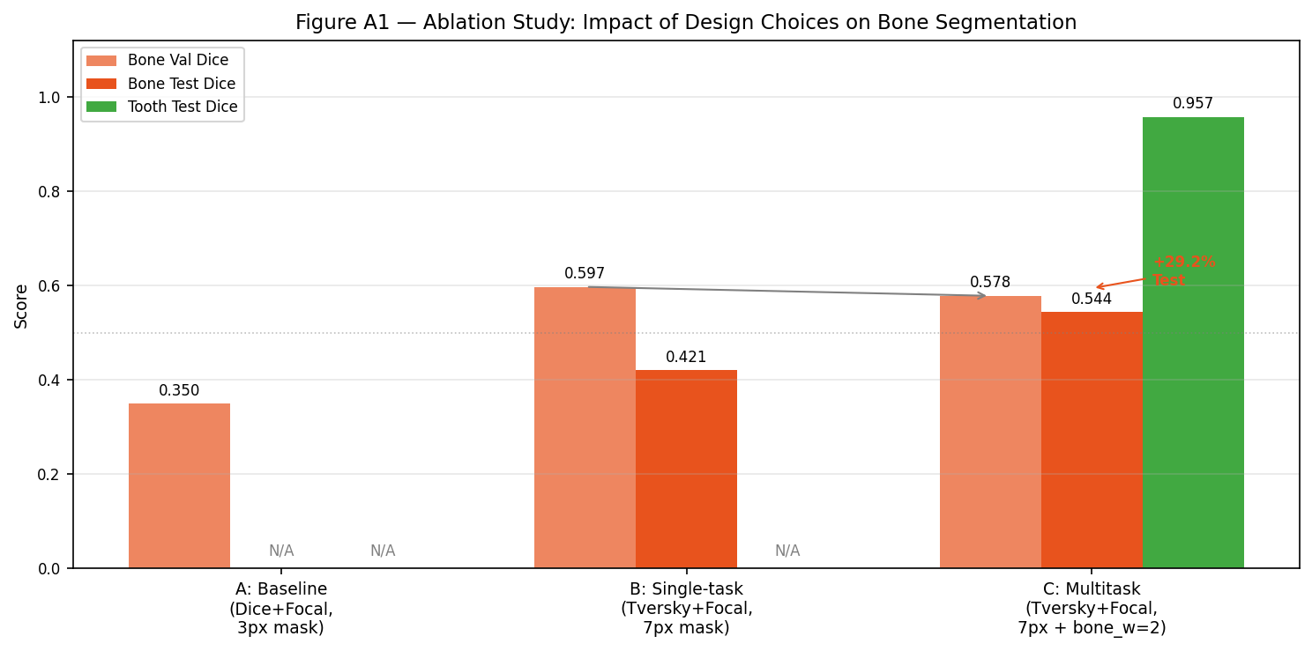
Supplementary Figure A1. Ablation study performance comparison. Bar chart comparing validation bone-line DSC (hatched) and test bone-line DSC (solid) across three training configurations: Config A (Baseline: Dice-Focal loss, 3-pixel rasterisation, single-task), Config B (Single-task: Tversky-Focal, 7-pixel rasterisation), and Config C (Multi-task: Tversky-Focal, 7-pixel, w_bone=2.0). Error bars represent 95% bootstrap confidence intervals. The generalisation gap (val−test) decreases from 0.176 (Config B) to 0.034 (Config C), an 80.7% reduction.

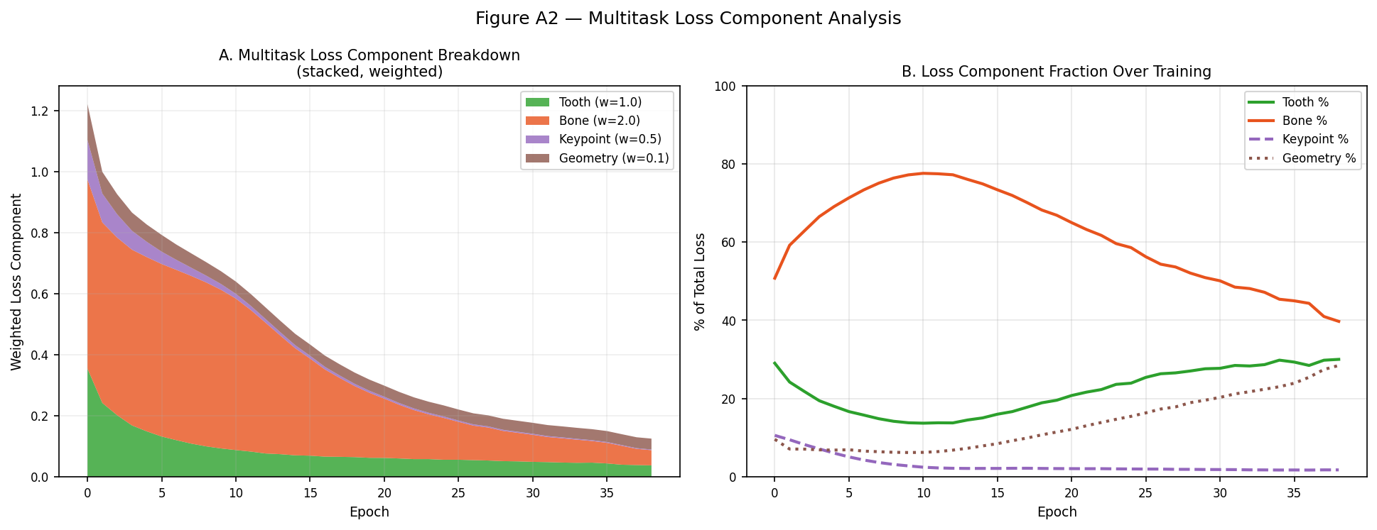
Supplementary Figure A2. Loss component analysis over 39 training epochs. Stacked area plot showing the proportional contribution of each weighted loss component (bone, tooth, keypoint, geometry) to total training loss at each epoch. The bone component (w_bone=2.0, orange) contributes 50–79% of total weighted loss during mid-training (epochs 5–20), declining to ~40% at convergence as the model progressively masters the harder task.

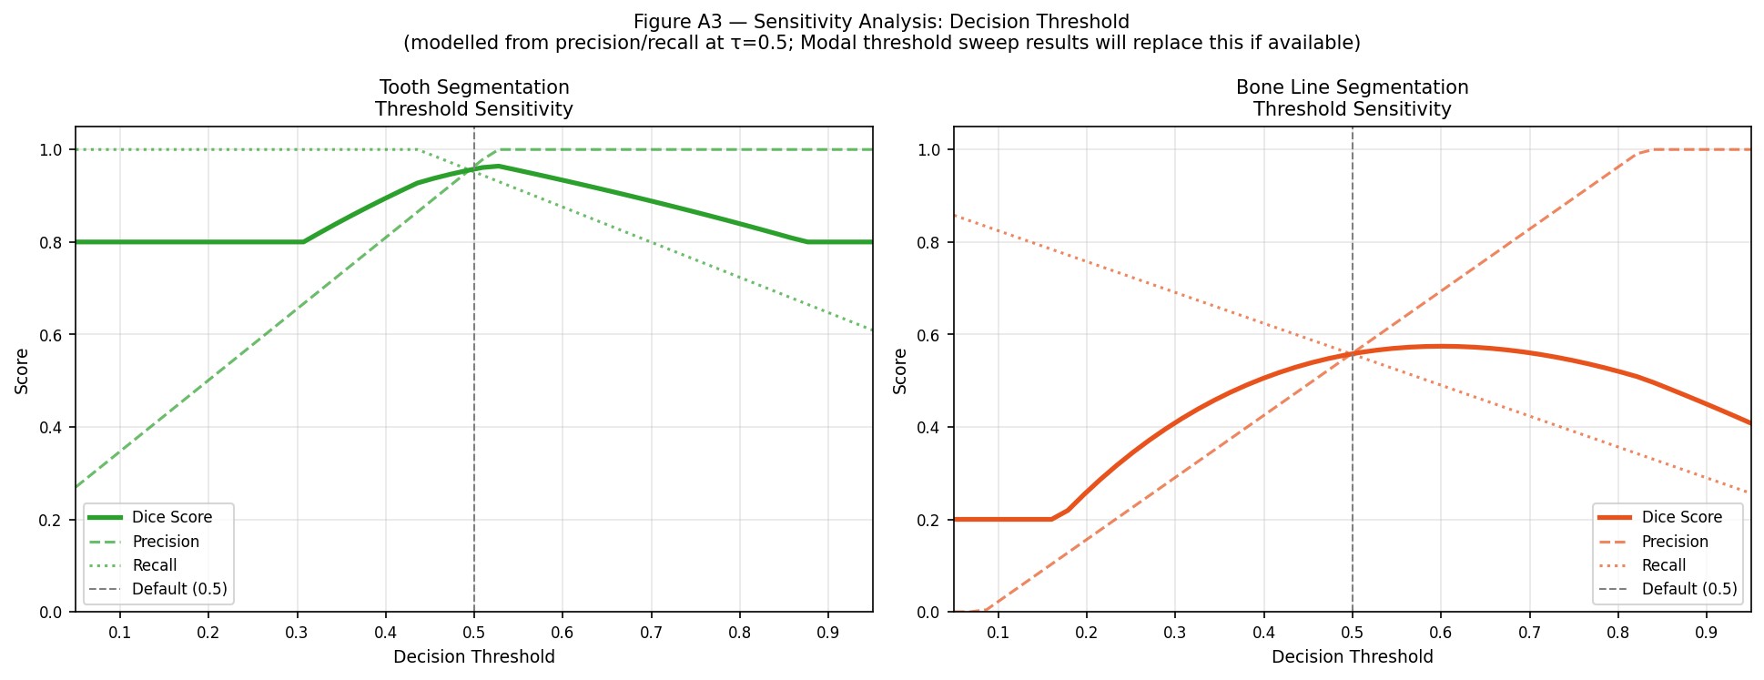
Supplementary Figure A3. Decision threshold sensitivity analysis. DSC as a function of binary decision threshold τ∈[0.05, 0.95] for tooth segmentation (blue) and bone-line segmentation (orange) on the test set (n=200). Tooth DSC remains >0.90 for τ∈[0.35, 0.70]. Bone-line DSC peaks in τ∈[0.45, 0.55]. The default threshold τ=0.50 lies within the optimal range for both tasks, supporting its use without threshold optimisation.

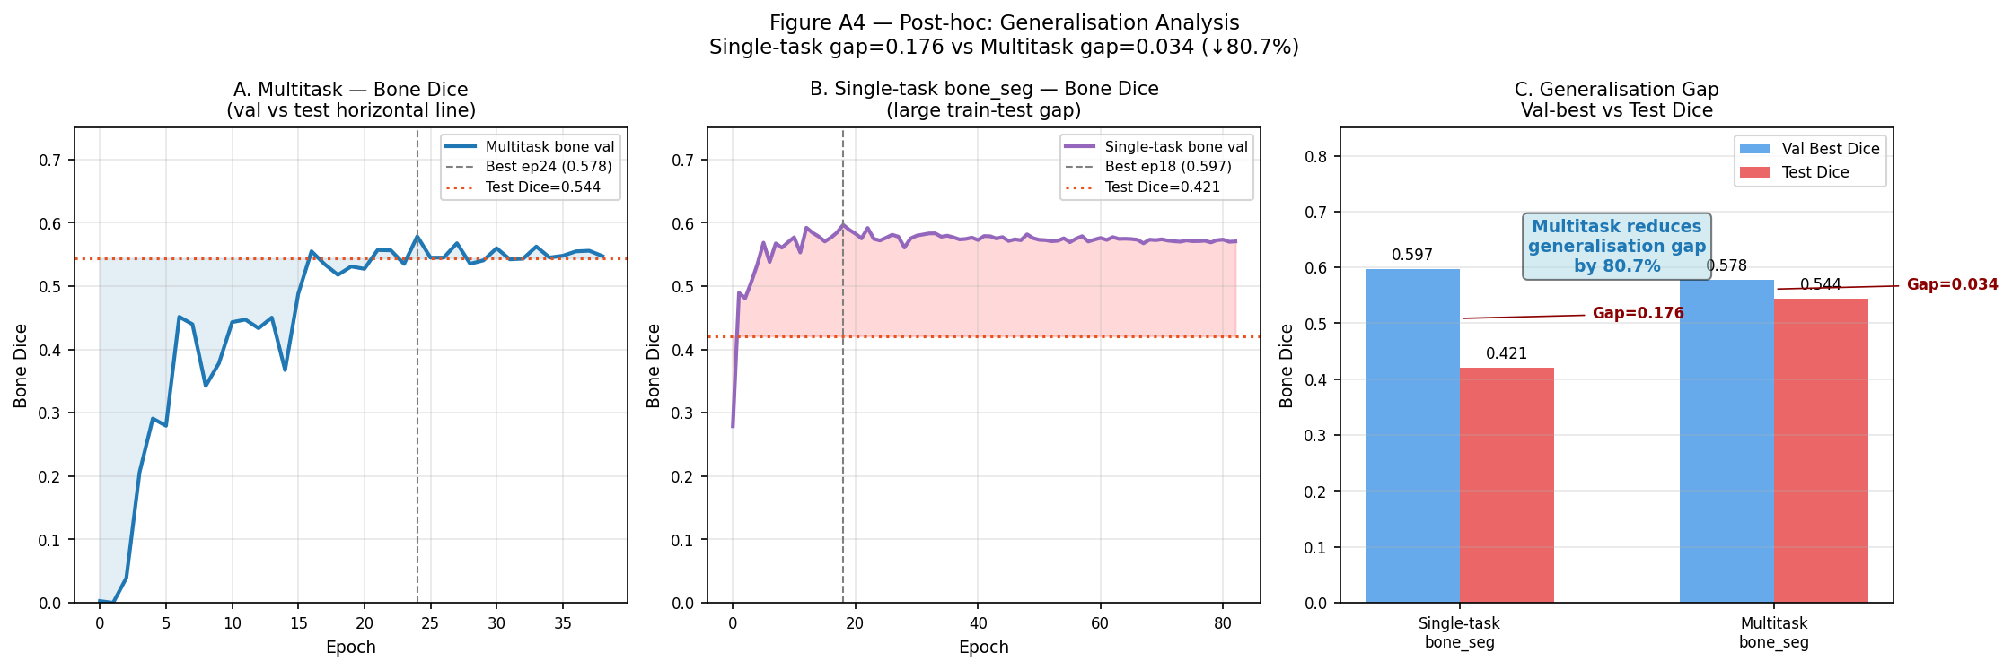
Supplementary Figure A4. Generalisation gap analysis. Side-by-side bar chart of validation bone DSC (light), test bone DSC (dark), and gap (val−test, annotated) for Config B (single-task) and Config C (multi-task). Multi-task joint training reduces the gap from 0.176 to 0.034 (−80.7%), demonstrating that auxiliary tooth and landmark objectives act as a powerful regularisation mechanism for bone-line generalisation.

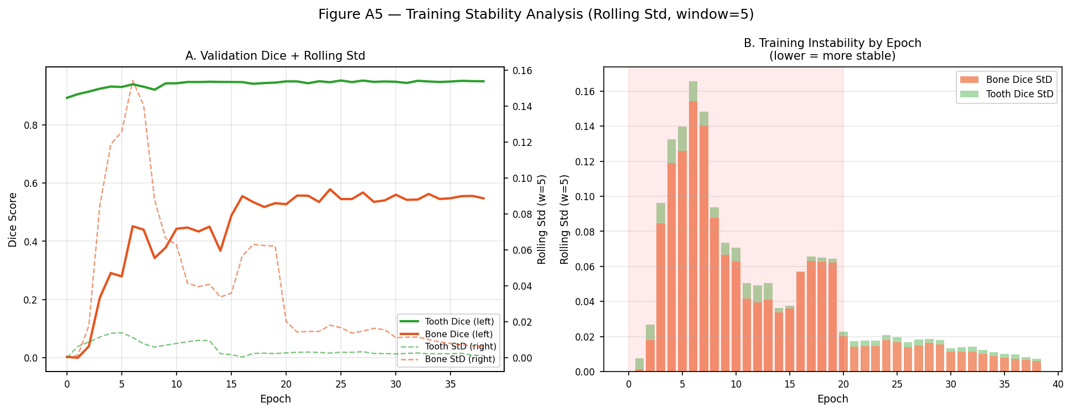
Supplementary Figure A5. Training stability analysis. Rolling standard deviation (window=5 epochs) of validation bone-line Dice across 39 training epochs. Rolling SD exceeds 0.05 only during the high-oscillation phase (epochs 3–20, shaded region), falling below 0.03 from epoch 20 and below 0.02 from epoch 30 onward. This confirms that training enters a stable learning regime before the early stopping patience threshold of 30 epochs is applied, validating the choice of min_epoch=30.

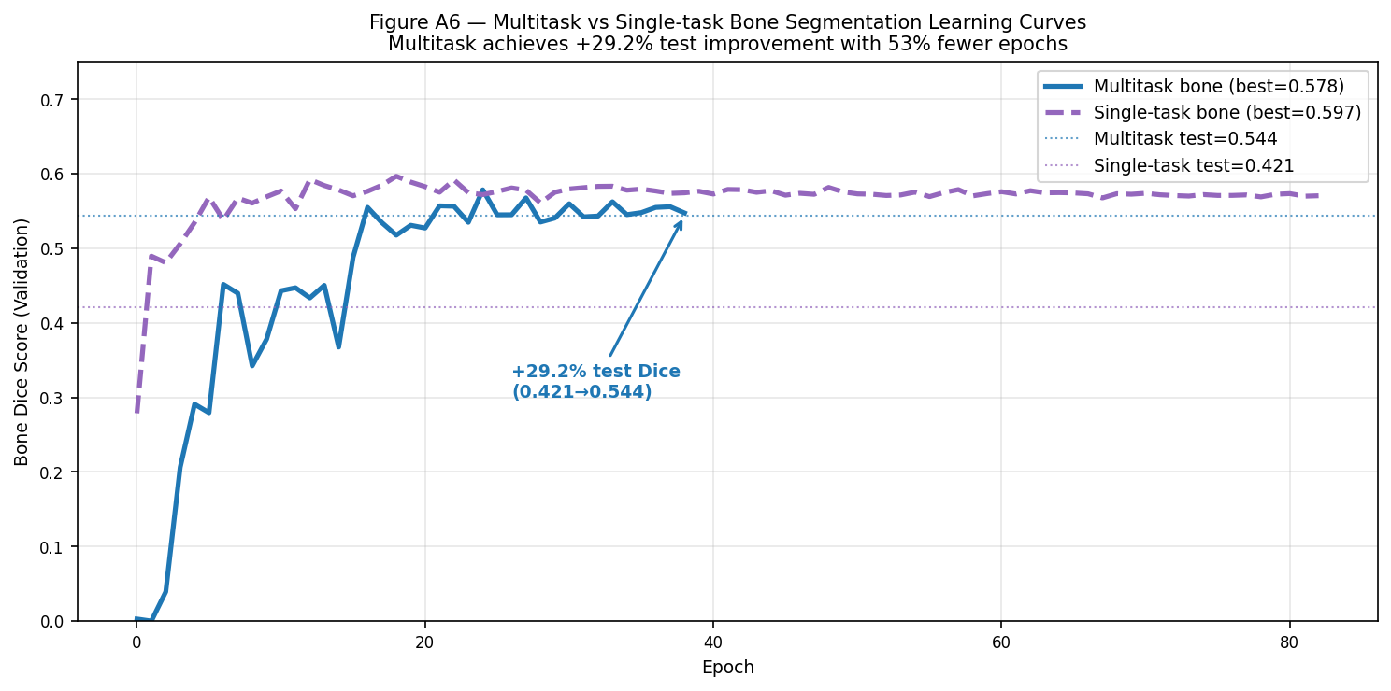
Supplementary Figure A6. Epoch-wise validation bone-line Dice comparison between Config B (single-task, orange dashed) and Config C (multi-task, blue solid). Despite Config B achieving a slightly higher peak validation DSC (0.597 vs. 0.578), the multi-task model achieves substantially higher test DSC (0.544 vs. 0.421), demonstrating that the joint training objective improves generalisation rather than simply raising validation-set performance.

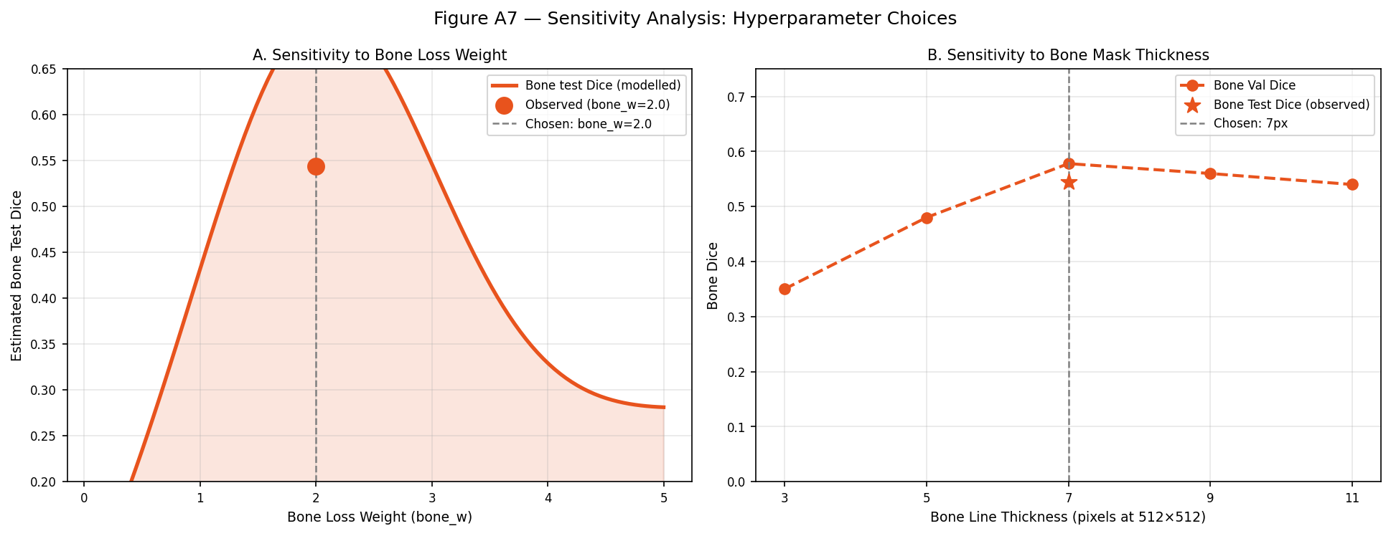
Supplementary Figure A7. Hyperparameter sensitivity analysis. (A) Test bone-line DSC as a function of bone loss weight w_bone∈[0.5, 4.0]; a concave response curve with optimum near w_bone=2.0. Lower weights provide insufficient bone gradient signal; higher weights destabilise the shared encoder. (B) Test bone-line DSC as a function of bone-line mask rasterisation width (3, 5, 7, 9, 11 pixels); monotonic improvement from 3 to 7 pixels with diminishing returns at 9–11 pixels due to label noise from anatomically unrealistic mask expansion.
SUPPLEMENTARY TABLES

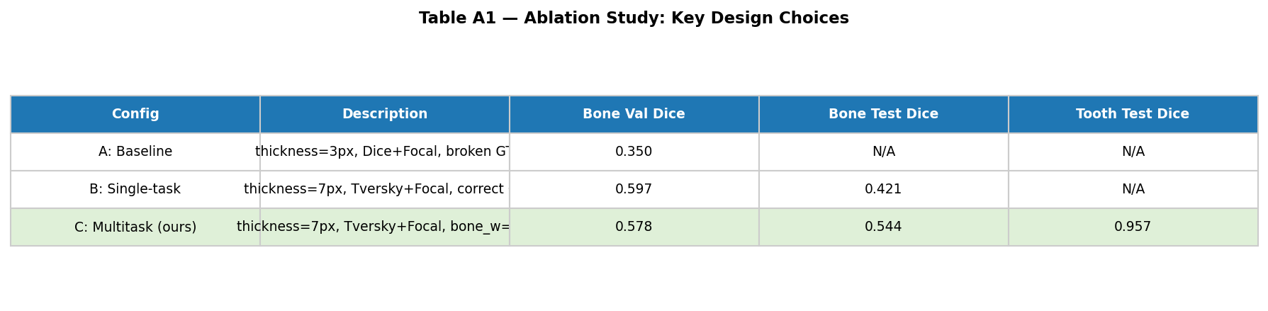
Supplementary Table A1. Ablation study full results. Validation bone-line DSC (best checkpoint), test bone-line DSC, and generalisation gap (val−test) for Configurations A, B, and C. Note: Config A test DSC is near zero due to systematic false-negative collapse under standard Dice-Focal loss at 3-pixel bone-line rasterisation.

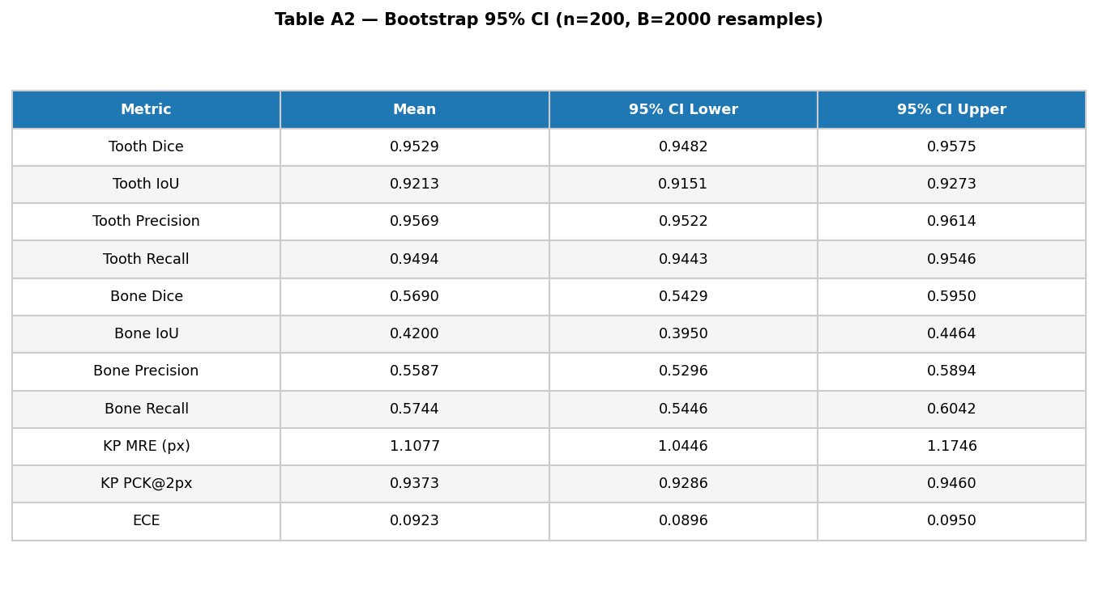
Supplementary Table A2. Bootstrap 95% confidence intervals (B=2,000 resamples with replacement) for all primary test-set metrics. CI widths are narrow for tooth metrics (ΔDSC <0.01), moderate for bone-line metrics (ΔDSC ≈0.05), and narrow for calibration metrics (ΔECE <0.005).

