Experiment 1.1

Student Name: Prateek Verma  Branch: MCA (CC & DEVOPS)  Semester: IInd  Subject Name: Technical Training | UID: 25MCC20062  Section/Group: 25MCC-101/A  Date of Performance: 07/01/2026  Subject Code: 25CAP-652

1. Aim:
To design and implement a sample database system using DDL, DML, and DCL commands, including database creation, data manipulation, schema modification, and role-based access control to ensure data integrity and secure, read-only access for authorized users.
2. Objective:
To gain practical experience in implementing Data Definition Language (DDL), Data Manipulation Language (DML), and Data Control Language (DCL) operations in a real database environment. This will also include implementing role-based privileges to secure data.
3.Experiment Steps:
- Create table queries:
  - CREATE TABLE DEPARTMENT (DEPT_ID INT PRIMARY KEY, DEPT_NAME VARCHAR(20) NOT NULL UNIQUE );

  - CREATE TABLE PROJECT (PROJ_ID INT PRIMARY KEY, PROJ_NAME VARCHAR(50) NOT NULL, DEPT_ID INT NOT NULL, FOREIGN KEY (DEPT_ID) REFERENCES DEPARTMENT(DEPT_ID) );

  - CREATE TABLE EMPLOYEE (EMP_ID VARCHAR(10) PRIMARY KEY,EMP_NAME VARCHAR(30) NOT NULL,DEPT_ID INT NOT NULL,PROJ_ID INT NOT NULL,FOREIGN KEY (DEPT_ID) REFERENCES DEPARTMENT (DEPT_ID) ON DELETE CASCADE ON UPDATE CASCADE,FOREIGN KEY (PROJ_ID) REFERENCES PROJECT (PROJ_ID) ON DELETE CASCADE ON UPDATE CASCADE );

- Insert queries:
  - INSERT INTO DEPARTMENT VALUES (1, 'Sales'), (2, 'Marketing'), (3, Legal'), (4, 'IT'), (5, 'Accounts'), (6, 'HR');

  - INSERT INTO PROJECT VALUES (1000, 'Lead Gen Campaign', 1);

  - INSERT INTO EMPLOYEE VALUES ('E100', 'Vikram Singh', 1, 1000);

- DML UPDATE and DELETE
  - UPDATE EMPLOYEE SET PROJ_ID = 6000 WHERE PROJ_ID = 6001;

  - DELETE FROM PROJECT WHERE DEPT_ID = 3;

- Access Control and Security
  - Creating a user: CREATE USER REPORTER WITH PASSWORD 'reporter@123';

  - Granting select privileges: GRANT SELECT ON EMPLOYEE, DEPARTMENT, PROJECT TO REPORTER;

  - Explicitly revoking create privilege on the DB: REVOKE CREATE ON SCHEMA PUBLIC FROM REPORTER;

- Schema modification
  - Alter table: ALTER TABLE EMPLOYEE ADD COLUMN BASE_SAL INT;

  - Alter table to remove foreign key constraint further to drop project table: ALTER TABLE EMPLOYEE DROP CONSTRAINT EMPLOYEE_PROJ_ID_FKEY;

  - Drop table: DROP TABLE PROJECT;

4. Output
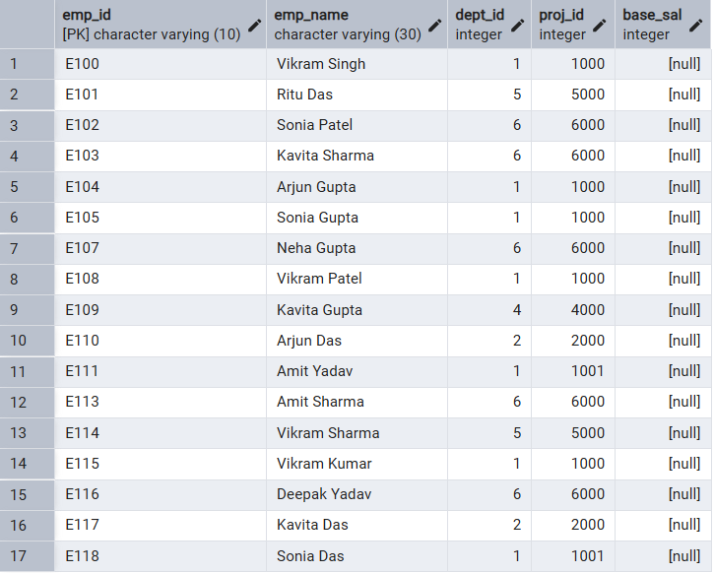

5. Learning Outcome
- Learning DDL, DML, and DCL commands in SQL.
- How to implement integrity and domain constraints in SQL.
- DBMS privilege management.

