Experiment 2

Student Name: Prateek Verma  Branch: MCA (CC & DEVOPS)  Semester: IInd  Subject Name: Technical Training | UID: 25MCC20062  Section/Group: 25MCC-101/A  Date of Performance: 13/01/2026  Subject Code: 25CAP-652

- Aim:
  - To implement and analyze SQL SELECT queries using filtering, sorting, grouping, and aggregation concepts in PostgreSQL for efficient data retrieval and analytical reporting.

- Objective:
  - To retrieve specific data using filtering conditions
  - To sort query results using single and multiple attributes
  - To perform aggregation using grouping techniques
  - To apply conditions on aggregated data
  - To understand real‑world analytical queries

- Experiment Steps:
  - Create table queries:
    - Create table customer_orders (order_id int primary key, customer_name varchar(30) not null, product varchar(50) not null, quantity int not null check (quantity > 0), price decimal(8, 2) not null check (price >= 0), order_date date not null);

  - Insert queries:
    - Insert into customer_orders values (1023, 'amit sharma', 'laptop', 1, 55000.00, '2024-01-05' );

  - Filtering Data using conditions
    - Select * from customer_orders where price > 45000;

  - Sorting Query Results:
    - Sorting in descending order:
Select order_id, customer_name as name, price as shopping_value from customer_orders order by shopping_value desc;

    - Priority based sorting:
Select order_id, customer_name as name, price as shopping_value from customer_orders order by shopping_value desc, order_id;

  - Grouping data for aggregation:
    - Select product, count(product) as quantity_sold, sum(quantity * price) as total_sales from customer_orders group by product;

  - Applying conditions on aggregate data:
    - Select product, sum(quantity) as quantity_sold, sum(quantity * price) as total_sales from customer_orders group by product having sum(quantity) >= 5;

- Output
  - Filtering data using conditions:
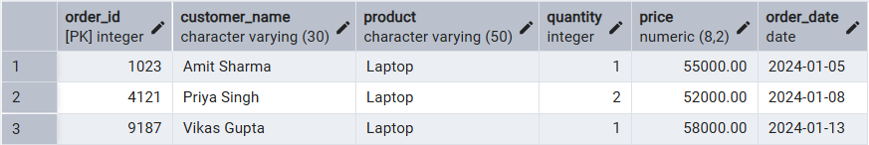

  - Sorting in descending order:
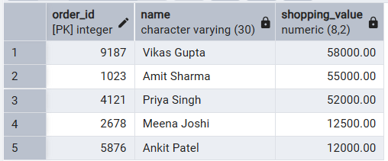

  - Priority based sorting:
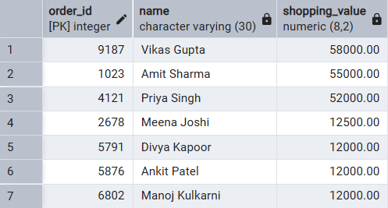

  - Grouping data for aggregation:
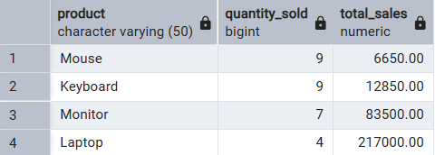

  - Conditions on aggregated data:
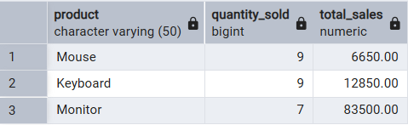

- Learning Outcome
  - Understand how data can be filtered to retrieve only relevant records from a database.
  - Learn how sorting improves readability and usefulness of query results in reports.
  - Gained the ability to group data for analytical purposes.
  - Differentiate between row-level conditions and group-level conditions.
  - Writing analytical SQL queries used in real-world scenarios.
  - Better prepared to answer SQL-based questions related to filtering, grouping, and aggregation.

