Experiment 10

Student Name: Prateek Verma  Branch: MCA (CC & DEVOPS)  Semester: IInd  Subject Name: Technical Training | UID: 25MCC20062  Section/Group: 25MCC-101/A  Date of Performance: 21/04/2026  Subject Code: 25CAP-652

Title: Transaction Control in SQL.
- Aim:
  - To implement transaction control mechanisms in PostgreSQL to ensure data integrity and consistency by enforcing ACID properties.

- Software Requirements:
  - PostgreSQL (Database Server)
  - pgAdmin
  - OS: Windows

- Objective:
  - Data integrity: ensure that a system failure occurs during a transaction, the entire operation is rolled back, preventing partial corrupted data.
  - Consistency: Maintains data validity by preventing scenarios like lost updates or inconsistent analysis.
  - Isolation: Allows multiple transactions to occur simultaneously without interfering with each other.
  - Recovery: Enables recovery of changed resources after a system failure.
  - Error Management (Savepoints): Allows partial rollbacks using savepoints without reversing the entire transaction.

- Procedure of the Practical:
  - Start the system.
  - Open pgAdmin.
  - Create and select the database in which you want to perform the experiment.
  - Establish connection to the database using Alt+Shift+Q.
  - Run the following queries given in Experiment Steps (5).

Base Table
Payroll:
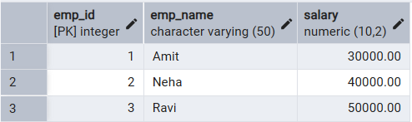

- Experiment Steps:
BEGIN;
-- Update 1
UPDATE Payroll
SET salary = salary + 5000
WHERE emp_id = 1;

-- Savepoint
SAVEPOINT sp1;

-- Update 2
UPDATE Payroll
SET salary = salary + 7000
WHERE emp_id = 2;

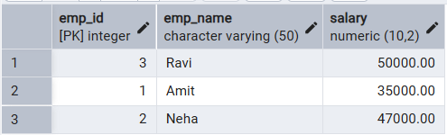

-- Error simulation
UPDATE Payroll
SET salary = -1000
WHERE emp_id = 3;
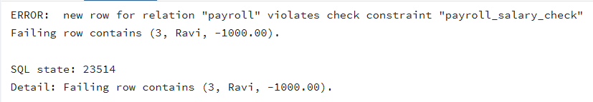

-- Rollback to savepoint
ROLLBACK TO sp1;

-- Commit valid changes
COMMIT;
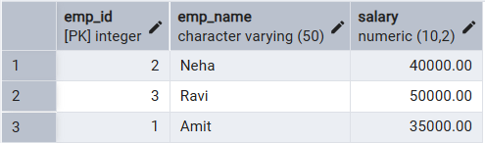

- Input/Output Details:
  - The input for the experiment is the SQL queries mentioned in Experiment Steps (5).
  - The output for each query is attached after the query itself.

- Learning Outcome
  - Understanding of transactions in SQL.
  - Transaction Control Language commands.
  - Ensuring ACID properties using transactions.

