Experiment 3

Student Name: Prateek Verma  Branch: MCA (CC & DEVOPS)  Semester: IInd  Subject Name: Technical Training | UID: 25MCC20062  Section/Group: 25MCC-101/A  Date of Performance: 27/01/2026  Subject Code: 25CAP-652

Title: Implementation of Conditional Logic using IF–ELSE and CASE Statements in PostgreSQL
- Aim:
  - To implement conditional decision-making logic in PostgreSQL using IF–ELSE constructs and CASE expressions for classification, validation, and rule-based data processing.

- Software Requirements:
  - PostgreSQL (Database Server)
  - pgAdmin
  - OS: Windows

- Objective:
  - To understand conditional execution in SQL
  - To implement decision-making logic using CASE expressions
  - To simulate real-world rule validation scenarios
  - To classify data based on multiple conditions
  - To strengthen SQL logic skills required in interviews and backend systems

- Procedure of the Practical:
  - Start the system.
  - Open pgAdmin.
  - Create and select the database in which you want to perform the experiment.
  - Establish connection to the database using Alt+Shift+Q.
  - Run the following queries given in Experiment Steps (5).

- Experiment Steps:
  - Create table queries:
    - Create table schema_violations (schema_id int primary key, schema_name varchar(50) not null, violation_count int not null check (violation_count >= 0));

  - Insert queries:
    - Insert into schema_violations values (1,'finance_schema', 0);
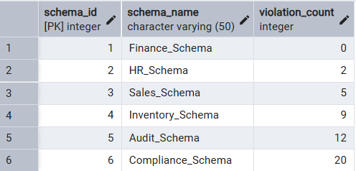

  - Classifying data using case expression:
    - Select *, case
when violation_count = 0 then 'no violation'
when violation_count between 1 and 3 then 'minor violation'
when violation_count between 4 and 7 then 'moderate violation'
else 'critical violation'
end as violation_category
from schema_violations;
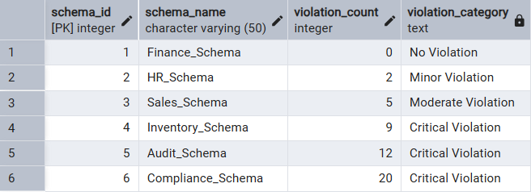

  - Applying case logic in data updates:
    - Alter table to add status attribute:
Alter table schema_violations add column approval_status varchar(20);

    - Updating status using case logic:
Update schema_violations set approval_status = case when violation_count = 0 then 'Approved' when violation_count between 1 and 7 then 'Needs Review' else 'Rejected' end;
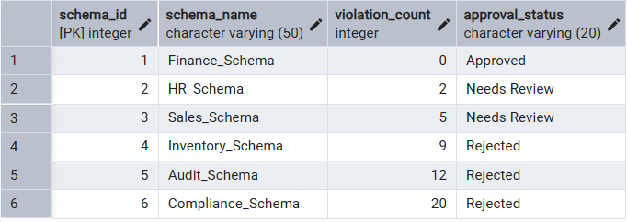

  - Using case statement for custom sorting (descending):
    - Select * from schema_violations order by case when approval_status='rejected' then 1 when approval_status='needs review' then 2 when approval_status='approved' then 3 end;
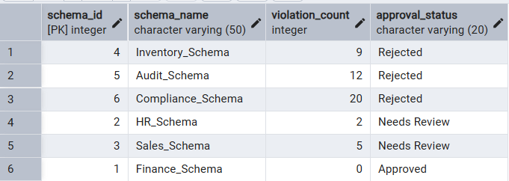

  - Real world classification scenario (grading system):
    - Create table:
      - create table students (id int primary key, name varchar(30) not null, marks int not null check(marks<>0 and marks<=100));

    - Inserting records:
      - Insert into students (id, name, marks) values (1, 'Aarav', 95);
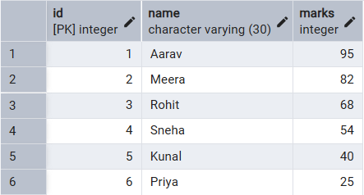

    - Adding new grade column:
      - alter table students add column grade varchar(2);

    - Updating grade column to reflect student grade based on marks using case statement:
      - Update students set grade = case when marks >= 90 then 'A+' when marks >= 80 then 'A' when marks >= 70 then 'B' when marks >= 60 then 'C’ when marks >= 50 then 'D' else 'F' end;
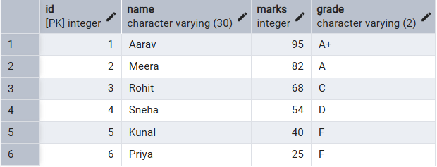

  - PL/pgSQL block to implement IF-ELSE logic
    - do $$
declare
i int := 7;
begin
if i = 0 then
raise notice 'no violation';
elsif i <= 3 then
raise notice 'minor violation';
elsif i <= 7 then
raise notice 'moderate violation';
else
raise notice 'critical violation';
end if;
end $$;
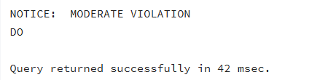

- Input/Output Details:
  - The input for the experiment is the SQL queries mentioned in Experiment Steps (5).
  - The output for each query is attached after the query itself.

- Learning Outcome
  - Knowledge on how conditional logic is implemented in PostgreSQL using CASE expressions and IF–ELSE constructs.
  - Strong command over rule-based SQL logic, which is essential for:
    - Backend systems
    - Analytics
    - Compliance reporting
    - Placement and technical interviews

