Experiment 8

Student Name: Prateek Verma  Branch: MCA (CC & DEVOPS)  Semester: IInd  Subject Name: Technical Training | UID: 25MCC20062  Section/Group: 25MCC-101/A  Date of Performance: 31/03/2026  Subject Code: 25CAP-652

Title: Stored Procedures in SQL.
- Aim:
  - To apply the concept of Stored Procedures in database operations in order to perform tasks like insertion, updating, deletion, and retrieval of data efficiently, securely, and in a reusable manner within the database system.

- Software Requirements:
  - PostgreSQL (Database Server)
  - pgAdmin
  - OS: Windows

- Objective:
  - Apply stored procedure concepts for database operations

- Procedure of the Practical:
  - Start the system.
  - Open pgAdmin.
  - Create and select the database in which you want to perform the experiment.
  - Establish connection to the database using Alt+Shift+Q.
  - Run the following queries given in Experiment Steps (5).

Base Table:
Employees
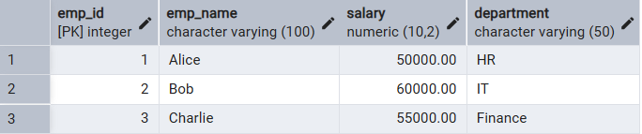

- Experiment Steps:
  - SQL procedure to insert employee data.
CREATE OR REPLACE PROCEDURE INSERT_EMPLOYEE_PROC (
IN P_EMP_ID INT,
IN P_EMP_NAME VARCHAR(100),
IN P_SALARY NUMERIC(10,2),
IN P_DEPARTMENT VARCHAR(50),
OUT STATUS VARCHAR(50)
) AS $$
BEGIN
INSERT INTO EMPLOYEES (EMP_ID, EMP_NAME, SALARY, DEPARTMENT)
VALUES (P_EMP_ID, P_EMP_NAME, P_SALARY, P_DEPARTMENT);
STATUS := 'Success';
EXCEPTION
WHEN unique_violation THEN
STATUS := 'Error: Employee ID already exists';
WHEN not_null_violation THEN
STATUS := 'Error: Missing required fields';
WHEN OTHERS THEN
STATUS := 'Error: ' || SQLERRM;
END;
$$ LANGUAGE PLPGSQL;

CALL INSERT_EMPLOYEE_PROC(4, 'David', 65000, 'Marketing',NULL);
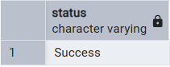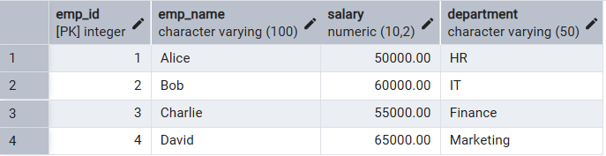

  - SQL procedure to update employee salary
CREATE OR REPLACE PROCEDURE UPDATE_SALARY_PROC (
IN P_EMP_ID INT,
INOUT P_SALARY NUMERIC(20, 3),
OUT STATUS VARCHAR(20)
) AS $$
DECLARE
CURR_SAL NUMERIC(20, 3);
BEGIN
SELECT
SALARY + P_SALARY INTO CURR_SAL
FROM
EMPLOYEES
WHERE
EMP_ID = P_EMP_ID;
IF NOT FOUND THEN RAISE EXCEPTION 'Employee Not Found';
END IF;
UPDATE EMPLOYEES
SET
SALARY = CURR_SAL
WHERE
EMP_ID = P_EMP_ID;
STATUS := 'Success';
P_SALARY := CURR_SAL;
EXCEPTION WHEN OTHERS THEN IF SQLERRM LIKE '%Employee Not Found%' THEN STATUS := 'Employee Not Found';
END IF;
END;
$$ LANGUAGE PLPGSQL;

CALL UPDATE_SALARY_PROC(4, 5000.00,null);
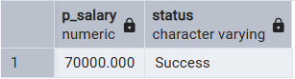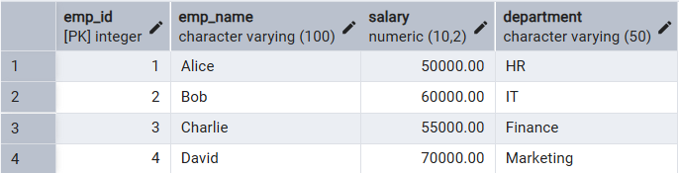

  - SQL procedure to delete employee
CREATE OR REPLACE PROCEDURE DELETE_EMPLOYEE_PROC (
IN P_EMP_ID INT,
OUT STATUS VARCHAR(50)
) AS $$
DECLARE
V_DELETED_ROWS INT;
BEGIN
DELETE FROM EMPLOYEES
WHERE EMP_ID = P_EMP_ID;
GET DIAGNOSTICS V_DELETED_ROWS = ROW_COUNT;
IF V_DELETED_ROWS = 0 THEN
STATUS := 'Employee Not Found';
ELSE
STATUS := 'Success';
END IF;
EXCEPTION
WHEN OTHERS THEN
STATUS := 'Error: ' || SQLERRM;
END;
$$ LANGUAGE PLPGSQL;

CALL DELETE_EMPLOYEE_PROC(4,null);

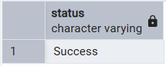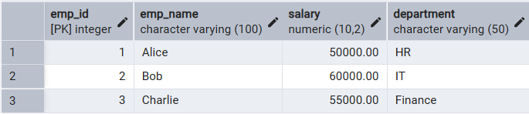

  - SQL procedure to retrieve a row from the employee table.
CREATE OR REPLACE PROCEDURE GET_EMPLOYEE_PROC (
IN P_EMP_ID INT,
OUT P_EMP_NAME VARCHAR(100),
OUT P_SALARY NUMERIC(10,2),
OUT P_DEPARTMENT VARCHAR(50),
OUT STATUS VARCHAR(50)
) AS $$
BEGIN
SELECT EMP_NAME, SALARY, DEPARTMENT
INTO P_EMP_NAME, P_SALARY, P_DEPARTMENT
FROM EMPLOYEES
WHERE EMP_ID = P_EMP_ID;
IF NOT FOUND THEN
STATUS := 'Employee Not Found';
P_EMP_NAME := NULL;
P_SALARY := NULL;
P_DEPARTMENT := NULL;
ELSE
STATUS := 'Success';
END IF;
EXCEPTION
WHEN OTHERS THEN
STATUS := 'Error: ' || SQLERRM;
P_EMP_NAME := NULL;
P_SALARY := NULL;
P_DEPARTMENT := NULL;
END;
$$ LANGUAGE PLPGSQL;

CALL GET_EMPLOYEE_PROC(4,null,null,null,null);
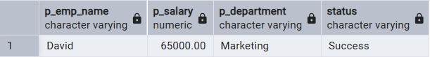

- Input/Output Details:
  - The input for the experiment is the SQL queries mentioned in Experiment Steps (5).
  - The output for each query is attached after the query itself.

- Learning Outcome
- Understanding of how to create procedures in SQL.
- Handling errors in SQL procedures.
- IN, OUT, and INOUT variables in SQL procedures.
- Calling the procedures.

