Experiment 4

Student Name: Prateek Verma  Branch: MCA (CC & DEVOPS)  Semester: IInd  Subject Name: Technical Training | UID: 25MCC20062  Section/Group: 25MCC-101/A  Date of Performance: 03/02/2026  Subject Code: 25CAP-652

Title: Implementation of Iterative Control Structures using FOR, WHILE, and LOOP in PostgreSQL
- Aim:
  - To understand and implement iterative control structures in PostgreSQL conceptually, including FOR loops, WHILE loops, and basic LOOP constructs, for repeated execution of database logic.

- Software Requirements:
  - PostgreSQL (Database Server)
  - pgAdmin
  - OS: Windows

- Objective:
- To understand why iteration is required in database programming
- To learn the purpose and behavior of FOR, WHILE, and LOOP constructs
- To understand how repeated data processing is handled in databases
- To relate loop concepts to real-world batch processing scenarios
- To strengthen conceptual knowledge of procedural SQL used in enterprise systems.

- Procedure of the Practical:
  - Start the system.
  - Open pgAdmin.
  - Create and select the database in which you want to perform the experiment.
  - Establish connection to the database using Alt+Shift+Q.
  - Run the following queries given in Experiment Steps (5).

- Experiment Steps:
  - For Loop (simple iteration):
DO $$
BEGIN
FOR i IN 1..5 LOOP
RAISE NOTICE 'Number: %', i;
END LOOP;
END $$;
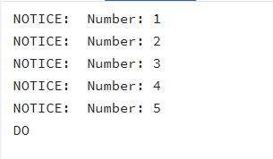

  - For Loop with Query (Row-by-Row Processing):
DO $$
DECLARE
rec RECORD;
BEGIN
FOR rec in SELECT id, marks FROM "Experiment_3".students LOOP
RAISE NOTICE 'ID: %, Marks: %',rec.id, rec.marks;
END LOOP;
END $$;
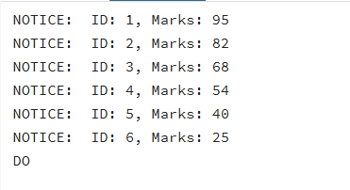

  - While Loop (conditional iteration):
DO $$
DECLARE
i int:=1;
BEGIN
WHILE i<=5 LOOP
RAISE NOTICE 'WHILE LOOP turn %',i;
i:=i+1;
END LOOP;
END $$
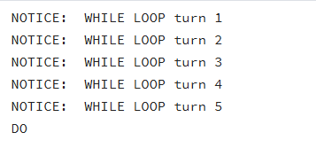

  - Loop with ‘EXIT WHEN’:
DO $$
DECLARE
i int :=1;
BEGIN
LOOP
RAISE NOTICE 'i=%',i;
i:=i+1;
EXIT WHEN i>5;
END LOOP;
END $$;
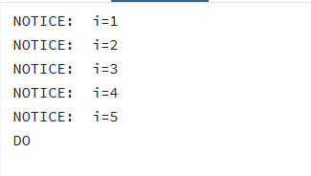

  - Salary increment using For Loop:
DO $$
DECLARE
rec RECORD;
BEGIN
FOR rec IN (SELECT id, salary from salaries)
LOOP
-- Update logic
UPDATE salaries
SET salary = rec.salary * 1.10
WHERE id = rec.id;
END LOOP;
END $$;

Before:
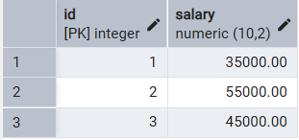
After:
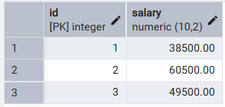

  - Combining Loop with IF condition:
DO $$
DECLARE
rec RECORD;
BEGIN
For rec in (select id, marks from "Experiment_3".students)
LOOP
IF rec.marks>50 THEN
RAISE NOTICE 'ID: %, Marks: %',rec.id,rec.marks;
END IF;
END LOOP;
END $$;
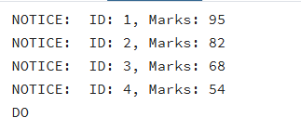

- Input/Output Details:
  - The input for the experiment is the SQL queries mentioned in Experiment Steps (5).
  - The output for each query is attached after the query itself.

- Learning Outcome
  - Understanding of how iterative control structures work in PostgreSQL at a conceptual level.
  - Usage of loops in database systems, such as workflow engines, complex decision cycles, validation loops, etc.
  - Foundational knowledge required for writing procedural logic in enterprise-grade applications.

