Experiment 5

Student Name: Prateek Verma  Branch: MCA (CC & DEVOPS)  Semester: IInd  Subject Name: Technical Training | UID: 25MCC20062  Section/Group: 25MCC-101/A  Date of Performance: 17/02/2026  Subject Code: 25CAP-652

Title: Creating and using cursors for row-by-row processing in a database.
- Aim:
  - To gain hands-on experience in creating and using cursors for row-by-row processing in a database, enabling sequential access and manipulation of query results for complex business logic.

- Software Requirements:
  - PostgreSQL (Database Server)
  - pgAdmin
  - OS: Windows

- Objective:
- Sequential Data Access: To understand how to fetch rows one by one from a result set using cursor mechanisms.
- Row-Level Manipulation: To perform specific operations or calculations on individual records that require conditional procedural logic.
- Resource Management: To learn the lifecycle of a cursor: Declaring, Opening, Fetching, and importantly, Closing and Deallocating to manage system memory.
- Exception Handling: To handle cursor-related errors and performance considerations during large-scale data iteration.
- Theory: While SQL is generally set-oriented, certain tasks require a procedural approach where we process one row at a time. This is where Cursors are used:
  - Cursor Types: Cursors can be Implicit (managed by the system) or Explicit (defined by the developer). They can also be Forward-Only (moving only toward the end) or Scrollable (moving back and forth).
  - The Lifecycle:
    - DECLARE: Defines the SQL query for the cursor.
    - OPEN: Executes the query and establishes the result set.
    - FETCH: Retrieves a specific row into variables for processing.
    - CLOSE: Releases the current result set.
    - DEALLOCATE: Removes the cursor definition from memory.
  - Use Case: Cursors are ideal for generating row-specific reports, updating balances based on complex historical data, or migrating data where each record needs individual validation.

- Procedure of the Practical:
  - Start the system.
  - Open pgAdmin.
  - Create and select the database in which you want to perform the experiment.
  - Establish connection to the database using Alt+Shift+Q.
  - Run the following queries given in Experiment Steps (6).

- Experiment Steps:
Base Table:
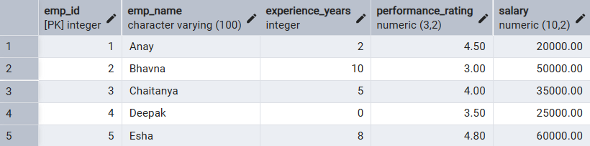

  - Implementing a simple forward only cursor.
DO $$
DECLARE
emp_cursor CURSOR FOR SELECT emp_id, emp_name, salary FROM Employee;
emp_record RECORD;
BEGIN
FOR emp_record IN emp_cursor LOOP
RAISE NOTICE 'Employee ID: %, Name: %, Salary: %',
emp_record.emp_id,
emp_record.emp_name,
emp_record.salary;
END LOOP;
END $$;
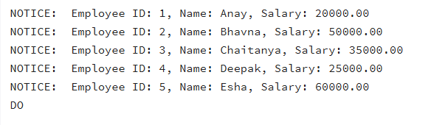

  - Complex row-by-row manipulation using cursor to update salaries based on dynamic “experience to performance” ratio.
DO $$
DECLARE
emp_cursor CURSOR FOR SELECT emp_id, emp_name, experience_years, performance_rating, salary FROM Employee;
emp_record RECORD;
v_ratio NUMERIC;
v_bonus_multiplier NUMERIC;
BEGIN
FOR emp_record IN emp_cursor LOOP

v_ratio := emp_record.performance_rating / (emp_record.experience_years + 1);

IF v_ratio >= 1.5 THEN
v_bonus_multiplier := 1.20;
ELSIF v_ratio >= 0.8 THEN
v_bonus_multiplier := 1.10;
ELSE
v_bonus_multiplier := 1.05;
END IF;

UPDATE Employee
SET salary = salary * v_bonus_multiplier
WHERE emp_id = emp_record.emp_id;

RAISE NOTICE 'Employee: % salary incremented by multiplier of %',
emp_record.emp_name, v_bonus_multiplier;

END LOOP;
END $$;
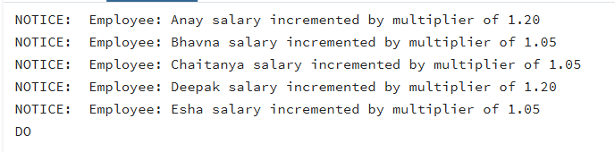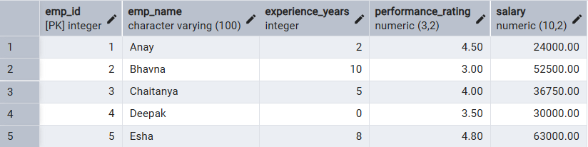

  - Exception and status handling ensuring the cursor handles empty result sets and termination signals gracefully.

DO $$
DECLARE
emp_cursor CURSOR FOR SELECT * FROM Employee;
emp_record RECORD;
v_ratio NUMERIC;
BEGIN
OPEN emp_cursor;

LOOP
FETCH emp_cursor INTO emp_record;
EXIT WHEN NOT FOUND;

BEGIN
IF emp_record.experience_years < 0 THEN
RAISE EXCEPTION 'Invalid experience for employee %', emp_record.emp_name;
END IF;

v_ratio := emp_record.performance_rating / (emp_record.experience_years + 1);

UPDATE Employee
SET salary = salary * (1 + (v_ratio / 10)) -- Dynamic 10% scaled raise
WHERE emp_id = emp_record.emp_id;

RAISE NOTICE 'Success: Updated %', emp_record.emp_name;

EXCEPTION
WHEN OTHERS THEN
RAISE WARNING 'Skipping Employee % due to error: %', emp_record.emp_name, SQLERRM;
END;

END LOOP;

CLOSE emp_cursor;

EXCEPTION
WHEN OTHERS THEN
RAISE EXCEPTION 'Critical Failure in Cursor Processing: %', SQLERRM;
END $$;

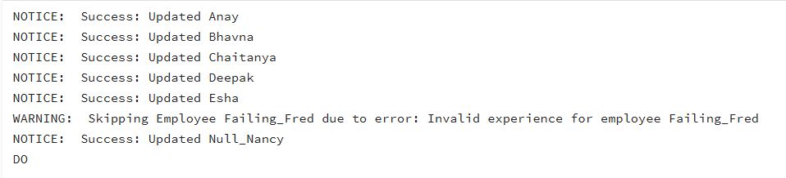
Before:
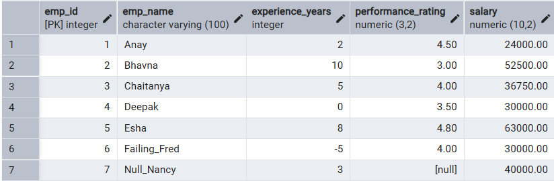
After:
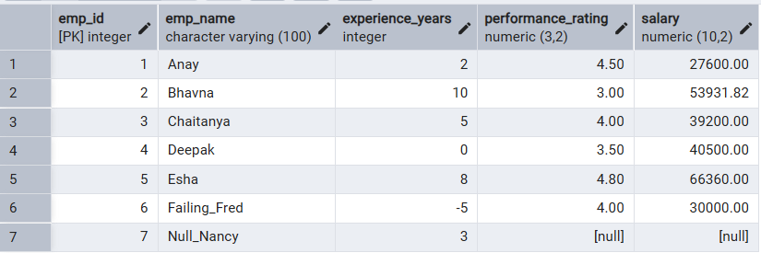

- Input/Output Details:
  - The input for the experiment is the SQL queries mentioned in Experiment Steps (5).
  - The output for each query is attached after the query itself.

- Learning Outcome
- Cursor Implementation: Ability to design, implement, and manage cursors to solve row-wise processing problems.
- Lifecycle Mastery: Gaining knowledge of the correct syntax for declaring, opening, fetching, and closing cursors.
- Error Prevention: Understanding how to properly handle row-by-row processing exceptions and prevent memory leaks via deallocation.
- Analytical Thinking: Applying cursor-based logic to solve real-world scenarios like multi-level payroll adjustments or data migrations.

