Experiment 7

Student Name: Prateek Verma  Branch: MCA (CC & DEVOPS)  Semester: IInd  Subject Name: Technical Training | UID: 25MCC20062  Section/Group: 25MCC-101/A  Date of Performance: 31/03/2026  Subject Code: 25CAP-652

Title: Joins in SQL Databases.
- Aim:
  - Implementation of joins in PostgreSQL (inner join, left join, right join, self-join and cross join)

- Software Requirements:
  - PostgreSQL (Database Server)
  - pgAdmin
  - OS: Windows

- Objective:
  - Apply joins to a real-world database schema (e.g., Students, Courses, Enrollments, Departments).
- Procedure of the Practical:
  - Start the system.
  - Open pgAdmin.
  - Create and select the database in which you want to perform the experiment.
  - Establish connection to the database using Alt+Shift+Q.
  - Run the following queries given in Experiment Steps (5).

- Experiment Steps:
Base Table:
Students
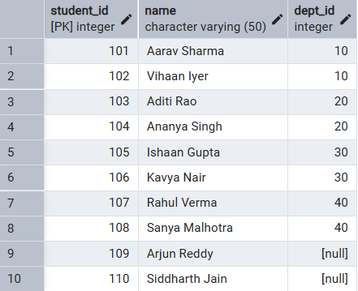
Departments
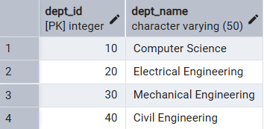
Courses
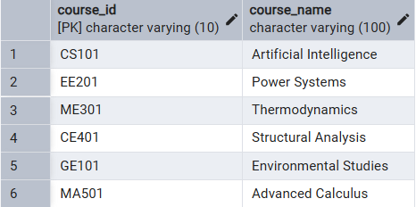
Enrollments
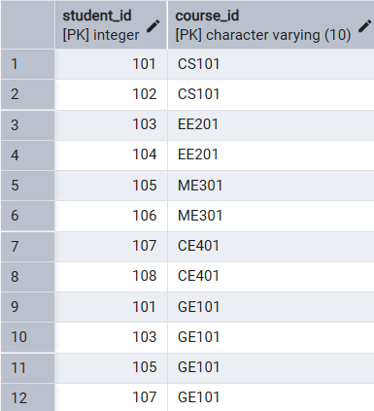

  - Write queries to list students with their enrolled courses (INNER JOIN).
SELECT S.Name AS Student_Name, C.Course_Name FROM Students S
INNER JOIN Enrollments E ON S.Student_ID = E.Student_ID
INNER JOIN Courses C ON E.Course_ID = C.Course_ID
ORDER BY S.Name;
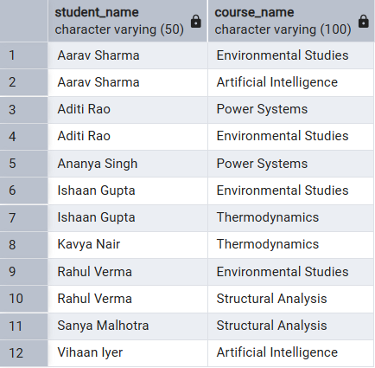

  - Find students not enrolled in any course (LEFT JOIN).
SELECT S.Name AS Unenrolled_Student FROM Students S
LEFT JOIN Enrollments E ON S.Student_ID = E.Student_ID
WHERE E.Course_ID IS NULL;
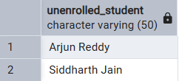

  - Display all courses with or without enrolled students (RIGHT JOIN).
SELECT C.Course_Name, S.Name AS Student_Name
FROM Enrollments E JOIN Students S ON E.Student_ID = S.Student_ID
RIGHT JOIN Courses C ON E.Course_ID = C.Course_ID;
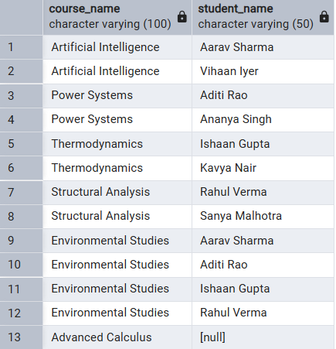

  - Show students with department info using SELF JOIN or multiple joins.
SELECT S.Name AS Student, D.Dept_Name, C.Course_Name
FROM Students S INNER JOIN Departments D ON S.Dept_ID = D.Dept_ID
INNER JOIN Enrollments E ON S.Student_ID = E.Student_ID
INNER JOIN Courses C ON E.Course_ID = C.Course_ID;
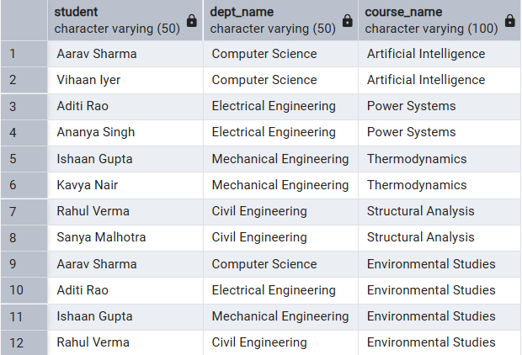

  - Display all possible student-course combinations (CROSS JOIN).
SELECT S.Name AS Student, C.Course_Name AS Potential_Course
FROM Students S CROSS JOIN Courses C;
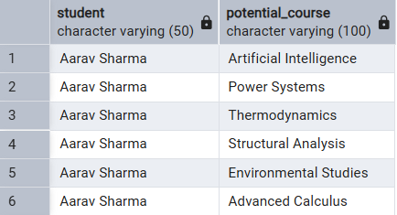
….
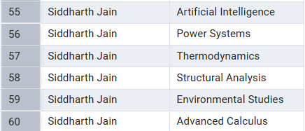

- Input/Output Details:
  - The input for the experiment is the SQL queries mentioned in Experiment Steps (5).
  - The output for each query is attached after the query itself.

- Learning Outcome
- Understanding of the JOINS in SQL.
- Implementing referential integrity in SQL using foreign keys.
- Understanding of data relationships.

