Experiment 9

Student Name: Prateek Verma  Branch: MCA (CC & DEVOPS)  Semester: IInd  Subject Name: Technical Training | UID: 25MCC20062  Section/Group: 25MCC-101/A  Date of Performance: 07/04/2026  Subject Code: 25CAP-652

Title: Triggers in SQL.
- Aim:
  - To implement database triggers in PostgreSQL to automatically calculate values and enforce constraints during data insertion operations.

- Software Requirements:
  - PostgreSQL (Database Server)
  - pgAdmin
  - OS: Windows

- Objective:
  - Trigger Implementation: To understand how to create and use triggers in PostgreSQL.
  - Automation: To automate calculation of total payable amount using triggers.
  - Data Integrity: To enforce constraints using trigger conditions.
  - Real-time Processing: To execute logic automatically before inserting data.

- Procedure of the Practical:
  - Start the system.
  - Open pgAdmin.
  - Create and select the database in which you want to perform the experiment.
  - Establish connection to the database using Alt+Shift+Q.
  - Run the following queries given in Experiment Steps (5).

- Experiment Steps:
  - Creating trigger function
CREATE OR REPLACE FUNCTION CACULATE_PAYABLE_AMOUNT() RETURNS TRIGGER
AS
$$
BEGIN
NEW.total_payable_amount:=NEW.perhour_salary*New.working_hours;

IF NEW.total_payable_amount>25000 THEN
RAISE EXCEPTION 'INVALID ENTRY BEACUSE PAYABLE AMOUNT CAN NOT BE GREATER THAN 25000';
END IF;

RETURN NEW;
END;
$$ LANGUAGE PLPGSQL;

  - Creating trigger
CREATE OR REPLACE TRIGGER AUTOMATED_PAYABLE_AMOUNT_CALCULATION
BEFORE INSERT
ON employee
FOR EACH ROW
EXECUTE FUNCTION CACULATE_PAYABLE_AMOUNT()

  - Inserting valid data
INSERT INTO EMPLOYEE(EMP_ID, EMP_NAME,working_hours,perhour_salary) VALUES (1, 'AKASH',10,1000)

  - Inserting invalid data
insert into employee(emp_id, emp_name, working_hours, perhour_salary) values (2,'Ankush',8,100000)
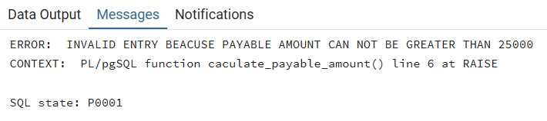

- Input/Output Details:
  - The input for the experiment is the SQL queries mentioned in Experiment Steps (5).
  - The output for each query is attached after the query itself.

- Learning Outcome
  - Create and use triggers in PostgreSQL.
  - Use triggers for automation in SQL.
  - Enforce constraints using trigger conditions.
  - Real-time execution of database logic.

