Experiment 6

Student Name: Prateek Verma  Branch: MCA (CC & DEVOPS)  Semester: IInd  Subject Name: Technical Training | UID: 25MCC20062  Section/Group: 25MCC-101/A  Date of Performance: 24/02/2026  Subject Code: 25CAP-652

Title: Views in SQL Databases
- Aim:
  - Learn how to create, query, and manage views in SQL to simplify database queries and provide a layer of abstraction for end-users.

- Software Requirements:
  - PostgreSQL (Database Server)
  - pgAdmin
  - OS: Windows

- Objective:
  - Data Abstraction: To understand how to hide complex table joins and calculations behind a simple virtual table interface.
  - Enhanced Security: To learn how to restrict user access to sensitive columns by providing views instead of direct table access.
  - Query Simplification: To master the creation of views that pre-join multiple tables, making reporting easier for non-technical users.
  - View Management: To understand the syntax for creating, altering, and dropping views, as well as the naming conventions required for efficient data access.
- Theory: A View is essentially a virtual table based on the result-set of an SQL statement. It does not contain data of its own but dynamically pulls data from the underlying "base tables".
  - Simple Views: Created from a single table without any aggregate functions or grouping. These are often updatable.
  - Complex Views: Created from multiple tables using JOINs, or including GROUP BY and aggregate functions. These provide a consolidated summary of the database.
  - Security Layer: In enterprise environments, views are used to grant permissions on specific subsets of data. For example, a "SalaryView" might exclude the "Employee_SSN" or "Home_Address" columns for privacy.

  - Benefits: They simplify the user experience, ensure data consistency across reports, and reduce the risk of accidental data modification by providing read-only abstractions.
- Procedure of the Practical:
  - Start the system.
  - Open pgAdmin.
  - Create and select the database in which you want to perform the experiment.
  - Establish connection to the database using Alt+Shift+Q.
  - Run the following queries given in Experiment Steps (6).

- Experiment Steps:
Base Table:
Employees
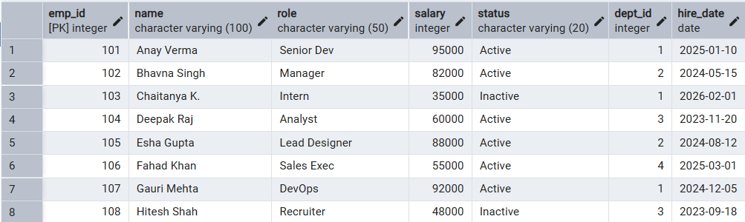
Department
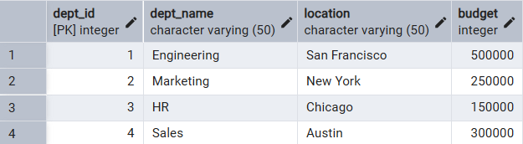

  - Creating a simple view to list active employees without exposing entire table.
CREATE VIEW Active_Employees_List AS
SELECT emp_id, name, role, dept_id FROM Employees
WHERE status = 'Active';
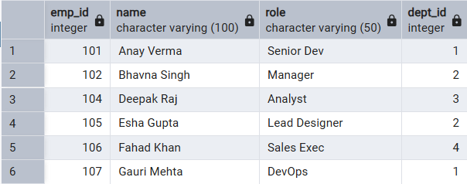

  - Creating a view for joining multiple tables to simplify the retrieval of data distributed across employees and departments table.
CREATE VIEW Employee_Department_Details AS
SELECT e.emp_id, e.name AS employee_name, e.role, d.dept_name, d.location,
e.salary FROM Employees e
JOIN Departments d ON e.dept_id = d.dept_id;
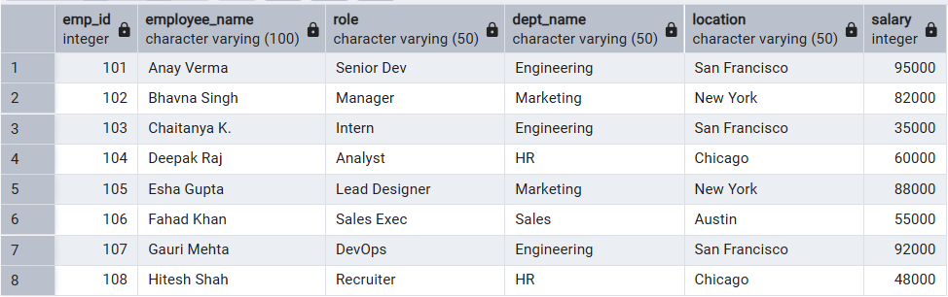

  - Creating an advanced view to provide department wise statistics.
CREATE VIEW Department_Summary AS
SELECT d.dept_name, d.location, COUNT(e.emp_id) AS total_employees,
SUM(e.salary) AS total_salary_payout FROM Departments d
LEFT JOIN Employees e ON d.dept_id = e.dept_id
GROUP BY d.dept_id, d.dept_name, d.location, d.budget;
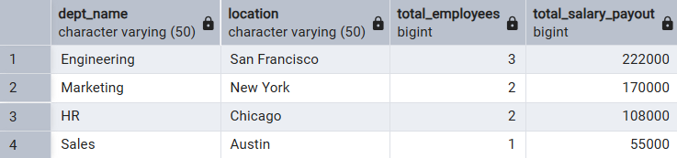

- Input/Output Details:
  - The input for the experiment is the SQL queries mentioned in Experiment Steps (6).
  - The output for each query is attached after the query itself.

- Learning Outcome
- Abstraction Proficiency: create and query views to simplify efficient data access and abstraction.
- Security Implementation: how to use views for data masking and providing restricted access to sensitive information.
- Syntactic Accuracy: gaining knowledge of correct syntax for creating and querying views, ensuring logical clarity in naming conventions.
- Real-world Application: design views for practical domains like Library Management Systems or Payroll Systems to demonstrate functionality.

