Academic RAG Study Assistant
Project Report
  - Document grounded question answering for academic study
B Tech Computer Science and Engineering Mini Project

2 Abstract
Students often search lecture notes and subject PDFs manually. This takes time, and answers from general search may not be supported by the material assigned for a course. Academic RAG addresses this problem by letting a student upload a searchable PDF and ask questions in natural language. The system retrieves passages from the uploaded material, asks a language model to answer from that evidence, and displays the source file and page references so the student can verify the result.
The application extracts page text with pypdf, divides it into overlapping chunks, requests embeddings from Google's Gemini API, and stores each chunk with its source and page metadata in Chroma. For a question, the application embeds the query, retrieves up to three relevant passages, and sends those passages to Gemini for grounded answer generation. Streamlit provides PDF upload, chat, library statistics, session history, and a light or dark appearance. The current code also validates PDFs and reports common configuration, API, and storage errors.
A development run with the supplied three page test PDF reported 10 chunks and 10 stored records. The end to end script produced an answer with source page references. This report describes the current local prototype; deployment, per user data isolation, durable cloud storage, and measured load performance remain future work.

Project Overview
Project element | Current implementation
Input | Searchable academic PDFs uploaded through the Streamlit interface
Core process | Extract, split, embed, store, retrieve, and generate an evidence based answer
Output | A concise answer with the source PDF name and page references
Status | Working local prototype with manual development checks

3 Technology Stack
The project uses Python to connect the interface, PDF processing, vector search, and Gemini API. Each main responsibility lives in its own module, which makes the data path easier to follow and individual parts easier to maintain.
Layer | Technology | Role in this project
User interface | Streamlit | PDF uploader, chat, indexed library view, session history, and light or dark mode.
PDF extraction | pypdf | Checks and reads PDF files while retaining page numbers; scanned image PDFs need OCR, which is not implemented.
Chunking | Python module | Splits page text into 800 character chunks with 150 characters of overlap.
Embeddings | Google Gemini API  gemini-embedding-2 | Converts each chunk and question into a numeric vector for semantic matching.
Vector store | ChromaDB | Persists vectors, text, and source/page metadata locally in the academic_notes collection; returns up to three matches.
Answer generation | Google Gemini API  gemini-3.5-flash-lite | Uses retrieved passages as context and is prompted to answer from that evidence and cite sources.
Configuration and errors | python-dotenv  Streamlit secrets | Loads the API key locally or from Streamlit Cloud settings and maps expected failures to readable messages.

Technology Choices
Streamlit keeps the interface in Python. Gemini provides managed embedding and answer generation, so the project does not need to download a large language model. Chroma runs in persistent local mode for the current build. The API key stays outside the source code: local work uses .env, while the Gemini client can also read st.secrets when configured for Streamlit Cloud.
The local database and uploaded files are not durable cloud storage. A deployed multi user version will need a persistent hosted store and a way to separate each user's documents.

4 System Flow and Architecture
The system has an ingestion path for PDFs and a question answering path for student queries. Both paths meet at the vector store: ingestion writes searchable passages, while retrieval reads the best matching passages for a question.
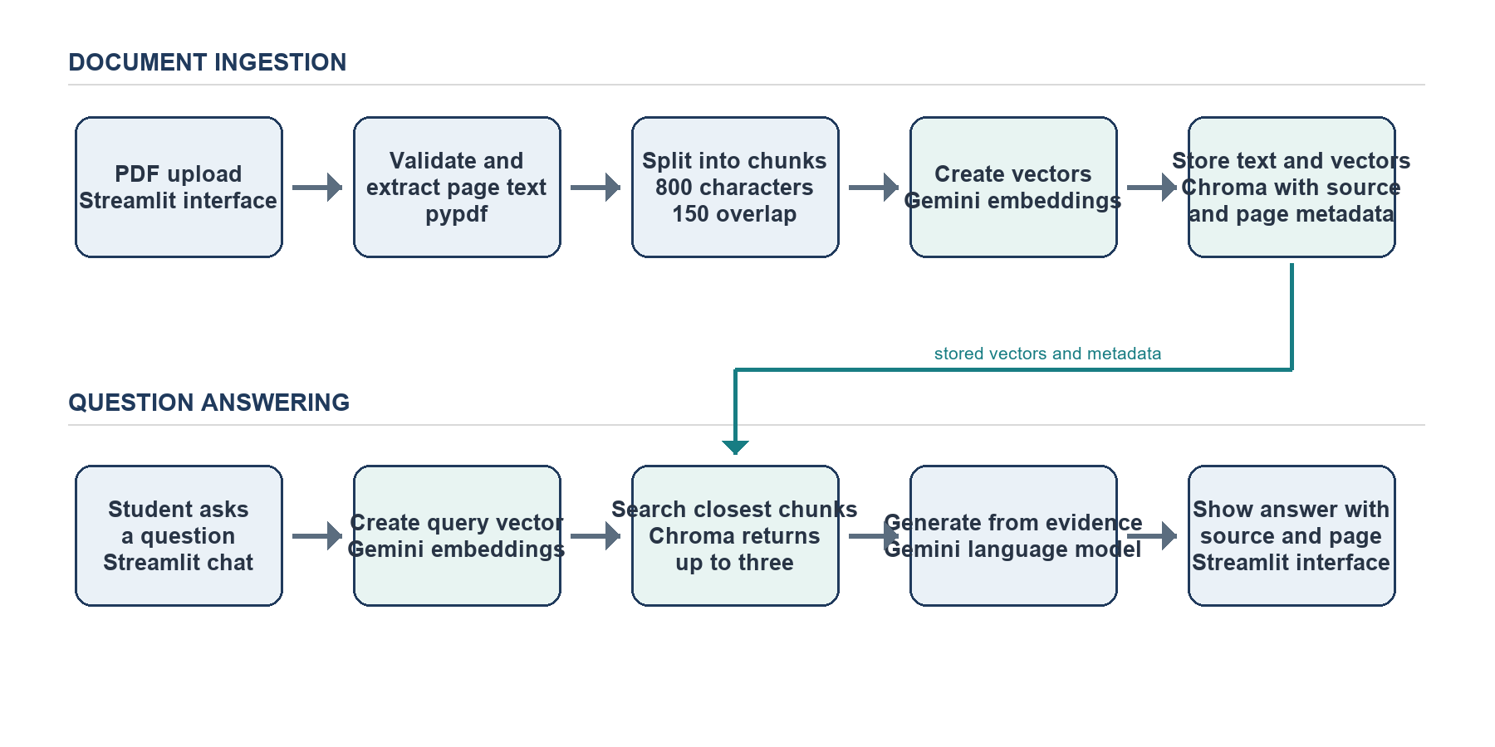
Figure 1 Academic RAG document ingestion and question answering paths
1 Upload and extract The user uploads a PDF. The application checks the file and extracts text one page at a time while preserving the page number.
2 Split and index The splitter creates overlapping chunks. Gemini embeds each chunk, and Chroma stores the vector, text, filename, and page.
3 Retrieve evidence The application embeds the question and asks Chroma for up to three semantically similar passages.
4 Generate and cite Gemini receives the question and retrieved passages. The answer is shown with source and page details; chat messages remain in the active Streamlit session.

5 Directory Structure
The source is organized around the application entry point and focused modules under src. The tree below reflects the current project and its local data folders.
Academic-RAG/
├── app.py Streamlit user interface
├── requirements.txt Python dependencies
├── .env.example API key placeholder
├── .gitignore excludes local secrets and data
├── .streamlit/
│ └── config.toml default theme configuration
├── src/
│ ├── pdf_loader.py PDF checks and page extraction
│ ├── text_splitter.py overlapping text chunks
│ ├── embeddings.py Gemini vector requests
│ ├── vector_store.py Chroma storage and search
│ ├── rag_chain.py evidence grounded answer generation
│ ├── gemini_client.py API client and secret lookup
│ └── errors.py expected error messages
├── test_search.py manual retrieval script
├── test_rag.py manual end to end script
└── data/
├── uploads/ local uploaded PDFs
├── chroma_db/ local vector database
└── Academic_RAG_Test_Document_3_Pages.pdf

Module Responsibilities
app.py coordinates the user interaction. pdf_loader.py and text_splitter.py prepare content; embeddings.py and gemini_client.py call the remote model service; vector_store.py manages Chroma retrieval; and rag_chain.py builds the grounded response. errors.py defines the safe exceptions surfaced by the interface. The two test_*.py files are manual smoke scripts rather than a formal automated test suite.
The actual .env file contains a private API key and is excluded by .gitignore. The uploads and Chroma folders are also local working data. They are omitted from Git so the repository does not expose credentials or accidentally publish student documents.

6 Testing and Performance
The current evidence comes from manual command line checks on the supplied three page PDF. These checks demonstrate the main pipeline, but they are not a substitute for automated regression tests or a load benchmark.
Check | Observed development result
PDF ingestion and chunking | The sample PDF produced 10 text chunks; the save command reported 10 stored Chroma records.
Embedding output | A console check returned one vector containing 3,072 numeric values for a sample text.
Semantic retrieval | The retrieval script searches for a question and prints matching passages with their source and page.
End to end RAG | The answer script returned a response to a RAG question and displayed citations to pages 2 and 3 of the sample PDF.

Performance Status
No ingestion time, query latency, throughput, or concurrent user benchmark has been recorded, so this report makes no speed or capacity claim. The current implementation requests an embedding for each chunk sequentially. A question uses one query embedding, a local Chroma search of up to three results, and one Gemini generation request. Actual response time therefore depends on document size, network conditions, and Gemini service availability.

7 Conclusion and Future Scope
Academic RAG demonstrates a complete retrieval augmented generation workflow for academic PDFs: it extracts and chunks text, indexes embeddings, retrieves relevant evidence, and presents a sourced answer. The manual checks confirm that the local prototype can process a small test PDF and answer a document based question. Its present scope is a single shared local library, and deployment has intentionally been postponed.
- User accounts and isolation. Give each student a separate document collection and chat history before opening the app to multiple users.
- Durable storage. Move PDFs and vectors to hosted object and vector storage so data survives application restarts.
- Broader document support. Add OCR for scanned PDFs and test extraction against tables, diagrams, and difficult layouts.
- Measured quality and speed. Add repeatable automated tests, retrieval and citation quality checks, API retry controls, and latency or concurrency benchmarks.

