E-COMMERCE WEB APPLICATION

PROJECT SPECIFICATION

Prepared for

dummy text

dummy text

dummy text

Plans & Specifications Prepared by

dummy text

dummy text

dummy text

CONTENTS

Introduction…………………………………………………………………………………………03

Project Overview………………………………………………………………………………….03

Site User Roles……………………………………………………………………………………..04

Functional Requirements……………………………………………………………………..05

Design Specifications.…………………………………………………………………………..06

Site Map……………………………………………………………………………………………….07

Site Maintenance …………………………………………………………………………………08

Project Milestone ………………………………………………………………………………..09

Risk Management ………………………………………………………………………………..10

Conclusion.…………………………………………………………………………………………..11

INTRODUCTION

A specification is a set of requirements that define website behavior and user interaction. In other words, requirements are capabilities and functionalities that are required in the end-product.

A website requirements specification document describes a website in detail. It also serves as an agreement between a store owner and the development agency, ensuring both sides are on the same page.

There are two main sets of requirements: functional and non-functional. Functional refers to the technical functionality of the website — how the website should function. Non-functional requirements are how the website is supposed to perform a certain function.

PROJECT OVERVIEW

The project aims to provide a complete web-based e-commerce solution and an administration section. This project is based on Business to Consumer model where a business sells a good or service to an individual consumer (e.g. You buy a pair of shoes from an online retailer).

The objective of this project is to develop a general purpose e-commerce store where any kind of product can be bought from the comfort of home through the internet. Customers can browse the catalog and select products of interest. The selected items may be collected in a shopping cart. Finally, the customer can check out using available payment options. Administration panel helps the shop manager/admin to add new products, delete products, edit products, get the list of new orders and edit or add new categories.

SITE USER ROLES

User roles determine the access level or permissions of a person authorized to use a web application. Each user is capable of everything that a less powerful role is capable of. A user can’t do everything that an admin can do. Below is the list of roles that the web application project will have:

* Visitor
* User
* Admin

Visitor can view, search, compare available products.

User can view and purchase products.

An admin has some extra privilege including all privilege of visitor and user.

* Admin can add products, edit product information and add/remove product.
* Admin can add/remove or edit available categories.
* Admin can see the list of orders and ship order to user.

FUNCTIONAL REQUIREMENTS

Before creating any website its common practice to visualize the layout, the design and all the features you intend to incorporate. In addition, you think about how users will interact with each page and how the site should perform. Establishing a list of requirements for a program is referred to as developing the functional requirements. Below is a list of all the functional requirements for the Ecommerce solution.

* The web application must have a front-end web interface and a back-end server for managing database.
* The web application must have the following 3 types of user: visitor, user and admin.
* Users and Admins will have their email and password stored in the database to login in order to use the system in a secure way.
* A visitor can explore the categories, search and get the desired product details. In order to make any purchase a visitor needs to login or signup providing necessary credentials.
* Products in the site could be filtered on the basis of different search criteria like category, newest products, oldest products, best sells, price etc.
* Each product should have short description and content description. On clicking a product the site should redirect to the description page of that product which also includes some related products.
* There will be a Cart system where users could collect multiple products and then proceed to checkout.
* Search should be implemented where any user could search for any product by their name or related keyword.
* Admins can add a new product, delete a product and edit a product. They can see all the orders made and take steps to deliver those products.
* Products in the site will be categorized under some predefined categories. Admins can create a new category and edit or delete an existing category.
* A payment system should be integrated for making any purchase.

DESIGN SPECIFICATIONS

The UI of the web application will be simple but elegant. The use of color will be not too flashy, there will be only 3 base color for the whole application.

The index page will have a home page, shop, login and register in the navigation panel. After a user has logged in there should be some additional navigation items like cart and history. The home page will show a variety of products and some filter option along with a search bar.

Products should be displayed in the home page and clicking any product will redirect to another page containing the details of that product and some related products will appear in the bottom. There should be buttons to add any product into cart or a user can proceed to checkout directly from product details page.

A logged in user can see the history of previous purchases inside the history page.

Cart page should show all the products the user has added into the cart. A user can set the quantity of a product and proceed to checkout from the cart page. The checkout page will show the selected products and total amount along with payment option.

Admins can login by providing their credentials. They have the same user interface along with some extra options like selecting one or multiple product and delete them. Navigation bar should contain additional pages like create product and categories. Create product page will have some input fields for uploading image and giving product details required for creating a product. Edit product should be same as Create product but with previously filled input fields where admin can edit any details or product image. History page will show all the purchases made and help admin ship the products. The categories page will help admin create, edit or delete any category.

The entire front-end should be implemented using HTML, CSS and Java Script. Any front-end library like React, Angular, Vue etc. should be used. The website should be responsive for any size of screen including mobile devices.

SITE MAP

Sitemaps are organized lists or flow chart diagrams that shows connections between web pages, web page threes, and website content, A visual sitemap is a very effective method for both planning and communicating ideas about a website’s structure. As a 2D representation of a website, sitemaps allow designers and developers to efficiently plan website projects by offering a bird’s-eye view of the entire project at one time. Pages and content are typically organized in a hierarchical tree with root and parent pages at the top, deeper and more specific child pages toward the bottom, and subject matter distributed horizontally. Here is an initial sitemap of the e-commerce solution.

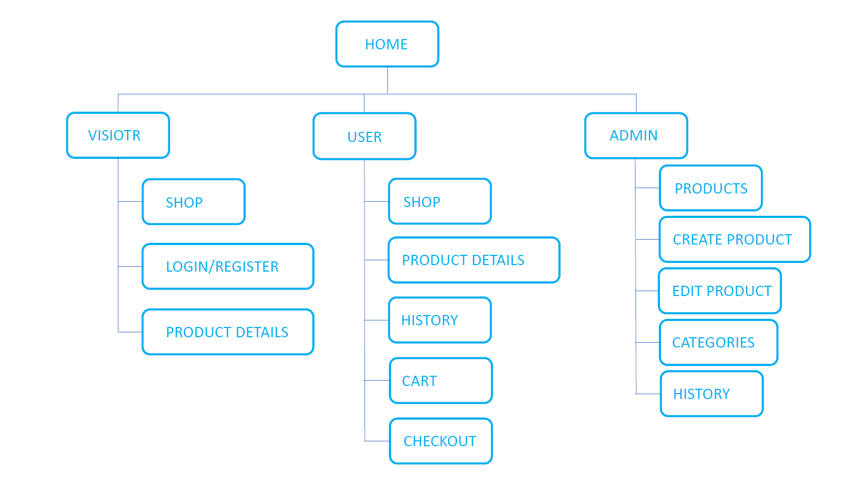

SITE MAINTENANCE

A website is never really complete. It must constantly be updated with fresh content in order to engage and grow the audience. By using a website maintenance plan, we can ensure that our website is up to date regarding design, content, regular backups and protection against malicious login attempts, span, and malware.

Any effective website maintenance plan needs to consider the specific needs and requirements of the business. Small static websites usually need less effort to maintain than large sites. We can provide with comprehensive website audit and need assessment and go over all the options with to help make the best decision for the business. This site maintenance is solely done by the site administrator who has the accessibility of both the front and the back end of the web application.

The following tasks must be done to ensure proper maintenance:

* Collaborate with development teams to discuss, analyze, or resolve suability issues. Track, compile, and analyze web site usage data.
* Document application and web site changes or change procedures. Develop or document style guidelines for web site content.
* Test new software packages for use in web applications and develop or implement procedures for ongoing web site revision.
* Set up or maintain monitoring tools on web servers or web sites.
* Test backup or recovery plans regularly and resolve any problems.
* Recommend web site improvements, and develop budgets to support recommendations.
* Implement updates, upgrades, and patches in a timely manner to limit loss of service.
* Identify, standardize, and communicate levels of access and security.
* Inform web site users of problems, problem resolutions or application changes and updates.
* Provide training or technical assistance in web site implementation or use.
* Preform user testing or usage analyses to determine websites’ effectiveness or usability.
* Correct testing-identified problems, or recommended actions for their resolution and develop testing routines and procedures.
* Identify or document backup or recovery plans.

PROJECT MILESTONE

Milestones are tools used in project management to mark specific points along a project timeline. A milestone chart focuses on planned significant events scheduled to occur in specific times during the project implementation. Here is a milestone for the ‘e-commerce solution’ with an estimated start and end date and the total duration of the project.

|  |  |  |  |  |
| --- | --- | --- | --- | --- |
| Task ID | Phase Name | Estimated  Start Date | Estimated  End Date | Estimated  Duration |
| 1 | Requirement Analysis | 10/11/2020 | 16/11/2020 | 6 days |
| 2 | Planning | 16/11/2020 | 26/11/2020 | 10 days |
| 3 | Web UI Design | 26/11/2020 | 01/12/2020 | 5 days |
| 4 | Home Page (start implementation) | 01/12/2020 | 02/12/2020 | 1 day |
| 5 | Login/Register Page | 02/12/2020 | 03/12/2020 | 1 day |
| 6 | Back-end (start implementation) | 03/12/2020 | 05/12/2020 | 2 days |
| 7 | Database Creation and Connection | 05/12/2020 | 08/12/2020 | 3 days |
| 8 | Shop page, Filters and History | 08/12/2020 | 10/12/2020 | 2 days |
| 9 | Product Card and Description Page | 10/12/2020 | 12/12/2020 | 2 days |
| 10 | Implementing Cart System | 12/12/2020 | 15/12/2020 | 3 days |
| 11 | Admin Products Page | 15/12/2020 | 17/12/2020 | 2 days |
| 12 | Admin Create and Edit Product | 17/20/2020 | 20/12/2020 | 3 days |
| 13 | Admin Category and History | 20/12/2020 | 22/12/2020 | 2 days |
| 14 | Payment System Integration | 22/12/2020 | 24/12/2020 | 2 days |
| 15 | Merge Backend with Frontend | 24/12/2020 | 28/12/2020 | 4 days |
| 16 | Fixing Issues and Finalizing | 28/12/2020 | 31/12/2020 | 3 days |
| 17 | Domain Registration and Web hosting | 31/12/2020 | 03/01/2021 | 3 days |
| 18 | Mobile Application Development | 03/01/2021 | 15/01/2021 | 12 days |
| 19 | Testing | 15/01/2021 | 20/01/2021 | 5 days |
| 20 | Delivery | 20/01/2021 | 21/01/2021 | 1 day |
| 21 | Installation & Maintenance | 21/01/2021 | 23/01/2021 | 2 days |
| Total Days | | 10/11/2020 | 23/01/2021 | 74 days |

RISK MANAGEMENT

Risk is defined as the possibility of any negative occurrence that may happen due to external or internal factors, and that may be mitigated through preventive actions. All projects are subject to risks. In fact, there is an infinite number of things that might prevent us from achieving our goals when working on a project. Risk management minimizes those threats that could cause project failure, and allows you to stay in control of your project’s schedule, budget and quality requirements. Here are some of the project risk factors:

* **Too many decision makers:** This can cause bottlenecks in the decision and approval process. Ensure that project managers/representatives are sufficiently empowered and supported to make decisions.
* **Staff turnover**: Ensure that project communications and status reporting are clear, up-to-date and accessible to new project members. And there are enough members in the team to complete the project successfully by time.
* **Scope creep:** Both client and supplier must be on the lookout for the dreaded scope creep. Scope creep is where new project features are being requested that didn’t form part of the original brief, and can’t have reasonably been expected to be included. Additional feature requests must be evaluated in terms of likely project impact, and decisions then need to be made in terms of whether to include or not include the new feature requests in the current phase.
* **Underestimation of the time:** On average, we observe that clients underestimate the amount of time they themselves will need to invest in the project for it to keep on moving forwards promptly. After all, many clients are already doing a full-time job, and the website project is in addition to that. All project members need to be granted sufficient time alongside their normal duties.
* **3rd Party systems:** Integrating (synchronizing, importing/exporting) a new system with one or more 3rd party systems can seem straightforward on the surface, but sometimes prove very challenging. If such integration is mission-critical for overall project success, then the requirements must be fully identified and tested/prototyped, and sooner rather than later.
* **Data migration:** Similar to the above, time and effort is typically underestimated to source the content, and to populate the new site with that content. It’s important to fully identify and specify all data i.e. website content, that is to be supplied for the new site, whether it exists yet, who has, what format it’s in, etc.
* **Cross-platform compatibility:** It’s harder than you think to get websites to look function on every version of every browser (old and new) on every screen size and orientation (portrait or landscape). The combinations are almost infinite. Optimizing for a specific combination can cause de-optimization for another. Try to ensure that your websites are standards-compliant, but still accept that perfect consistency is virtually impossible.

CONCLUSION

This specification is prepared for the project ‘e-commerce solution’. In the paper we gave a short description of the project on the project overview section. We showed different site user roles for the application. We have discussed in details about the functional requirements of the system. We gave a rough idea of the design specifications of the project. We then gave the site map of the web application. We discussed how the site will be maintained by the site administrator. We prepared a rough calculation of the timeline of the project. And finally, we discussed about the risk associated with the system implementation. Hope this will help to understand of the project outcomes without any major issues.