

**American International University- Bangladesh**

**CSC 3215: Web Technologies**

**CO1 and CO3 Evaluation**

**Project Report**

**Spring 2019-2020**

**Project Title: Autism Care**

**Section: H**

|  |  |
| --- | --- |
| Student Name | Student Id |
| H.N. Ashiqur Ruhullah | **17-33688-1** |
| Plabon Kumar Saha | **17-33636-1** |
| MD Tanvir Anjum | **17-33647-1** |
|  |  |

**Autism Care**

**Introduction:**

Autism Care is a platform for connecting autistic kids and their parents with authentic doctor/therapists and provide a secured and hassle-free medication service. With this website the parents, who has autistic kids they will be able to find their doctor/therapists and also make an online reservation. A portal will be given to the doctor and to the patient’s guardians so that they can keep track of their updates.

**Background Study:**

Autism is very alarming but less known disease in Bangladesh. Bangabandhu Sheikh Mujib Medical University (BSMMU) in Bangladesh confirmed that almost 2 in 1000 children have been suffering from ASD in Bangladesh. [1] The ratio is higher in urban areas than the rural. According to a survey by WHO in 2014, against this magnitude of disease burden only 200 psychiatrists and limited number of other health professionals are serving the nation. [2] So there is a huge crisis for available doctors in this site. And we have found few websites also (one of them named Autism BD) for this kind of services but they are just putting some blogs and creating a community not doing any reactive work for solving the issue. And from the analysis we find out the problems that:

1. Parents are unable to identify ASD in early stage because of the lack of information
2. Lack of communicational problem between doctor/therapists with parents

And the core issue we have identified is:

“No proper platform exists to communicate with the certified specialist at the right time.”

**Requirement Analysis:**

1. **User Category:**

After doing analysis on problems and also in the user segments we have distinguished our users into four categories:

1. Parents of autistic children
2. Specialist Doctors
3. Therapists
4. Donors
5. Bloggers
6. Admin
7. **Feature List:**

**User: Parents of autistic Children**

1. **Registration:** Patient’s parents will register their children’s problem with proper documentation.
2. **update profile:** They will be able to update his profile
3. **select doctor for consulting**: Parents will be able to select doctor/therapist and take booking online from the website. They will be able to see a basic history of the doctor/ therapists. A filter type will be added so that users can search with their specific portion of problems.
4. **Separated portal with doctor/therapists:** Separated portal for doctor/therapist with the parents of the patient’s will be ensured so that they can keep track about their medicine history and also the prescriptions.
5. **See past medical history of himself:** They will be able to see the past medical history with all the doctors and also the total fee’s that they are providing.
6. **Cancel booking:** Our website will have cancel booking option for the user but the user only can cancel the reservation 1 day before.
7. **Feedback about doctor/therapist/system:** Feedback form will be ensured after each medication/ meeting with doctors/therapists.

**User: Specialist Doctors**

1. **Registration system for the doctor:** Doctors will register in the system but not will be included directly. Admin will confirm from his end. After that doctor will be confirmed.
2. **Update his schedule and information:** Doctors will set their schedule at the beginning. There will be an option for updating them. Whenever a patient will book a schedule, the doctor can either accept or reject or reschedule them.
3. **Separated portal for doctor and patient (for each):** In this portal doctor and patient can interchange files and doctor can upload his prescriptions and suggestions.
4. **write blogs:** Doctor/ Therapist / Bloggers can write blogs which will be filtered by admin initially.

**User: Therapists**

1. **Registration system for the Therapist:** Therapist will register in the system with proper documents and after filtering from the admin the therapist will be added in the system.
2. **Update his schedule and information:** Therapists will set their schedule at the beginning. There will be an option for updating them.
3. **Take booking:** users will select a time and therapist must confirm the booking after then user will be registered in that booked time.
4. **See booked patients history:** After confirming therapist can see the patient history and also a portal will be open for file sharing between both. The whole process will be monitored by admin.
5. **Cancel/confirm the consultation time:** Therapist/ Users both can cancel the booking before a certain time.
6. **Feedback about system:** There will be common comment box for the user/ therapist to comment on both.

**User: Admin**

1. **Verifies the Doctor/therapists:** Verifies from the admin end if the doctor/therapist is verified by verifying their submitted certified and verifying their id card number.
2. **Monitor the feedback of the users:** The feedback from the users will be strictly monitored.
3. **Update about the latest terms and benefits:** Updating terms and conditions regularly
4. **Control the access of the users:** Controlling the users from doing any kind of spam/creating any unwanted issues. Admin will have all the rights to blacklist a user if he/she will not follow the rules and regulations.

**User: Donors:**

1. **Donors can make donations.**
2. **The email address of donors will be saved for tracking further donations.**

**Design:**

The entity relation diagram of the project is given below:

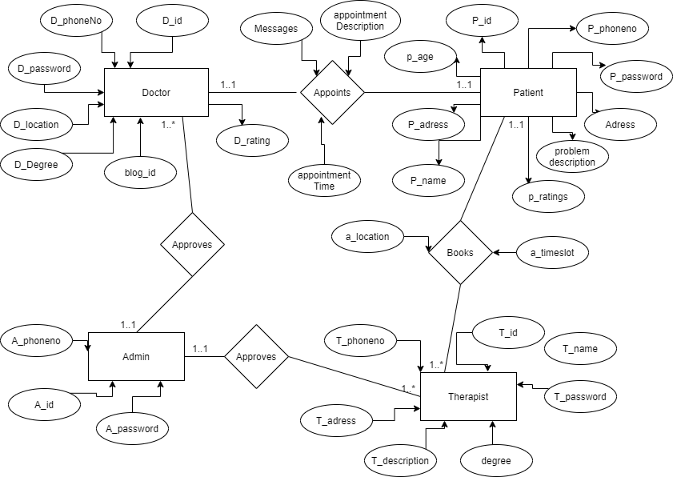

Figure 1: Entity Relationship Diagram

Use case diagram of the project is given below:

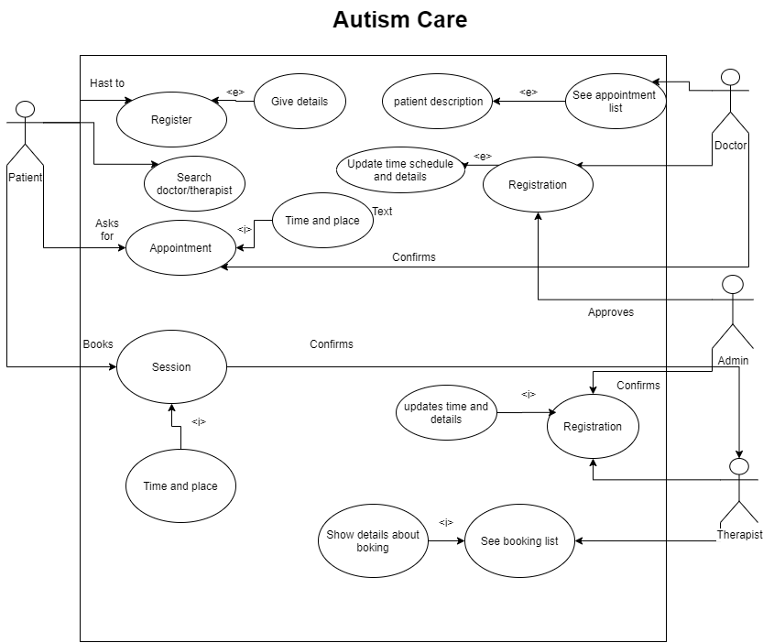

Figure 2: Use Case Diagram

**Tools Used:**

To Develop this project, we are using:

Editor:

* 1. Visual studio Code
  2. Sublime Text
  3. Brackets

Languages:

1. HTML
2. CSS
3. JavaScript
4. Bootstrap
5. PHP
6. Ajax
7. JQuery

System Images against the specification:

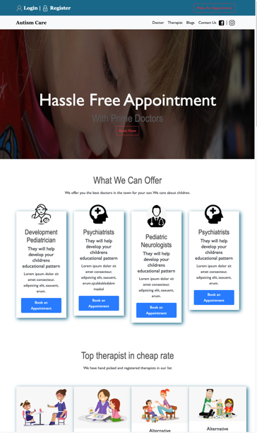

Figure: Homepage

This is totally coded homepage. I have included Github file of this page. This is a basic view of the homepage with hovers and also different sections. This is fully responsive.

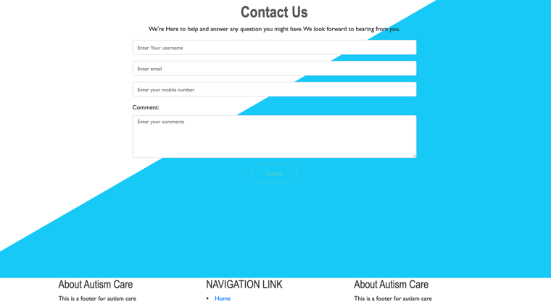

Figure: Contact Us Page

This is a contact us page for everyone to share their problems/questions to the users.

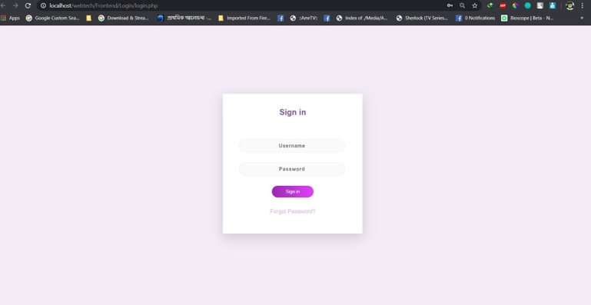

Figure: Login Page

The login page is made with proper server side and client-side validation with full responsiveness.

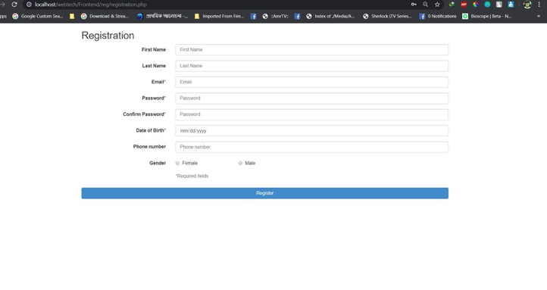

Figure: Registration Page

Full responsive registration page with server side and client-side validation.

**Impact:**

As the problem regarding autism and also the scarcity for doctors is increasing day by day our website can create a bridge between doctors and parents, who are concerned about their children’s future. This will help our country to fight with this big social issue. Children are the future of the country. We are giving autistic children a brighter future so that they can contribute in our growth rather than throwing off from the society.

**Limitations and Possible Future Improvements:**

This version of website is not being made with proper user research, so want to develop our future version of the project by implementing a proper user research and improve UI accordingly. Using ETA and map is not included in this version because of our lack of knowledge on using map API. We want to automate the payment system by using SSLCOMMERZ and include SSL certification for safer uses.

**Reference:**

[1] https://www.dhakatribune.com/health/2018/07/12/child- autism-rates-twice-as-high-in-urban-areas-survey- reveals?fbclid=IwAR2UyayLRexrIQQ- e8y80M5GSb7EkQlrws9UBxgtjkXIb2ZCyo246WmTn6k

[2] http://www.autismbd.com/category/success/

[3] <https://github.com/Tanvir-21/Autism-Care>

|  |  |  |  |  |  |
| --- | --- | --- | --- | --- | --- |
| **CO1 and CO3 Evaluation: Project Report Evaluation** | | | | | |
| **Project Proposal**  **(5)** | **Background**  **Study**  **(5)** | **Requirement Analysis**  **(5)** | **Entity**  **Diagram**  **(5)** | **System Images**  **against the**  **Specification (5)** | **Total (25)** |
|  |  |  |  |  |  |
|  | | | | | |