Robert Place

Fantasy Character Creator

Fall 2018

Intro to Java 110

CCAC North Campus

Generates a fantasy character based on user input. User selects a race with basic stats for strength, agility, knowledge, vitality, charisma, and luck, and then a class that modifies those stats.

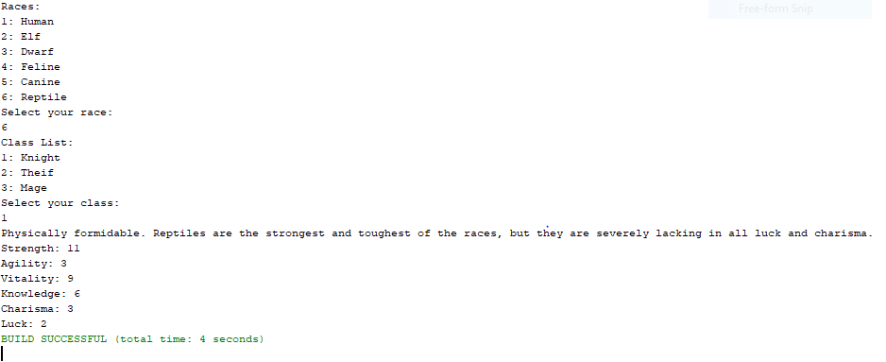

In future, I would have added more races, more classes or allow users to combine races and freely distribute points between stats