GDD

Group 2

Nicole, Hannah, Callum & Szymon.

Contents

The Game. 3

What is the game about and who it’s aimed at? 3

What do the characters look like? 3

How do the characters move? 3

What does the environment look like? 3

What sounds are we using? 4

These bits are difficult. 4

Player Interface. 5

How many players and how will it be played? 5

Controls. 5

The Artwork. 6

Diagrams and Maps. 7

Our Inspiration. 8

# The Game.

## What is the game about and who it’s aimed at?

Our game is about a little girl Ellie who suffers from nightmares and uses her trusty teddy bear ‘Mr. Baku’ to comfort her through these.

The game is a playable nightmare, Ellie can become very scared and will hug ‘Mr. Baku’ who will then create a ball of light scaring away the multiple monsters, so then Ellie can overcome her fears.

There will be multiple levels and 1 collectible per level, this ensures that when Ellie meets the witch, a wand will be created to defeat the final boss. The final boss is ‘Mr. Baku’ himself and the wand is the only way to defeat him.

This game is aimed at those people who enjoy horror and indie games.

## What do the characters look like?

Ellie and ‘Mr. Baku’ will look cute and friendly (until the final boss, only ‘Mr. Baku’ will change.

All monsters and characters will be created as pixel art with text bars showing the characters in more detail.

## How do the characters move?

Ellie will be able to move left, right and she will be able to jump.

Mr.Baku will follow Ellie around each level

The witch and the frog will also be able to move but the player will not control her.

The monsters shall move left and right but are unable to jump.

## What does the environment look like?

Each level will be different as each level is based on different fears.

Level 1 – Cave

Level 2 – Forest

Level 3 – Lake

Level 4 – Witch house

Level 5 – Boss Level

## What sounds are we using?

https://dhsfx.itch.io/unnerving-ambient-sounds?download

Exploring Nightmare 1.wav 22 MB

Jun 20, 2020

2.Exploring Nightmare 2.wav 30 MB

Jun 20, 2020

3.Exploring Nightmare 3.wav 22 MB

Jun 20, 2020

4.Exploring Nightmare 4.wav 33 MB

Jun 20, 2020

5.Exploring Nightmare 5.wav 4 MB

Jun 20, 2020

## These bits are difficult.

Figuring out the movements for the characters/monsters is going to be difficult as we he 2 characters on screen with multiple monsters and getting them to move separately and in a way that’s going to make the game work, not glitch and not be completely random.

Making Mr.Baku and Ellie glow whilst Mr.Baku is being hugged and making the monsters run away bit by bit.

Making the boss battle, as only the wand will be able to defeat Mr.Baku, so making sure the player collects the collectibles and figuring out whether the player can’t pass the level without them or to let the player carry on without knowing the boss can not be beaten.

Putting all the idea’s together to make the game fully functional.

# Player Interface.

## How many players and how will it be played?

This will be a single player game.

We would like this game to be played on the PC using the keyboard and mouse.

## Controls.

We plan to use the standard “W,A,S & D” to control the movement of Ellie.

The space bar to jump and to press next or clear on the text boxes.

E to hug ‘Mr. Baku’ .

# The Artwork.



This is the witch and the frog and this is how they will move in the game.

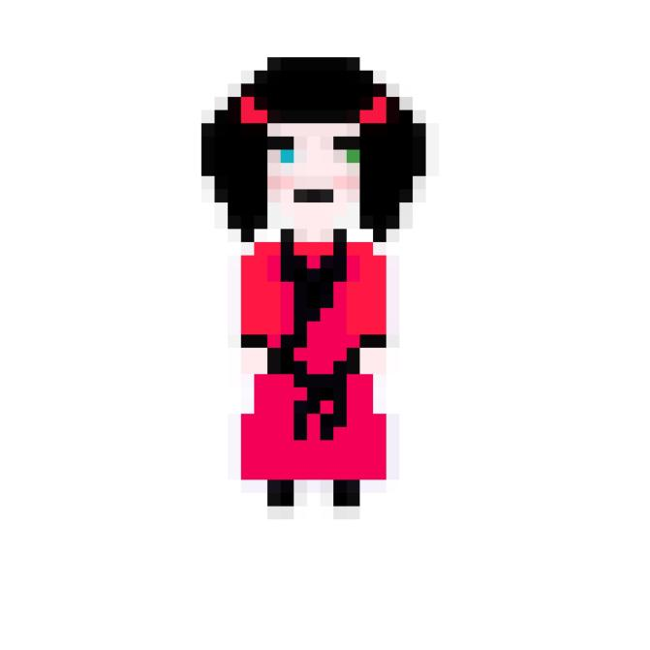

This is Ellie, the girl who is having the nightmare.

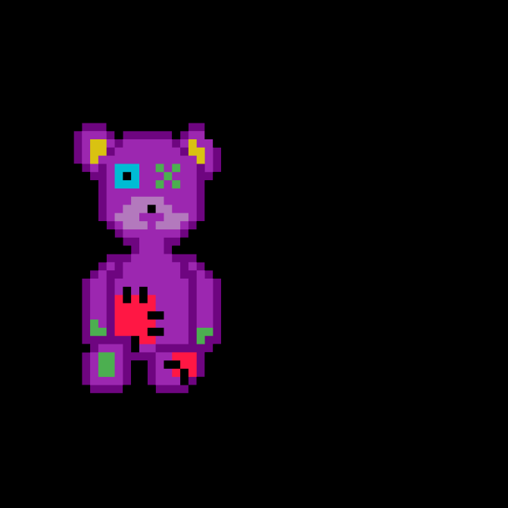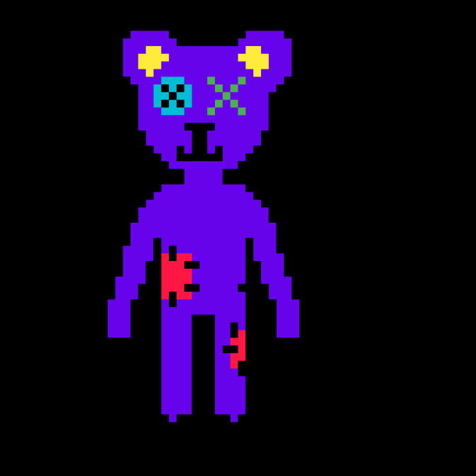

This is Mr.Baku, the teddy bear that will be following Ellie around each level.

# Diagrams and Maps.

This is an idea for the first level of the game.

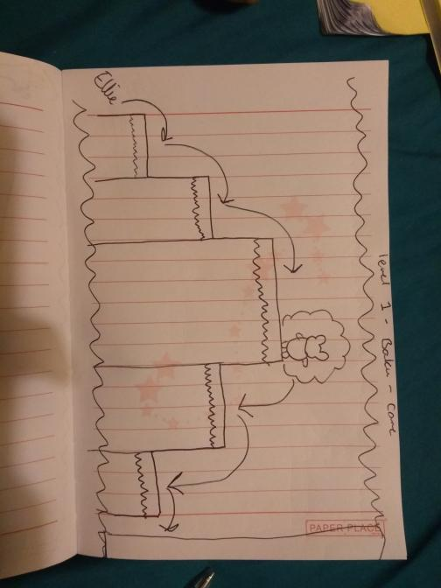

This is the second idea for the first level.

We decided to keep this first level more simple as it’s going to be more of a tutorial level to ensure the player knows how to play the games and gets used to the controls.

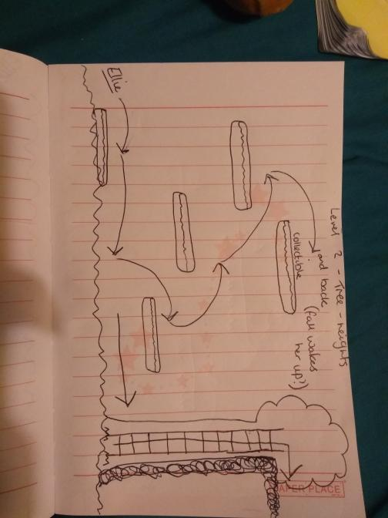

This is an idea for level 2.

# 

# 

This is another idea for level 2.

These include the phobia’s of tree’s and heights.

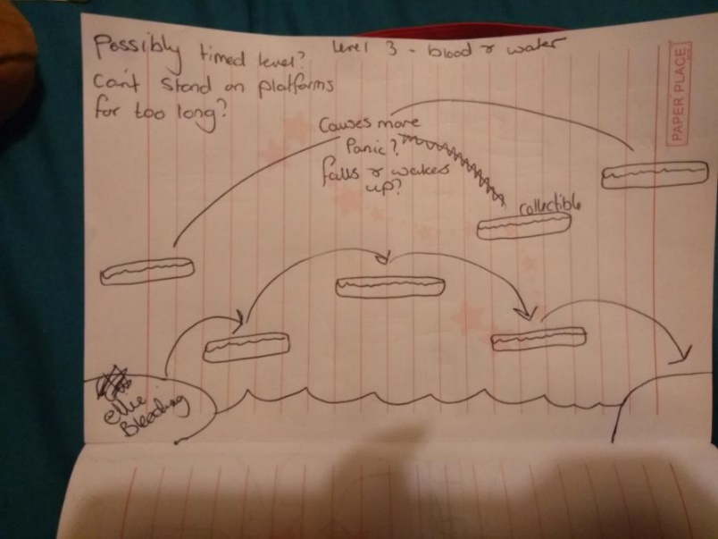

This is an idea for level 3.

This level focuses on Ellie injuring herself (fear of blood) and fear of open water, which she will have to navigate across to find the witch who will give her the wand.

# Our Inspiration.

Our inspiration falls upon the games ‘Stardew Valley’ and ‘Celeste’. From the game play to the artwork, we feel as these games had a big part to play as both games are friendly, partially eerie and full of game play.

Stardew valley was mainly the inspiration for the artwork as we decided to work with 2-D pixel. We will then use text boxes with a more in detail picture of the characters.

Celeste is mainly for the playable levels and the movement used by the character, as this is a 2-D game and we are making a 2-D game. We thought that the movement from Celeste was smooth and easy flowing and we would like our characters to also move that way.