README

My user comments management project is named as “commentservice”. It is implemented by using phpMyAdmin. It contains the following entities and relations:

=====================================================================================

This is the home page of the website: <http://localhost/commentservice/>

You can log in by enter the correct username and passwords.

You can manually choose to log in as a “customer” or a “user”.

The login path for customer is: <http://localhost/commentservice/index.php?c=customer&a=login>;

For user: <http://localhost/commentservice/index.php?c=user&a=login>

For example, here, we use the account “test; 123” to log in as a customer:

After login, we can see all articles that the customer published:

if we click into an article, we will find its comments.

All these data are generated by php faker factory.

There is also an option for the customer to add new article.

You can choose to open comment or not while adding new articles:

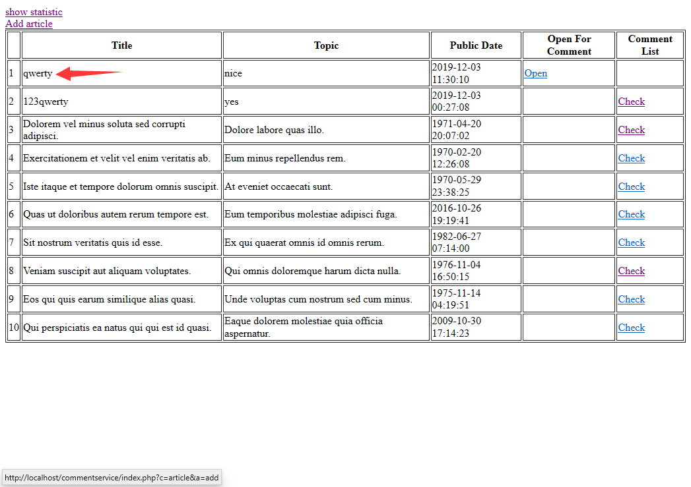

Here, we added a new article named “qwerty” and with comment open. (If you selected “NO” during adding an article, you could still set it “open for comment” after.)

It does not have any comment yet at this point.

As a regular user, you can check comments of articles as well as add new comments:

Here’s what we get:

Then, lets log in as a senior user (user1; 123456).

It will shows the exact same thing as it does for regular users:

But when you check the comment list, you can use a new feature: “check flag comments”.

The comment was not flagged, so nothing showed here.

If a user added a comment that contains certain words in “curseword” table, it will be flagged for senior users to check. Here, we use the regular user to add other comments.

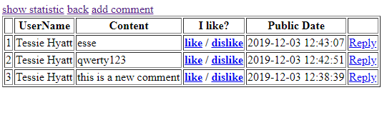

So, if a senior user mark this comment as NOT derogatory, it will no longer be flagged; otherwise, the comment will be removed.

By click the left-top “show statistic” button, we can view the traffic the project manages.

END