# **SCREENSHOT RESULTS**

-- selecting using where

select * from artist where ID = 580;

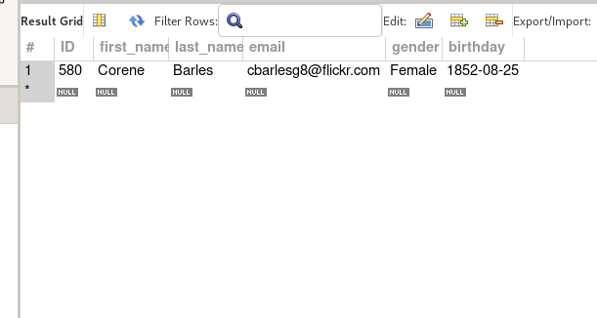

-- selecting using inner join where ID are the same in both tickets and aduence tables

select * from audience

inner join tickets on audience.ID = tickets.ID;

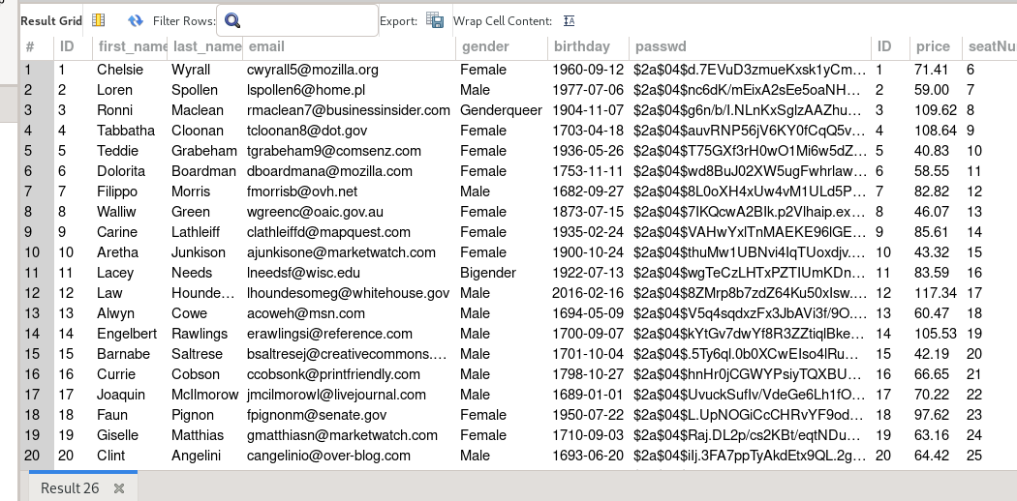

-- selecting using a subquery to get info from buys table where

-- audience id is less than the audience number 20

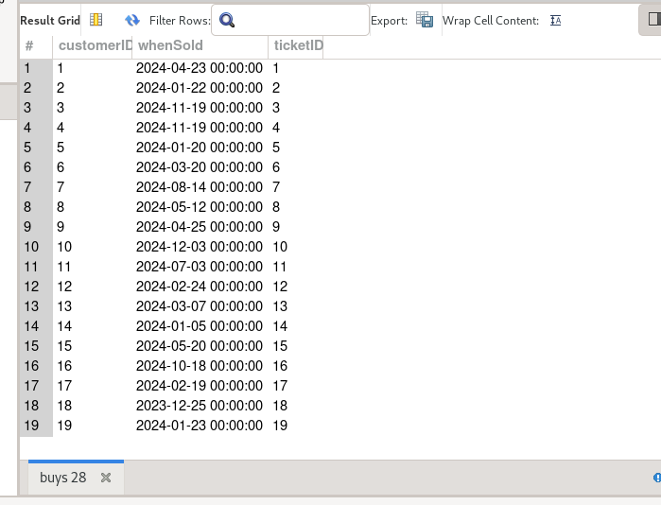

select * from buys

where customerID < (

select ID from audience where ID = 20

);

-- aggregate function and grouping

-- selecting all state and grouping by their counting or total

select state,count(*) from events

group by state

order by count(*) desc;

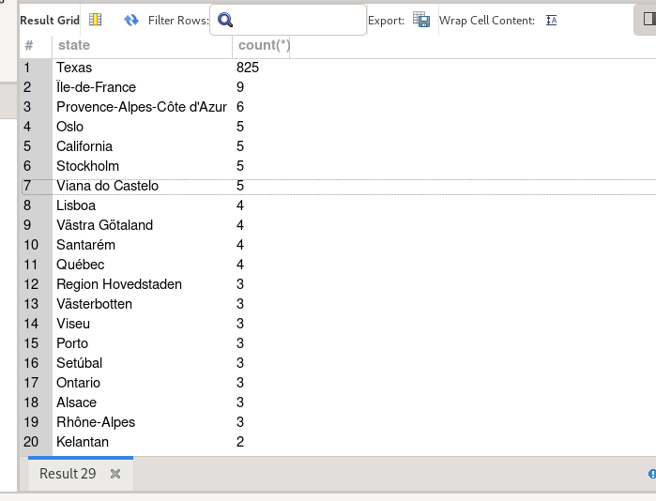

-- adding a record to artist table

insert into artist (first_name, last_name, email, gender, birthday)

values ('Placide', 'Ndai', 'placidendai@gmail,com', 'male', '1834-10-10');

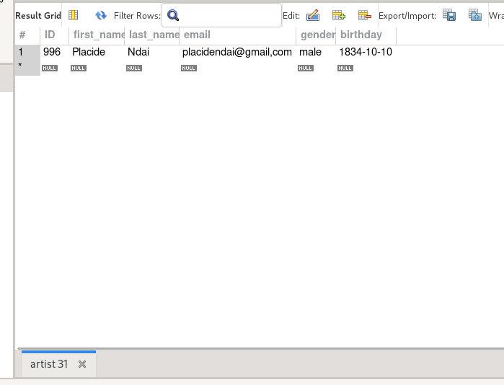

-- deleting a record from managers table

delete from maneges where publisherID = 700;

