RESTAURANT MANAGEMENT

- Tables Reservation New Reservation cannot be created, error occurring while creating it.

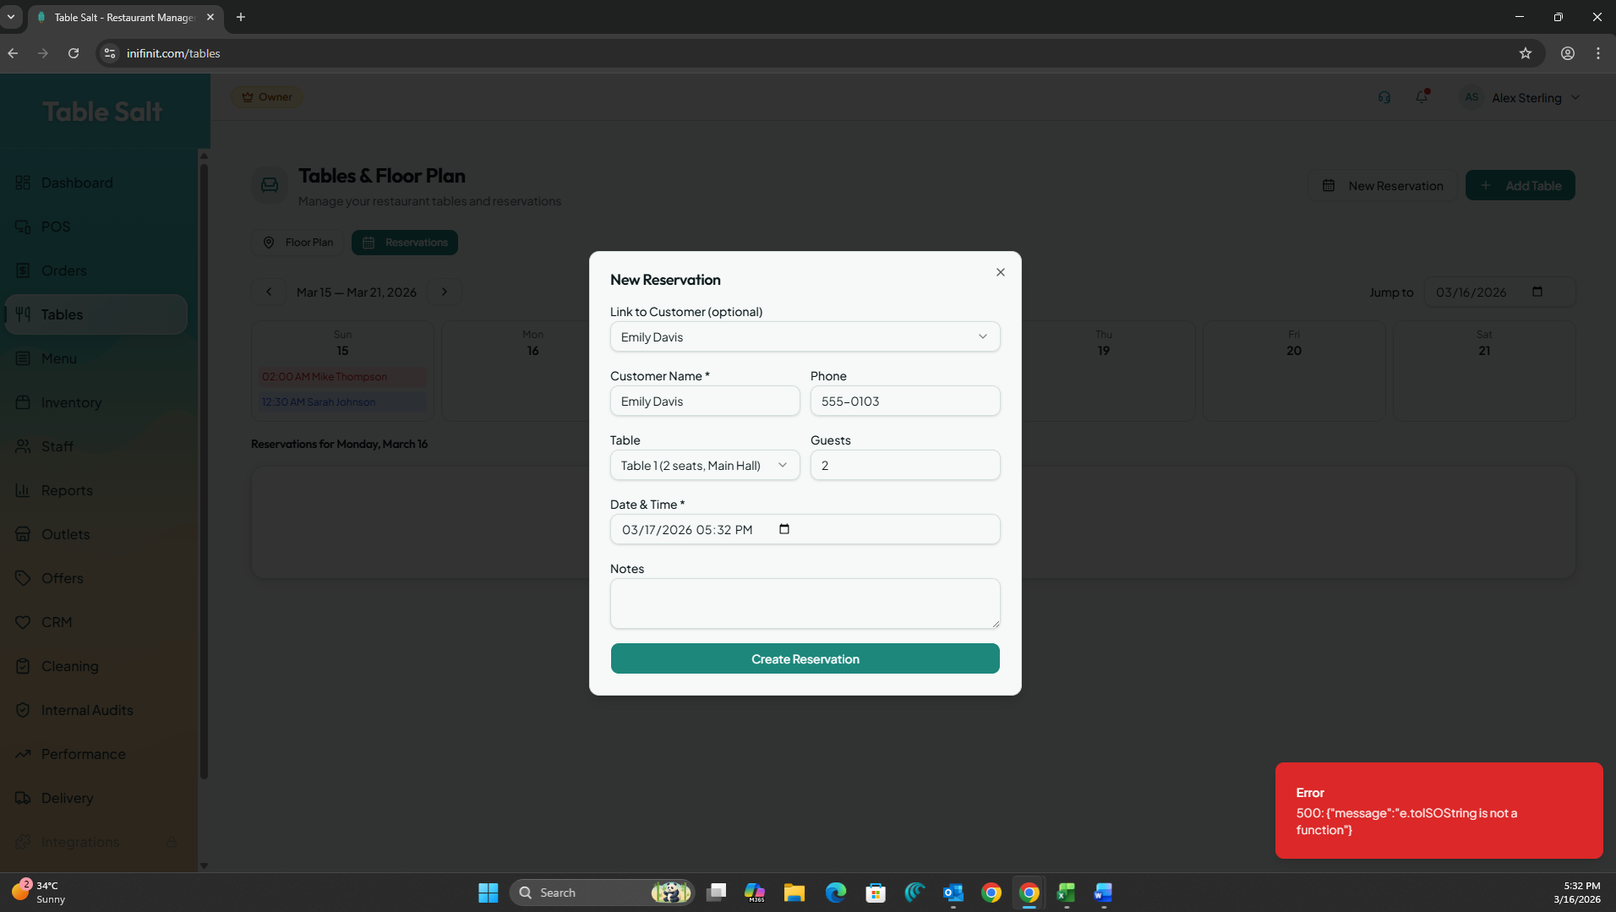

- Staff Staff details cannot be updated as error occurs.

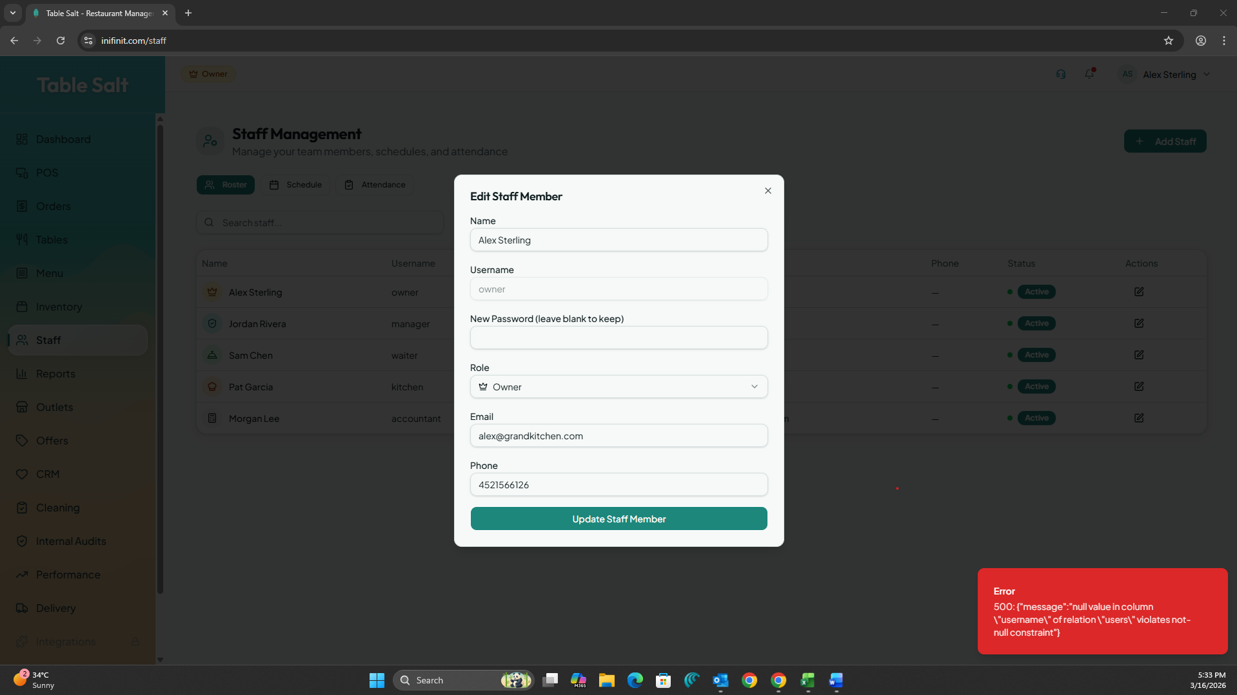

- Staff Staff members is not able to add.

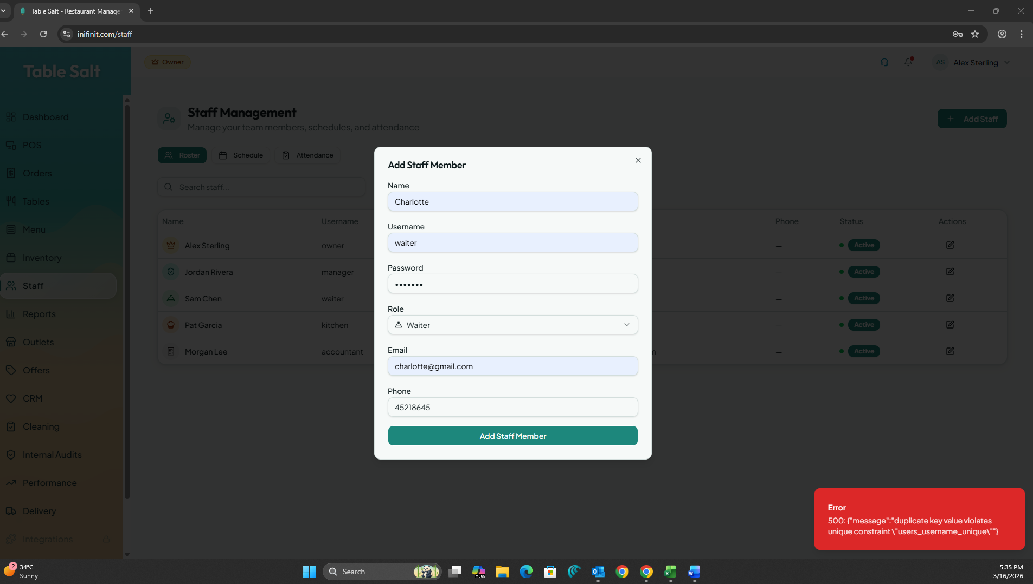

- Staff Schedule “Add Shift” is not able to add.

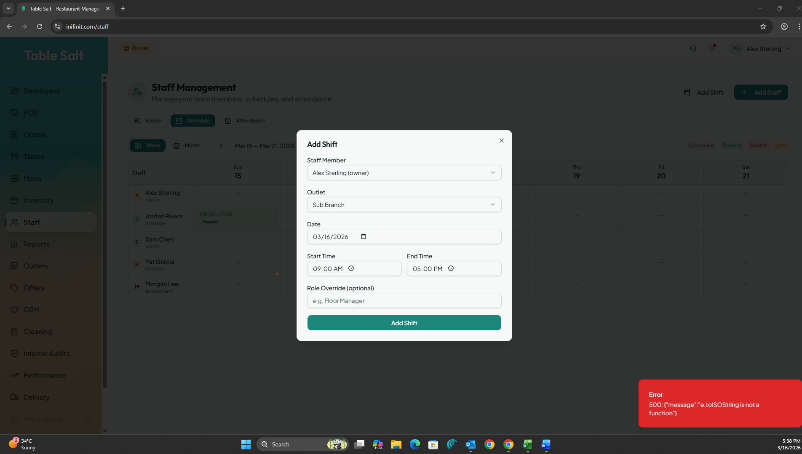

- Tags are shown in menu but not displaying in POS

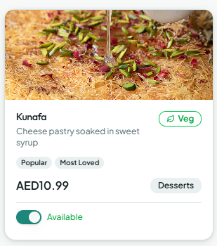

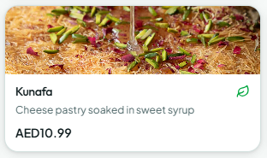

- Veg icons are visible but non veg icons are not visible in POS

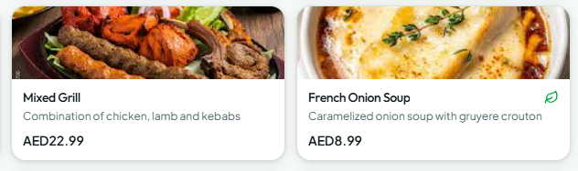

- Images can be added only using Url’s

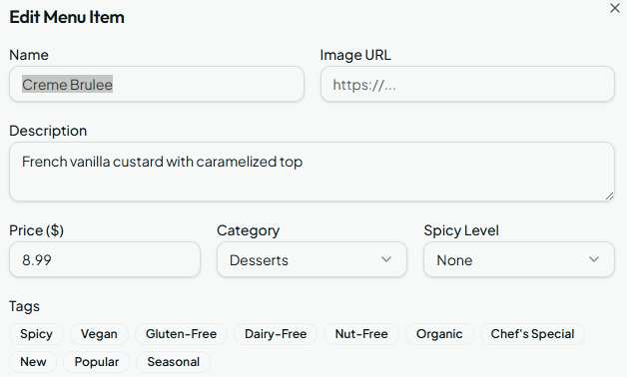

- Same table name is accepted in a same zone

