**Design Project Autumn 2020-21**

Progress Report

**Plagiarism Detector**

**Supervisor** - Dr. Bhupendra Kumar

**Group Members**

Adit Alware – 201851006 Saksham Jain – 201851106

Jainil Shah – 201851116 Utkarsh Tiwari – 201851138

We decided to implement our Design project based on Plagiarism Detection as collaboration of the two ideas discussed below –

* **PHASE 1** - A Web Application which takes input as text files from the user and displays the output as a list of potential links found over the internet from where the text within the file may be copied - with the help of Some Web Search API’s. In addition to this, it also provides us the percentage of the amount of content copied from each link by using the Cosine Algorithm.
* **PHASE 2** - A Web Application where the user can give multiple files as inputs (Minimum 2) to the system. It checks the percentage of similarity between the multiple input files using ……

Implementation of the First Phase of our Design Project (Working – Mentioned Above) has been Completed including the Front-End and Back-End portion of the Application. Further, we have done some research for implementing the next part of the web application and are currently working on it. Some Screenshots of the Input and Output format are given below.

**Taking Input File from the User (Input File)**

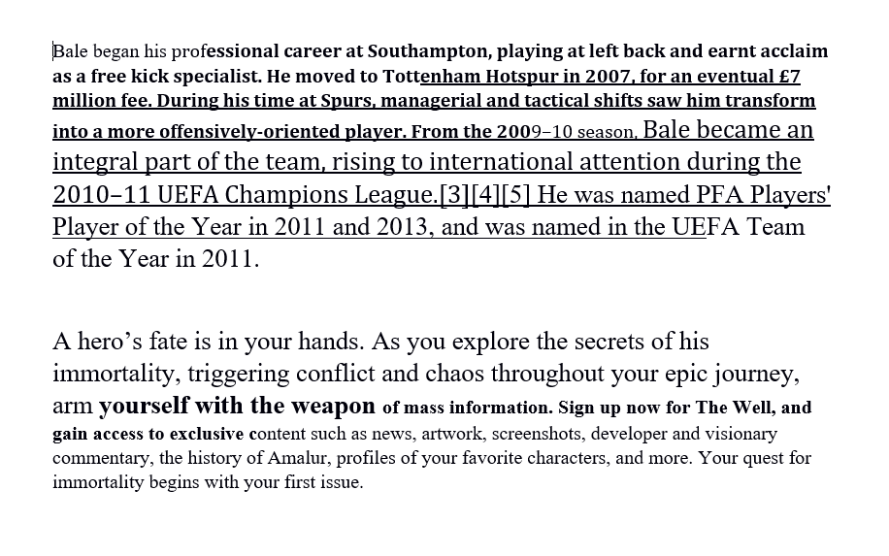

**Most Occurring List of Links (with copied percentage)**

