ARTIFICIAL INTELLIGENCE FOR GAMES

ASSIGNMENT

- ATHUL VINOD (UR16CS068)
- ANISH JOHN MOOTHEDAM (UR16CS093)
- VARUN NAIR (UR16CS126)

- GAME NAME : FLAPPY BIRD 2.0

- STYLE : 2D RETRO

- LANGUAGE USED : C#

- PLATFORM : UNITY 3D

-------------------------------------------------------------------

DESCRIPTION

OBJECTIVE :

The game is a side-scroller where the player controls a bird, attempting to fly between columns of green pipes without hitting them.

Retro style is something that "generally implies a vintage of at least 15 or 20 years". It is like being inspired from the vintage ages of 2D games with simplistic gameplay to generate a sense of excitement and satisfaction.

Flappy Bird is a side-scrolling mobile game featuring 2D retro style graphics. The objective is to direct a flying bird who moves continuously to the right, between sets of Mario-like pipes. If the player touches the pipes, they lose.The bird briefly flaps upward each time that the player taps the screen; if the screen is not tapped, the bird falls because of gravity; each pair of pipes that he navigates between earns the player a single point.

There is no variation or evolution in gameplay throughout the game, as the pipes always have the same gap between them and there is no end to the running track, having only the flap and ding sounds and the rising score as rewards.

Flappy Bird facilitates this precondition in a non-obvious manner, where only those who can get over the initial learning phase will be able to experience it.
In other popular video games, such as Angry Birds and Candy Crush, the levels normally provide clear progressive challenges from extremely simple single-action goals to very hard complicated levels.
This is considered “good” game design practice as it allows players to slowly train in the skills required to play the game while becomingly increasingly more challenged, by which time they’ll hopefully reach the flow state.
Flappy Bird is different.
From the outset, the player faces a very high level of challenge, the hope being that the player will self-train their skills to match the challenge.

PLATFORM

Unity3D is a powerful cross-platform 3D engine and a user friendly development environment. Easy enough for the beginner and powerful enough for the expert; Unity should interest anybody who wants to easily create 3D games and applications for mobile, desktop, the web, and consoles.

The Unity application is a complete 3D environment, suitable for laying out levels, creating menus, doing animation, writing scripts, and organizing projects. The user interface is well organized and the panels can be fully customized by dragging and dropping.

BEHAVIOURS

Steering behaviours are an amalgam of different behaviours that are used to organically manage the movement of an AI agent. Steering behaviour are usually applied in a 2D plane: it is sufficient, easier to implement and understand.

The seeking behaviour is the idea that an AI agent "seeks" to have a certain velocity (vector).

Seek attempts to steer a vehicle so that it moves toward the goal. This is in contrast to a central force (such as gravity) which causes an inward acceleration and so leads to orbital motion.

In our game, the seek behaviour is used to generate velocity which is generated by a click.

Seeing Ahead

The first step to avoid obstacles in the environment is to perceive them. The only obstacles the character must worry are the ones that are in front of it and directly blocking the current route.

The collision avoidance behaviour allows any character to dodge obstacles in the environment.

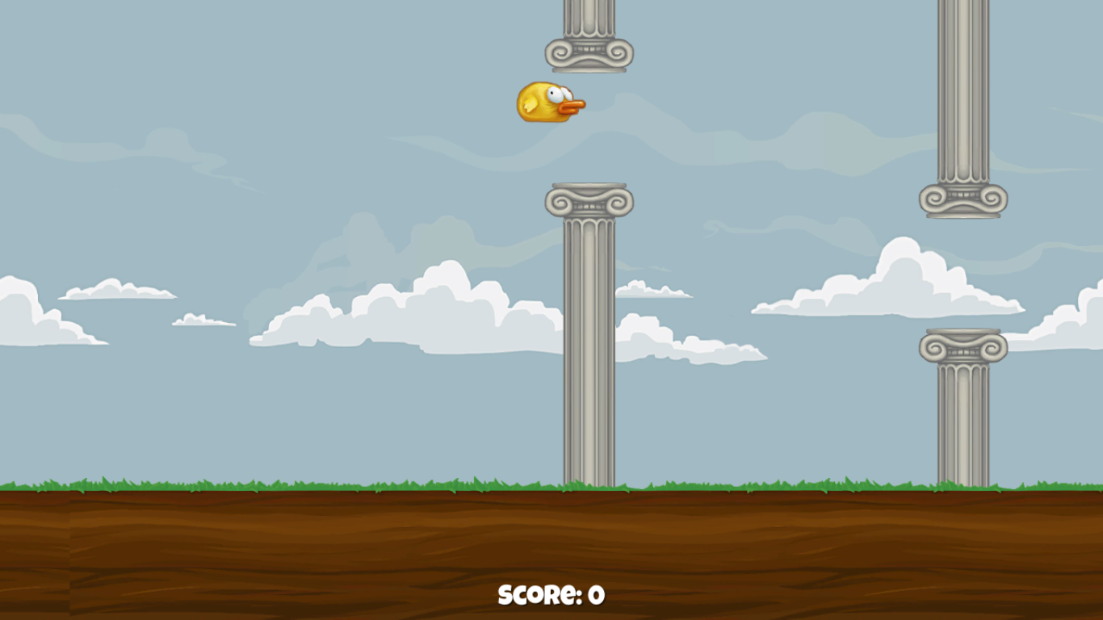
In our game the bird tries to avoid hitting the pipes which is the object. Hence avoiding these pipes is the collision avoidance in our game’s case.
SCREENSHOTS:
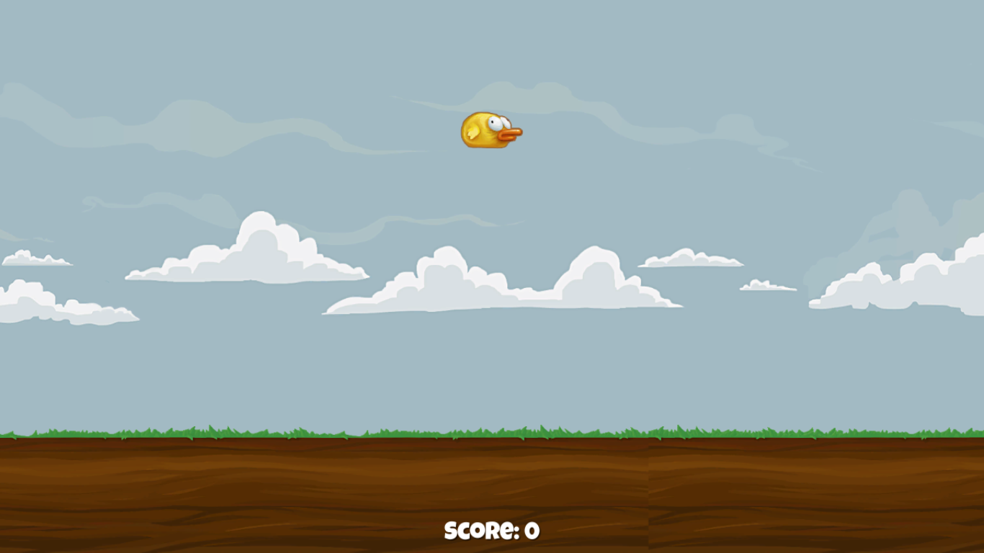
The Character moving in the game space

The Character avoiding the obstacles

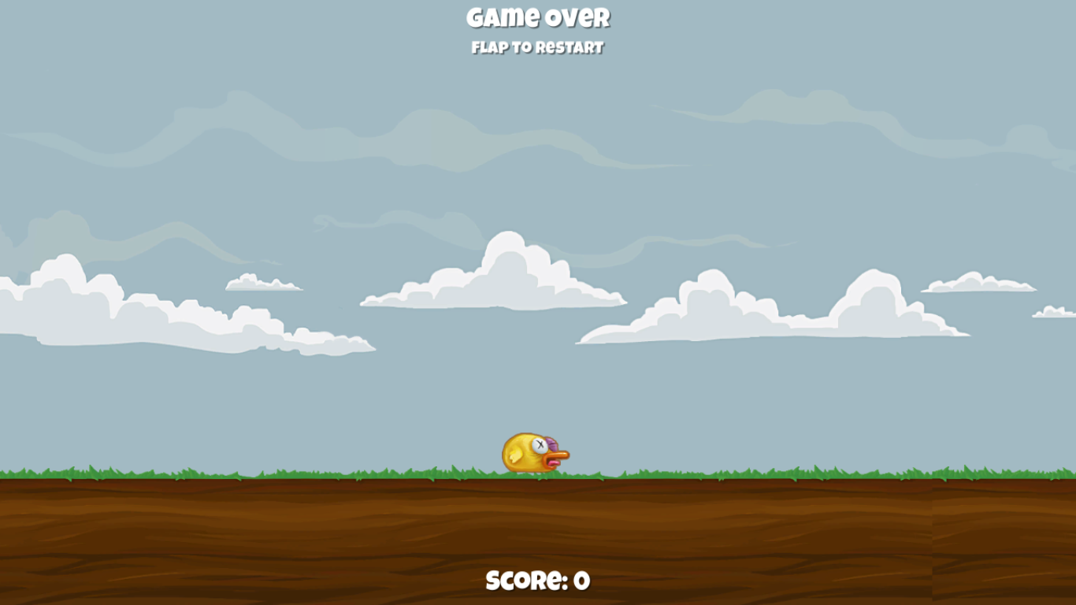
The Character falls to the ground which results in ‘Game Over’
NOTE :

There is no conclusion to the game. The only point is to get the highest score possible.

