# Exercises: ADO.NET

This document defines the **exercise assignments** for the ["Databases Advanced – EF Core" course @ Software University](https://softuni.bg/trainings/3492/entity-framework-core-october-2021).

## Initial Setup

Write a program that connects to your **localhost** server. Create **a new database**called **MinionsDB** where we will keep information about our minions and villains.

For each **minion**, we should keep information about its **name**, **age**, and **town**.

Each **town** has information about **the** **country** where it is located. **Villains** have **name** and **evilness** **factors** (**super good**, **good**, **bad**, **evil**, **super** **evil**). Each **minion** can **serve** **several** **villains** and **each** **villain** can **have** **several** **minions** **serving** **him**. Fill all tables with at least 5 records each.

In the end, you should have the following tables:

* Countries
* Towns
* Minions
* EvilnessFactors
* Villains
* MinionsVillains

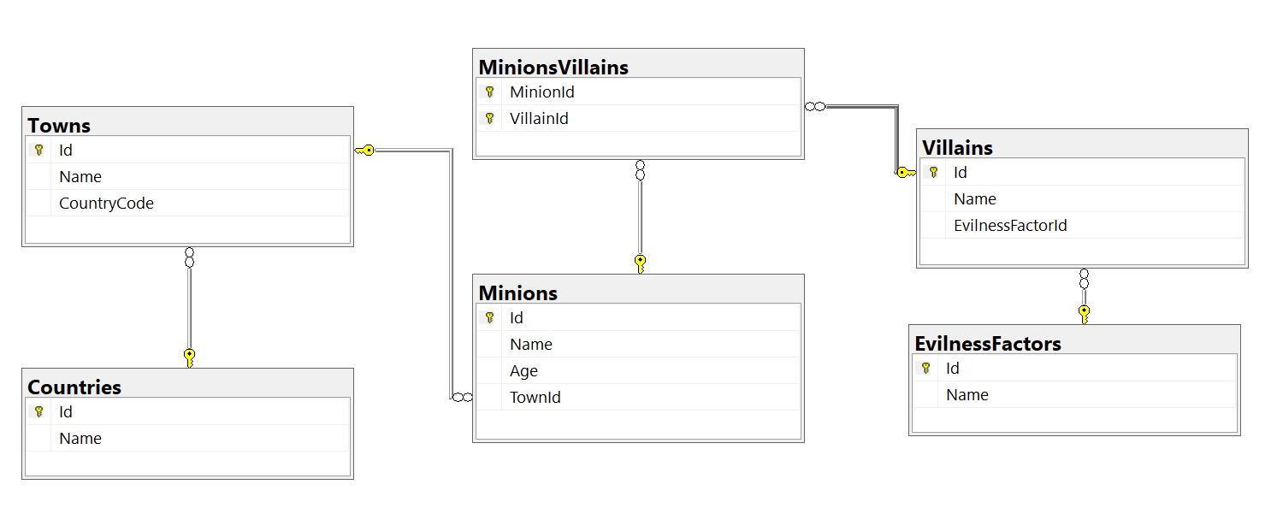

## Villain Names

Write a program that prints on the console **all villains’ names** and their **number of minions** of those who have more than 3 minions **ordered descending** by the number of minions.

### Example

|  |
| --- |
| **Output** |
| Gru - 6  Victor - 4  Jilly – 4 |

## Minion Names

Write a program that prints on the console **all minion names** and ages for a given **villain id**, ordered by **name** **alphabetically.**

If there is no villain with the given ID, print "**No villain with ID <VillainId> exists in the database.".**  
If the selected villain has no minions, print "(no minions)" on the second row.

### Example

|  |  |  |  |  |  |  |  |
| --- | --- | --- | --- | --- | --- | --- | --- |
| **Input** | **Output** |  | **Input** | **Output** |  | **Input** | **Output** |
| 1 | Villain: Gru  1. Bob 13  2. Kevin 14  3. Steward 19 |  | 3 | Villain: Victor  1. Bob 13  2. Simon 22 |  | 2 | Villain: Victor Jr.  (no minions) |

|  |  |
| --- | --- |
| **Input** | **Output** |
| 10 | No villain with ID 10 exists in the database. |

## Add Minion

Write a program that **reads** **information** about a minion and its villain and **adds it to the database**. In case the town of the minion is not in the database, **insert** it as well. In case the villain is not present in the database, add him too with a default **evilness** **factor** of "evil". Finally set the new minion to be a servant of the villain. Print appropriate messages after each operation.

### Input

The input comes in two lines:

* On the first line, you will receive the **minion** **information** in the format "**Minion: <Name> <Age> <TownName>**"
* On the second – the **villain** **information** in the format "**Villain: <Name>**"

### Output

After completing an operation, you must print one of the following messages:

* After adding a new **town** to the database: "**Town <TownName> was added to the database.**"
* After adding a new **villain** to the database: "**Villain <VillainName> was added to the database.**"
* Finally, after successfully adding the **minion** to the database and making it a **servant** of a villain: "**Successfully added <MinionName> to be minion of <VillainName>.**"

**\*Bonus task:** Make sure all operations are executed successfully. In case of an error do not change the database.

### Example

|  |  |
| --- | --- |
| **Input** | **Output** |
| Minion: Bob 14 Berlin  Villain: Gru | Successfully added Robert to be minion of Gru. |
| Minion: Cathleen 20 Liverpool  Villain: Gru | Town Liverpool was added to the database.  Successfully added Cathleen to be minion of Gru. |
| Minion: Mars 23 Sofia  Villain: Poppy | Villain Poppy was added to the database.  Successfully added Mars to be minion of Poppy. |
| Minion: Carry 20 Eindhoven  Villain: Jimmy | Town Eindhoven was added to the database.  Villain Jimmy was added to the database.  Successfully added Carry to be minion of Jimmy. |

## Change Town Names Casing

Write a program that **changes all town names to uppercase** for a given country.

You will receive one line of input with the **name** of the country.

**Print the** **number of towns that were changed** in the format **"<ChangedTownsCount> town names were affected."**. On a second line, **print** the **names that were changed**, separated by a comma and a space.

If **no** **towns** were affected (the country does not exist in the database or has no cities connected to it), **print** "**No town names were affected.**".

### Example

|  |  |
| --- | --- |
| **Input** | **Output** |
| Bulgaria | 3 town names were affected.  [SOFIA, VARNA, BURGAS] |
| Germany | No town names were affected. |

## *Remove Villain

Write a program that receives the **ID** of a villain, **deletes him from the database,** and **releases his minions** from serving to him. Print on **two** **lines** the name of the deleted villain in the format "<**Name**> **was** **deleted**." and the number of minions released in format "<**MinionCount**> **minions** **were** **released**.". Make sure all operations go as planned, otherwise do not make any changes in the database.

If there is no villain in the database with the given ID, print "**No such villain was found**.".

### Example

|  |  |
| --- | --- |
| **Input** | **Output** |
| 1 | Gru was deleted.  6 minions were released. |
| 3 | Victor was deleted.  0 minions were released. |
| 101 | No such villain was found. |

## Print All Minion Names

Write a program that **prints all minion names** from the minions table **in the following order:** first record, last record, first + 1, last - 1, first + 2, last - 2 … first + n, last - n.

|  |  |  |  |  |  |  |  |  |  |
| --- | --- | --- | --- | --- | --- | --- | --- | --- | --- |
| 1 | 10 | 2 | 9 | 3 | 8 | 4 | 7 | 5 | 6 |

### Example

|  |  |
| --- | --- |
| **Original Order** | **Output** |
| Bob  Kevin  Steward  Jimmy  Vicky  Becky  Jully | Bob  Jully  Kevin  Becky  Steward  Vicky  Jimmy |

## Increase Minion Age

Read from the console minion IDs separated by space.**Increment the age** of those minions **by 1** and make the title of their name**case**. Finally, **print the name and the age of all minions** in the database, each on a new row in the format **"<Name> <Age>**".

### Example

|  |  |  |
| --- | --- | --- |
| **Minions** | | |
| **Id** | **Name** | **Age** |
| 1 | bob | 14 |
| 2 | stuart | 22 |
| 3 | kevin | 13 |
| 4 | jimmy | 49 |
| 5 | vicky jackson | 26 |

|  |  |  |  |  |
| --- | --- | --- | --- | --- |
| **Input** | **Output** |  | **Input** | **Output** |
| 2 1 4 | Bob 15  Stuart 23  kevin 13  Jimmy 50  vicky jackson 26 |  | 5 | bob 14  stuart 22  kevin 13  jimmy 49  Vicky Jackson 27 |

## Increase Age Stored Procedure

Create stored procedure **usp_GetOlder** (**directly in the database** using **Management Studio** or any other similar tool) that receives **MinionId** and **increases that minion’s age by 1**. Write a program that **uses that stored procedure to increase the age** of a minion whose id will be given as input from the console. After that **print the name and the age** of that minion.

### Example

|  |  |  |
| --- | --- | --- |
| **Minions** | | |
| **Id** | **Name** | **Age** |
| 1 | bob | 14 |
| 2 | steward | 22 |
| 3 | kevin | 13 |
| 4 | jimmy | 49 |
| 5 | vicky jackson | 26 |

|  |  |
| --- | --- |
| **Input** | **Output** |
| 1 | bob – 15 years old |
| 3 | kevin – 14 years old |
| 5 | vicky jackson – 27 years old |