# Exercises: External Format Processing

This document defines the **exercise assignments** for the ["Databases Advanced – EF Core" course @ Software University.](https://softuni.bg/trainings/3492/entity-framework-core-october-2021)

# Products Shop Database

A products shop holds **users**, **products,** and **categories** for the products. Users can **sell** and **buy** products.

* Users have an **id**, **first** **name** (optional), and **last** **name** (at least 3 characters) and **age** (optional).
* Products have an **id**, **name** (at least 3 characters), **price**, **buyerId** (optional), and **sellerId** as IDs of users.
* Categories have an **id** and **name** (from **3** to **15** characters)

Using Entity Framework Code First create a database following the above description.

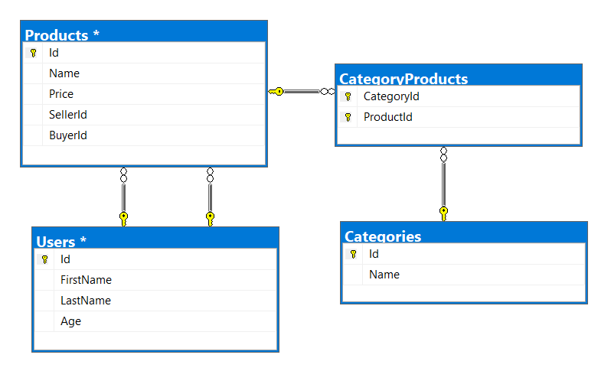

* **Users** should have **many products sold** and **many products bought**.
* **Products** should have **many categories**
* **Categories** should have **many products**
* **CategoryProducts** should **map products** and **categories**

### Import Data

### Import Users

**NOTE**: You will need method public static string ImportUsers(ProductShopContext context, string inputJson) and public StartUp class.

Import the users from the provided file **users.json**.

Your method should return a string with the message $"Successfully imported {Users.Count}";

### Import Products

**NOTE**: You will need method public static string ImportProducts(ProductShopContext context, string inputJson) and public StartUp class.

Import the users from the provided file **products.json**.

Your method should return a string with the message $"Successfully imported {Products.Count}";

### Import Categories

**NOTE**: You will need method public static string ImportCategories(ProductShopContext context, string inputJson) and public StartUp class.

Import the users from the provided file **categories.json**. Some of the names will be null, so you don’t have to add them to the database. Just skip the record and continue.

Your method should return a string with the message $"Successfully imported {Categories.Count}";

### Import Categories and Products

**NOTE**: You will need method public static string ImportCategoryProducts(ProductShopContext context, string inputJson) and public StartUp class.

Import the users from the provided file **categories-products.json**.

Your method should return a string with the message $"Successfully imported {CategoryProducts.Count}";

## Query and Export Data

Write the below-described queries and **export** the returned data to the specified **format**. Make sure that Entity Framework generates only a **single query** for each task.

Note that because of the random generation of the data output probably will be different.

**Export Products in Range**

**NOTE**: You will need method public static string GetProductsInRange(ProductShopContext context) and public StartUp class.

Get all products in a specified **price range:** 500 to 1000 (inclusive). Order them by price (from lowest to highest). Select only the **product name**, **price,** and the **full name** **of the seller**. Export the result to JSON.

|  |
| --- |
| **products-in-range.json** |
| [  {  "name": "TRAMADOL HYDROCHLORIDE",  "price": 516.48,  "seller": "Christine Gomez"  },  {  "name": "Allopurinol",  "price": 518.50,  "seller": "Kathy Gilbert"  },  {  "name": "Parsley",  "price": 519.06,  "seller": "Jacqueline Perez"  },  ...  ] |

### Export Successfully Sold Products

**NOTE**: You will need method public static string GetSoldProducts(ProductShopContext context) and public StartUp class.

Get all users who have **at least 1 sold item** with a **buyer**. Order them by **the last name**, then by **the first name**. Select the person's **first** and **last name**. For each of the **sold products** (products with buyers), select the product's **name**, **price**, and the buyer's **first** and **last name**.

|  |
| --- |
| **users-sold-products.json** |
| [  {  "firstName": "Gloria",  "lastName": "Alexander",  "soldProducts": [  {  "name": " Metoprolol Tartrate",  "price": 1405.74,  "buyerFirstName": "Bonnie",  "buyerLastName": "Fox"  }  ]  },  ...  ] |

**Export Categories by Products Count**

**NOTE**: You will need method public static string GetCategoriesByProductsCount(ProductShopContext context) and public StartUp class.

Get **all** **categories**. Order them in descending order by the category’s**products count**. For each category select its **name**, the **number of products**, the **average price of those products**(rounded to the second digit after the decimal separator), and the **total revenue** (total price sum and rounded to the second digit after the decimal separator) of those products (regardless if they have a buyer or not).

|  |
| --- |
| **categories-by-products.json** |
| [  {  "category": "Garden",  "productsCount": 23,  "averagePrice": "800.15",  "totalRevenue": "18403.47",  },  {  "category": "Drugs",  "productsCount": 22,  "averagePrice": "882.20",  "totalRevenue": "19408.43"  },  ...  ] |

### Export Users and Products

**NOTE**: You will need method public static string GetUsersWithProducts(ProductShopContext context) and public StartUp class.

Get all users who have **at least 1 sold product with a buyer**. Order them in descending order by the **number of sold products with a buyer**. Select only their **first** and **last name**, **age** and for each product - **name** and **price**. Ignore all null values.

Export the results to **JSON**. Follow the format below to better understand how to structure your data.

|  |
| --- |
| **users-and-products.json** |
| {  "usersCount":54,  "users":  [  {  "lastName": "Stewart",  "age": 39,  "soldProducts":  {  "count": 9,  "products":  [  {  "name": "Finasteride",  "price": 1374.01  },  {  "name": "Glyburide",  "price": 95.1  },  {  "name": "GOONG SECRET CALMING BATH ",  "price": 742.47  },  {  "name": "EMEND",  "price": 1365.51  },  {  "name": "Allergena",  "price": 109.32  },  ...  ]  }  },  ...  ]  } |

# Car Dealer

## Setup Database

A A car dealer needs information about cars, their parts, parts suppliers, customers, and sales.

* **Cars** have **make, model**, traveled distance in kilometers
* **Parts** have **name**, **price**, and **quantity**
* Part **supplier** have **name** and info whether he **uses imported parts**
* **The customer** has **a name**, **date of birth**, and info whether he **is a young driver** (Young driver is a driver that has **less than 2 years of experience**. Those customers get **an additional 5% off** for the sale.)
* **Sale** has **a car**, **customer**and **discount percentage**

A **price of a car** is formed by **the total price of its parts**.

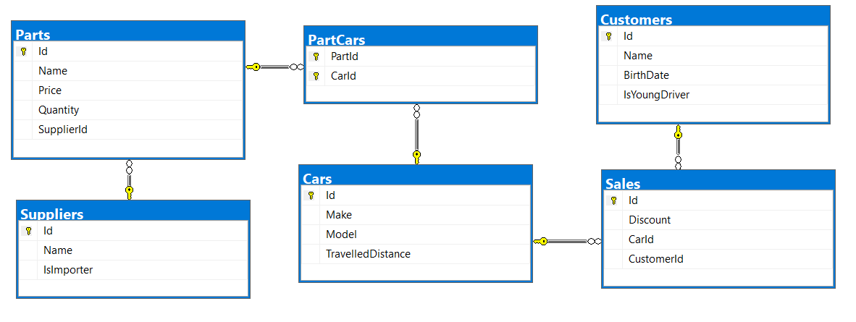

* A **car** has **many parts** and **one part** can be placed **in many cars**
* **One supplier** can supply **many parts** and each **part** can be delivered by **only one supplier**
* In **one sale**, only **one car** can be sold
* **Each sale** has **one customer** and **a customer** can buy **many cars**

## Import Data

Import data from the provided files (**suppliers.json, parts.json, cars.json, customers.json**)

### Import Suppliers

**NOTE**: You will need method public static string ImportSuppliers(CarDealerContext context, string inputJson) and public StartUp class.

Import the suppliers from the provided file **suppliers.json**.

Your method should return a string with the message $"Successfully imported {Suppliers.Count}.";

### Import Parts

**NOTE**: You will need method public static string ImportParts(CarDealerContext context, string inputJson) and public StartUp class.

Import the parts from the provided file **parts.json**. If the supplierId doesn’t exist, skip the record.

Your method should return a string with the message $"Successfully imported {Parts.Count}.";

### Import Cars

**NOTE**: You will need method public static string ImportCars(CarDealerContext context, string inputJson) and public StartUp class.

Import the cars from the provided file **cars.json**.

Your method should return string with message $"Successfully imported {Cars.Count}.";

### Import Customers

**NOTE**: You will need method public static string ImportCustomers(CarDealerContext context, string inputJson) and public StartUp class.

Import the customers from the provided file **customers.json**.

Your method should return a string with the message $"Successfully imported {Customers.Count}.";

### Import Sales

**NOTE**: You will need method public static string ImportSales(CarDealerContext context, string inputJson) and public StartUp class.

Import the sales from the provided file **sales.json**.

Your method should return a string with the message $"Successfully imported {Sales.Count}.";

## Query and Export Data

Write the below described queries and **export** the returned data to the specified **format**. Make sure that Entity Framework generates only a **single query** for each task.

### Export Ordered Customers

**NOTE**: You will need method public static string GetOrderedCustomers(CarDealerContext context) and public StartUp class.

Get all **customers** ordered by their **birth date ascending**. If two customers are born on the same date **first print those who are not young drivers** (e.g., print experienced drivers first). **Export** the list of customers **to JSON** in the format provided below.

|  |
| --- |
| **ordered-customers.json** |
| [  {  "Name": "Louann Holzworth",  "BirthDate": " 01/10/1960",  "IsYoungDriver": false  },  {  "Name": "Donnetta Soliz",  "BirthDate": "01/10/1963",  "IsYoungDriver": true  },  ...  ] |

**Export Cars from Make Toyota**

**NOTE**: You will need method public static string GetCarsFromMakeToyota(CarDealerContext context) and public StartUp class.

Get all **cars** from making **Toyota** and **order them by model alphabetically** and by **traveled distance descending**. **Export** the list of **cars to JSON** in the format provided below.

|  |
| --- |
| **toyota-cars.json** |
| [  {  "Id": 134,  "Make": "Toyota",  "Model": "Camry Hybrid",  "TravelledDistance": 486872832,  },  {  "Id": 139,  "Make": "Toyota",  "Model": "Camry Hybrid",  "TravelledDistance": 397831570,  },  ...  ] |

### Export Local Suppliers

**NOTE**: You will need method public static string GetLocalSuppliers(CarDealerContext context) and public StartUp class.

Get all suppliers that do not import parts from abroad. Get their id, name, and the number of parts they can offer to supply. Export the list of suppliers to JSON in the format provided below.

|  |
| --- |
| **local-suppliers.json** |
| [  {  "Id": 2,  "Name": "Agway Inc.",  "PartsCount": 3  },  {  "Id": 4,  "Name": "Airgas, Inc.",  "PartsCount": 2w  },  ...  ] |

### Export Cars with Their List of Parts

**NOTE**: You will need method public static string GetCarsWithTheirListOfParts(CarDealerContext context) and public StartUp class.

Get all **cars along with their list of parts**. For the **car** get only **make, model,**and **traveled distance** and for the **parts** get only **name** and **price**(formatted to 2nd digit after the decimal point). **Export** the list of **cars and their parts to JSON** in the format provided below.

|  |
| --- |
| **cars-and-parts.json** |
| [  {  "car": {  "Make": "Opel",  "Model": "Omega",  "TravelledDistance": 176664996  },  "parts": []  },  {  "car": {  "Make": "Opel",  "Model": "Astra",  "TravelledDistance": 516628215  },  "parts": []  },  {  "car": {  "Make": "Opel",  "Model": "Astra",  "TravelledDistance": 156191509  },  "parts": []  },  {  "car": {  "Make": "Opel",  "Model": "Corsa",  "TravelledDistance": 347259126  },  "parts": [  {  "Name": "Pillar",  "Price": "100.99"  },  {  "Name": "Valance",  "Price": "1002.99"  },  {  "Name": "Front clip",  "Price": "100.00"  }  ]  },...  ] |

### Export Total Sales by Customer

**NOTE**: You will need method public static string GetTotalSalesByCustomer(CarDealerContext context) and public StartUp class.

Get all customers that have bought at least 1 car and get their names, bought cars count, and total spent money on cars. Order the result list by total spent money descending then by total bought cars again in descending order. Export the list of customers to JSON in the format provided below.

|  |
| --- |
| **customers-total-sales.json** |
| [  {  "fullName": " Johnette Derryberry",  "boughtCars": 5,  "spentMoney": 13529.25  },  {  "fullName": " Zada Attwood",  "boughtCars": 6,  "spentMoney": 13474.31  },  {  "fullName": " Donnetta Soliz",  "boughtCars": 3,  "spentMoney": 8922.22  },  ...  ] |

### Export Sales with Applied Discount

**NOTE**: You will need method public static string GetSalesWithAppliedDiscount(CarDealerContext context) and public StartUp class.

Get first 10 **sales** with information about the **car**, **customer,** and **price** of the sale **with and without discount**. **Export** the list of sales **to JSON** in the format provided below.

|  |
| --- |
| **sales-discounts.json** |
| [  {  "car": {  "Make": "Seat",  "Model": "Mii",  "TravelledDistance": 473519569  },  "customerName": "Ann Mcenaney",  "Discount": "30.00",  "price": "2176.37",  "priceWithDiscount": "1523.46"  },  {  "car": {  "Make": "Renault",  "Model": "Alaskan",  "TravelledDistance": 303853081  },  "customerName": "Taina Achenbach",  "Discount": "10.00",  "price": "808.76",  "priceWithDiscount": "727.88"  },  ...  ] |