Team “Hornbuckle”
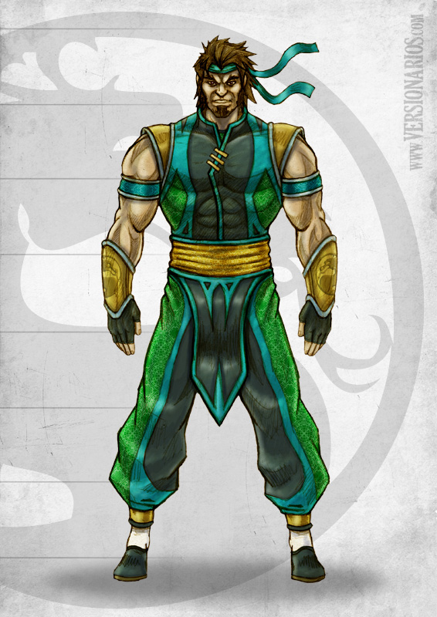

Пламен Петков – Plamen_Petkov
Стефан Михайлов – Hades 12
Мартин Христов – MartinHristov
Васил Василев – vasil.k.vasilev
Димитър Катъров – chichuMitku
Христо Колев – scarylabcat

Description of the project idea:
One of the most well-known games – Minesweeper. The player attempts to open all cell on a battlefield without triggering a mine.
In the current iteration of the game, there are 10 columns and 10 rows, therefore the field comprises 100 cells. The mines scattered around it are 10.

The left-button click on a cell reveals it and some of the following actions are taken:

- If the cell holds a mine, it explodes and the game is over.
- If the cell borders a mine in any of the six directions, it shows a number representing the mines it immediately around it.
- If the cell is empty and does not border a mine, it is revealed and the surrounding cells until a cell with number is reached.

The player has a maximum of 10 flags that he or she can put on a with the click of the right-button if he/she thinks that cell holds a mine.
The player wins the game when all empty cell and those with numbers are revealed.

Description of the implementation:

initGame() starts the game through functions that draw the playing field, randomly places 10 mines on the field, sets the number of bordering mine-cells. An eventlistener determines if a cell has been clicked and starts the appropriate action based on the cell value and in accordance with the game rules.

The project consists of an HTML page, two JS files - one holds the main game logic, th other one takes care of the background drawing. Styling files and images are stored in the corresponding folders.

Project requirements

KineticJS was used for drawing the playfield, the value of the cells, the coloring of revealed cells.

RaphaelJS was used in the drawing of the info-board, and the background.

Animation was through Raphael JS used on the smiley emoticon, which is used for starting a game.

The GIT repository is at https://github.com/Plamen5kov/Javascript-2-TeamWork-Minesweeper.

