TypeScript – Exercises
Exercises and homework assignments for “Introduction to Programming with AI” course at SoftUni.
Judge submission link: https://alpha.judge.softuni.org/contests/typescript-intro-exercises/5288.

Install TypeScript
Installing TypeScript is straightforward if you already have JavaScript and npm set up – like in our case. Follow the steps below for both Windows and macOS/Linux systems.

Step 1: Open Terminal / Command Prompt
The easiest way to install Typescript is using your system’s Command Prompt / Terminal application
Windows 11: Open a new Terminal. Press [Ctrl + Esc], type "Terminal", and hit [Enter].
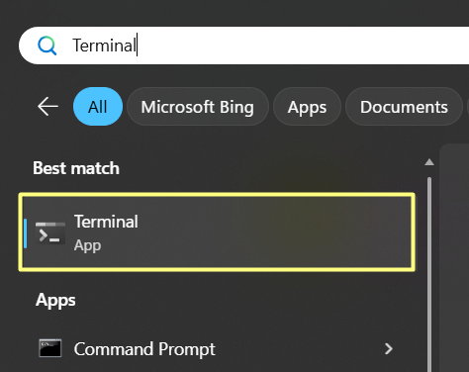
Windows 10 (or older): Open a new "Command Prompt" window. Press [Win + R], type "cmd", and hit [Enter].
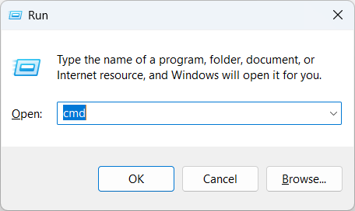
macOS / Linux: Open your Terminal application.
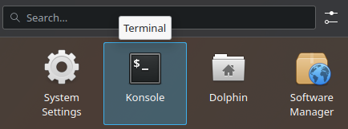

Step 2: Install TypeScript Globally
Run the following command to install TypeScript globally (not per project):
npm install -g typescript
This approach allows systemwide usage of TypeScript and is controlled by npm (the Node.js package manager).
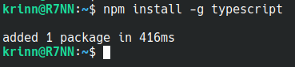
Note: in some environments (e.g. cloud-based VS Code like GitHub Codespaces), installing TypeScript globally may fail. In such a scenario, you can install TypeScript locally, for the current project only, as a local npm package (located in the node_modules project folder):
Alternative: local TypeScript installation (for the current project only)
npm install typescript

Step 3: Verify the TypeScript Installation
After the installation is completed, verify that TypeScript is installed by running the "tsc" command. This command is a shortened for “TypeScript Compiler”. It is the command-line tool used to compile TypeScript .ts files into JavaScript .js files. The TypeScript Compiler checks your TypeScript code for errors, ensures type safety, and generates JavaScript files that can run in any JavaScript environment.
Check if tsc is globally installed and check its version:
tsc –version
You should see the installed version number displayed:
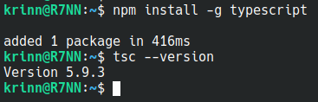
Note: if your TypeScript installation is local (for the current project), you should run it like this:
Alternative: run tsc from a local TypeScript installation (for the current project only)
npx tsc --version

Run TypeScript in VS Code
Follow the instructions to set up a simple, minimal working TypeScript environment in Visual Studio Code (VS Code).

Step 1: Create a TypeScript File
As usual, you should start working on the lesson exercises by creating a project folder which will hold your exercise files. Give it a reasonable name, e.g. "TypeScript-Exercises":
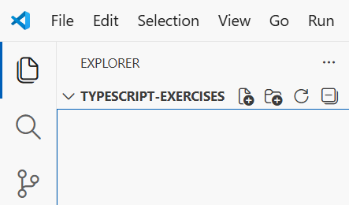
Next, create a file to hold your first few lines of TypeScript code, e.g. example.ts:
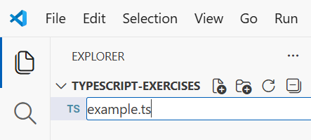

Step 2: Create a TypeScript Function
Inside your newly created TypeScript file, create the following function and save the file:
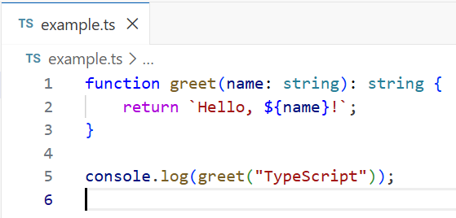

Step 3: Setting Up "Code Runner"
Now we want to run the newly created TypeScript file using the convenient extension “Code Runner”, as an easy way to avoid more complex approaches. Open Code Runner’s settings by first clicking the "Extensions" icon at the left side of VS Code, then by clicking on the little "Settings" icon on the extension’s page, and finally selecting settings from the drop-down menu:
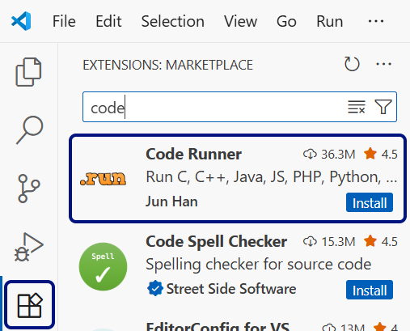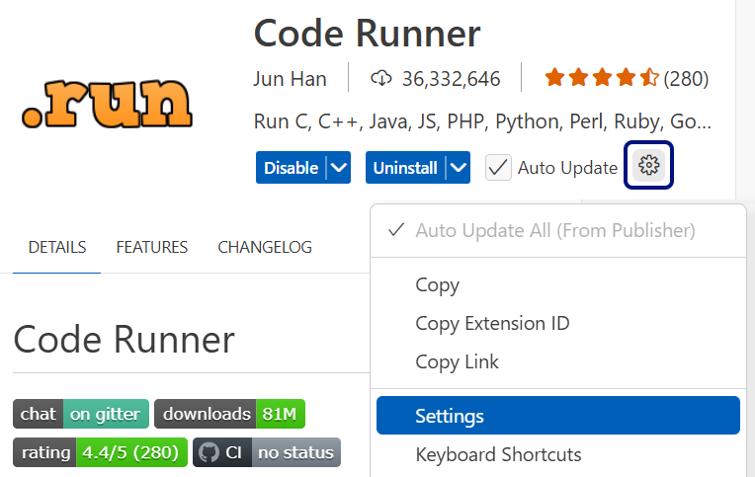
Scroll a bit down to find “Code-runner: Executor Map” and click on “Edit in settings.json”.
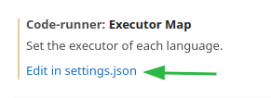
The settings.json file will be opened in a new tab and all the default Code Runner settings will be ready for editing. Before changing settings here, it is very important to know that this file contains many other plugin settings. Changing values here needs a careful approach and prior knowledge!
Hint: Integrated AI code assistants like GitHub Copilot are quite helpful for setting up settings, values, and formatting specific files. They will help you with code suggestions.
Find the line holding “typescript”. It holds the command, which will run .ts files:
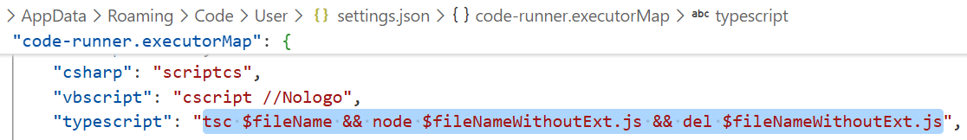
Change the default value "ts-node" in the quotes to one of these, according to what your operating system is.
For Windows environment:
tsc $fileName && node $fileNameWithoutExt.js && del $fileNameWithoutExt.js"
For macOS / Linux (Bash):
tsc $fileName && node $fileNameWithoutExt.js && rm $fileNameWithoutExt.js"
Save the changes and move to the final step.

Step 4: Running the TypeScript File
Now go back to the example.ts file. To run it, click the [Run Code] triangle icon in the upper right side of the code editor window:
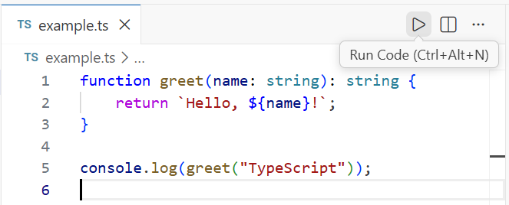
We have successfully set up both a TypeScript environment and Code Runner, as a fast way to execute the TypeScript code. Here is the result:
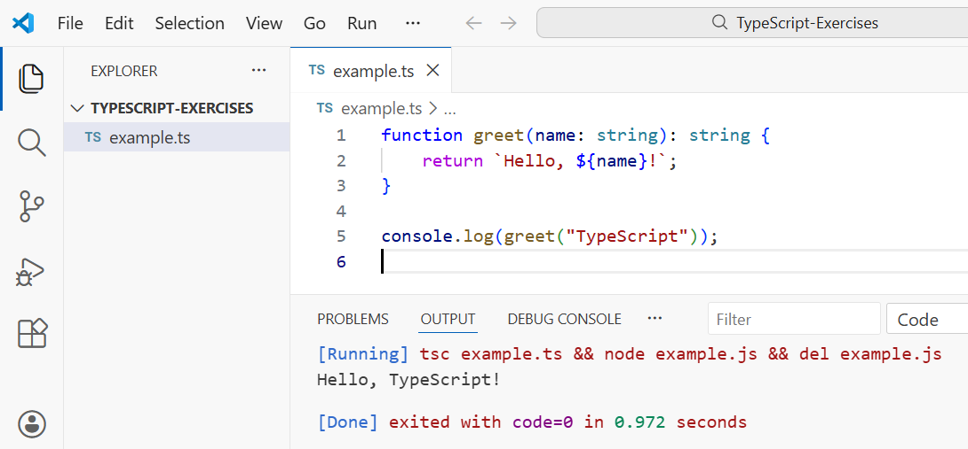
You can play a bit and write some simple TypeScript code to test your newly created project.

Reverse a String
Write a TypeScript function called reverseString() that takes a string as an argument and returns the string in a reversed order. The function should also print the reversed string to the console.

Input and Output
- The function should accept a single parameter of type string.
- It should return the reversed string in format: The reversed string of "{str}" is: "{reversedStr}".
Input | Output
console.log(reverseString("hello")); | The reversed string of "hello" is: "olleh"
console.log(reverseString("TypeScript")); | The reversed string of "TypeScript" is: "tpircSepyT"
console.log(reverseString("OpenAI")); | The reversed string of "OpenAI" is: "IAnepO"
Write a few function calls to test your implementation and print the outputs to the console.

Hints
This is a simple solution implementing the problem’s logic (unfinished):
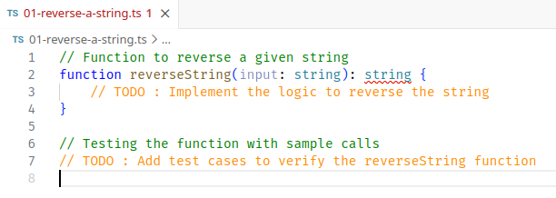
As seen in this screenshot, VS Code underlines the function’s return type – string. This demonstrates the strong type hinting that TypeScript implements in its design. The message there says: “A function whose declared type is neither 'undefined', 'void', nor 'any' must return a value.”. The function’s body is currently empty, and this causes this error message. When the function is implemented to return a string, the error message will disappear.

Judge Submission
Submit your code to the judge: https://alpha.judge.softuni.org/contests/typescript-intro-exercises/5288.
Visualization with HTML
Use Copilot to visualize the function’s logic. You can use a prompt like this one:
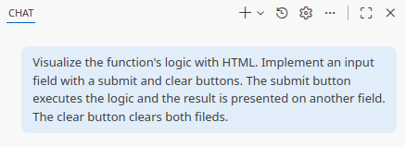
Here is a sample result. Copilot makes a beautiful interactive HTML page that both captures the logic and explains the functionality:
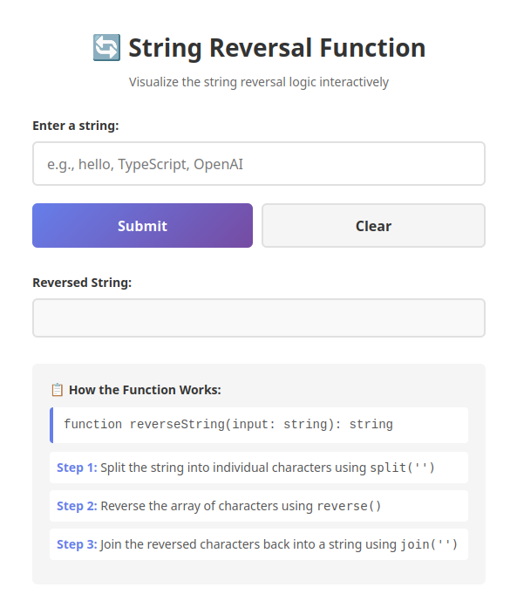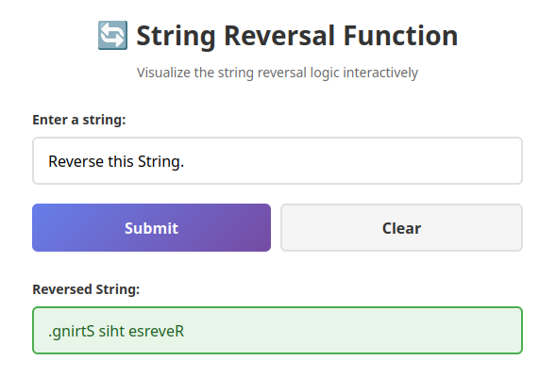

Creature Energy
We all love games, don't we? 😉
Write a TypeScript function called calculateCreatureEnergy that takes a GalacticCreature type as an input. This type includes a name, an array of energy levels for different activities (integers), and an optional avgEnergy property. The function should calculate the average energy level of the creature and update the avgEnergy property. Print the creature's name, its energy levels, and the calculated average to the console for verification.

Input and Output
Define a GalacticCreature type that includes:
- name: a string representing the creature's name
- energyLevels: an array of numbers representing the creature's energy levels during various activities
- avgEnergy: an optional number representing the average energy level
The function should accept a single parameter of type GalacticCreature.
It should return the GalacticCreature object with the avgEnergy property updated.
Input | const zorblax: GalacticCreature =  { name: "Zorblax", energyLevels: [35, 42, 50, 29] };  calculateCreatureEnergy(zorblax);
Output | Creature: Zorblax  Energy Levels: [35, 42, 50, 29]  Average Energy Level: 39.00
Input | const lumivex: GalacticCreature =  { name: "Lumivex", energyLevels: [75, 80, 90] };  calculateCreatureEnergy(lumivex);
Output | Creature: Lumivex  Energy Levels: [75, 80, 90]  Average Energy Level: 81.67
Include a few function calls to test your implementation and log the outputs to the console.

Hints
This is the GalacticCreature type definition:
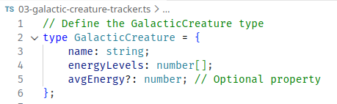
This is the TypeScript function definition:
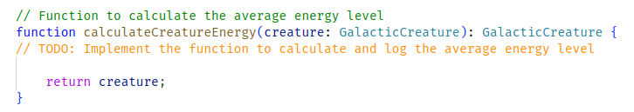

Judge Submission
Submit your code to the judge: https://alpha.judge.softuni.org/contests/typescript-intro-exercises/5288.

Visualization with HTML
Let’s test these creatures in battle 💢
Ask Copilot to create the imaginary grand battle of the Galactic Creatures. Use your imagination to guide the Agent with the setup while instructing him to use TypeScript types and logic. This is an example of the end result:
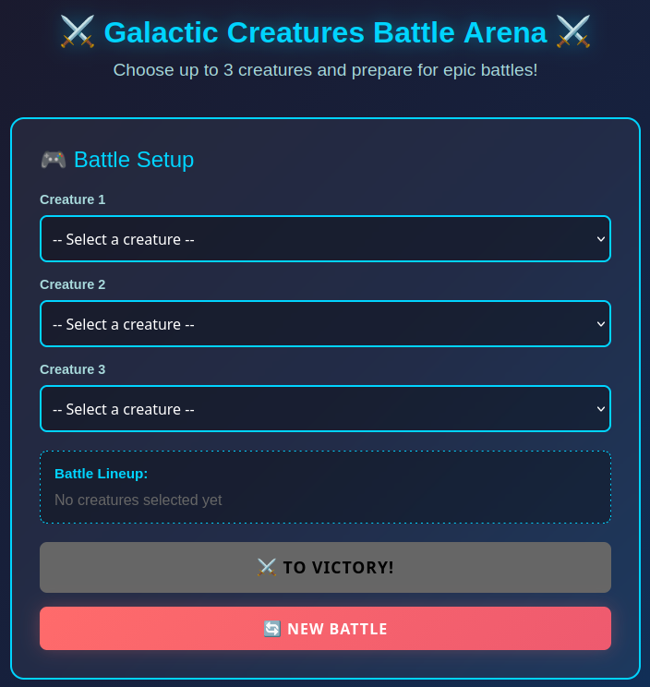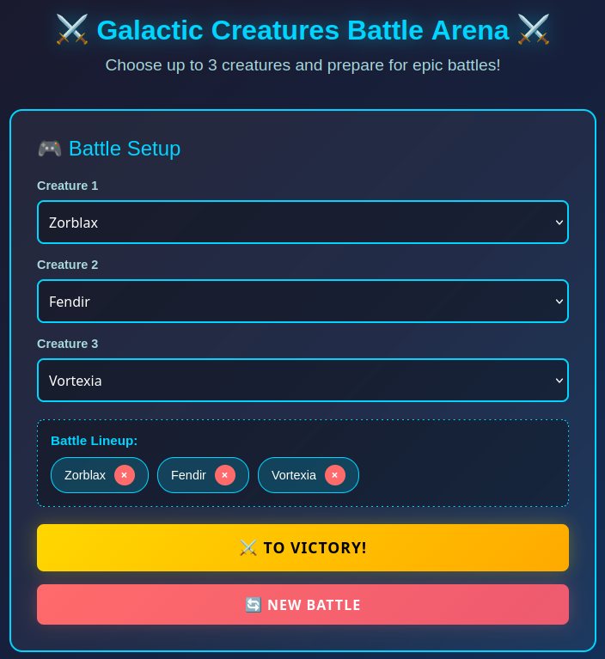


Student Grade Analyzer
Write a TypeScript function that analyzes student grades and returns a grade analysis report. It uses a grading scale from 2 (minimum) to 6 (maximum).

Input Requirements
- Define interface StudentInfo {name, grades[]} to hold student's results.
- Take as input two parameters: StudentInfo and minimum passing grade threshold.

Processing Logic
- Define an interface GradeAnalysisReport {studentName, averageGrade, highestGrade, passed, summary} to hold the results of student's grade analysis.
- Calculate the average grade (number).
- Determine if the student has passed (boolean) true if the average grade ≥ minimum passing grade.
- Identify the highest grade (number).
- Generate the summary: a descriptive message about the student's performance (see the examples below).
- Return an object holding the grade analysis report.
- Validate that all grades are within the valid range [2…6].
- Throw an error in case of invalid grades.

Output Requirements
In case of success return a GradeAnalysisReport object.
In case of error, throw an error with a message:
- If grades array is empty: “Grades array cannot be empty!”
- If any grade is outside the [2…6] range: `Invalid grade: ${grade}. Grades must be between 2 and 6.`
- If student info object is missing: “Student info is missing!”
- If student name is missing: “Student name is missing!”

Summary Message
Generate the summary message with “template literals”. Template literal (or “Template string”) is a modern JavaScript/TypeScript feature that allows you to embed variables and expressions directly into strings. Use the following template literals:
- `${name}'s average grade is ${averageGrade.toFixed(2)}. `
- `Excellent! The student passed with a highest grade of ${highestGrade}.`
- `Unfortunately, the student did not meet the minimum grade of ${minPassingGrade}.`
Follow the format from the examples below.

Input and Output
Input | console.log(analyzeGrades({ name: "Alice", grades: [5, 5, 5, 6] }, 4));
Output | {  studentName: 'Alice',  averageGrade: 5.25,  highestGrade: 6,  passed: true,  summary: "Alice's average grade is 5.25. Excellent! The student passed with a highest grade of 6."  }
Input | console.log(analyzeGrades({ name: "Eve", grades: [2] }, 3));
Output | {  studentName: 'Eve',  averageGrade: 2,  highestGrade: 2,  passed: false,  summary: "Eve's average grade is 2.00. Unfortunately, the student did not meet the minimum grade of 3."  }
Input | try {  console.log(analyzeGrades({ name: "Frank", grades: [5, 1, 5, 4] }, 4));  } catch (error: any) {  console.log(error.message);  }
Output | Invalid grade: 1. Grades must be between 2 and 6.

Hints
- Define the interface StudentInfo.
- Define the interface GradeAnalysisReport.
- Declare the TypeScript function:
  - analyzeGrades(student: StudentInfo, minPassingGrade: number): GradeAnalysisReport { … }
- Validate the input data and throw errors if grades are invalid.
- Calculate the average grade.
- Find the highest grade.
- Determine if the exam was passed.
- Generate the summary message (two cases exam passed / exam not passed).
- Return the result GradeAnalysisReport object.

Judge Submission
Submit your code to the judge: https://alpha.judge.softuni.org/contests/typescript-intro-exercises/5288.

Mystic Potion Calculator
We all love games, don't we? 😉 So, let's get back to gaming.
Write a TypeScript function called calculatePotionEffect(Potion) that takes a Potion type as an input and calculates the effect of the potion.
- The Potion type should be a union type that can represent either a HealingPotion or an EnhancementPotion.
- Each potion type has different properties, described below.
The function should calculate the effect of the potion based on its type and return it as text.

Requirements
Define a union type Potion that includes:
- HealingPotion:
- type: "healing"
- name: a string representing the potion's name
- healingAmount: a number representing the amount of health restored
- EnhancementPotion:
- type: "enhancement"
- name: a string representing the potion's name.
- enhancementAmount: a number representing the enhancement effect
The function should accept a single parameter of type Potion.
It should return a string describing the effect of the potion, according to its type:
- HealingPotion ${potion.name} restores ${potion.healingAmount} health points.
- EnhancementPotion ${potion.name} enhances abilities by ${potion.enhancementAmount} points.

Input and Output
Function Call | Output
let healingPotion: HealingPotion = {  type: "healing",  name: "Elixir of Life",  healingAmount: 50  };  calculatePotionEffect(healingPotion); | Elixir of Life restores 50 health points.
let enhancementPotion: EnhancementPotion = {  type: "enhancement",  name: "Strength Brew",  enhancementAmount: 25  };  calculatePotionEffect(enhancementPotion); | Strength Brew enhances abilities by 25 points.

Hints
Start with this sample Potion definition:
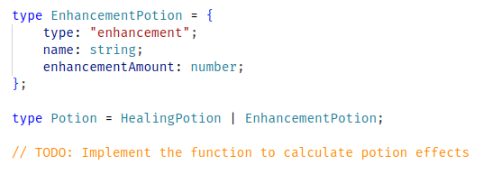
Finish with the other potion type and implement the calculation logic.
Idea: consult Copilot for suggestions on additional types of potions to incorporate into the union. Go further and ask him to create greater unions of Buff – Debuff potions. Or go even further and try writing some by yourself 😉
Visualization with HTML
Prompt the AI to make an interactive HTML page from the script:
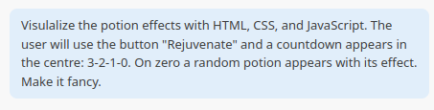
Results might be surprisingly pleasant:
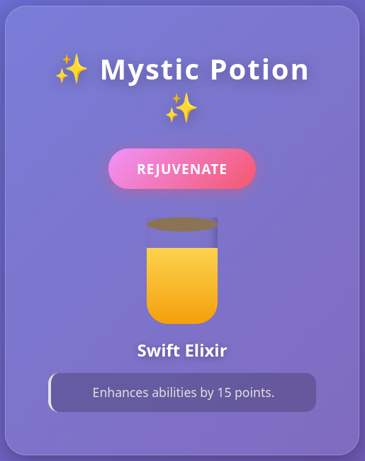

Judge Submission
Submit your code to the judge: https://alpha.judge.softuni.org/contests/typescript-intro-exercises/5288.

Falling Objects Game
Your task is to create a simple game called "Falling Objects". On a rectangular playing field of size 800 x 500 objects that fall down from the top of the field to the bottom. Different game objects may have different geometric forms, dimensions (size), speed of movement, and moving algorithms (simple "fall down" or more complex). The player stays at the bottom of the playing field and can move left and right. The goal of the player is to avoid the falling game objects in order to survive as long as possible. This is a sample how the game may look like:
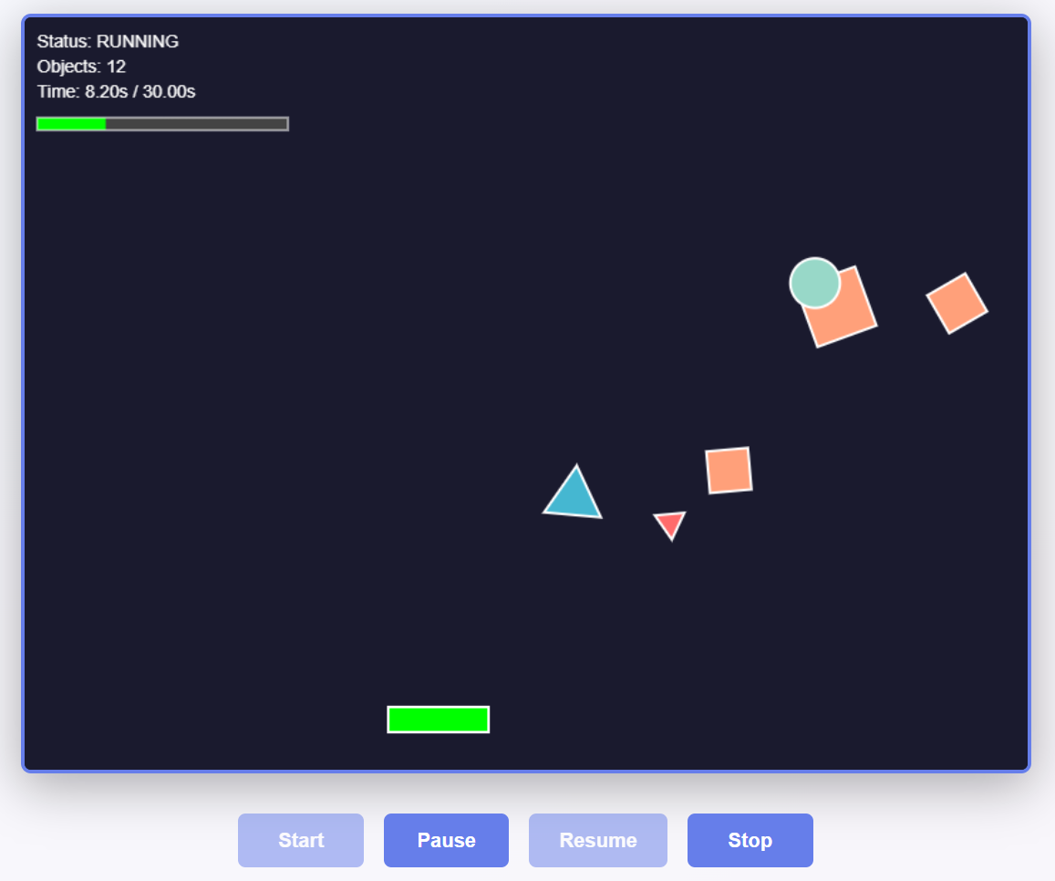
Your goal is to implement the game using TypeScript classes, by following these steps:
- Define an interface Point {x, y}. It will represent a location on the game field.
- Define an interface Bounds {x, y, width, height}. It will represent the bounds for the game objects, used for collision detection.
- Define an interface GameObject {location, speed, move(), getBounds(), hasCollision(gameObject)}. It will implement the abstraction of "game object": an object, which has location, speed and can move according to its own moving algorithm. Game objects can detect collisions with other game objects.
- Define a class FallingCircle {location, speed, radius, color, borderColor}. This is a colorful circle with certain size, which falls down with a fixed speed.
- Define a class RotatingFallingSquare {location, speed, size, color, borderColor}. This is a colorful square with certain size, which falls with a fixed speed, while rotating around its center.
- Define a class RotatingFallingTirangle {location, speed, size, color, borderColor}. This is a colorful triangle with certain size, which falls with a fixed speed, while rotating around its center.
- Define a class Player {location, width, height, color, borderColor, moveLeft(), moveRight()}.
- Define a class Level {difficulty, duration, levelObjects}. Levels have difficulty, duration and a sequence of game level objects.
- Define a class LevelObject {startTime, gameObject}. Each level holds a sequence of level objects: game objects that are created in the game field a certain time (in milliseconds) after the start of the level.
- Create a level generator (by duration, difficulty): generate a random sequence of level objects, appearing withing the given duration. Difficulty controls how many objects appear for the provided duration.
- Define a class GameField {width, height, gameObjects}. It will hold the active objects in the game.
- Define a class Game to hold the game field and to implement the game logic:
  - Generate levels initialize the field game loop.
  - In the game loop: render all objects, check for collisions, check for end of the level repeat the same after a reasonable amount of time (frames per second).
- Configure Vite, in order to use TypeScript with HTML and CSS together for this project.
- Implement a game rendering system, based on HTML canvas, using the existing classes and game logic.
The game ends after all levels are taken or the player collides with a game object during some of the levels.

Invoice Tracker
Your goal is to create an "Invoice Tracker" app, which will hold and track all the invoices of a certain company. These screenshots will give you an idea of what we want to build at the end:
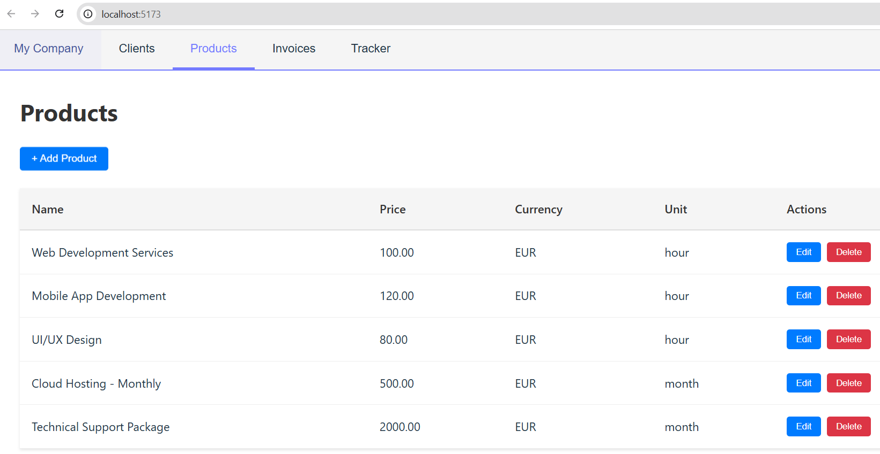
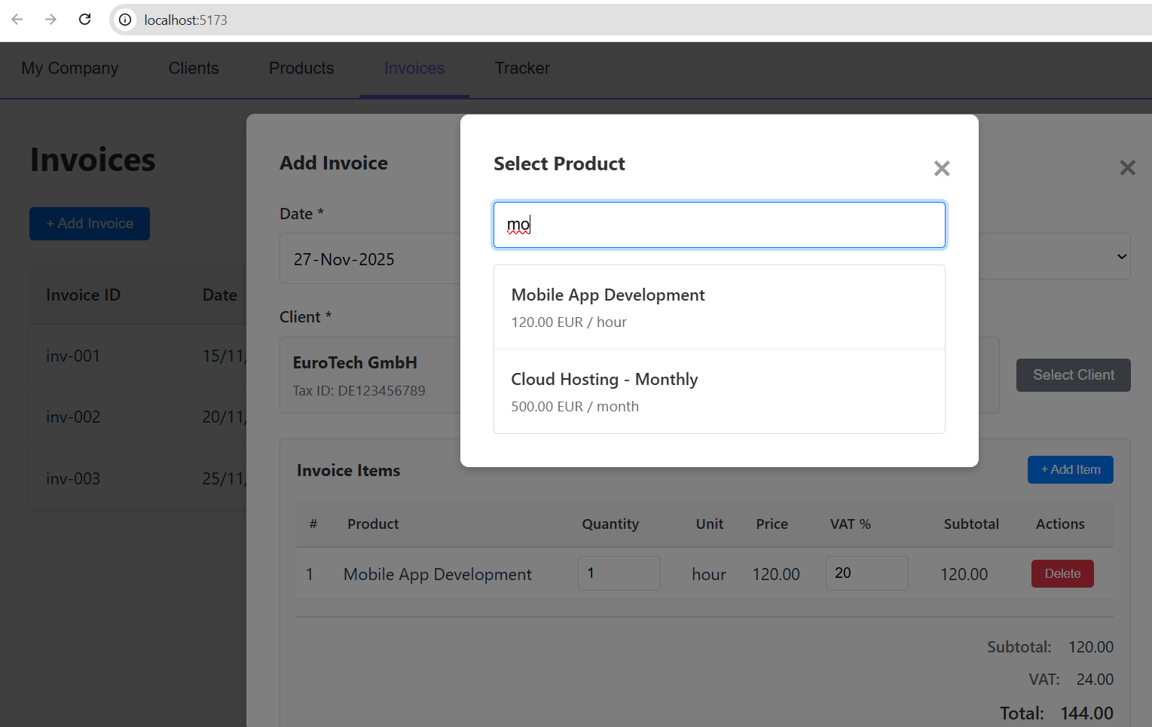
To build the app, follow the steps below:
- Create an empty Vite + TypeScript app.
- Implement tabs with navigation between tabs.
  - Implement several tabs (initially empty), which will hold different screens of the app:
    - My Company
    - Clients
    - Products
    - Invoices
    - Tracker
  - Keep the code for each tab in separate folder. Split the code (HTML, CSS and JavaScript) to separate files, e.g. tabs/clients/clients.html, tabs/clients/clients.ts, …
  - Use the entire screen to render tab contents.
- Define the data layer (data store) of the invoice tracker app as TypeScript data types:
  - Define type: Company {name, id, tax id, address, manager, IBAN}
  - Define type: Currency (BGN, EUR, USD)
  - Define type: Product {name, price, currency, unit}
  - Define type: InvoiceItem {product, quantity, VAT rate, value wihout VAT}
  - Define type: Invoice {id, date, issuer, recipient, items, amount subtotal, VAT, total amount}
  - Keep these files in separate folder "data".
  - Keep all app data in arrays and objects in the memory: companyProfile, clients, products, invoices.
  - Generate sample data, so that app will not be empty at the start.
- Implement the tab "My Company":
  - Display the company profile as a table: name, id, tax id, address, manager, ISBN.
  - Add [Edit] button. Implement an editor for my company data.
  - Add a field "Default VAT value" (in percents)
- Implement the tab "Clients":
  - Display the client companies as a table.
  - Add [Edit] and [Delete] buttons for each table row.
  - Implement add / edit / delete.
  - Implement delete confirmation as modal popup.
- Implement the tab "Products":
  - Display the products as a table.
  - Add [Edit] and [Delete] buttons for each table row.
  - Implement add / edit / delete.
  - Implement delete confirmation as modal popup.
- Implement the tab "Invoices":
  - Display the invoices as a table.
  - Add [Edit] and [Delete] buttons for each table row.
  - Implement the client selection as modal popup listing the clients (with search).
  - Implement add / edit / delete.
  - Implement delete confirmation as modal popup.
  - Implement the invoice items editor as table (visible when we edit an invoice). Implement add / edit / delete. Implement the product selection as modal popup listing the products (with search).
- Implement the tab "Tracker":
  - Display the invoices as a table, with a column "Paid" (yes / no).
  - Implement a simple way to mark an invoice as paid or not.

