Homework M6: Observability and Troubleshooting
Main goal is to build further on what was demonstrated during the practice
For the successful completion of the tasks, you will need a simple (two or three node) cluster like the one used during the practice

Tasks *
Try to solve the following set of tasks (files are in part3/ folder):
- Try to solve scenario 2 and make the application work again
- Try to solve scenario 3 and make the application work again
- Try to solve scenario 4 and make the application work again
As usual, you are not obliged to complete all the tasks but try to tackle as many as possible

Proof
Prepare a document that shows what you accomplished and how you did it. It can include (not limited to):
- The commands you used to achieve the above tasks
- A few pictures showing intermediary steps or results
- Any configuration files and/or manifests
I Problem with the cluster:
1.Building the cluster
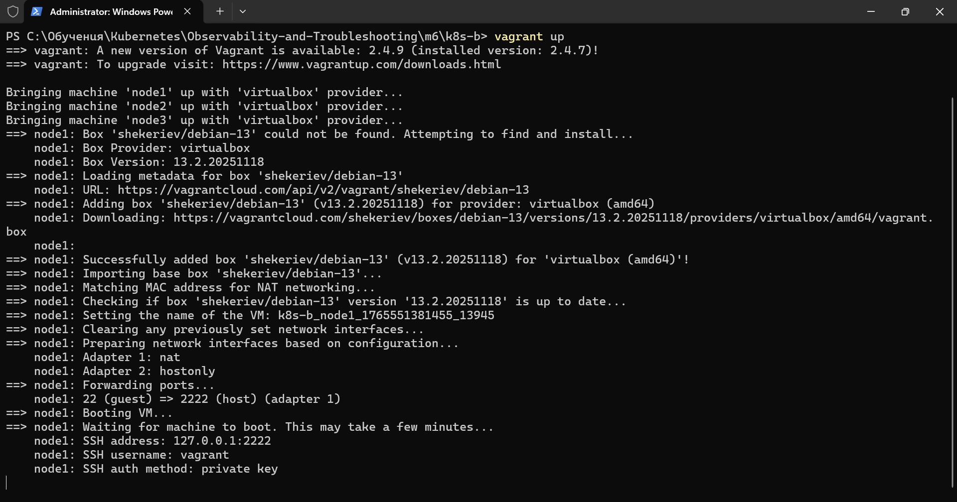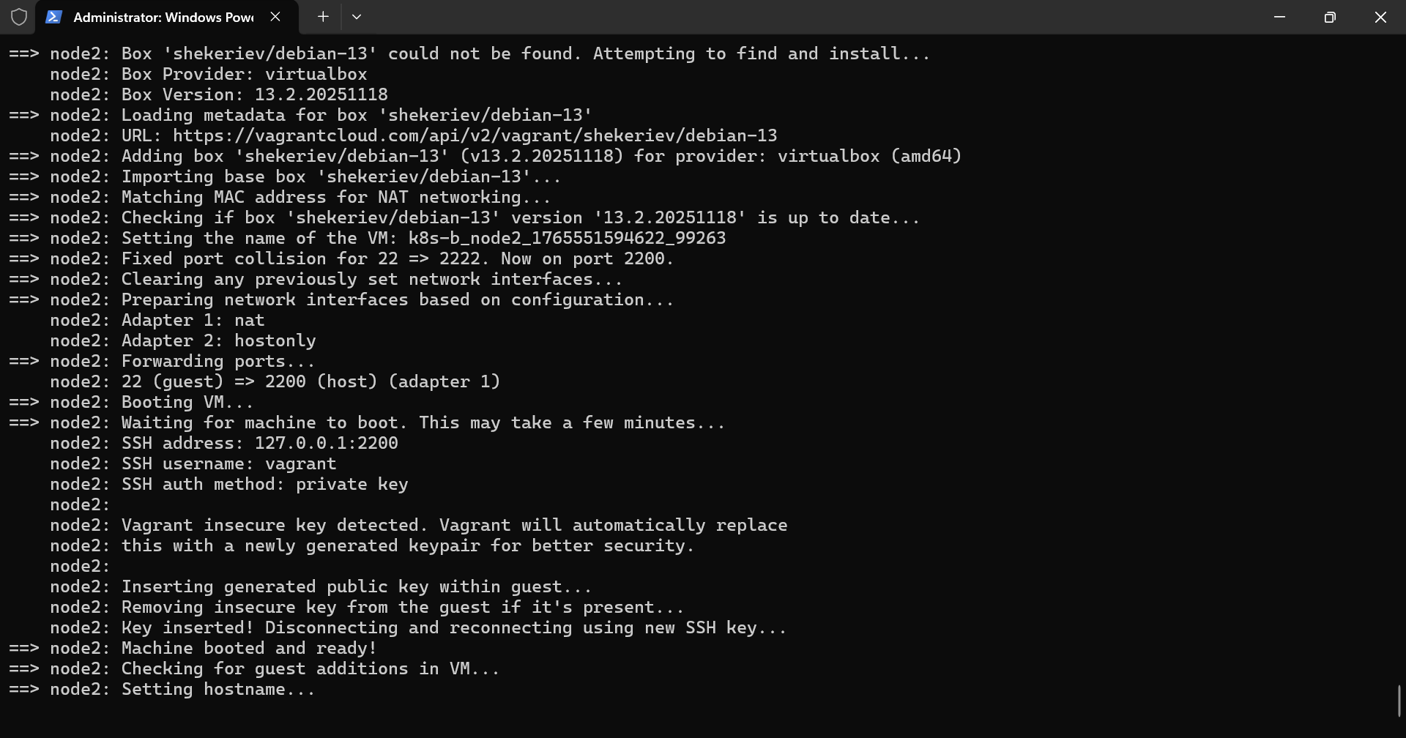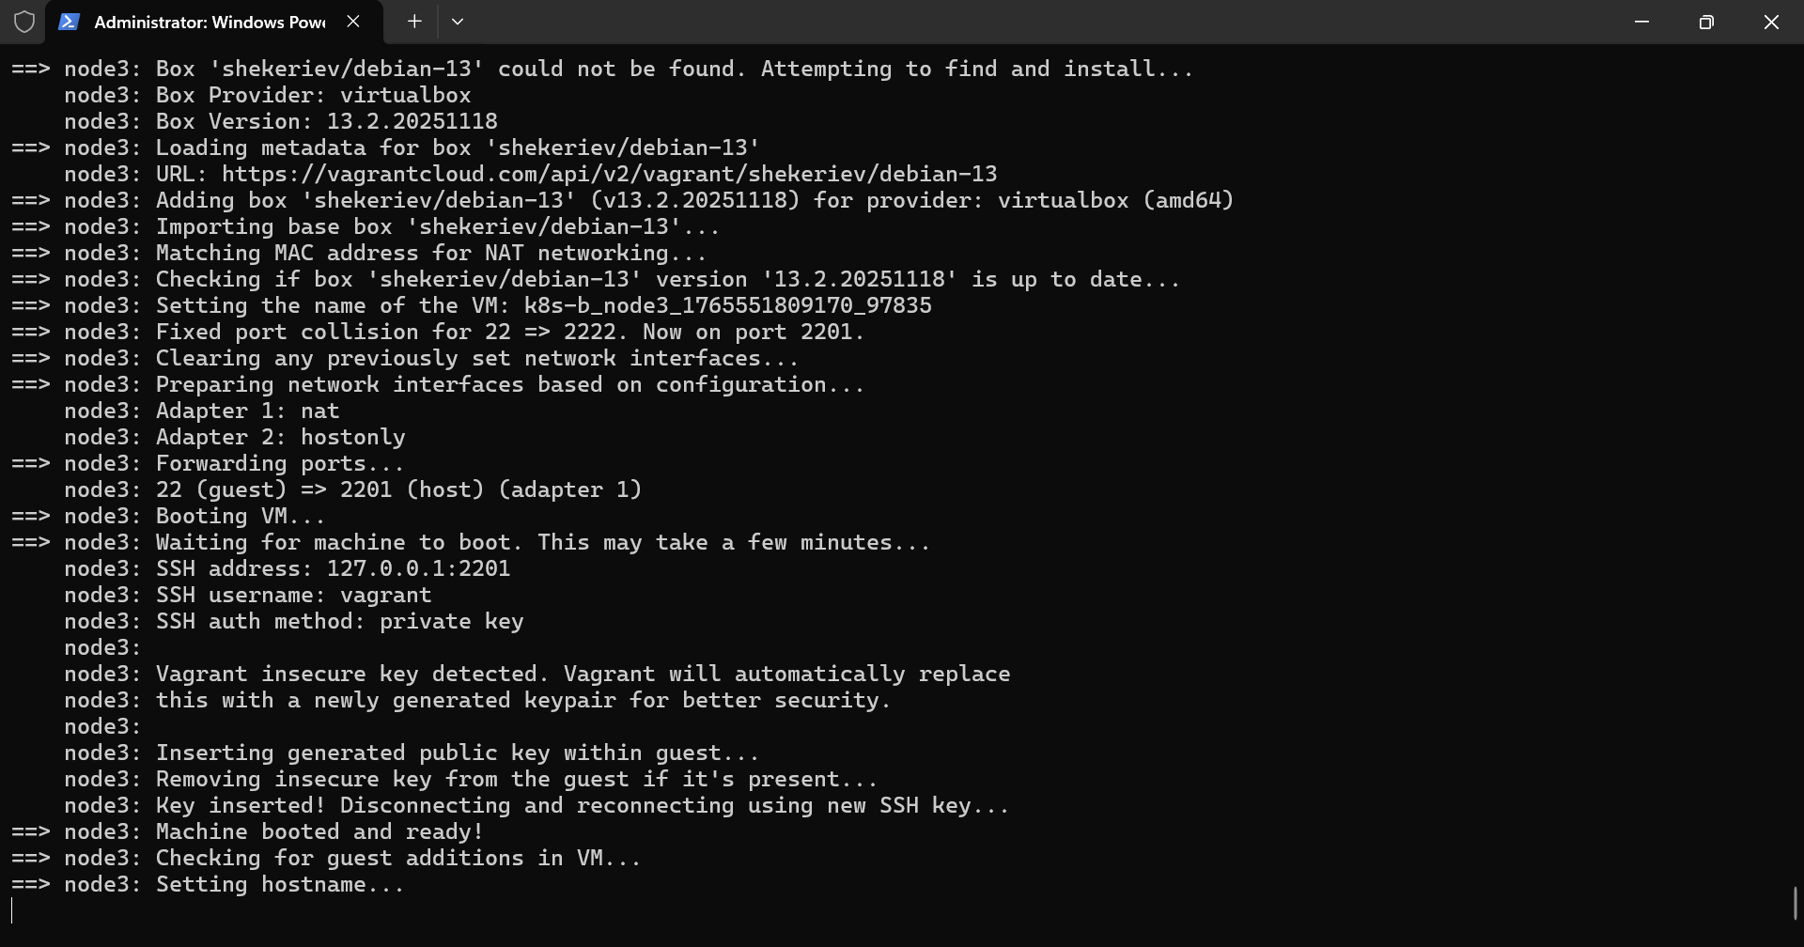
2.Accessing the cluster and finding the scenario files
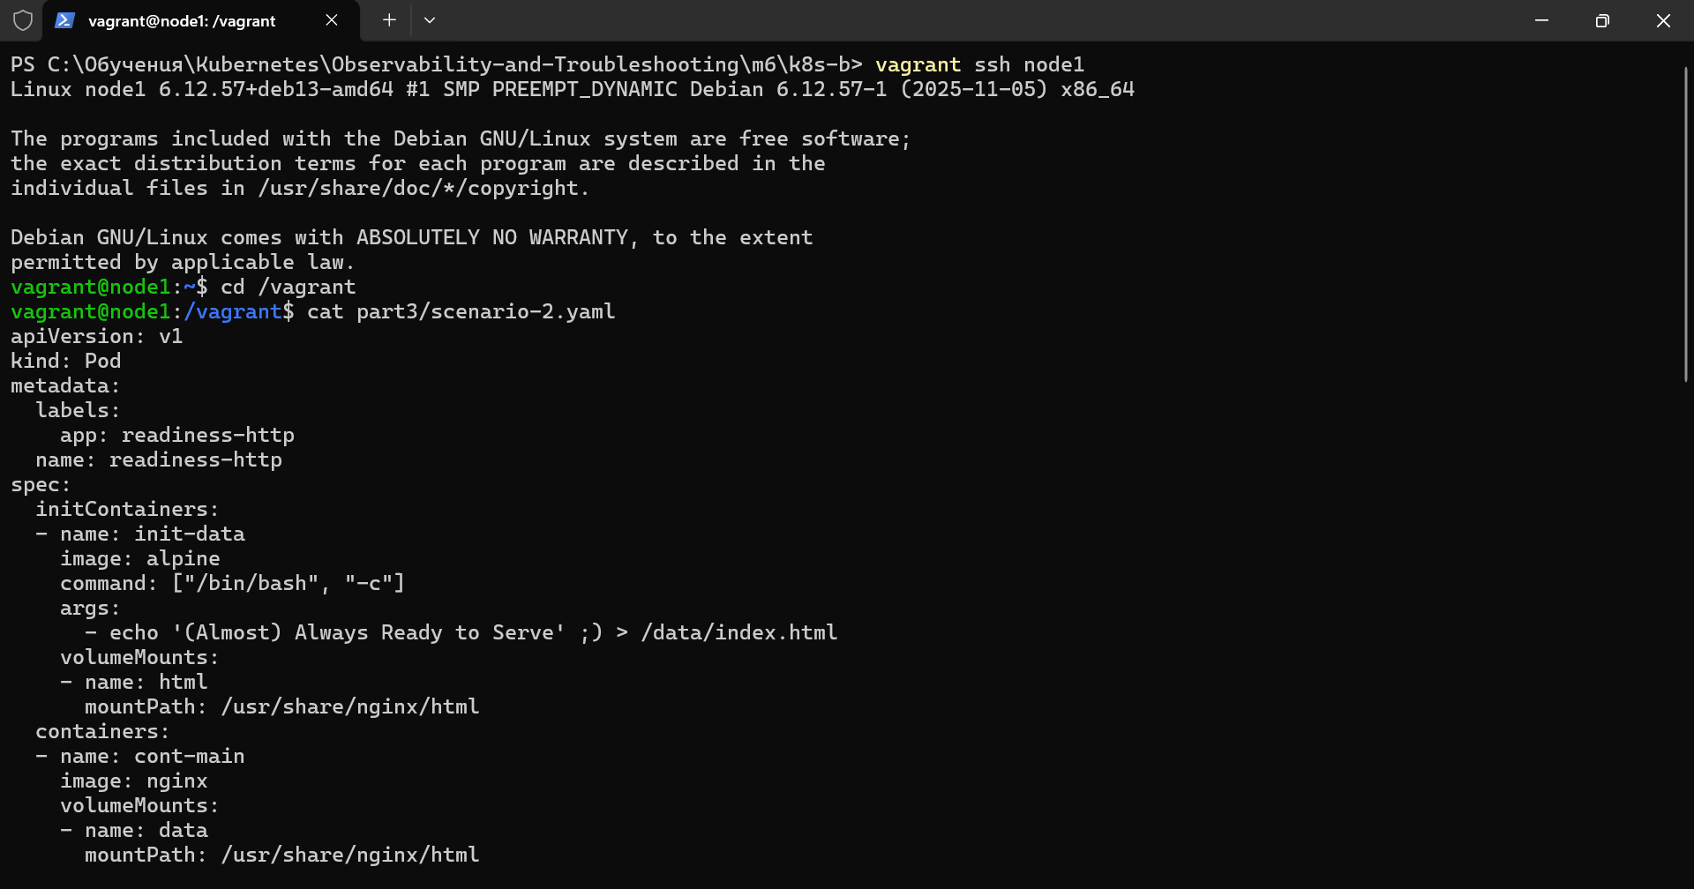
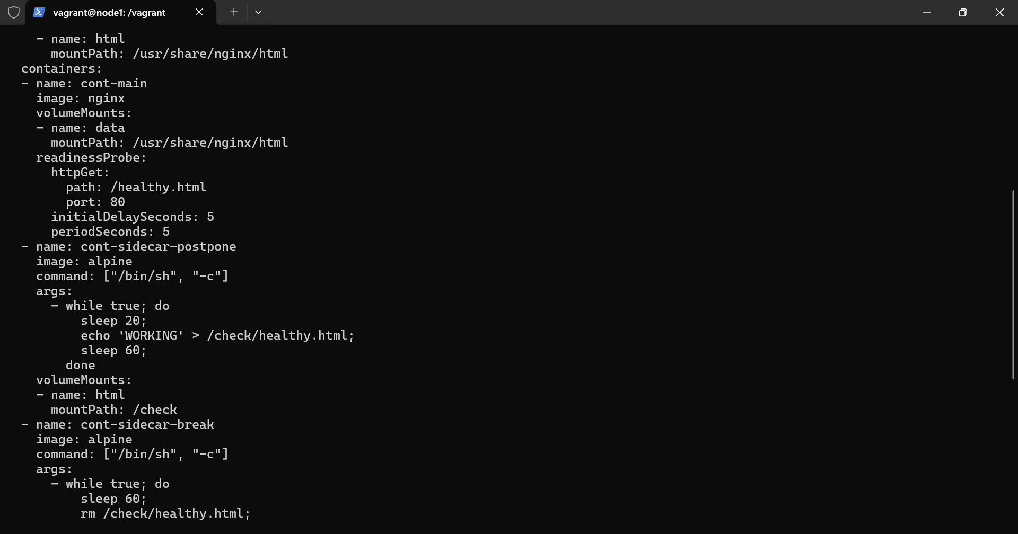
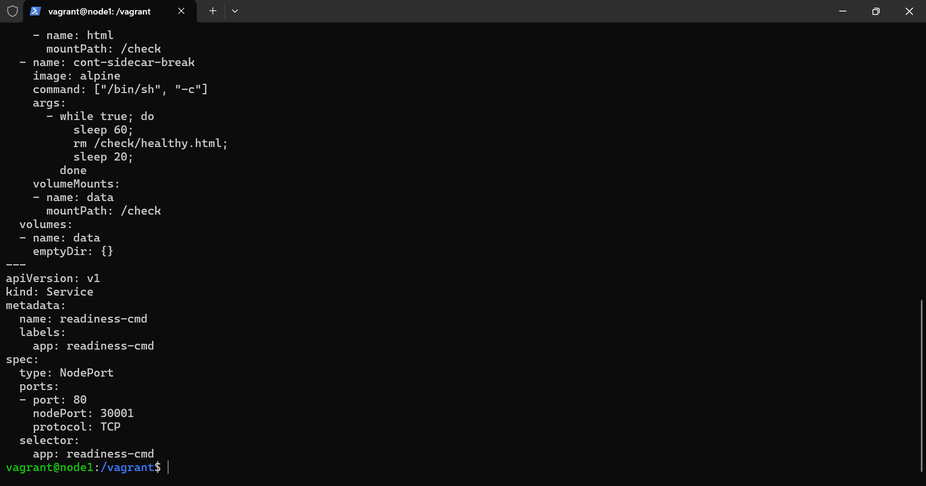
3.The cluster was not initialized so trying to initialize the cluster
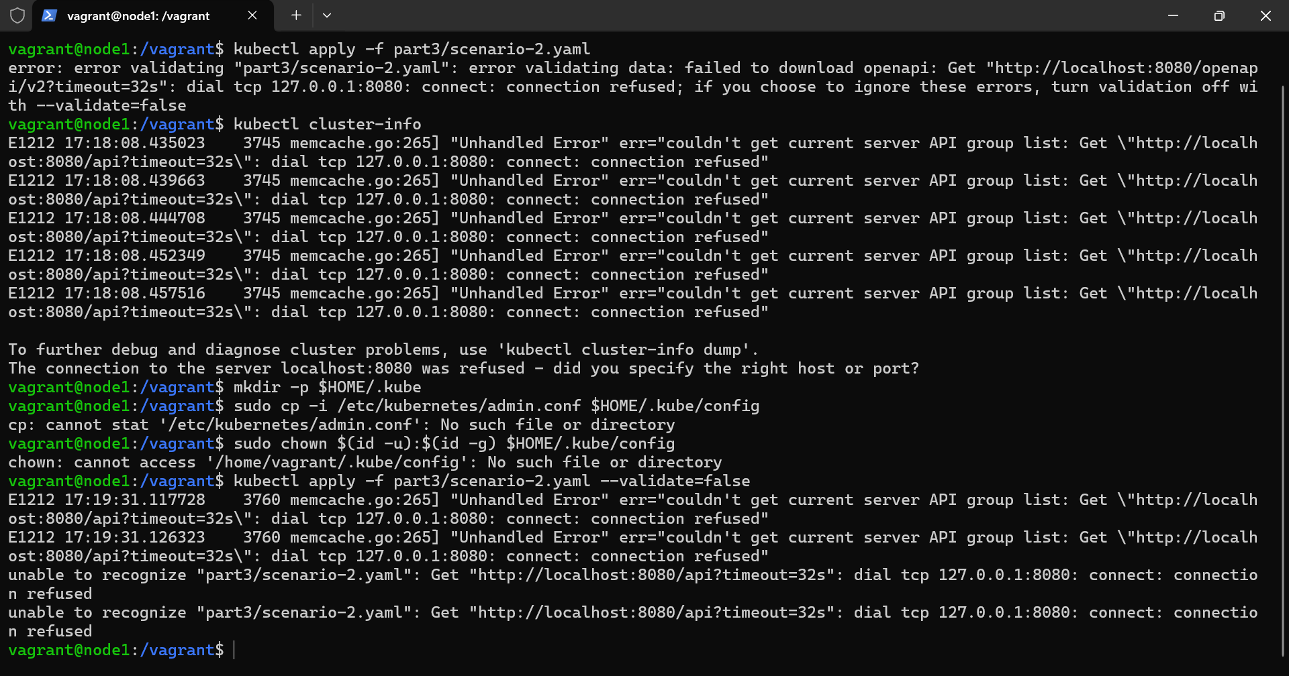
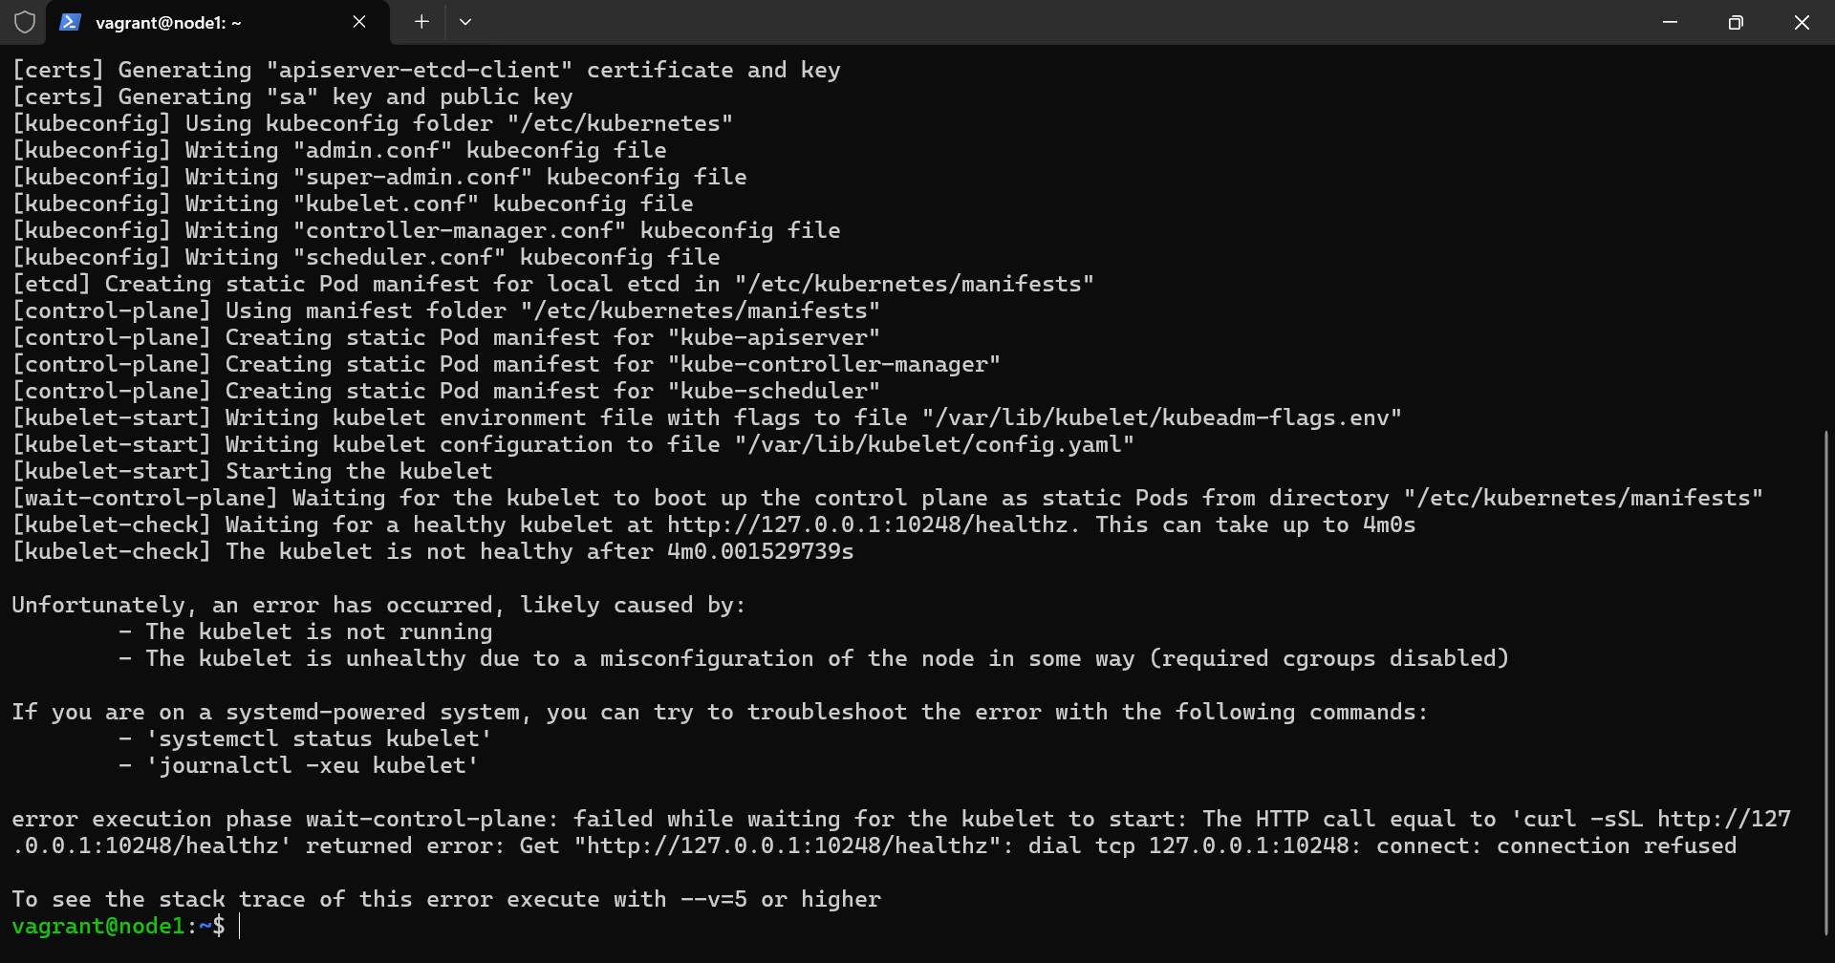
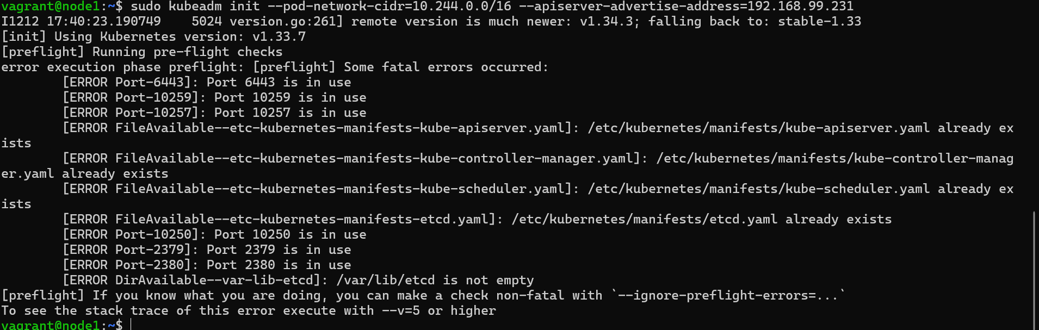
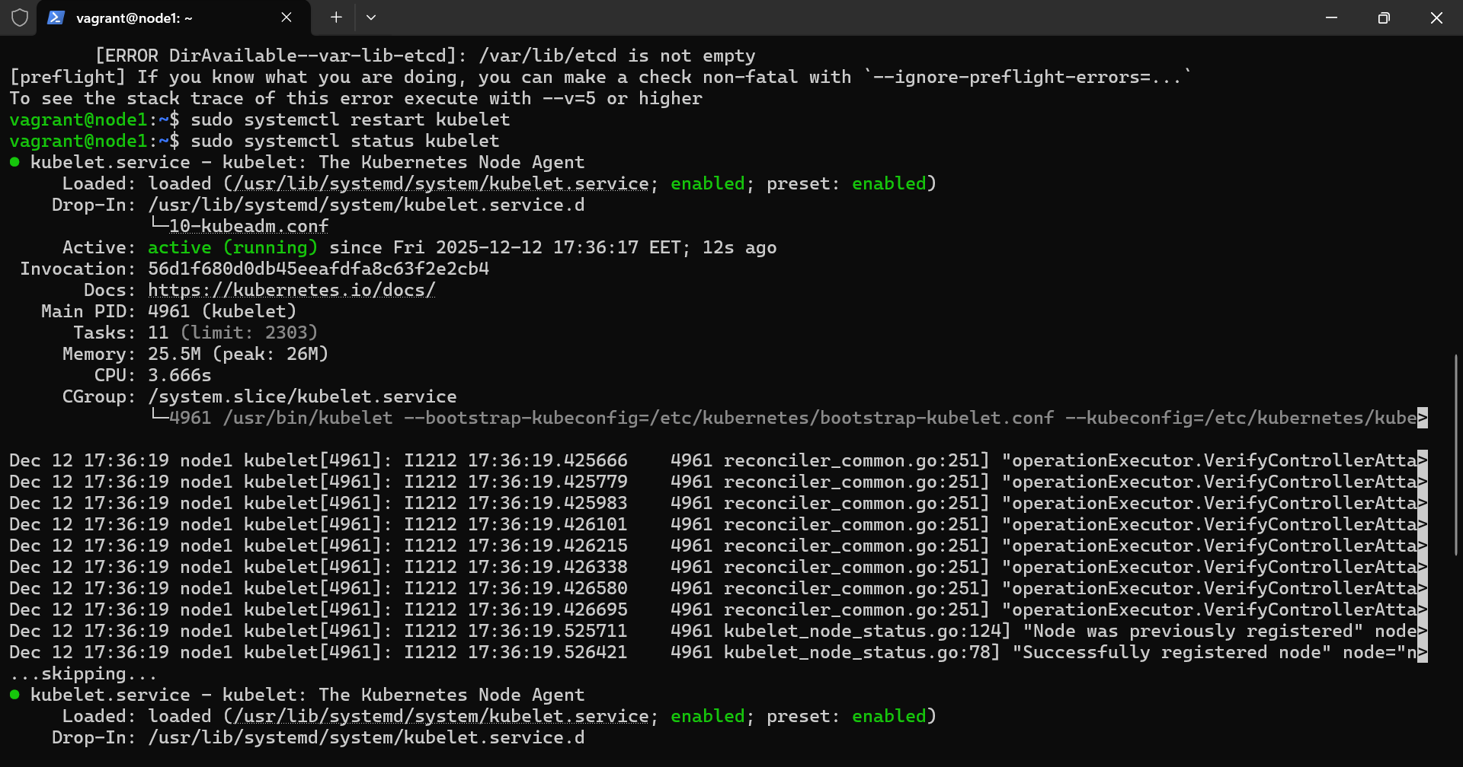
4.Reseting kubeadn and initializing the cluster
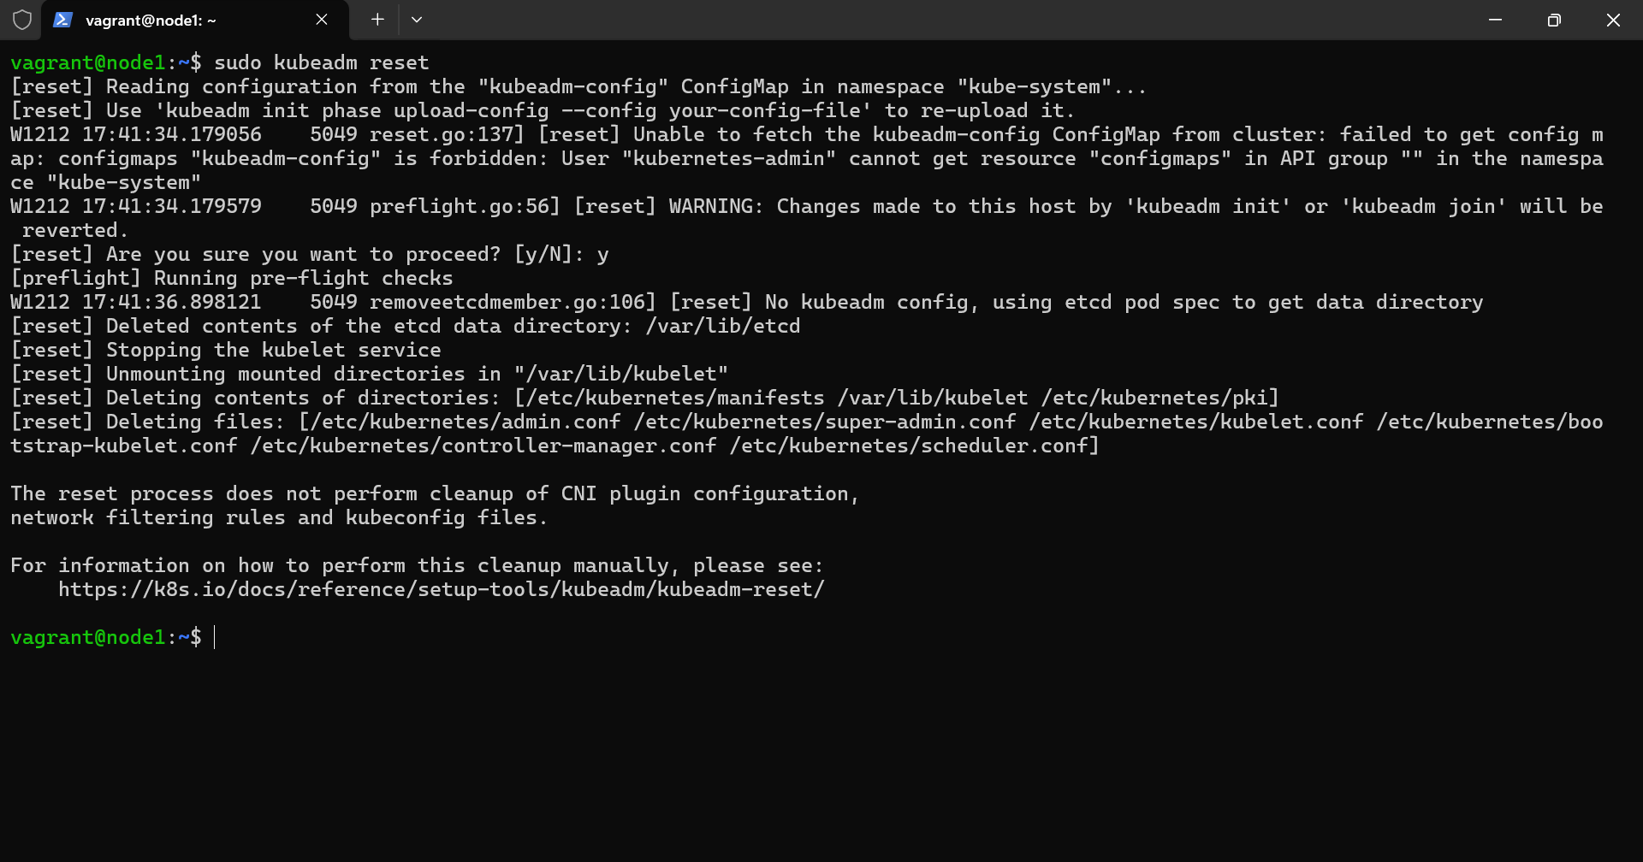
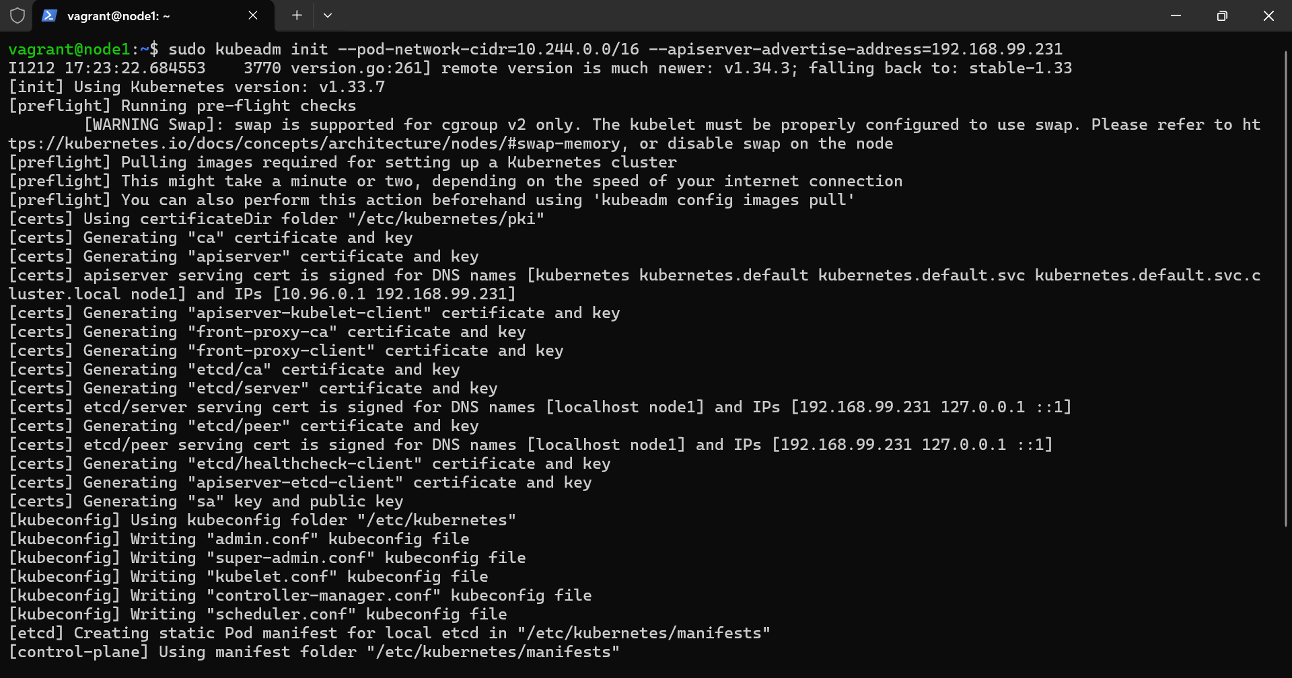
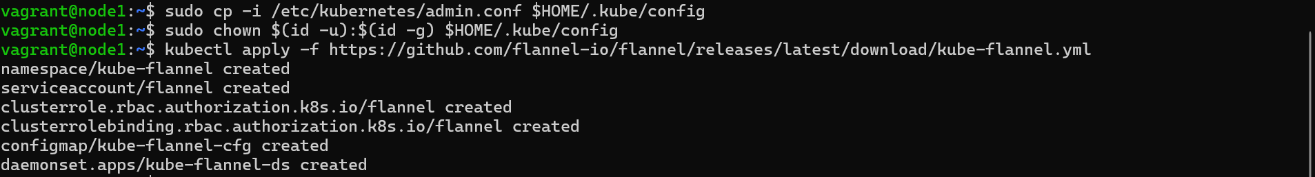
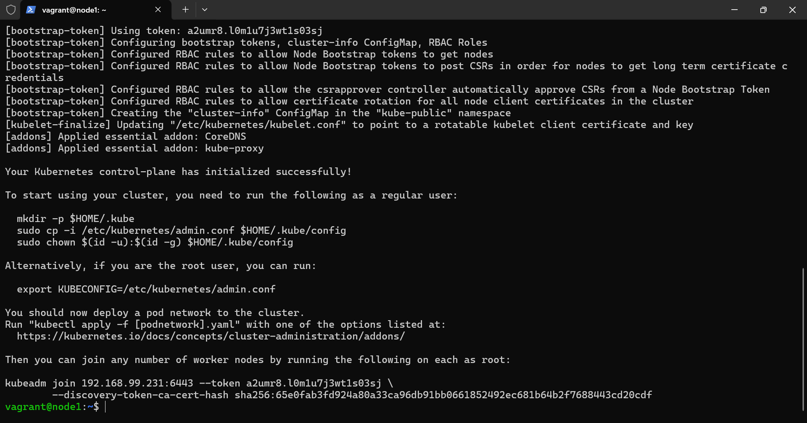
5.Joining other nodes to our cluster
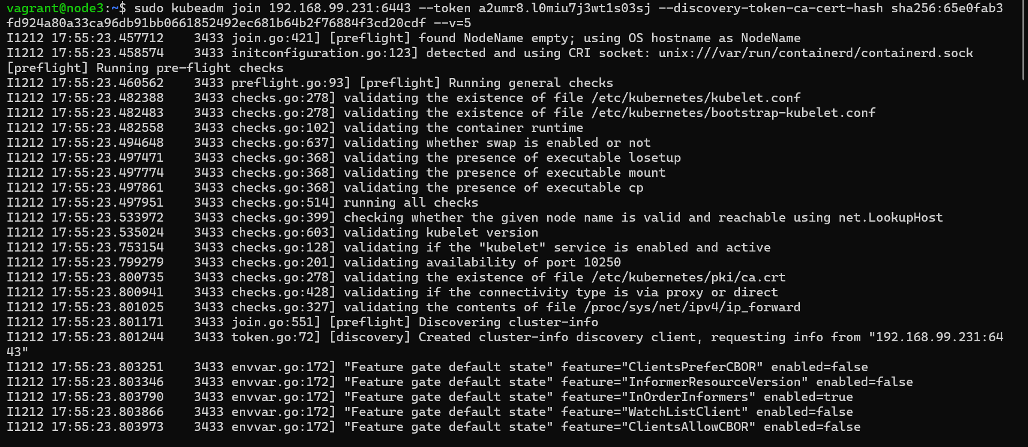

II.Scenario-2
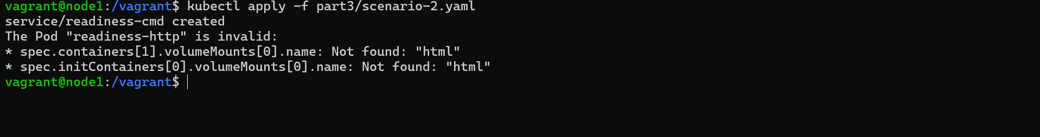
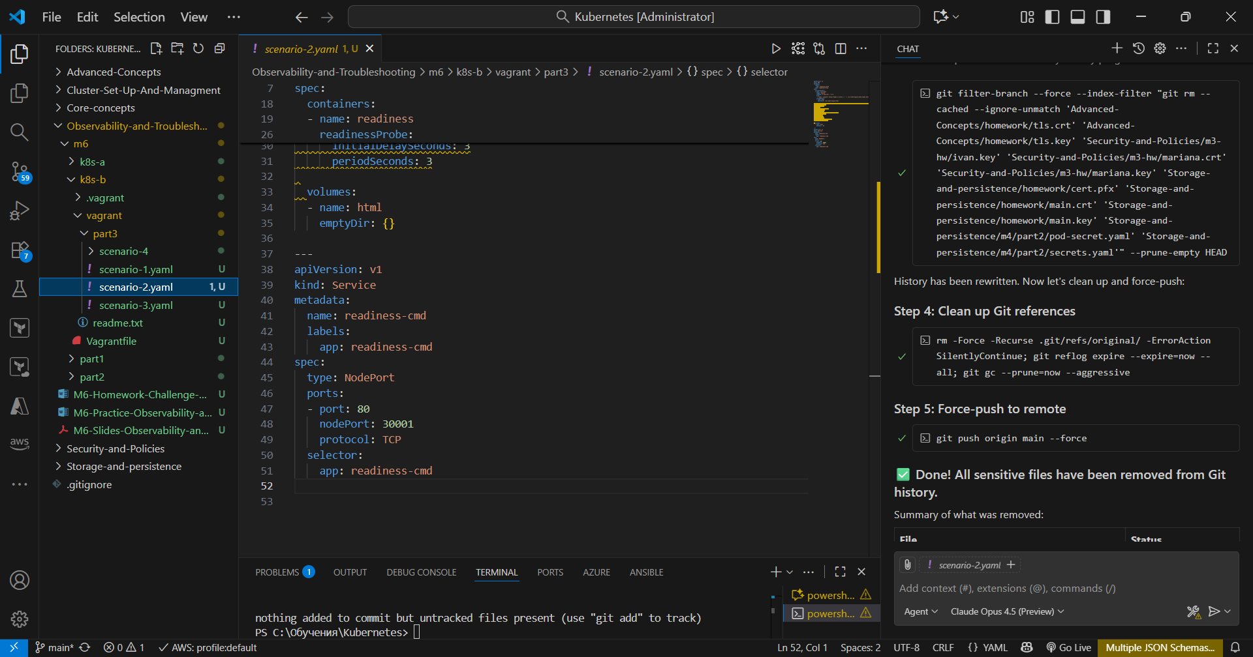
There was a taint on control-plane-node
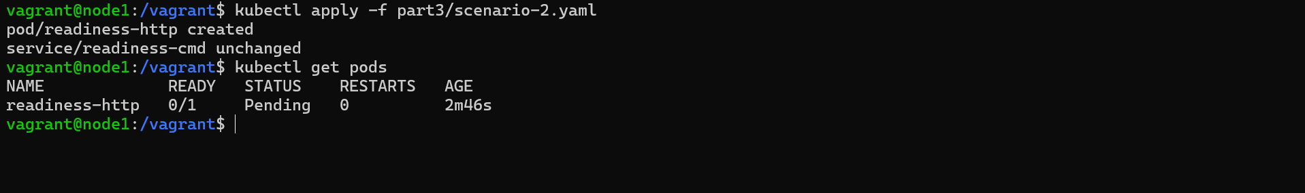
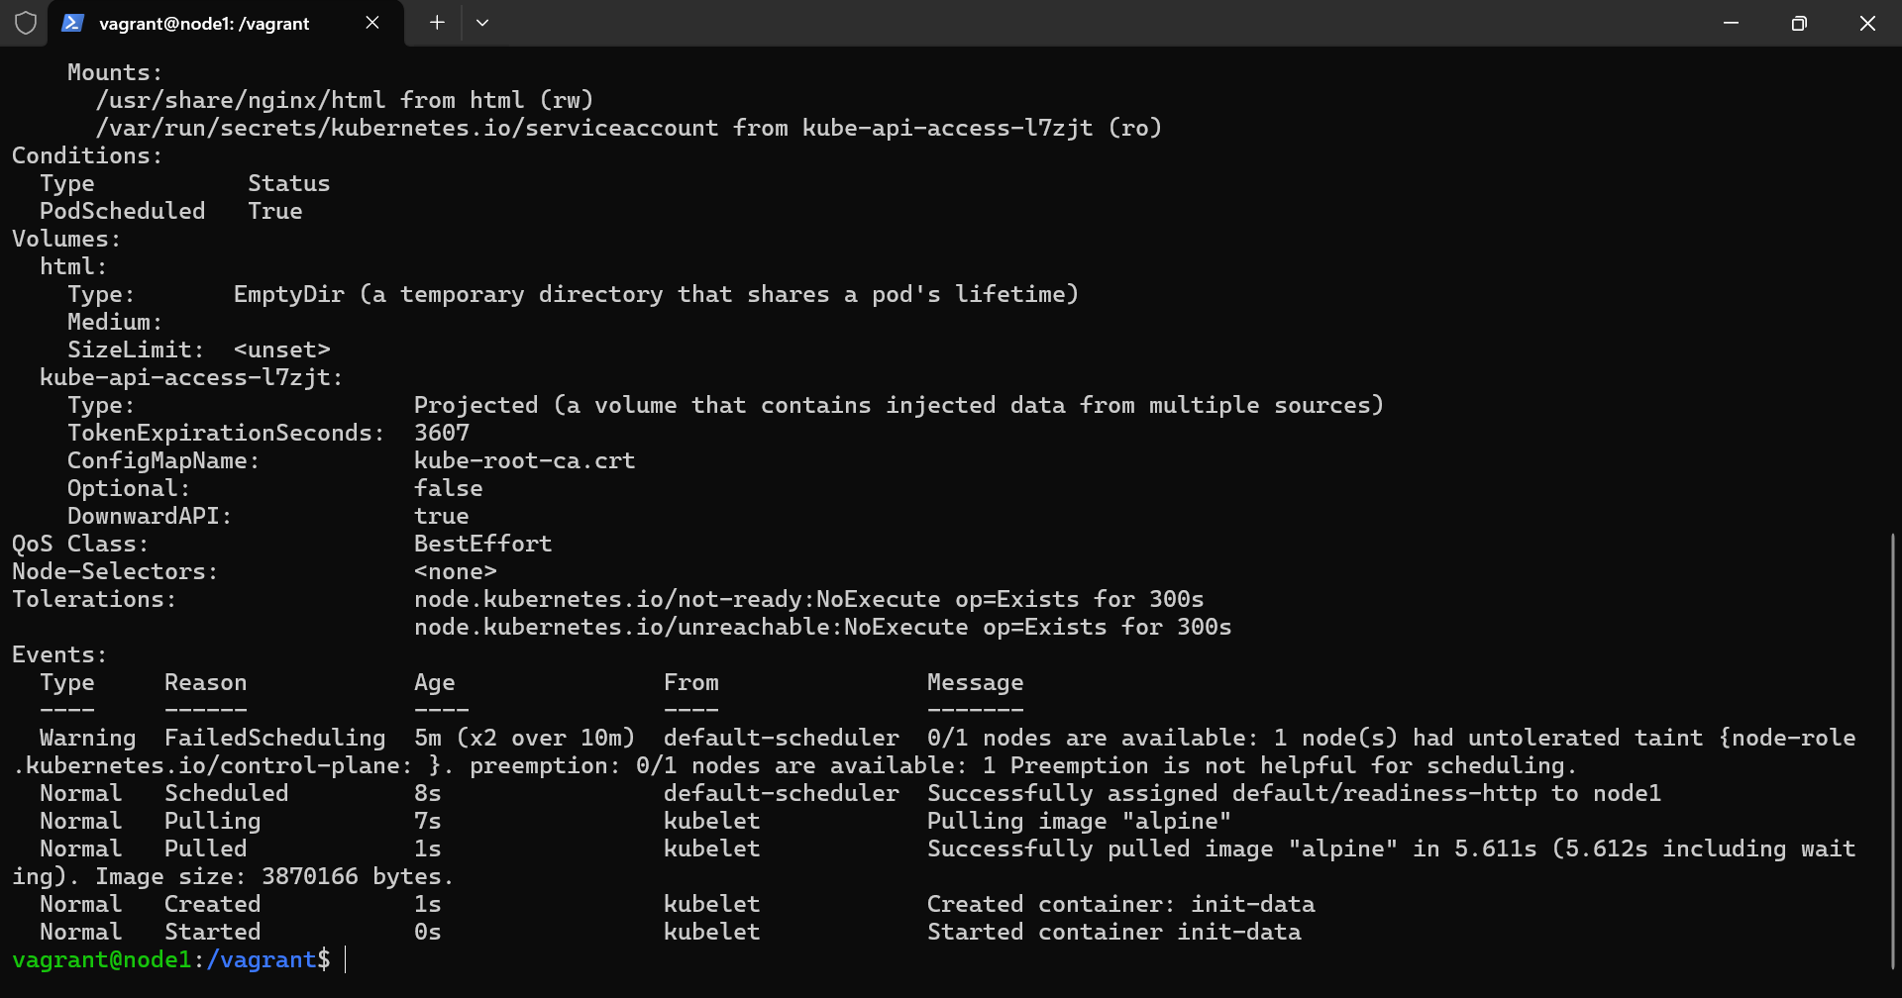
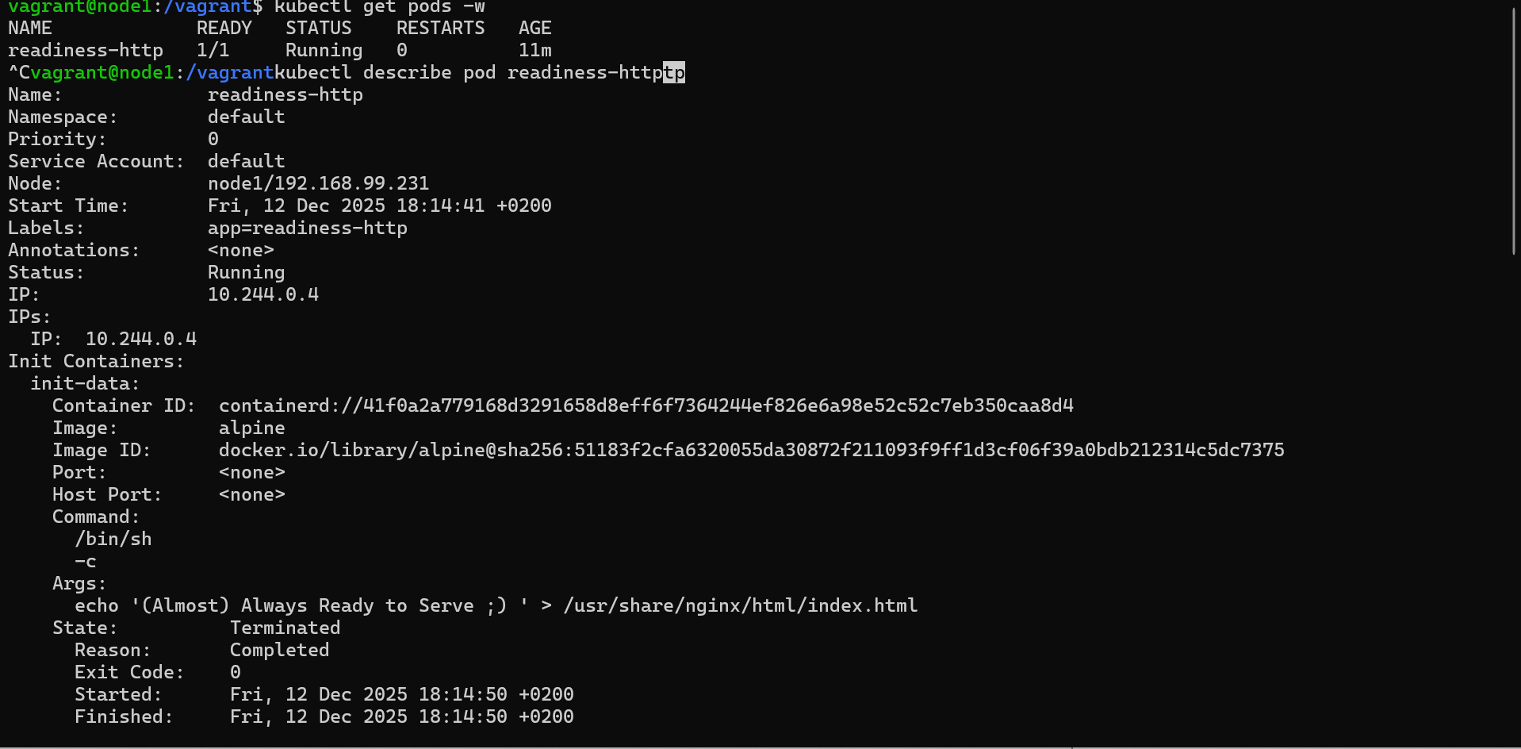
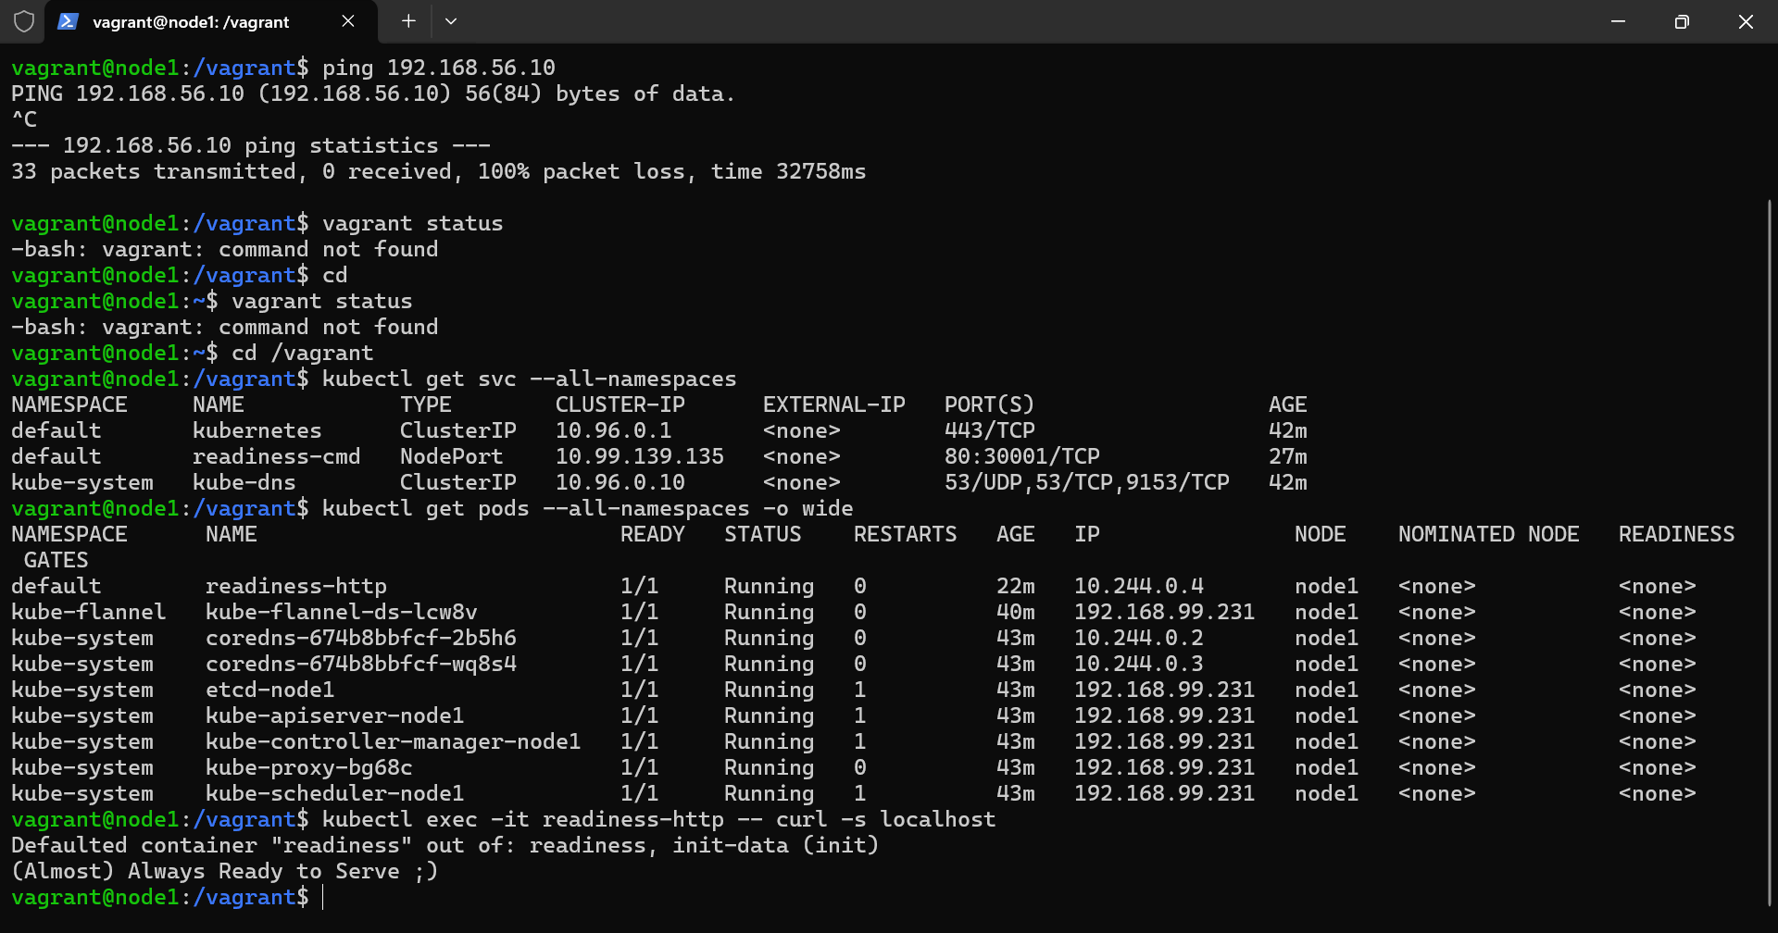
That seems legit to me but still don’t feel quite right

III.Scenario-3.yaml
