Homework M1: Core Concepts
Main goal is to build further on what was demonstrated during the practice
For the successful completion of the tasks, you will need a simple (single node) cluster as the one used during the practice

Tasks *
- Execute a series of commands to
  - Create a namespace named homework
  - Create a homework-1 pod in that namespace that uses this (shekeriev/k8s-oracle) image and set two labels on it (all at once) – app=hw and tier=gold
  - Remove the tier=gold label with a separate command
  - Create a homework-2 pod in that namespace that uses this (shekeriev/k8s-oracle) image
  - Add a label to the second pod app=hw with a separate command
  - Set annotation on both pods with the following content purpose=homework
  - Create a homerwork-svc service to expose both pods on port 32000 of every node in the cluster
- Create manifests for every object (the namespace, the two pods, and the service) from task 1 and apply them one by one
- Is there a way to submit those manifests at once? Find and demonstrate two ways of doing it
- Optional: Try to translate the attached docker-compose.yml file to a set of Kubernetes objects and the corresponding manifest(s)
- Optional: Give the KIND tool a try and spin up a Kubernetes cluster in a Docker instance. Once done, start the pod (task 1.b) and the service (task 1.g) either imperatively or with manifests (for example, the ones from task 2)
* There are five tasks. You are free to solve any number of them. Please keep in mind, that before continuing with the next task in the line, you should remove all objects from the previous one

Proof
Prepare a document that show what you accomplished and how you did it. It can include (not limited to):
- The commands you used to achieve the above tasks
- A few pictures showing intermediary steps or results

1.Creating namespace named homework
2. Creating a homework-1 pod in that namespace that uses this (shekeriev/k8s-oracle) image and set two labels on it (all at once) – app=hw and tier=gold
3. Removing the tier=gold label with a separate command
4. Creating a homework-2 pod in that namespace that uses this (shekeriev/k8s-oracle) image
5.Adding a label to the second pod app=hw with a separate command
6. Setting annotation on both pods with the following content purpose=homework
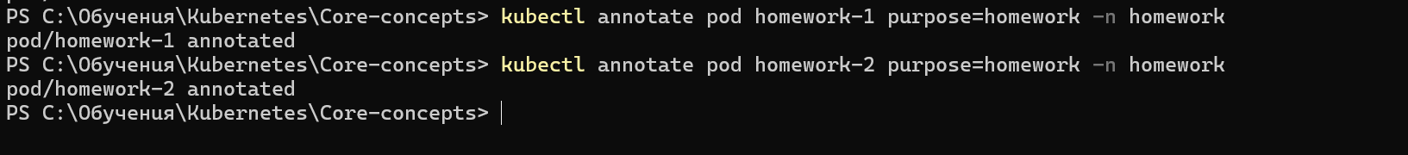
7. Creating a homerwork-svc service to expose both pods on port 32000 of every node in the cluster
8.Always check your work
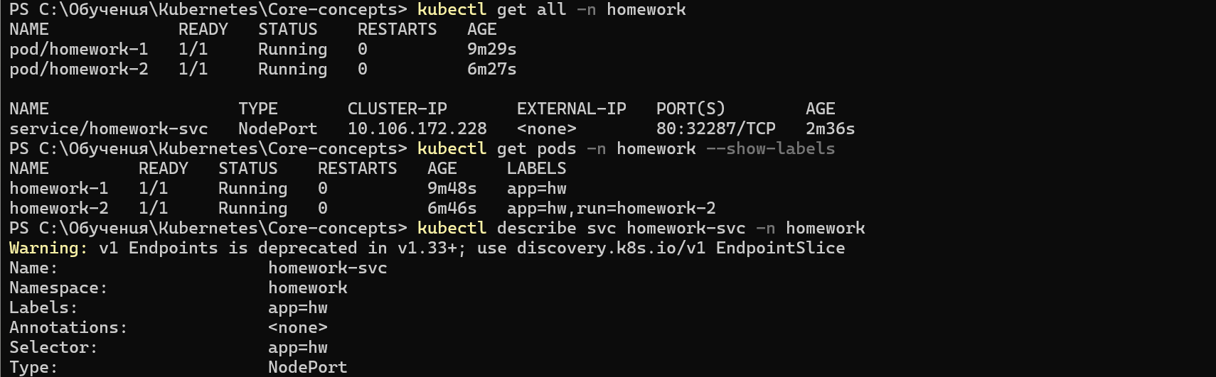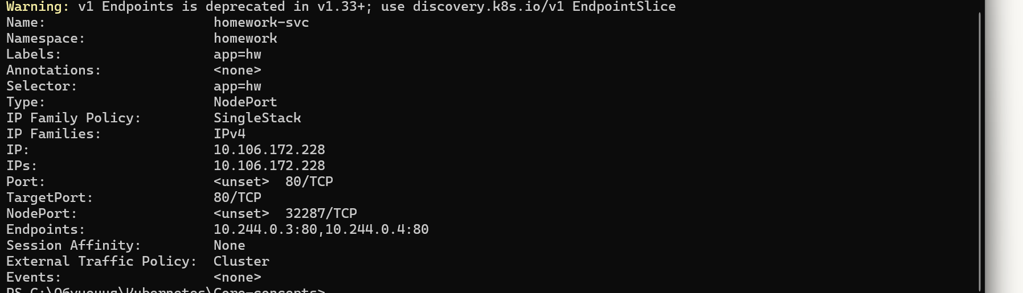
9. Creating manifests for every object (the namespace, the two pods, and the service) from task 1 and apply them one by one(for the purpose of this exercise I will use VSCode)
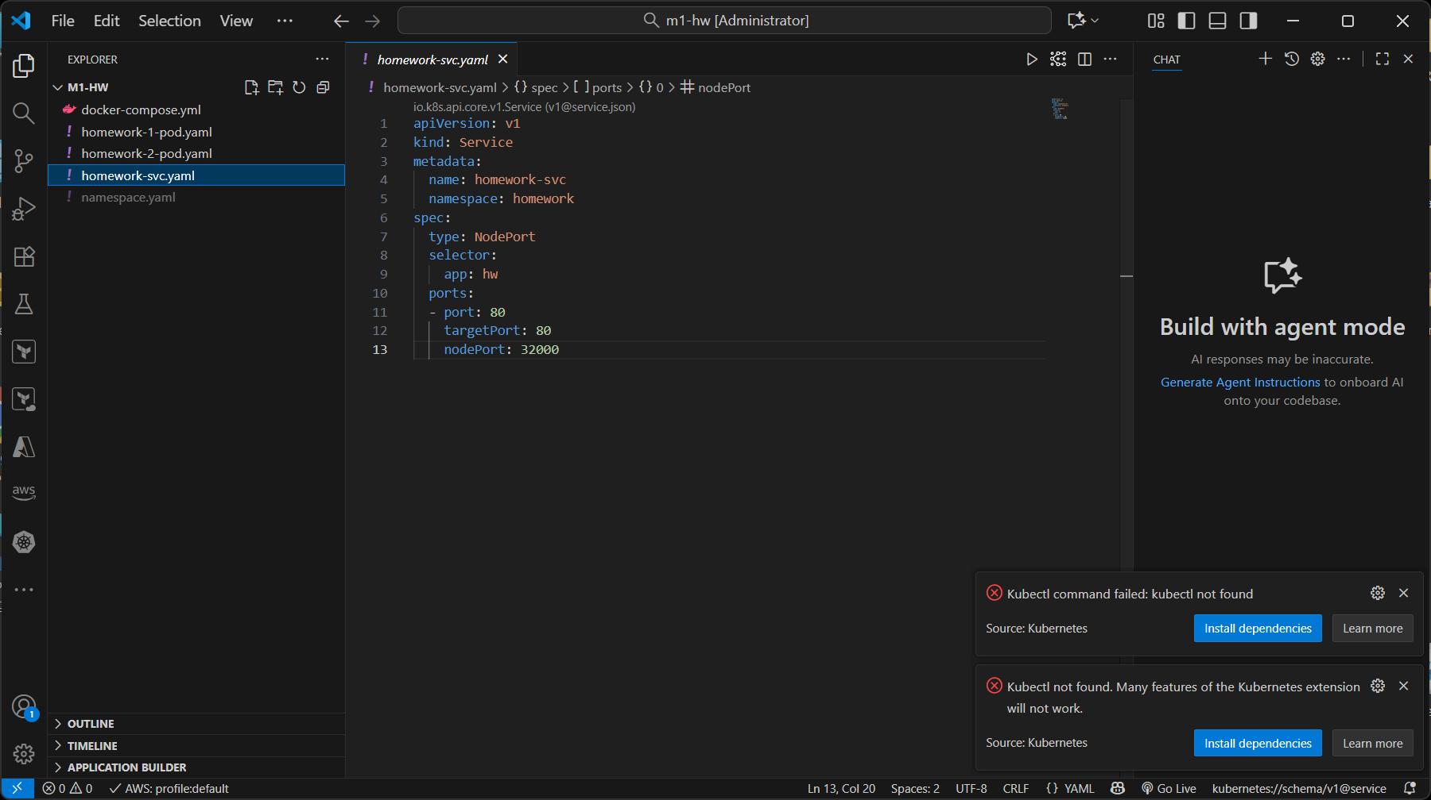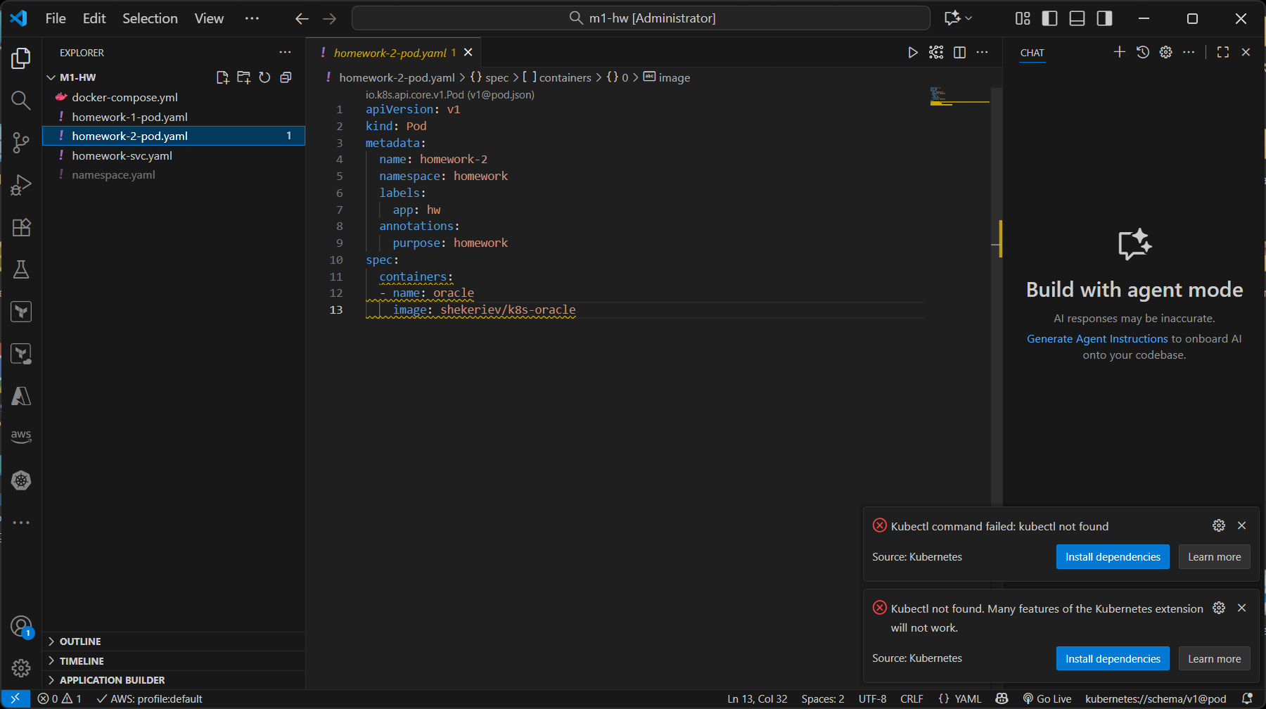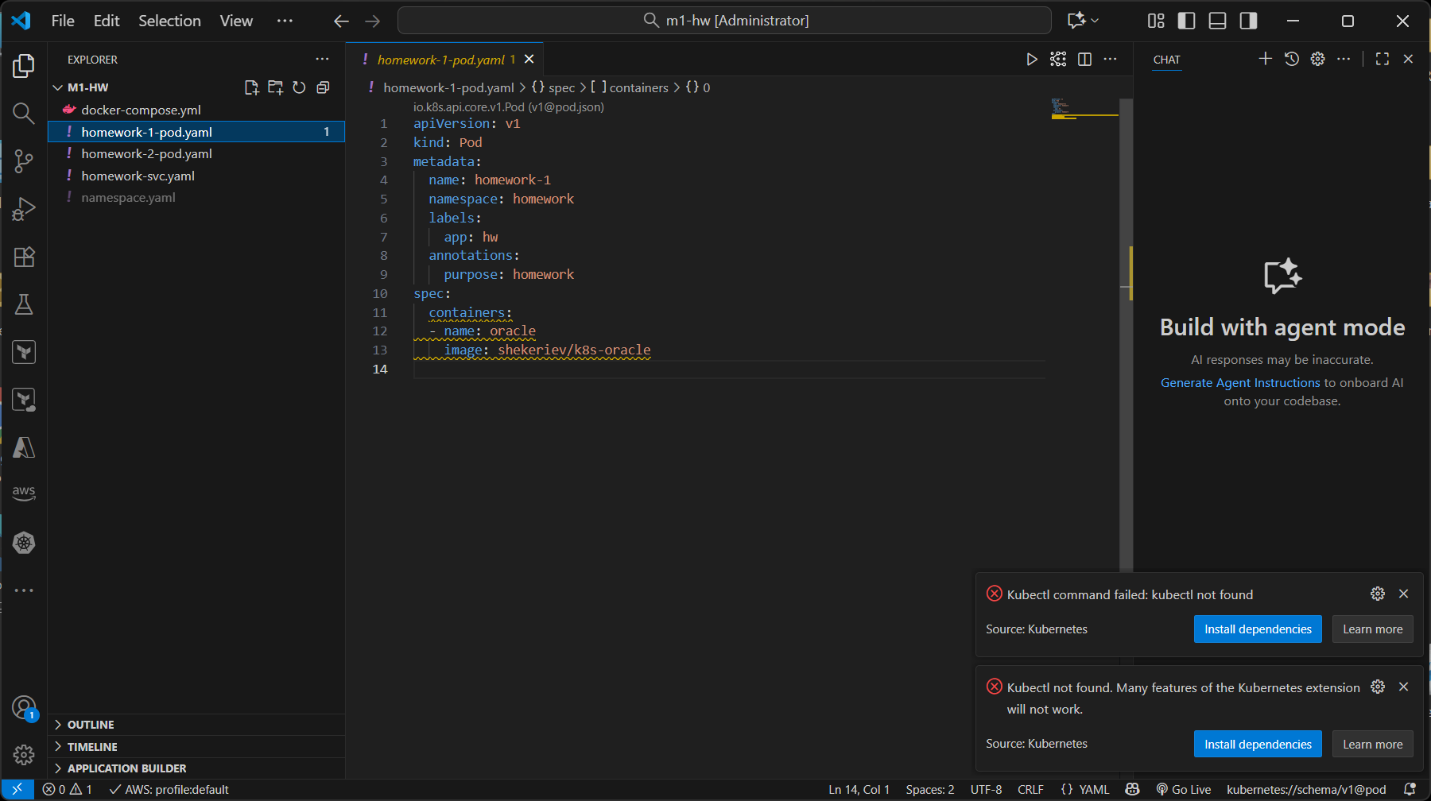
10. Is there a way to submit those manifests at once? Find and demonstrate two ways of doing it
10.1. Apply Multiple Files in One Command
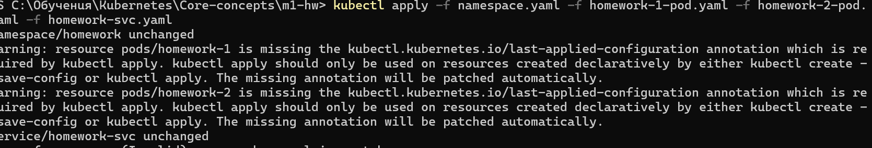
10.2. Apply All Files in a Directory
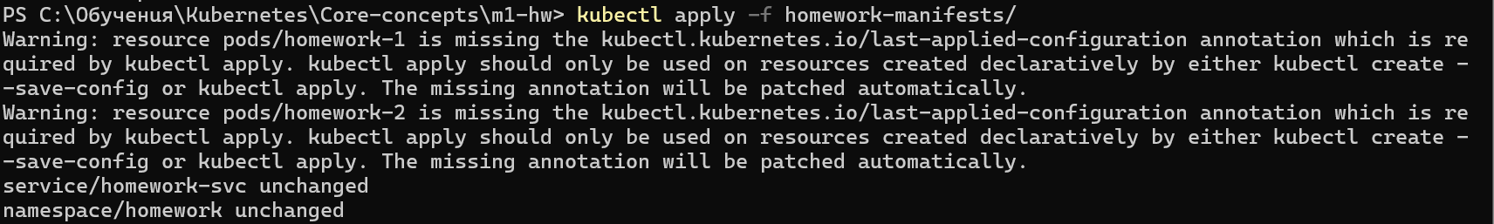
10.3. Multi-Document YAML File
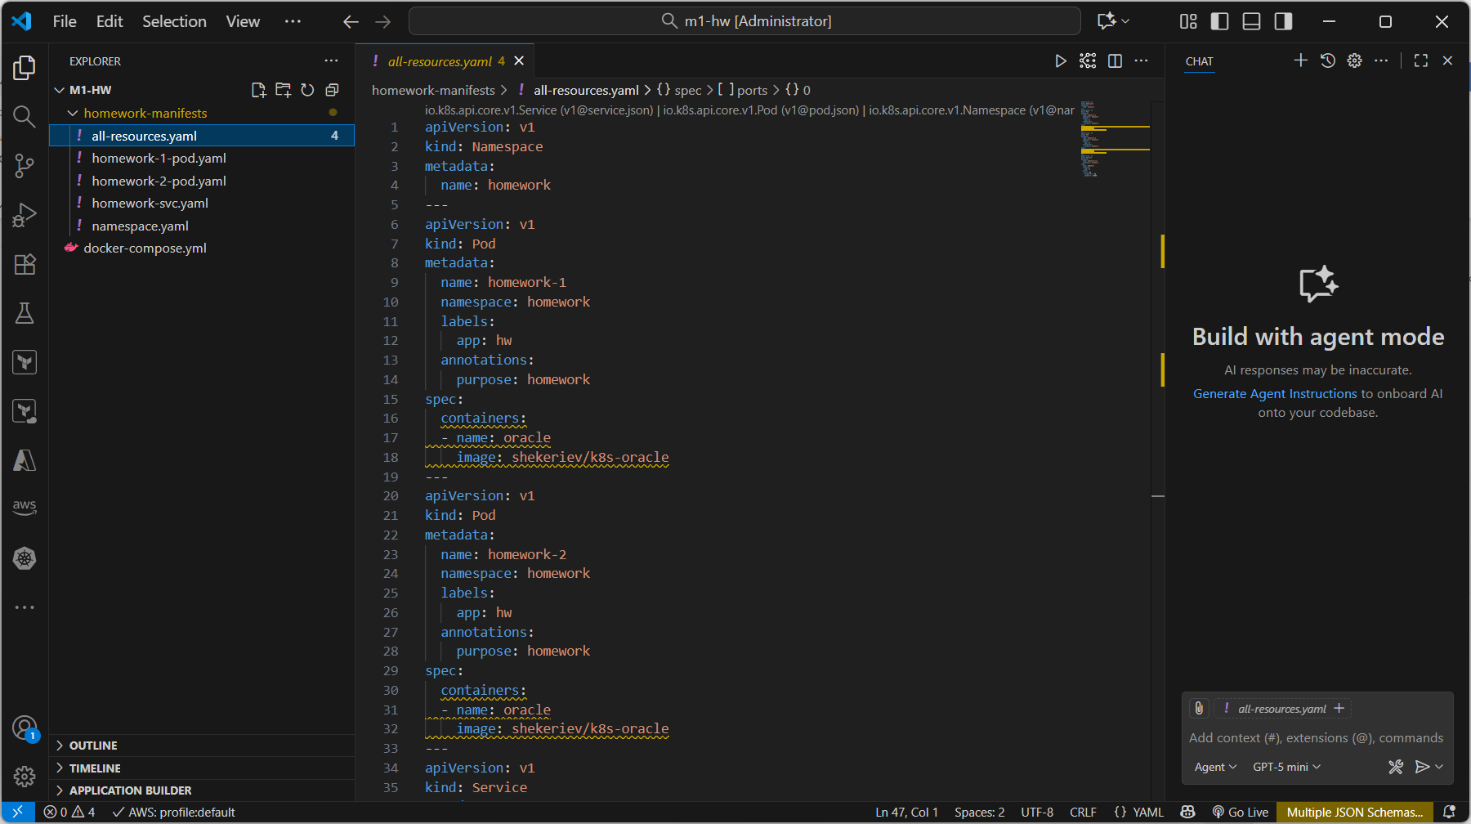

11. Trying to translate the attached docker-compose.yml file to a set of Kubernetes objects and the corresponding manifest(s). I admit I used AI tool to help me with that one
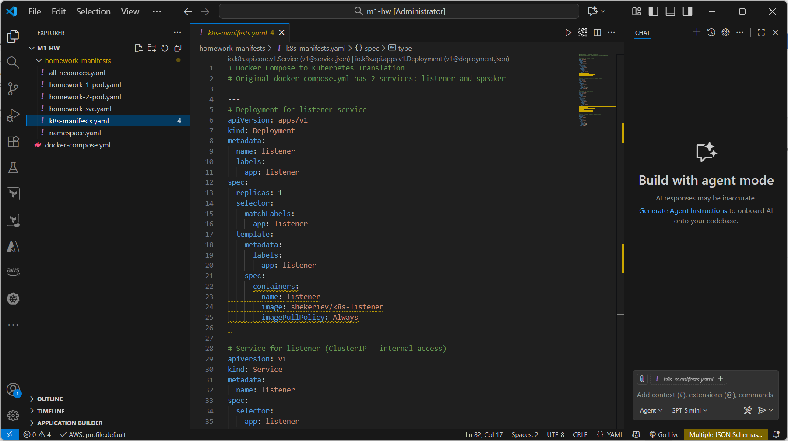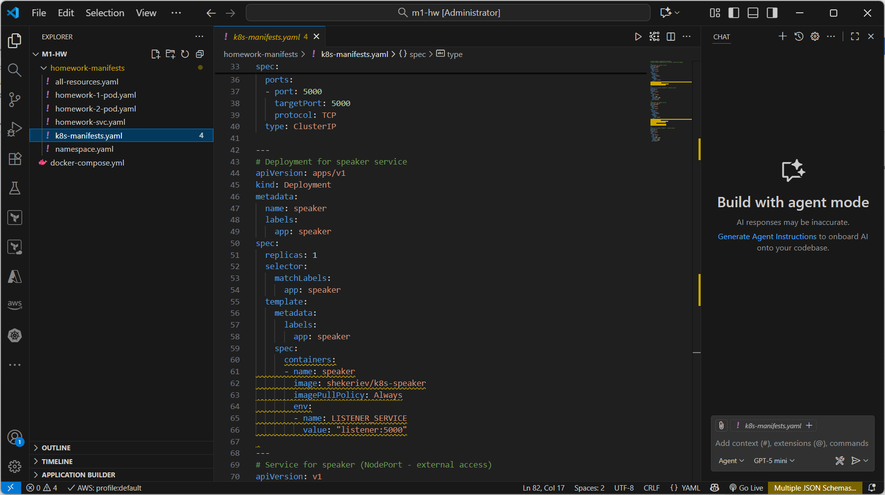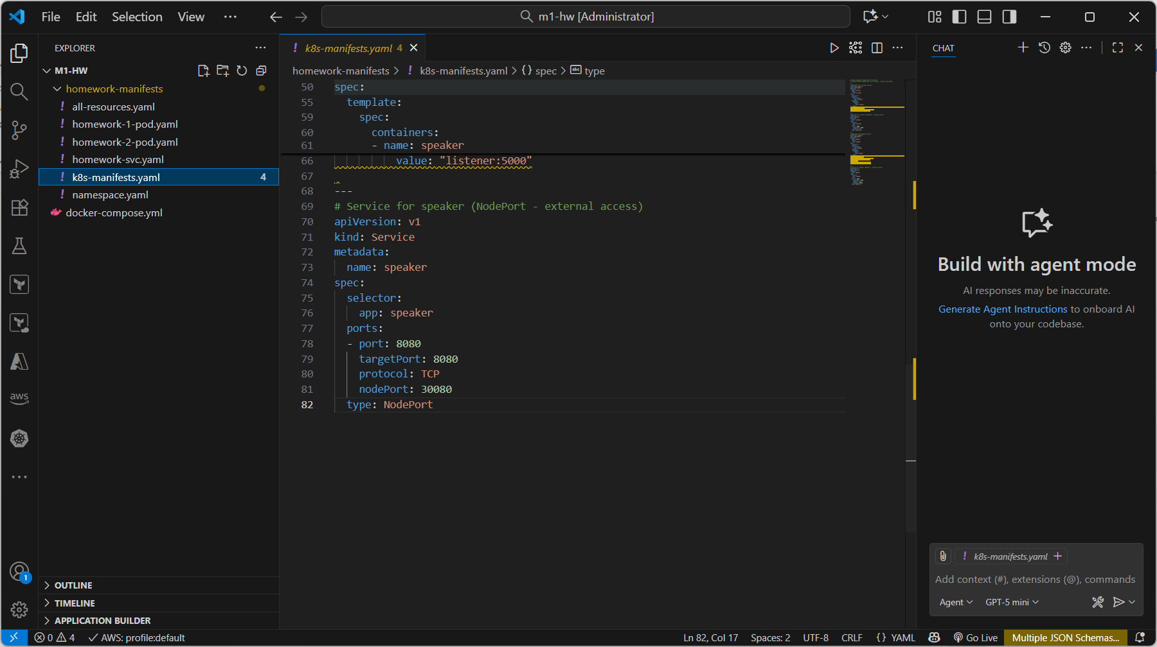

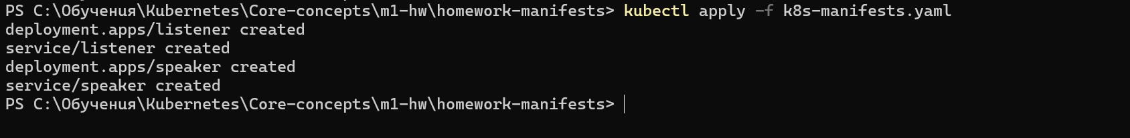
12. Giving KIND a chance
