Practice M8: Exam Preparation (Challenge)

Exam Plot
Should you want to reproduce the environment, you will have to prepare the following set of machines:
- Exam station* has kubectl + helm + kustomize installed
- Mars cluster – two machines – working cluster with Flannel as a pod network plugin and HAProxy as ingress controller
- Jupiter cluster – three machines – working cluster with Calico as a pod network plugin
- Venus cluster – two machines – broken cluster with Antrea as a pod network plugin (should be installed as part of the solution)
* For the sake of simplifying the setup, you could skip the exam station and instead use your host as one
All clusters are Kubernetes 1.33.3 and all their nodes are with 2 vCPU / 2 GB RAM / 32 GB Disk / Debian 13. The exam station has 1 vCPU / 2 GB RAM
There is an exam user which has sudo privileges on all machines and can authenticate to each one of them via SSH
If you are constrained by the available resources, you can spin up the clusters one by one, as the tasks are grouped by cluster. You can even omit the exam station and use your host to control and work with the clusters
Check the published archive for the setup files (folder 1-setup). There is a separate folder (2-files) that contains the source or input files referenced in the tasks. Its content is expected to be copied in /files folder of the station

Sample Exam

Infrastructure
You will have to accomplish a set of tasks in the following infrastructure
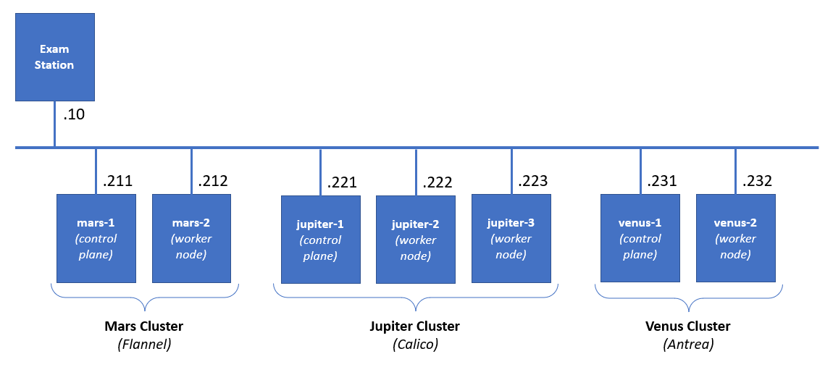

Rules
Be sure to follow strictly the naming conventions specified in the checklist
Tasks execution order should not be derived from the order in which they are listed below. Please note that there are tasks that depend on the successful completion of one or more other tasks
Usually, all steps can be achieved by following different paths and using different tools. In the end, not the means, but the results are being measured, except stated otherwise

Tasks checklist

Mars Cluster [18 pts]
- (T101 / 3 pts) There is the animals namespace. There are two pairs of pod and service. You are expected to create an ingress resource (using the available ingress controller and class) that
  - Will be in the same namespace and named pets-ingress
  - Will serve the pets.lab host
  - Path /cat to be redirected to cat-svc service and /dog to the dog-svc
  - Store it in /files/mars/t101-out.yaml and be sure to deploy it
- (T102 / 3 pts) Explore the tiger namespace. There is a pod that is not in running state, but it should be. Its manifest is /files/mars/t102-in.yaml. Your mission, should you accept it, is to
  - Correct the issue(s) and reflect this in a new manifest /files/mars/t102-out.yaml
  - Make sure that the pod is in running state and doesn’t restart periodically because of a probe
- (T103 / 4 pts) Templating is a good and necessary technique. We have a simple manifest (/files/mars/t103-in.yaml) which we want to be able to easily deploy in production (blue) and in test (green). Using the kustomize application, you must prepare a set of folders and files in the /files/mars/t103 folder that allows
  - Base (without any changes) deployment and deployment to both environments
  - The blue deployment should increase the replicas to 3, use the blue tag, and run on port 31103
  - The green deployment should use the green image tag and runs on port 32103
  - Make sure that blue and green are deployed (but not the base)
- (T104 / 2 pts) Explore the cherry namespace. There is a deployment that is failing. Your mission is to
  - Find the reason for this and write it down (type of the object:name of the object, for example limit:banana) in the /files/mars/t104-reason.txt file
  - Correct the situation by changing the offending parameter of the deployment to comply
- (T105 / 2 pts) Explore the pod manifest in /files/mars/t105-in.yaml file and
  - Create a new one (/files/mars/t105-out.yaml) that wraps the pod template in a CronJob named five-job
  - Set it to run every 5 minutes and deploy it
- (T106 / 4 pts) There is the fortress namespace. It is empty. Your mission is to
  - Create a ServiceAccount named observer
  - Create a Role named looknotouch that allows only get on pods
  - Create a RoleBinding named looknotouch that binds the role to the service account
  - Modify the pod manifest /files/mars/t106-in.yaml to run the pod with the observer service account, store the new version in /files/mars/t106-out.yaml and deploy it

Jupiter Cluster [25 pts]
- (T201 / 4 pts) There are three namespaces – apple, orange, and apricot. In all three, there is a pair of pod and service. There aren’t any restrictions. You should correct this:
  - Add a network policy that will limit the ingress access to the pods in the apple namespace to connections, coming only from pods in the orange namespace
- (T202 / 5 pts) We all know that using Helm charts is both fun and easy. So, let’s spin up one chart
  - Use artifacthub.io and find the NGINX chart provided by Bitnami and add the repository
  - Then install the chart as exam-httpd release in the kiwi namespace (create it if not existing)
  - Make sure that using the chart’s parameters it is set to use a service of type NodePort and to listen for HTTP request on port 32202
  - Create a ConfigMap named exam-httpd-cm in the same namespace that contains an index.html file with the following text Helm+Kubernetes=Fun and attach it to the release
- (T203 / 4 pts) There is a pod in the cucumber namespace that is consuming a secret in the same namespace. You are expected to:
  - Find the unencoded value of the secret and save it as /files/jupiter/t203-secret.txt
  - Then change the secret to Cucumbers are green
- (T204 / 2 pts) Add a new label (exam) to both worker nodes (jupiter-2 and jupiter-3):
  - Set its value to slow for jupiter-2
  - Set its value to fast for jupiter-3
- (T205 / 1 pts) Explore the manifest /files/jupiter/t205-in.yaml
  - Modify it in such a way that if deployed, the workload to go on the node with label exam set to fast and save the new manifest as /files/jupiter/t205-out.yaml
  - Deploy it to the cluster
- (T206 / 1 pts) Explore the manifest /files/jupiter/t206-in.yaml
  - Modify it in such a way that if deployed, the workload to go on the node named jupiter-2 and save the new manifest as /files/jupiter/t206-out.yaml
  - Deploy it to the cluster
- (T207 / 4 pts) Explore the banana namespace. There should be a pair of pod and service. They are created out of the /files/jupiter/t207-in.yaml manifest. The problem is that the pod (banana-pod-1) is not in running state and the service (banana-svc) does not have any endpoints. Your mission is to:
  - Correct these issues and save the changes as /files/jupiter/t207-out.yaml manifest
  - Make sure that the deployed objects are in a good shape (they reflect the corrections)
  - Add a second pod, in the new manifest file, of the same type but change the image tag to green and name it banana-pod-2
  - Make sure that the new pod is present in the service endpoints list
- (T208 / 4 pts) Explore the manifest /files/jupiter/t208-in.yaml and
  - Extend it to also include
    - A definition of a namespace named cherry
    - and a definition of a service named cherry-svc of type NodePort and port set to 32208
    - and save it as /files/jupiter/t208-out.yaml
  - Deploy the manifest

Venus Cluster [17 pts]
- (T301 / 5 pts) Install the missing system components (kubeadm, kubelet, and kubectl) on the venus-2 node and make sure that their version is aligned with the version installed on the venus-1 node
- (T302 / 3 pts) Join the venus-2 node to the Venus Cluster
- (T303 / 2 pts) Deploy Antrea pod network plugin on the Venus Cluster
- (T304 / 3 pts) Modify the configuration of the Venus Cluster in such a way to allow workload to be placed on the control plane node
- (T305 / 4 pts) Explore the manifest /files/venus/t305-in.yaml and
  - Change it in such a way (save it under /files/venus/t305-out.yaml) that the described pod is deployed on every node of the cluster
  - Deploy the resulting manifest

