Homework M5: Advanced Concepts
Main goal is to build further on what was demonstrated during the practice
For the successful completion of the tasks, you will need a simple (two or three node) cluster as the one used during the practice

Tasks *
Try to solve the following set of tasks:
- Init Containers
  - Create a set of two init containers and one app container (in fact modify/extend the example shown during the practice)
  - The first init container should generate the following two lines with 10 seconds delay
dd-mm-yyyy hh:mi:ss => begin initialization …
dd-mm-yyyy hh:mi:ss => … done
Please note that the dd-mm-yyyy hh:mi:ss should reflect the actual time the event is taking place
  - The second init container should add one more line like the following
dd-mm-yyyy hh:mi:ss => launching the application …
Please note that the dd-mm-yyyy hh:mi:ss should reflect the actual time the event is taking place
  - The app container should be nginx based and should display the three lines generated by the init containers instead of the default index page
- Ingress and TLS
  - Using either NGINX or HAProxy (the implementation should not differ significantly) ingress controller try to modify/extend the fan out example shown in the practice to handle TLS traffic
  - Note, that you will need to create a self-signed certificate and store it in a secret which then to be used in the ingress
- Another Ingress Controller
  - Repeat the fan out example shown in the practice but with another ingress controller of your choice (not NGINX or HAProxy)
As usual, you are not obliged to complete all the tasks but try to tackle as many as possible

Proof
Prepare a document that show what you accomplished and how you did it. It can include (not limited to):
- The commands you used to achieve the above tasks
- A few pictures showing intermediary steps or results
- Any configuration files and/or manifests

I. Init Containers
1. Creating 3 node Kubernetes container using minikube
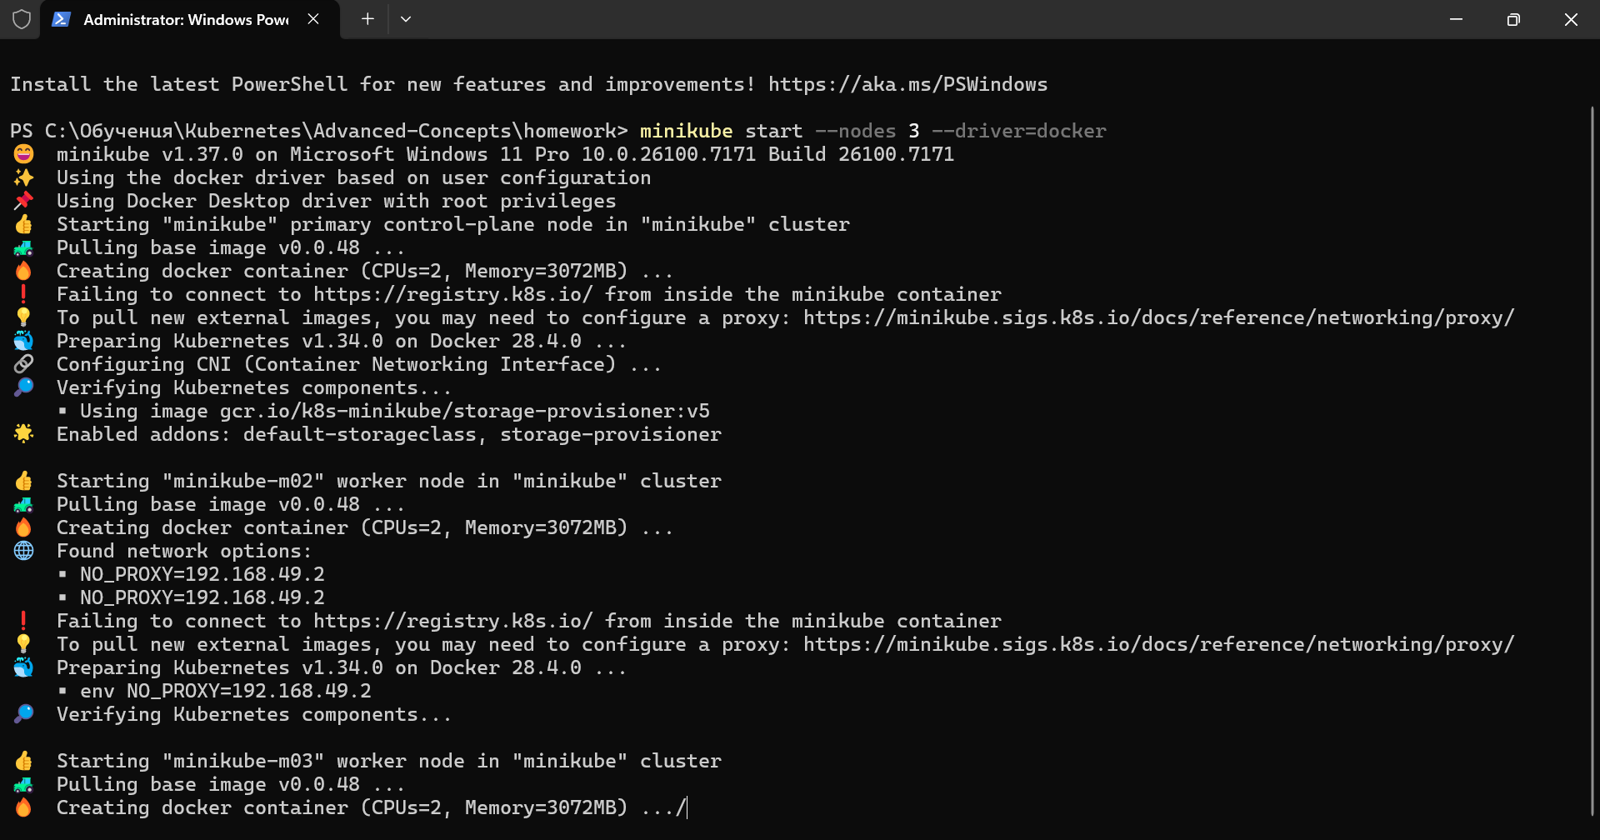
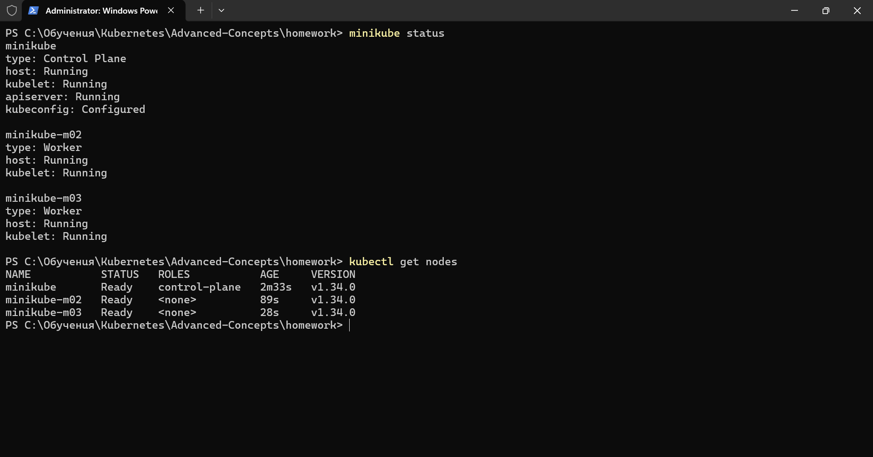
2.Creating the manifest and apply it for the two init containers and checks if they work properly
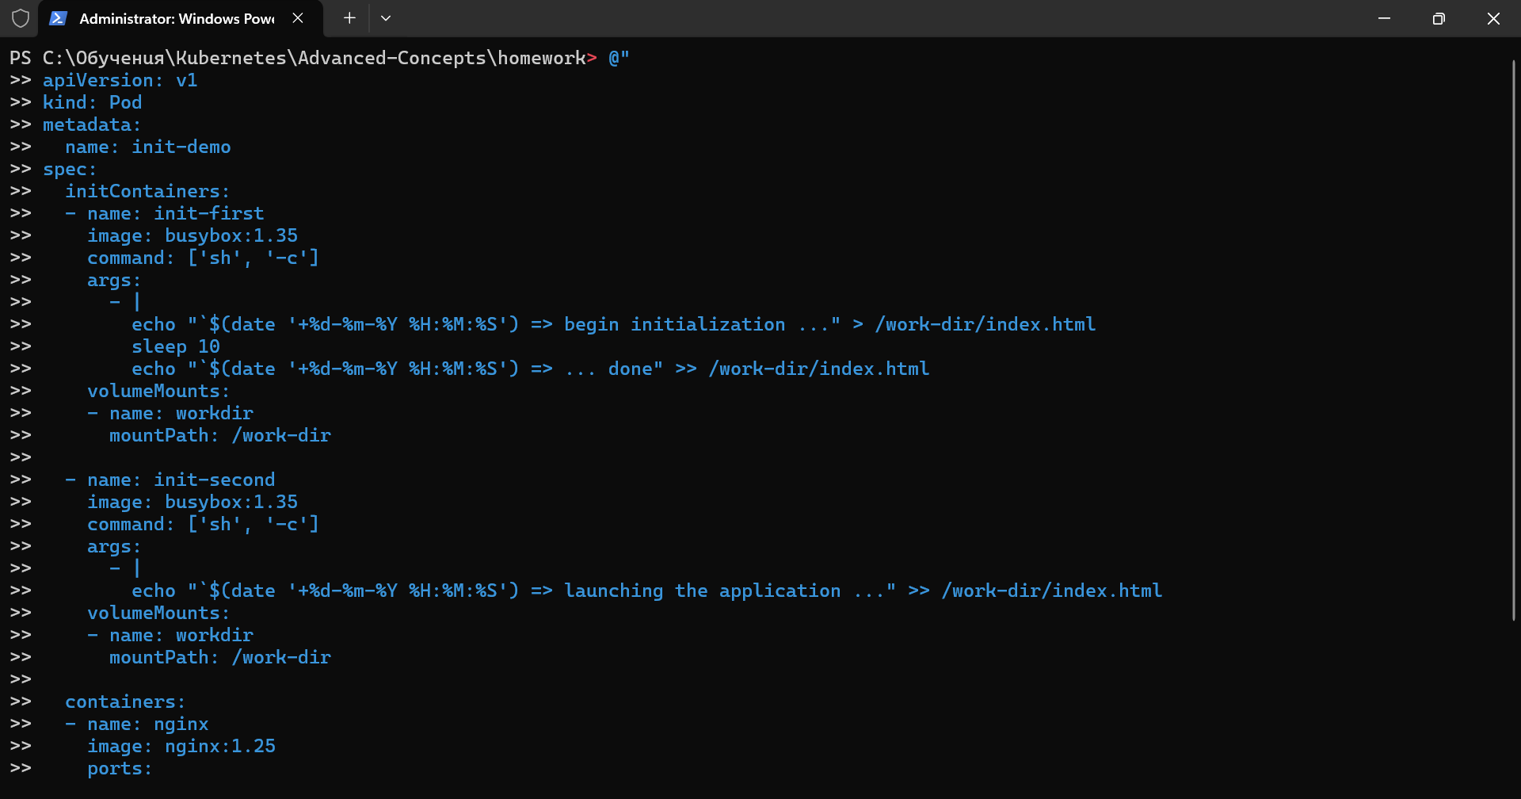
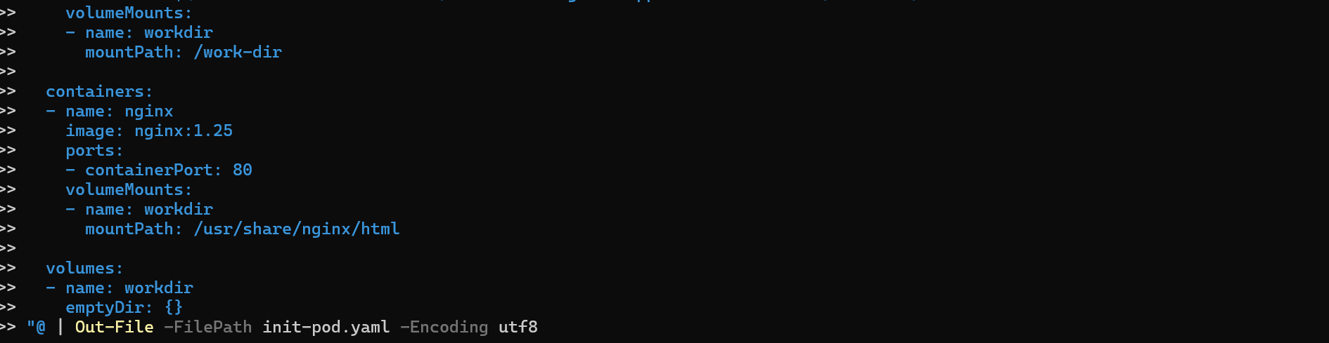
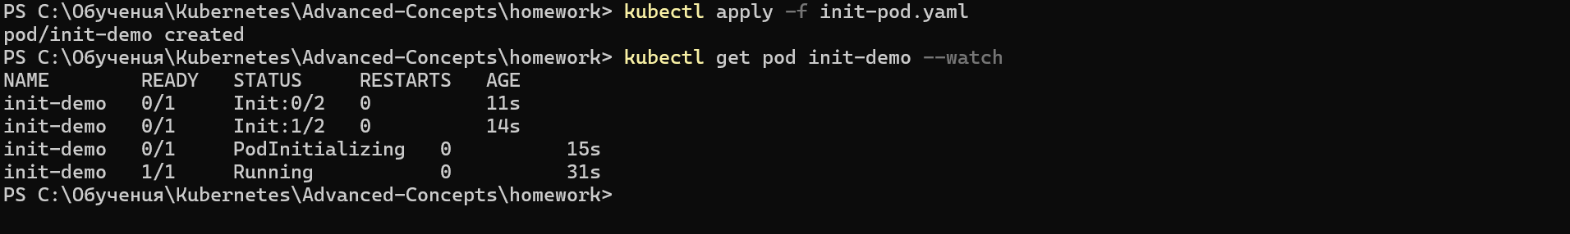
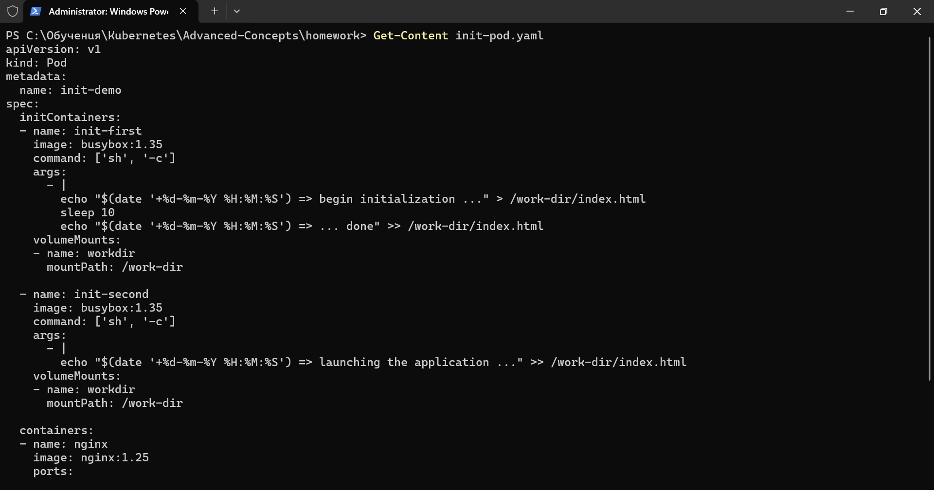
3.Check init container logs
4.Creating port forwarding rule
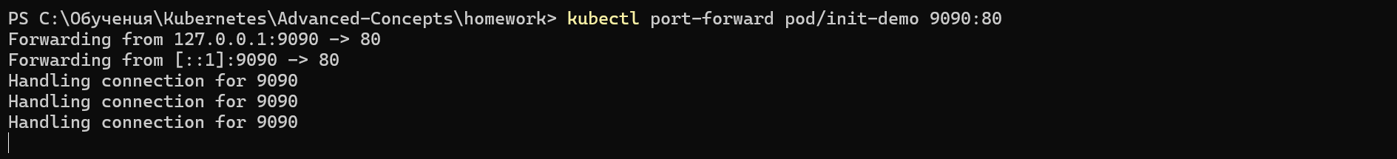
(I had to use port 9090, because port 8080 was in use of me doing something entirely different
5. Checking if everything is workin properly either on the console or on web
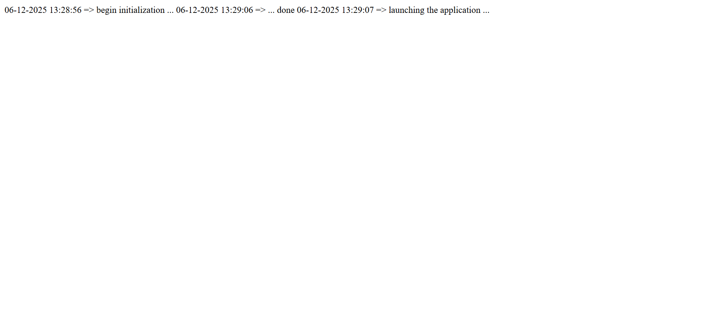
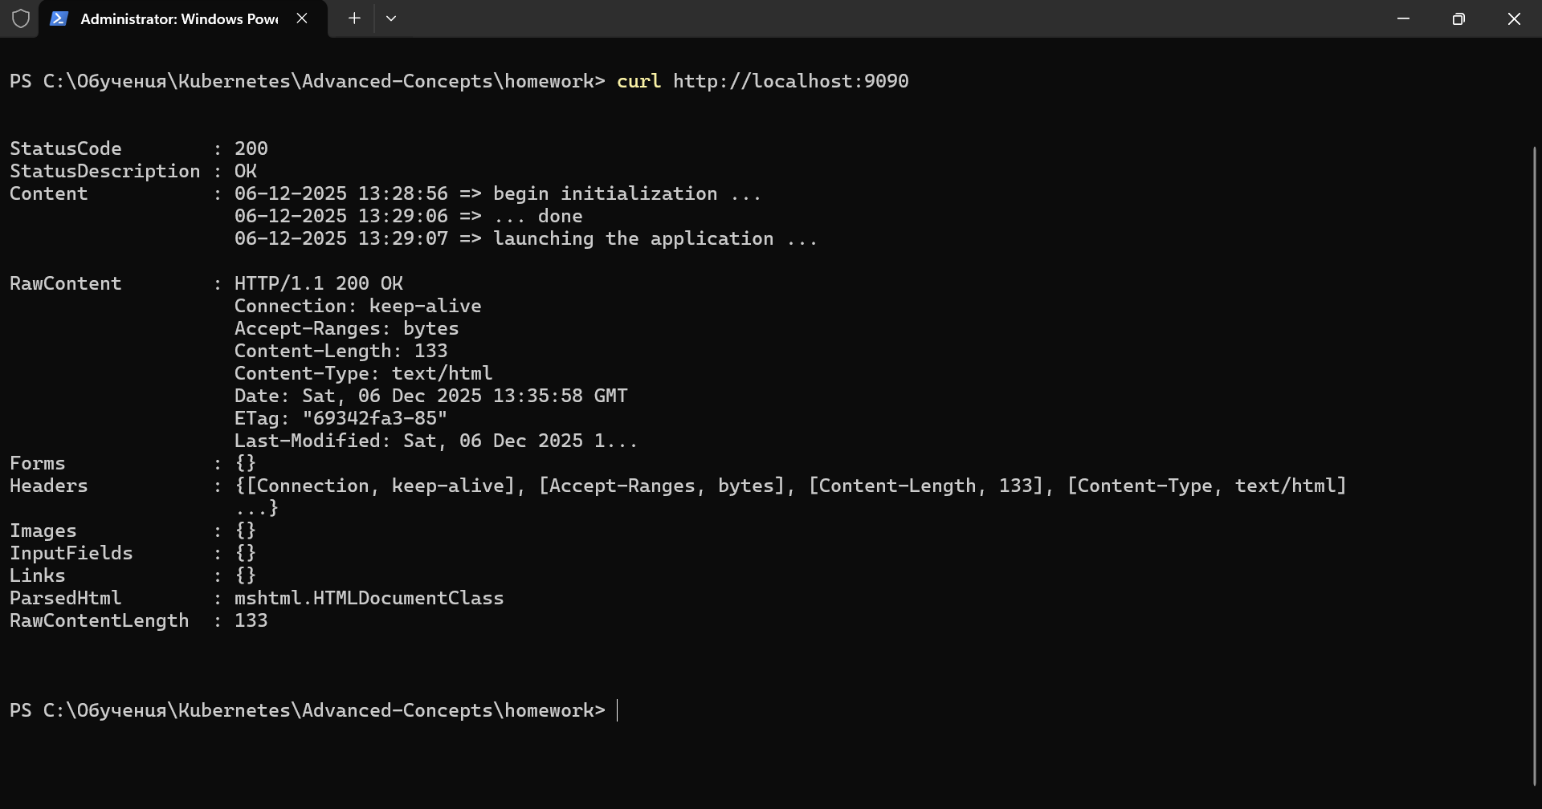

II .Ingress and TLS
1.Enable Nginx and verify that is working properly
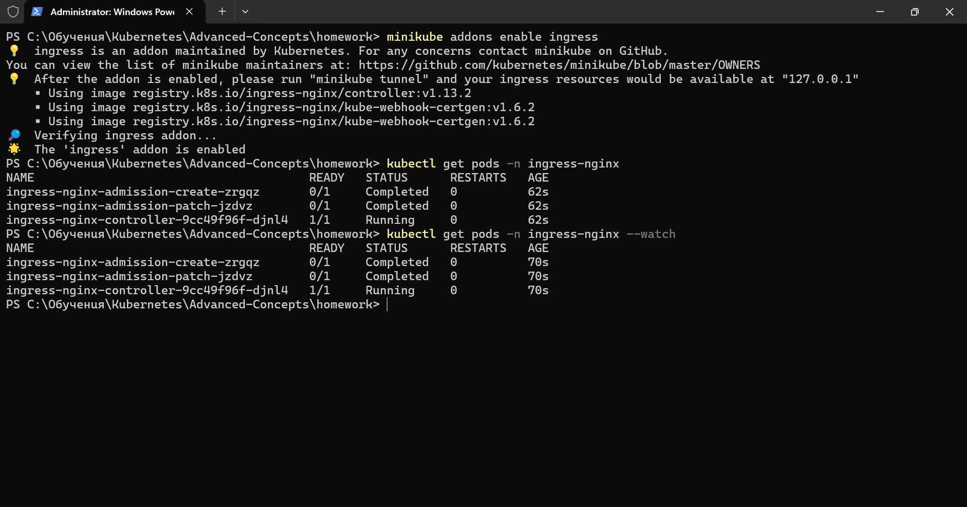
2.Creating app1 deployment and service
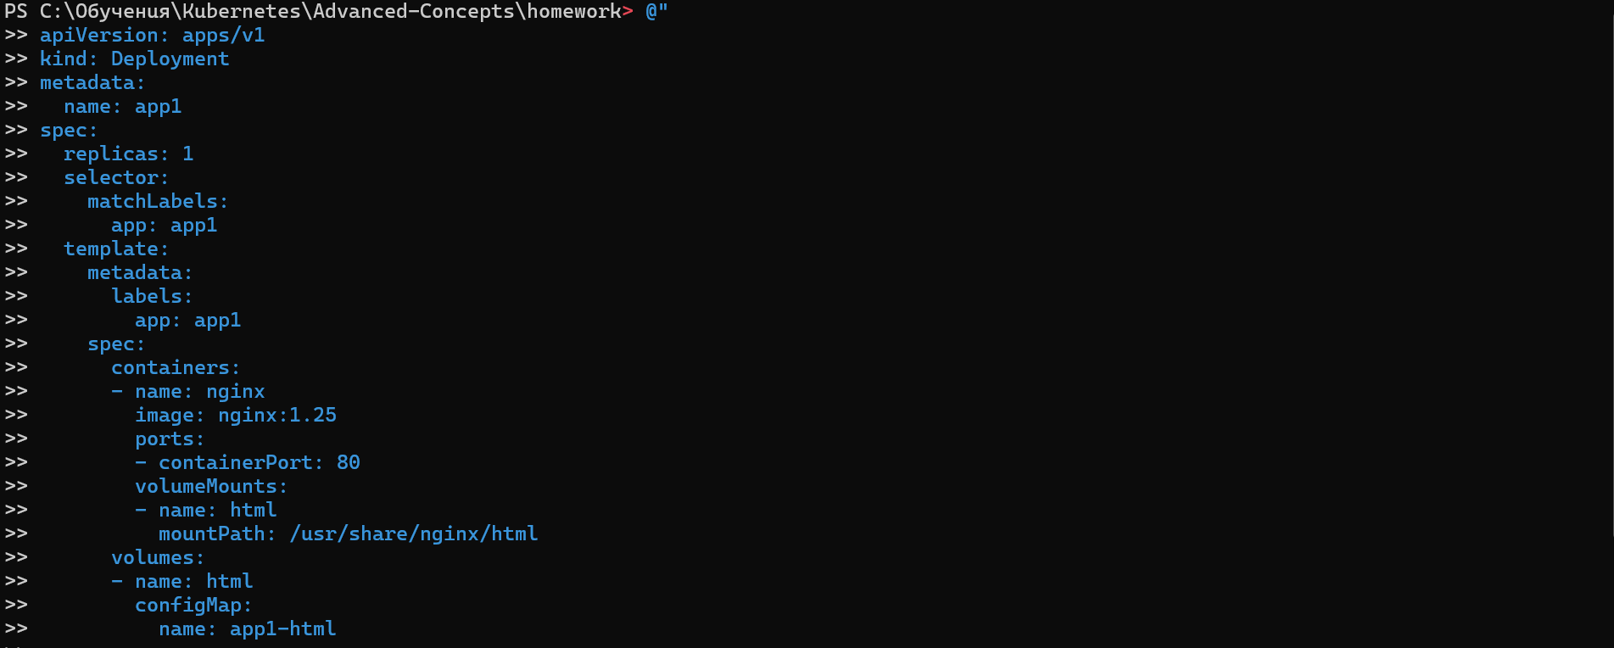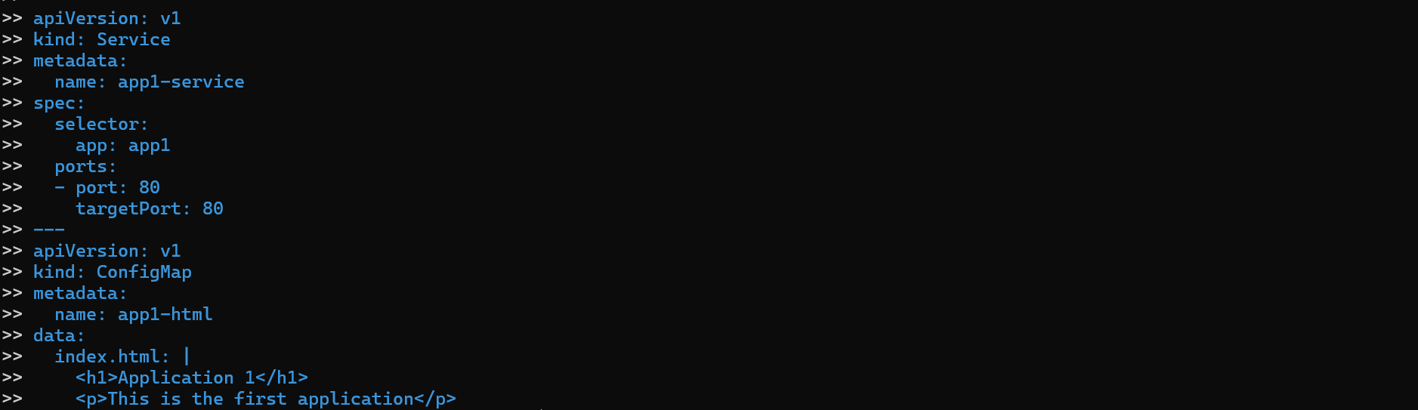
3.Creating app2 deployment and service
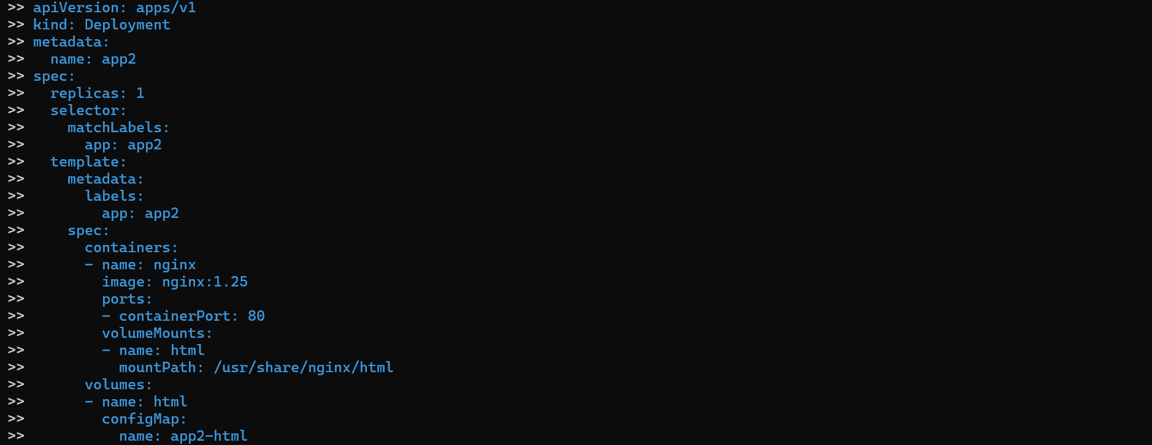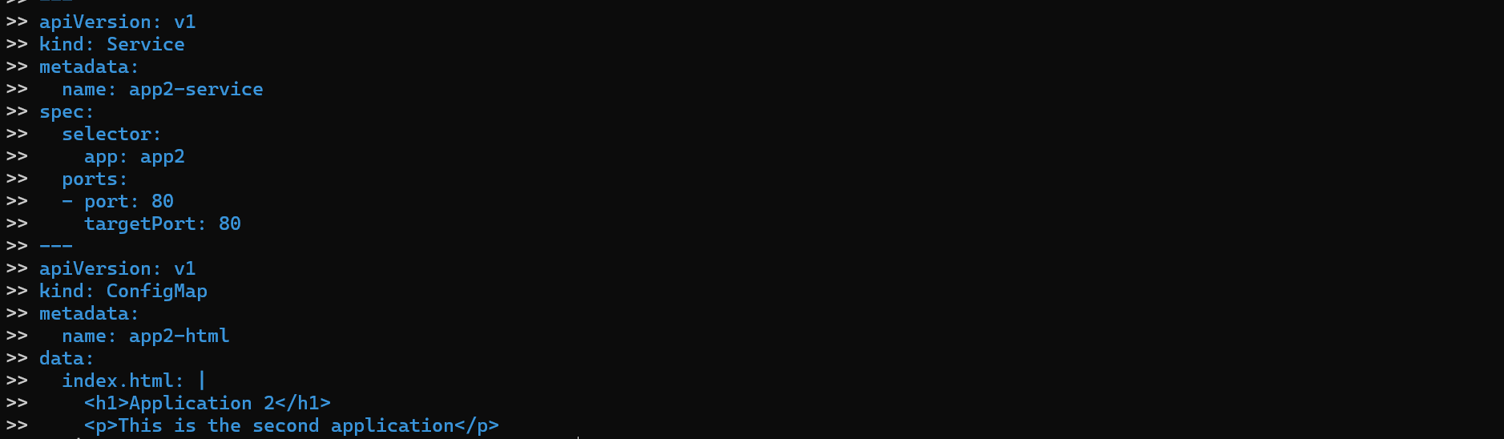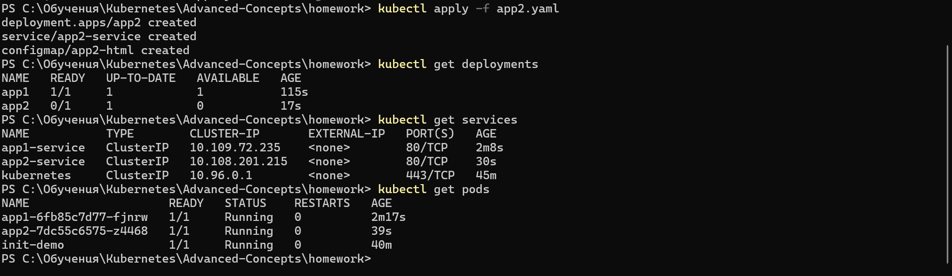
4.Creating self-signed certificates and using it to create a secret
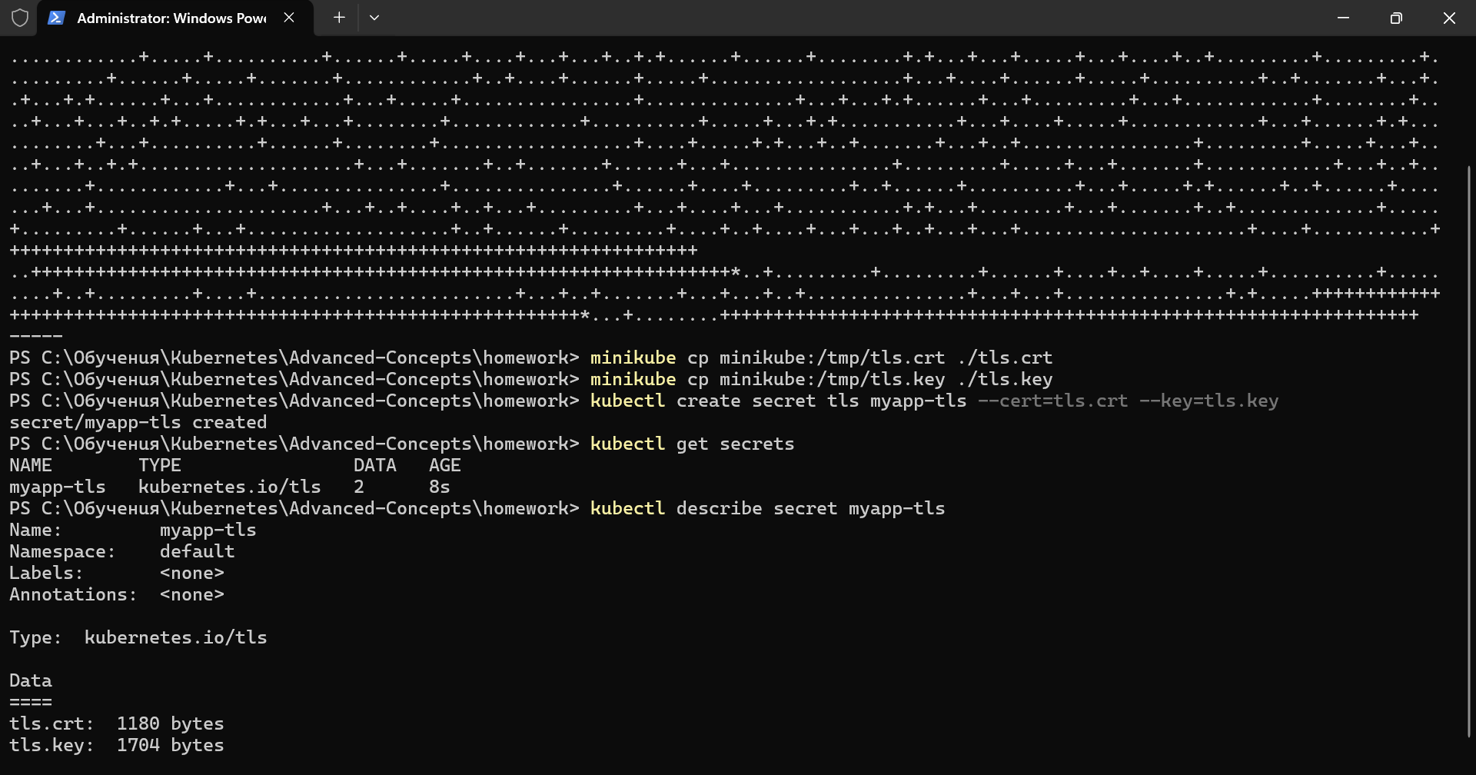
5.Creating ingres with TLS and check if it work properly
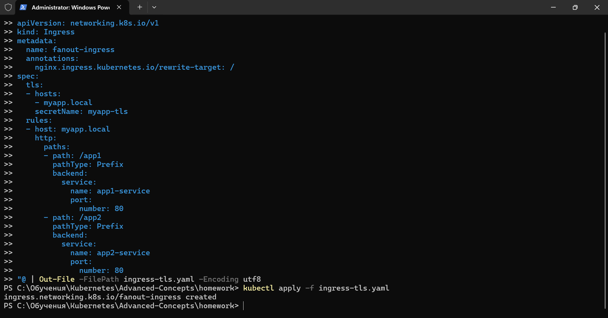
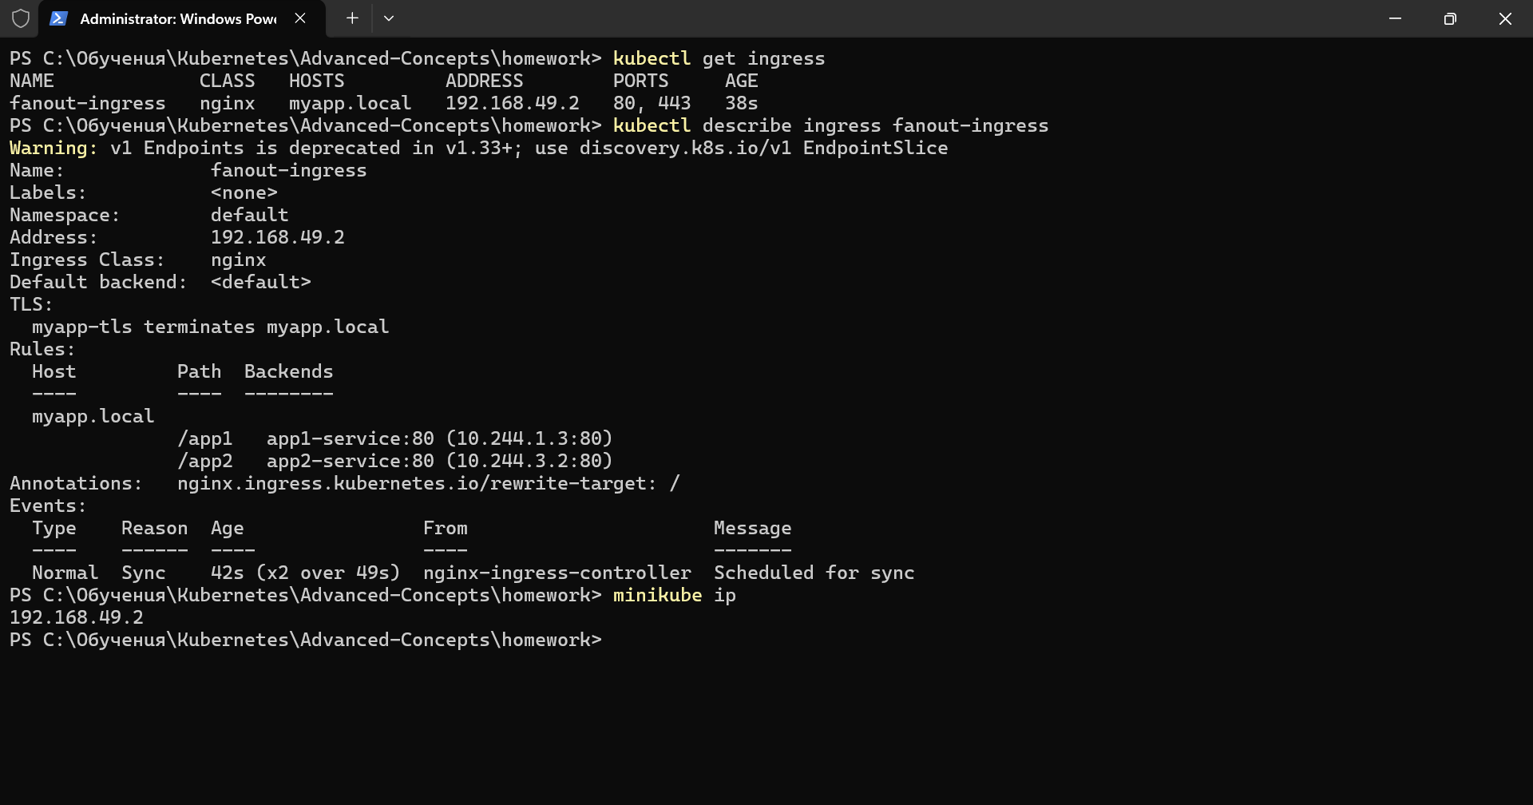
6.Checkin if the apps are working
