Homework M4: Storage and Persistence
Main goal is to build further on what was demonstrated during the practice
For the successful completion of the tasks, you will need a simple (two or three node) cluster like the one used during the practice

Tasks *
Try to solve the following set of tasks:
- Configuration maps and secrets
  - Create a ConfigMap resource hwcm that:
    - has two key-value pairs (k8sver and k8sos) initialized as literals that hold your Kubernetes version and the name of the OS where Kubernetes is running
    - has two more key-value pairs (main.conf and port.conf) initialized from files. The first one (main.conf) should contain:
# main.conf
name=homework
path=/tmp
certs=/secret
And the second one (port.conf):
8080
  - Create a Secret resource hwsec that:
    - Has two data entries – main.key and main.crt created from files
    - The content for the above two generate by using the openssl utility. For example:
openssl genrsa -out main.key 4096
openssl req -new -x509 -key main.key -out main.crt -days 365 -subj /CN=www.hw.lab
  - Mount the above resources to a pod created from the shekeriev/k8s-environ image (used during the practice) by
    - k8sver and k8sos should be mounted as environment variables with prefix HW_
    - main.conf should be mounted as a volume to the /config folder inside the container
    - port.conf should be mounted as an environment variable HW_PORT
    - main.key and main.crt should be mounted as a volume to the /secret folder inside the container
- Create and run a set of manifest files to spin the following application:
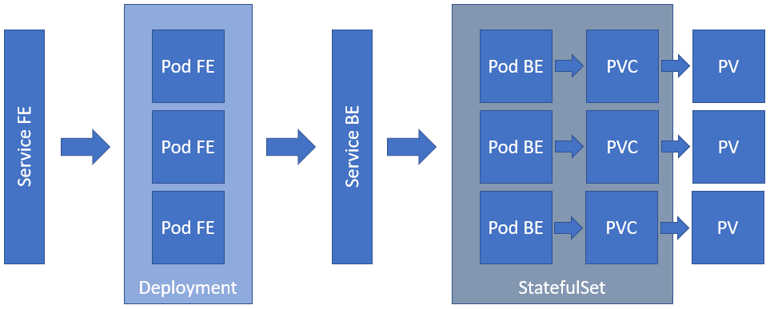
Please note that:
- Service FE should be of type NodePort
- Pod FE should use shekeriev/k8s-facts-fe image and should be initialized with two environment variables – FACTS_SERVER equal to the name of the Service BE and FACTS_PORT equal to the port of Service BE
- Pod FE listens on port 5000/tcp
- Service BE should be of type ClusterIP (please note that this is not the headless service but the "public" one)
- Pod BE should use shekeriev/k8s-facts image and expects a volume to be mounted at /data folder
- Pod BE listens on port 5000/tcp
- For the PVs and PVCs use NFS and storage capacity of 2Gi
- Both the Deployment and the StatefulSet should spin three replicas
As usual, you are not obliged to complete all the tasks but try to tackle as many as possible

Proof
Prepare a document that shows what you accomplished and how you did it. It can include (not limited to):
- The commands you used to achieve the above tasks
- A few pictures showing intermediary steps or results
- Any configuration files and/or manifests

