Homework M7: Templating Tools and Package Management
Main goal is to build further on what was demonstrated during the practice
For the successful completion of the tasks, you will need a simple (one-node or any other combination) cluster as the one used during the practice

Tasks *
Try to solve the following set of tasks:
- Using the files in task1 folder create a template using the sed-based approach. Parametrize the number of replicas and the service port
- Using the files in task2 folder create a template using kustomize with two variants – test and production with difference in the service port and number of replicas
- Create a Helm chart that spins a NGINX-based deployment with 3 replicas by default. It must mount a default index.html (with a text and a picture) page from a ConfigMap. The web server should be exposed via NodePort service on port 31000 by default. At least the text of the default page, number of replicas, and service port should be parametrized
* As usual, you are not obliged to complete all the tasks but try to tackle as many as possible

Proof
Prepare a document that shows what you accomplished and how you did it. It can include (not limited to):
- The commands you used to achieve the above tasks
- A few pictures showing intermediary steps or results
- Any configuration files and/or manifests

1.Building One-Node cluster using minikube
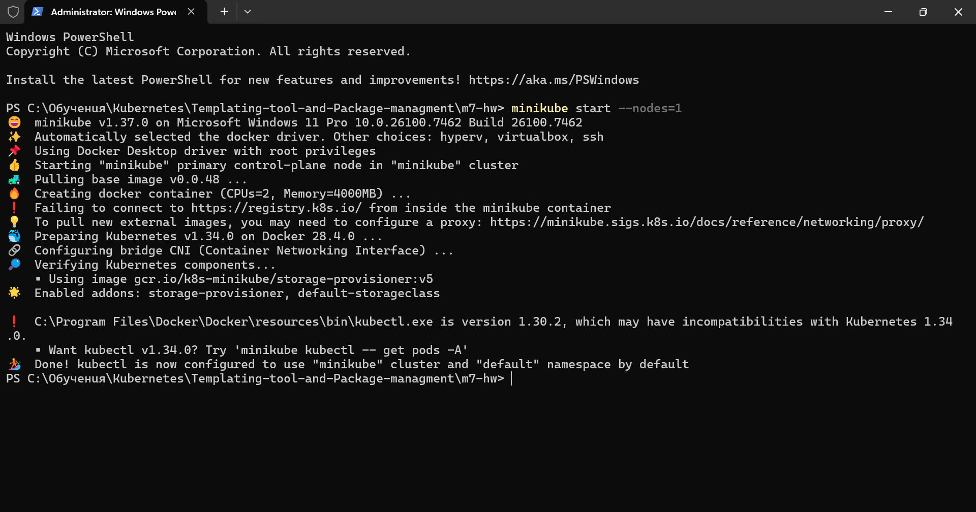
I. Task 1
1.Verifying that the cluster is up and running and building a template file from task1/homework.yaml file
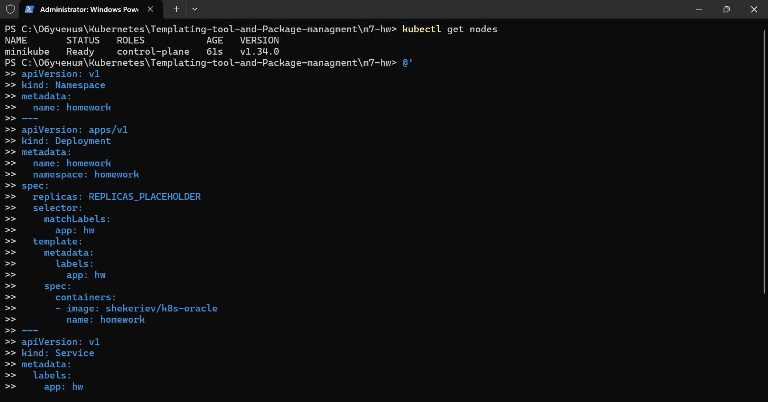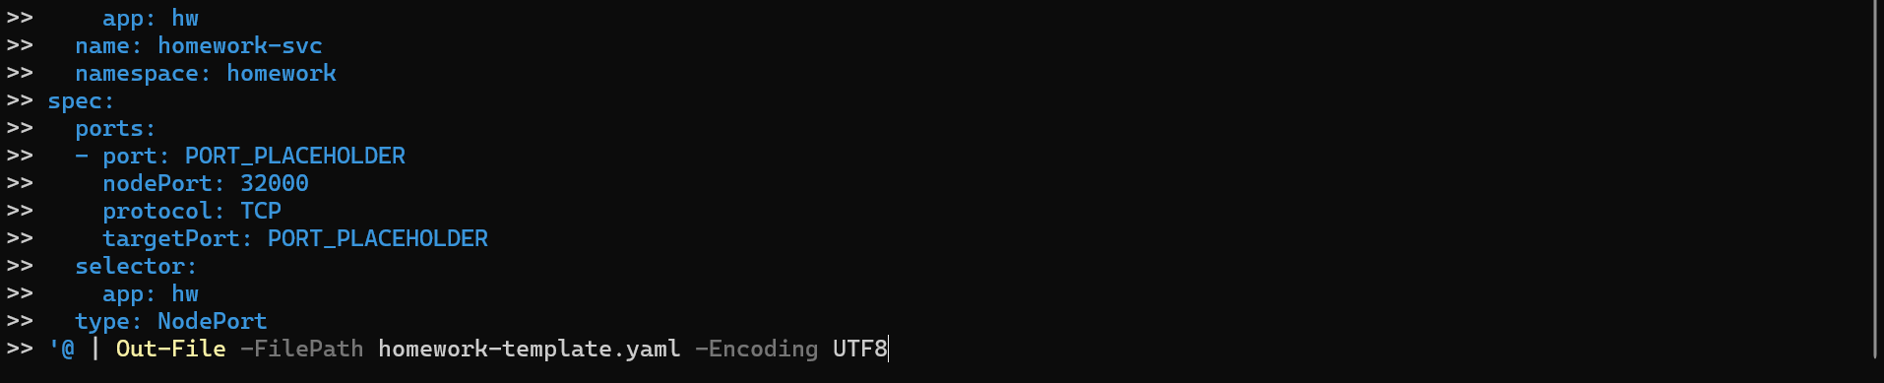
2.Building a function that mimics sed-like behavior for Windows
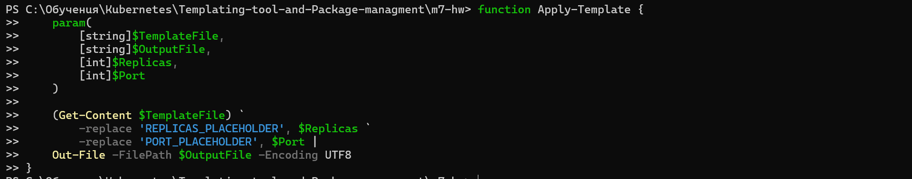
3.Genareta configured yaml file
4. Getting the content of the configured yaml file
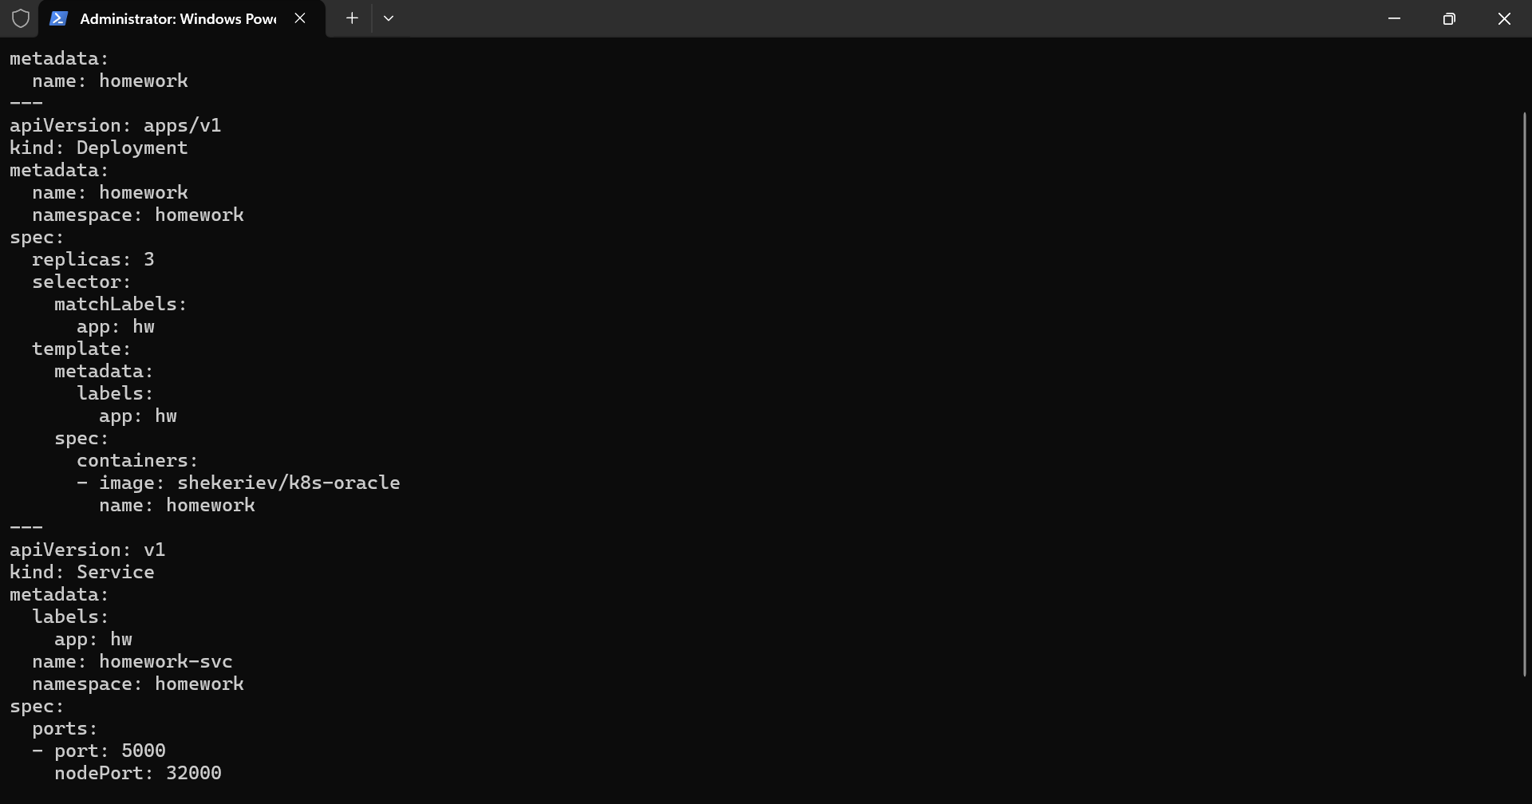
5.Deploying and verifying that deployment is working properly
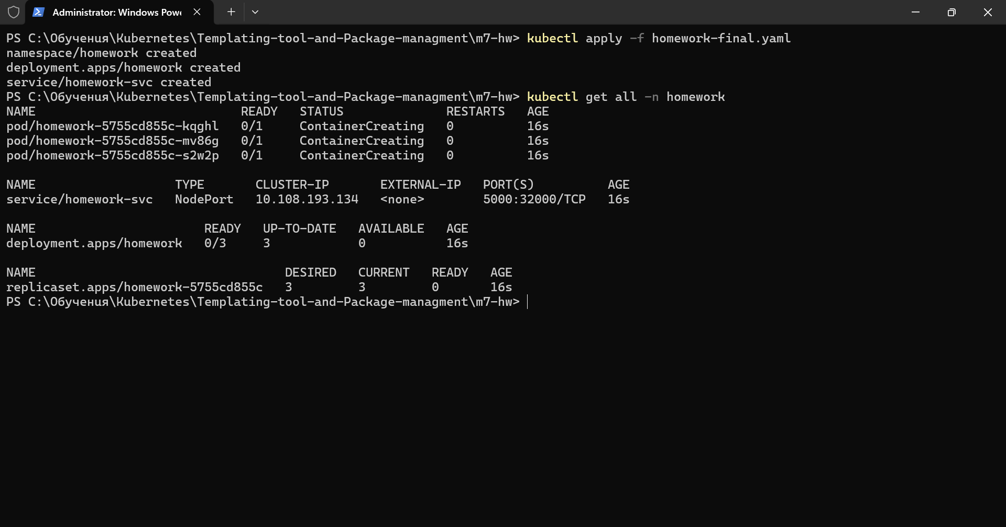
6.Deploying with different values and verifying that deployment is working properly
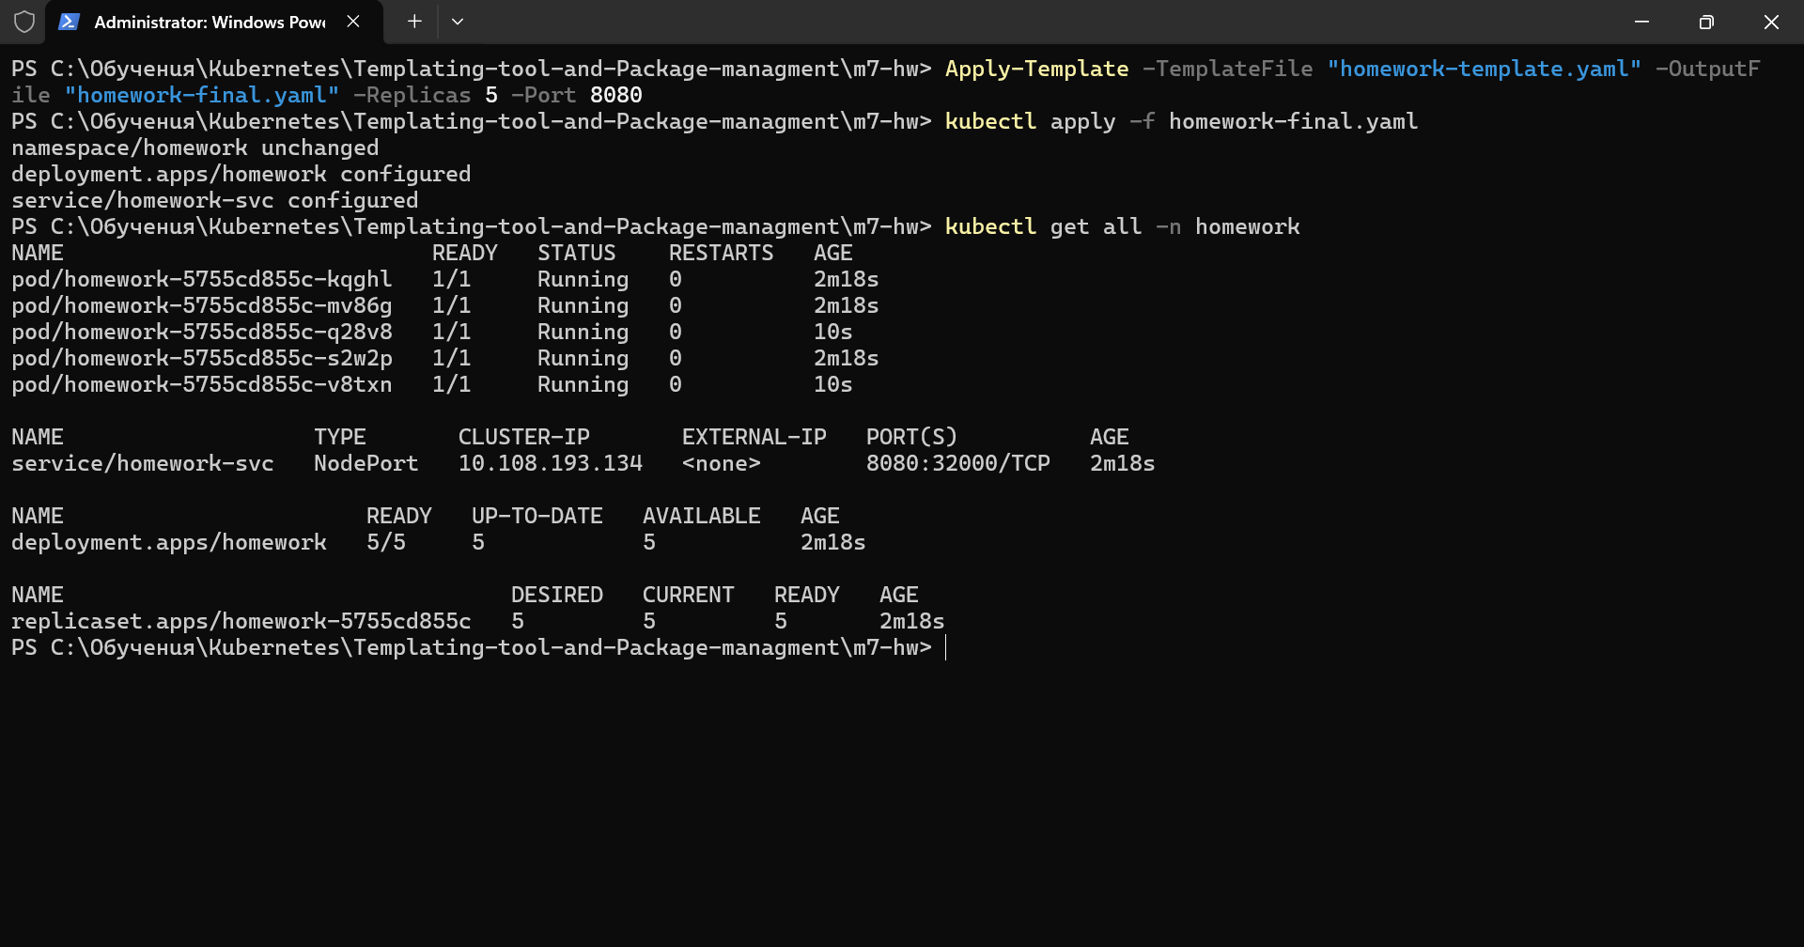

II. Task 2
1.Creating and verifying the directory structure
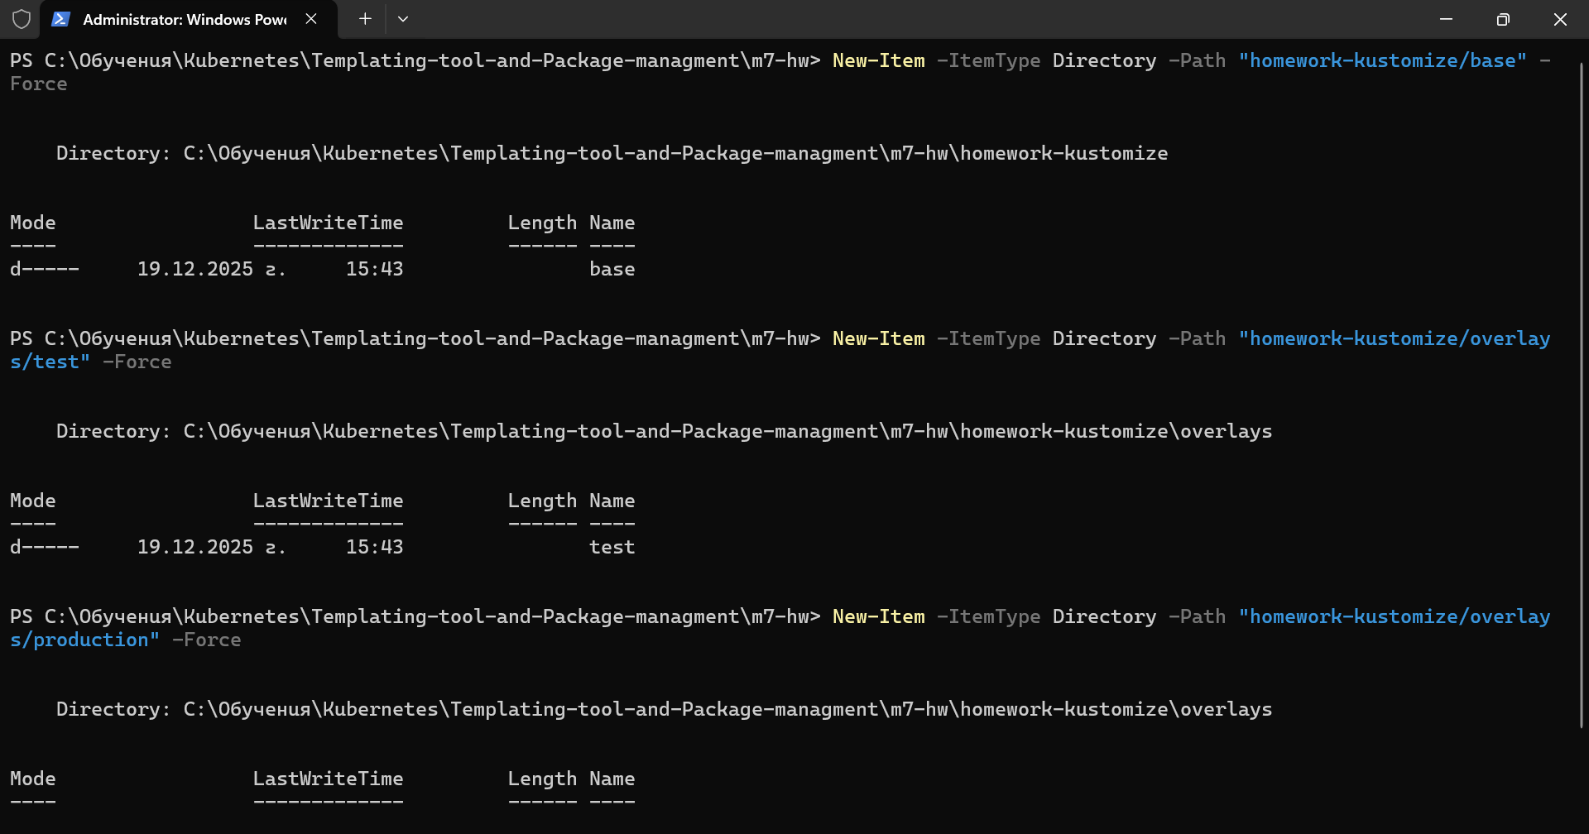
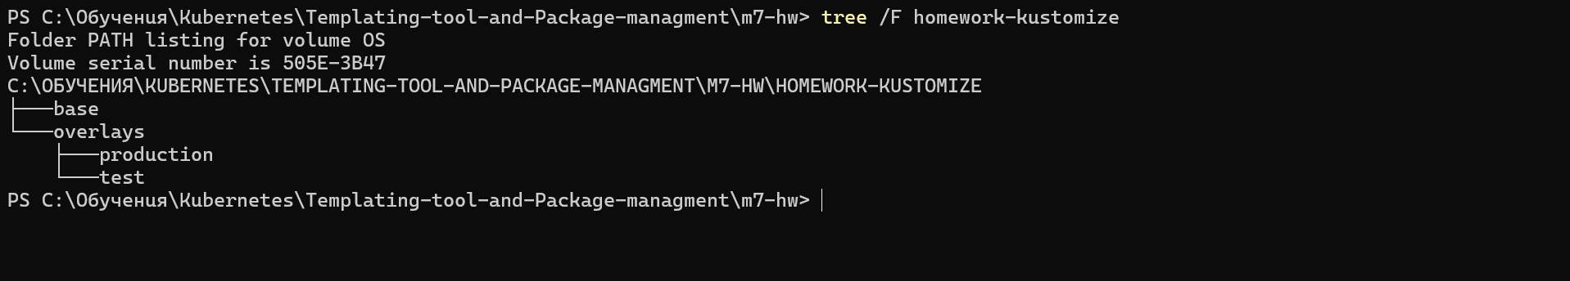
2.Creating the Base .yaml file from provided in task2/homework.yaml resources
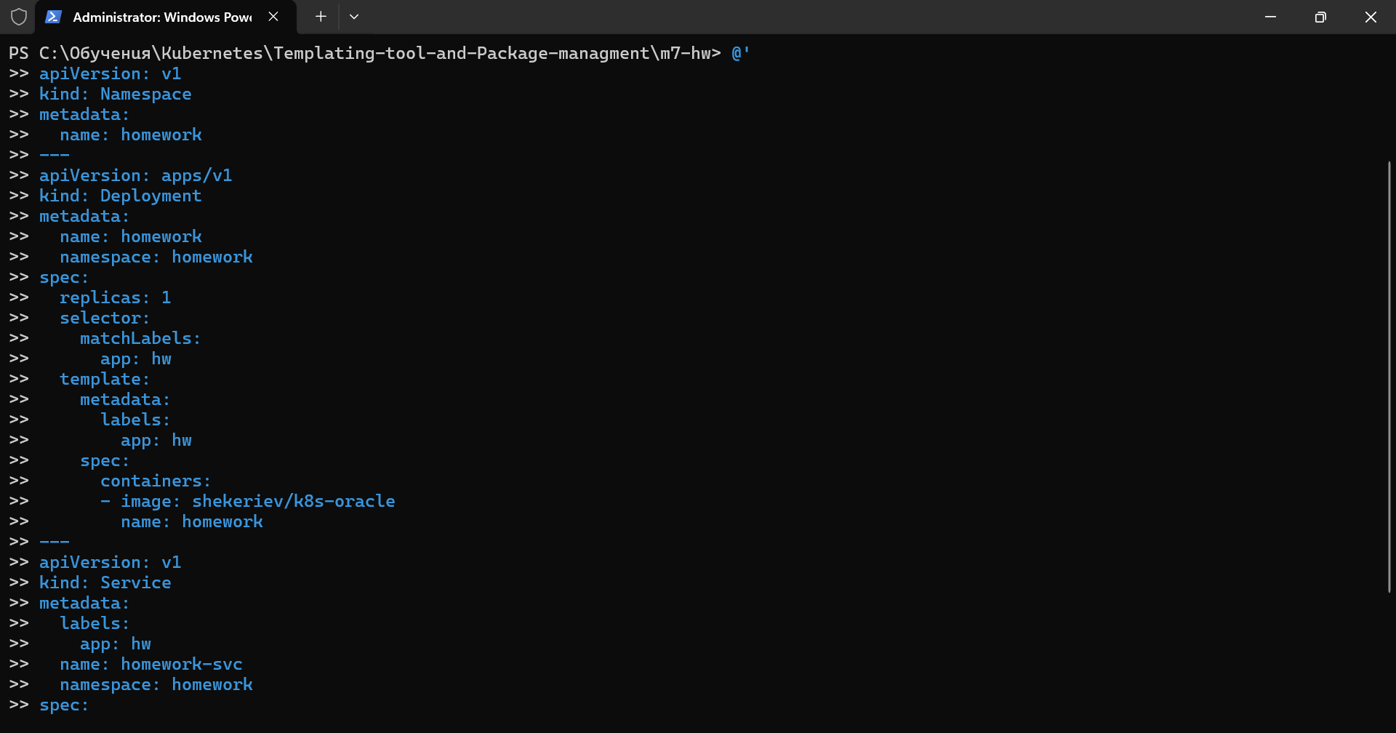
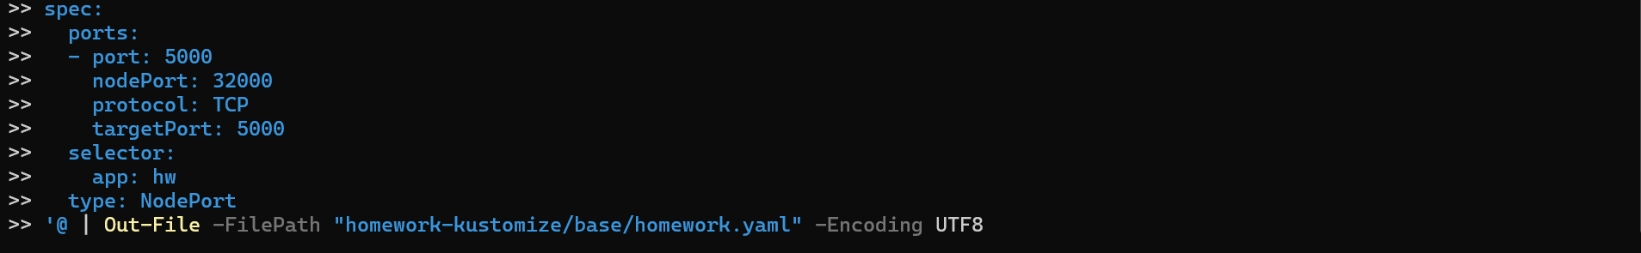
3.Creating the Base kustomization.yaml file
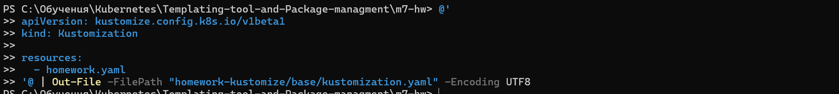
4.Creating test overlay .yaml file
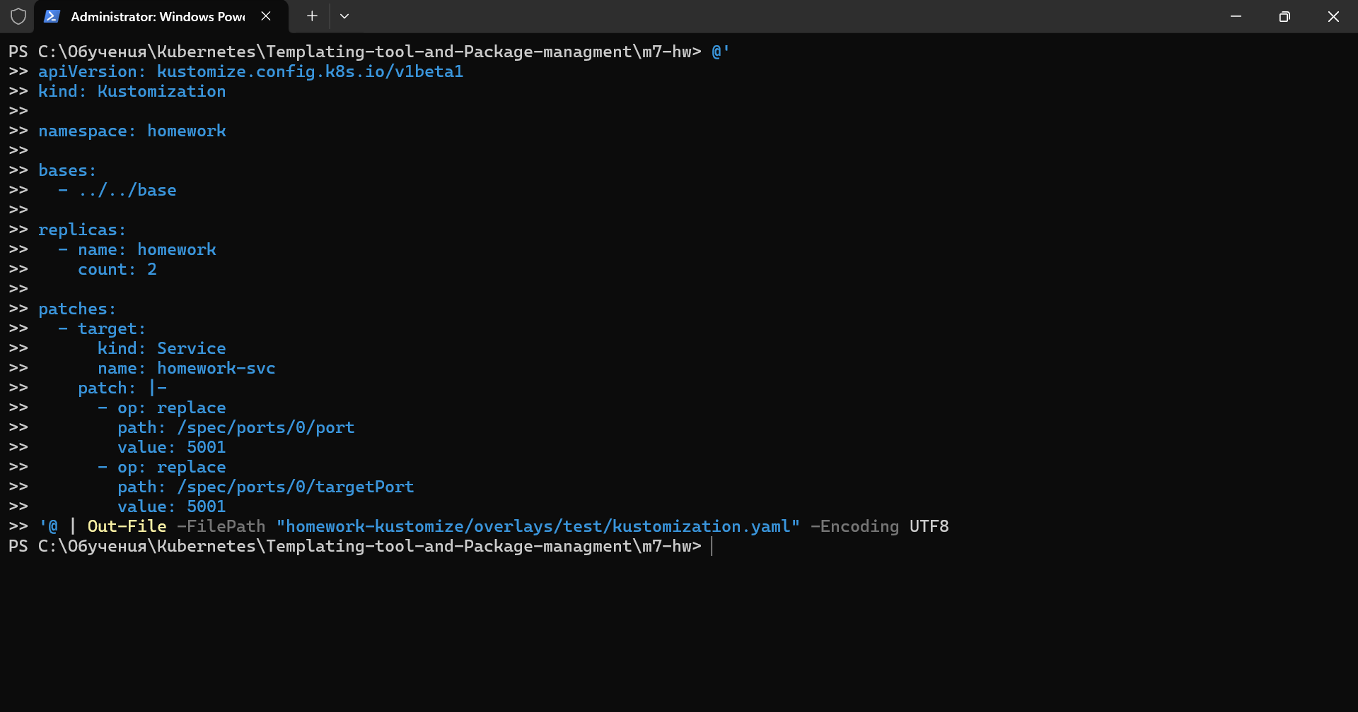
5.Creating production overlay .yaml file
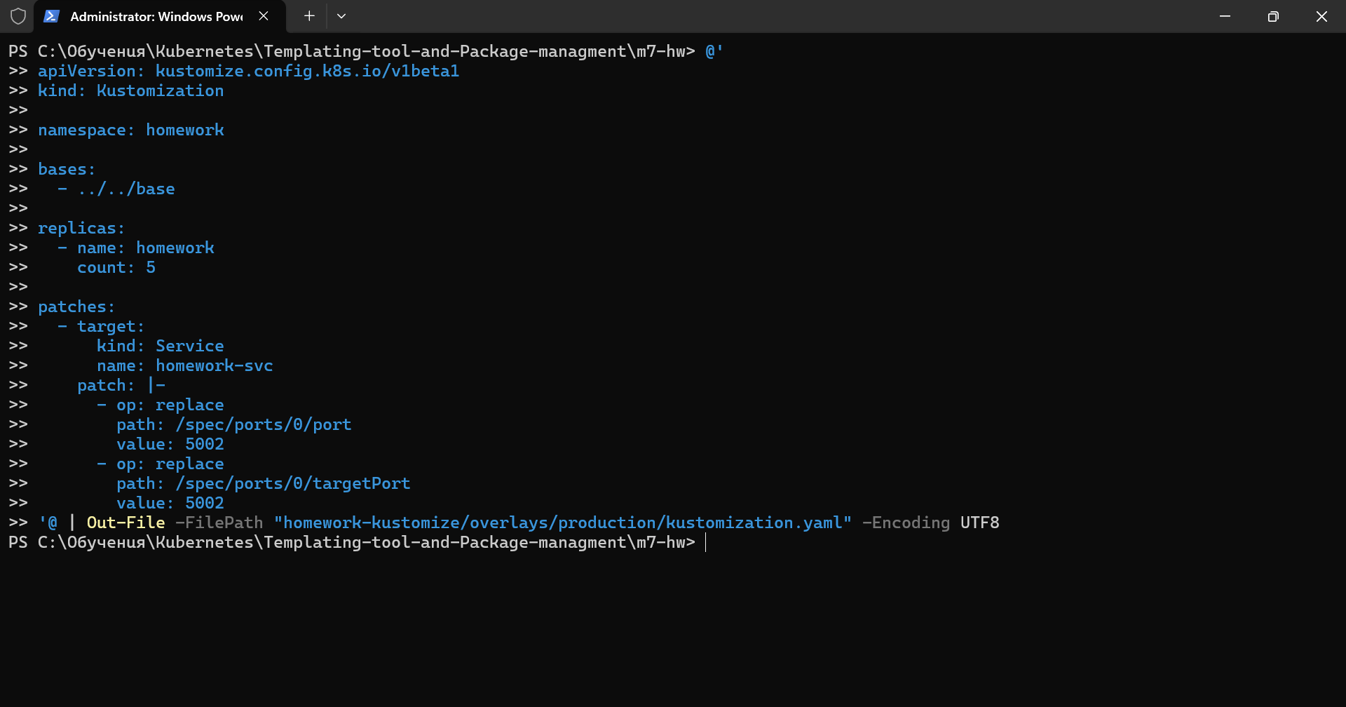
6. Verify the complete structure
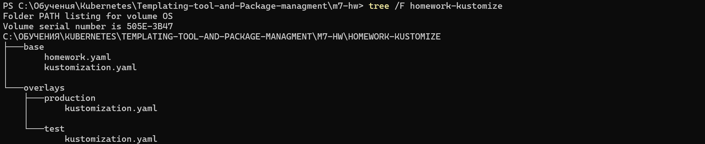

7.Preview Test configuration
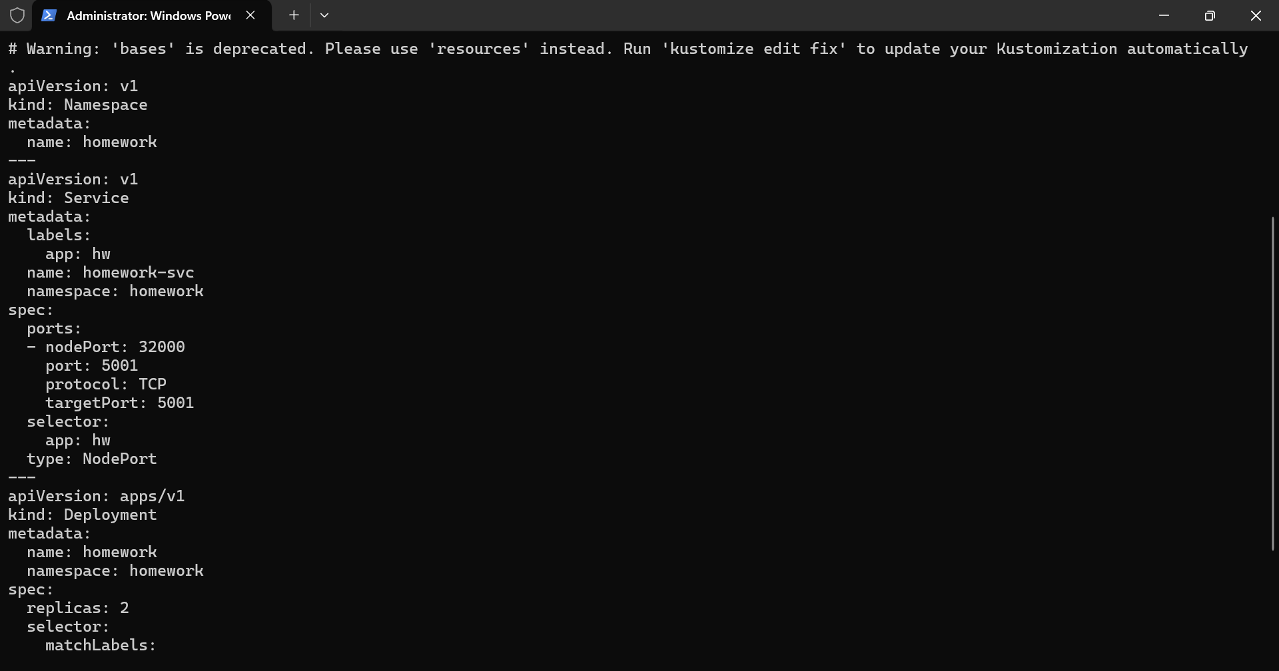
8.Preview production configuration
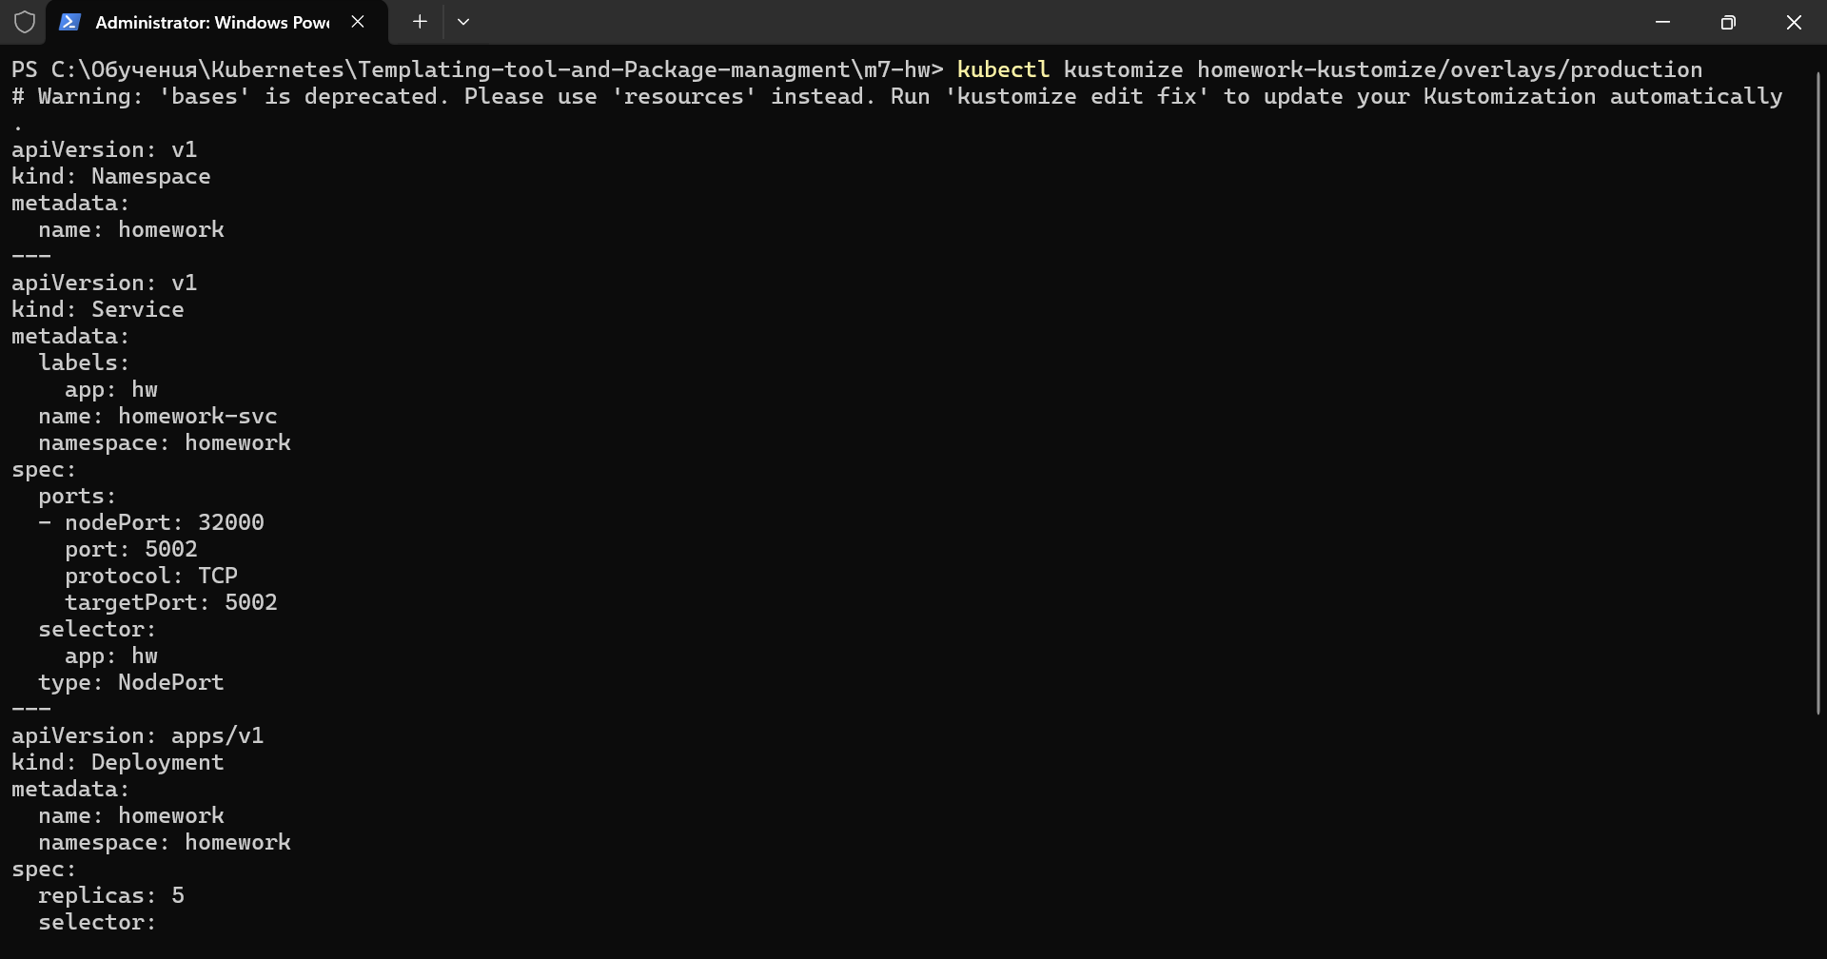
9.Deploy and verifying the Test environment and deployment
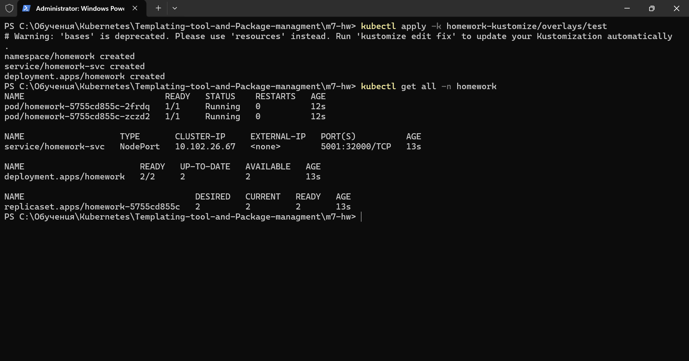
10.Checking the svc
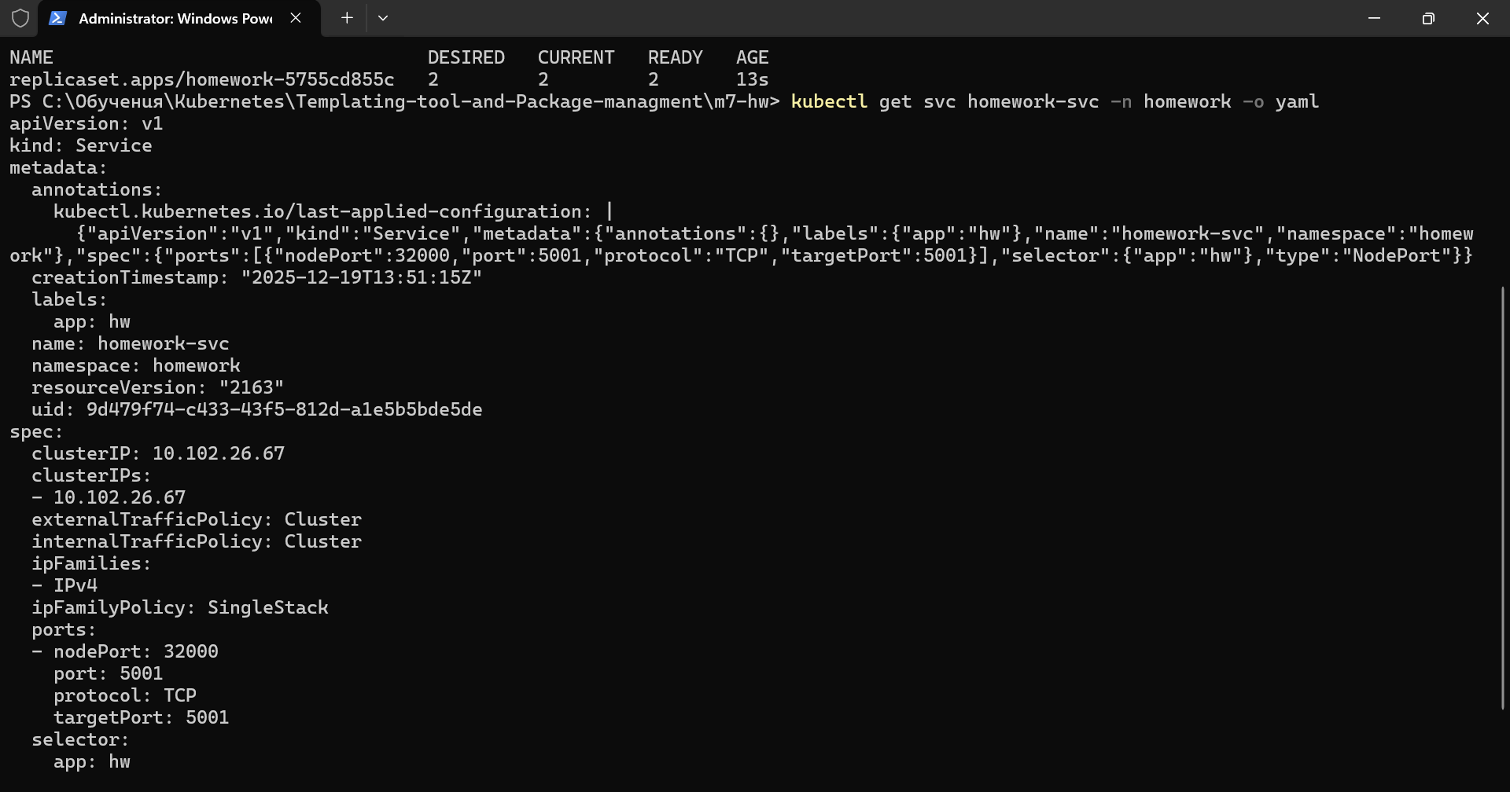
11. Switch to production. Deploy and verify
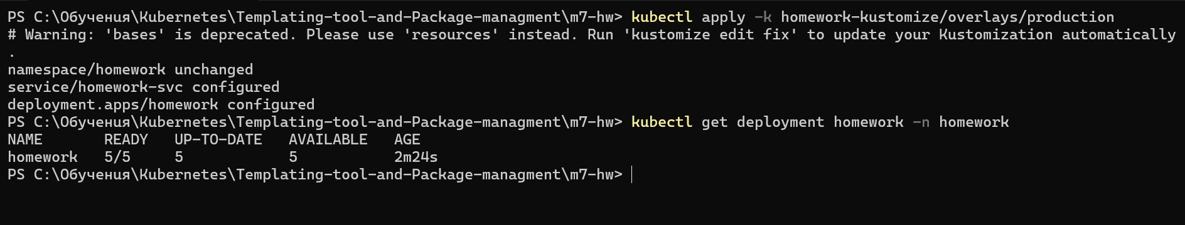

III. Task 3
1.Creating and verifying folder structure
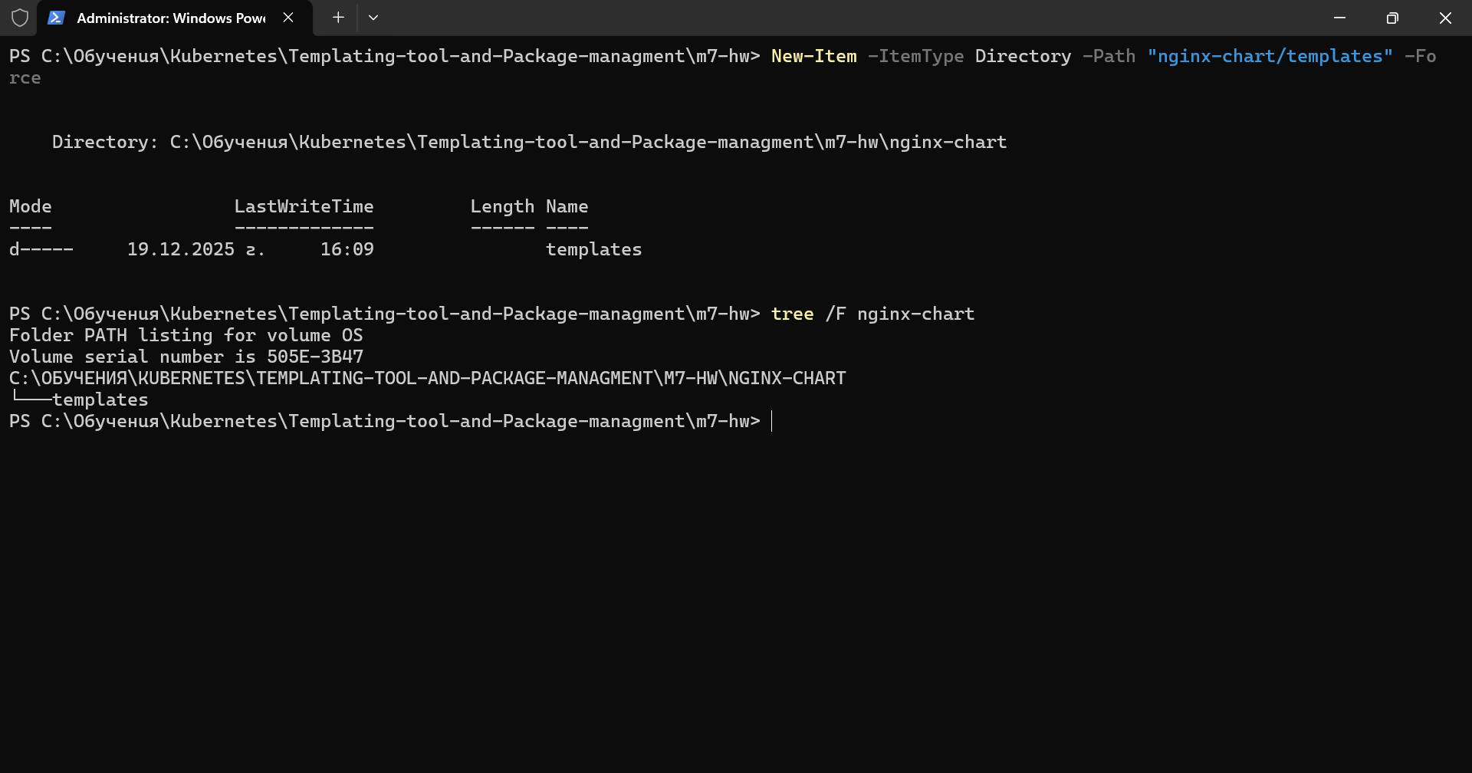
2.Creating Chart.yaml file
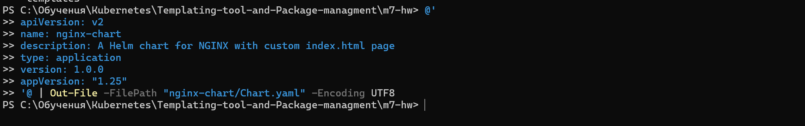
3.Creating values.yaml file
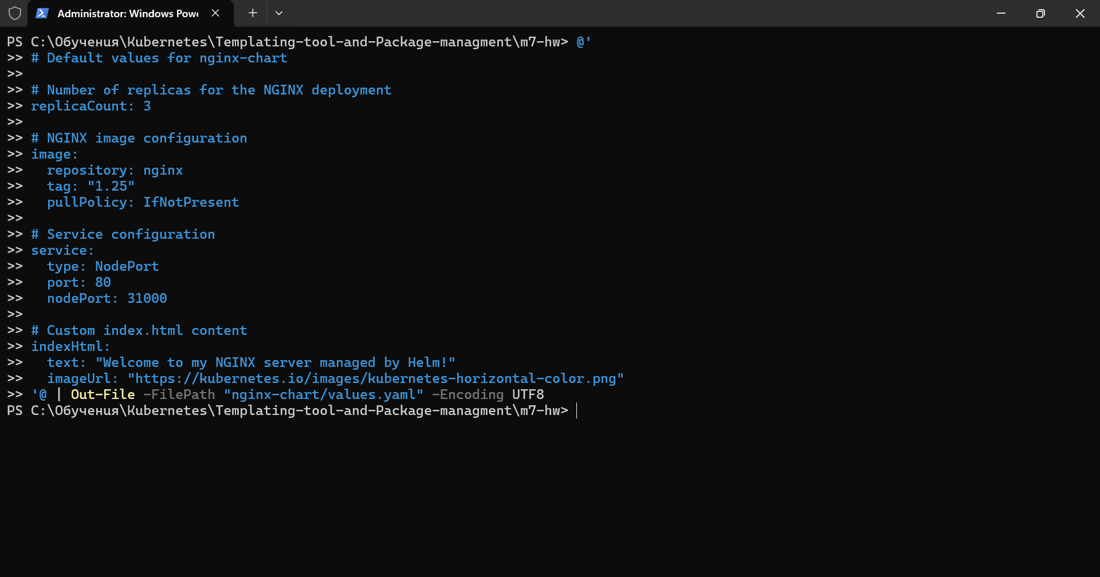
4.Creating ConfigMap template
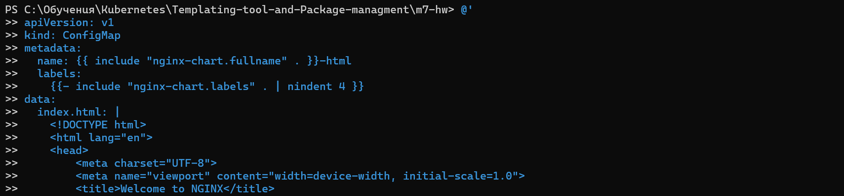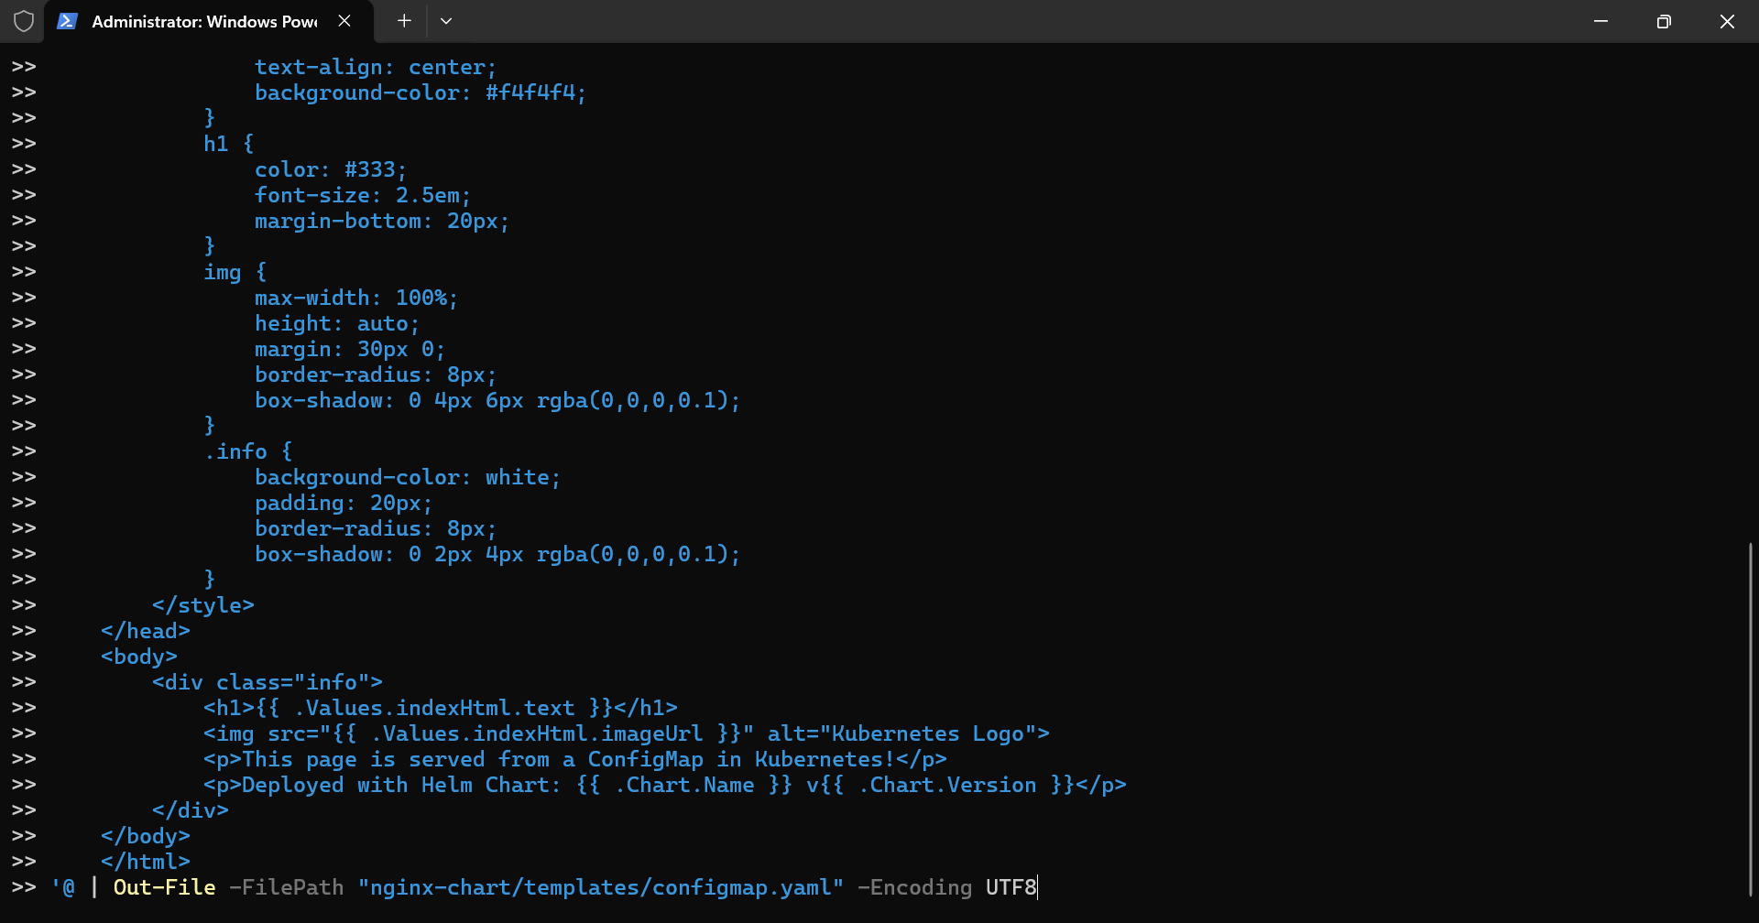
5.Creating deployment template
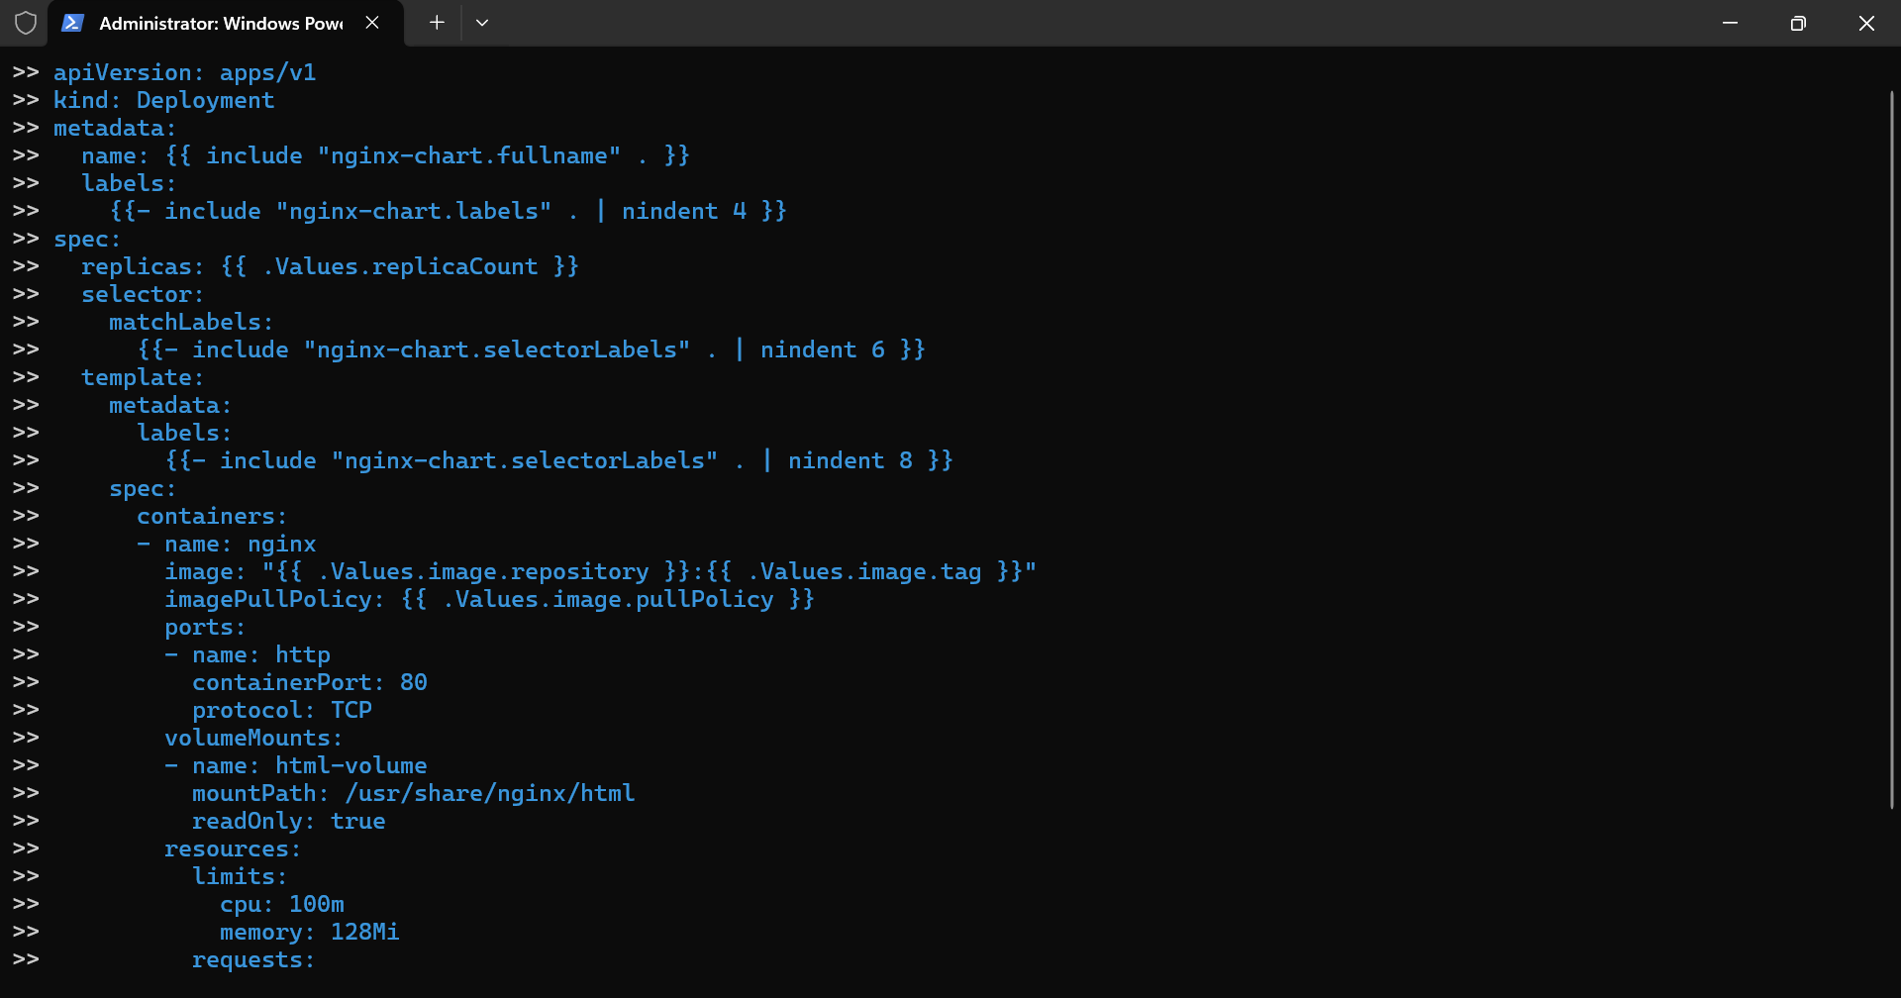
6.Creating service template
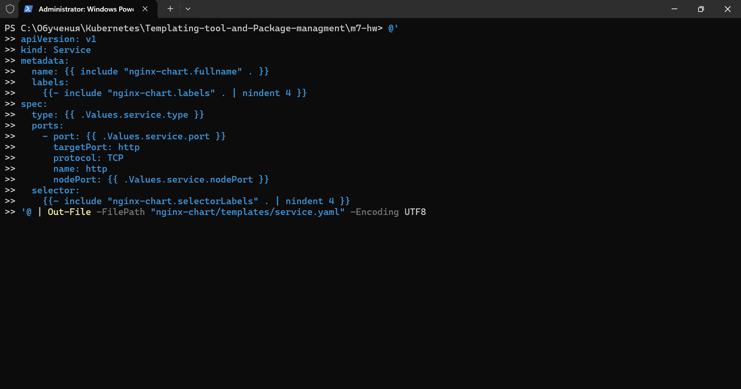
7.Creating _helpers template. I admit AI created it for me. I have nothing to do with it .I didn’t even knew that we needed it
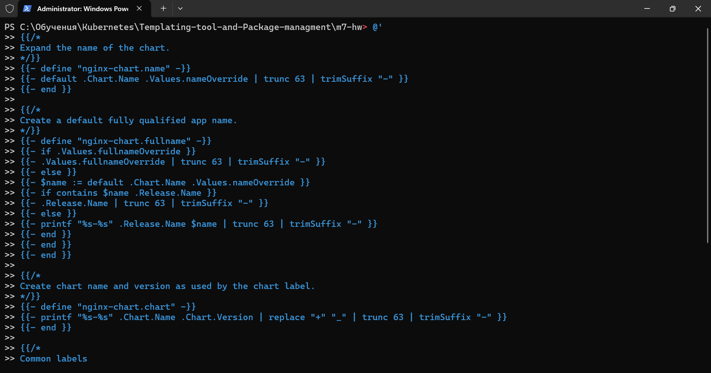
8.Verify the complete structure
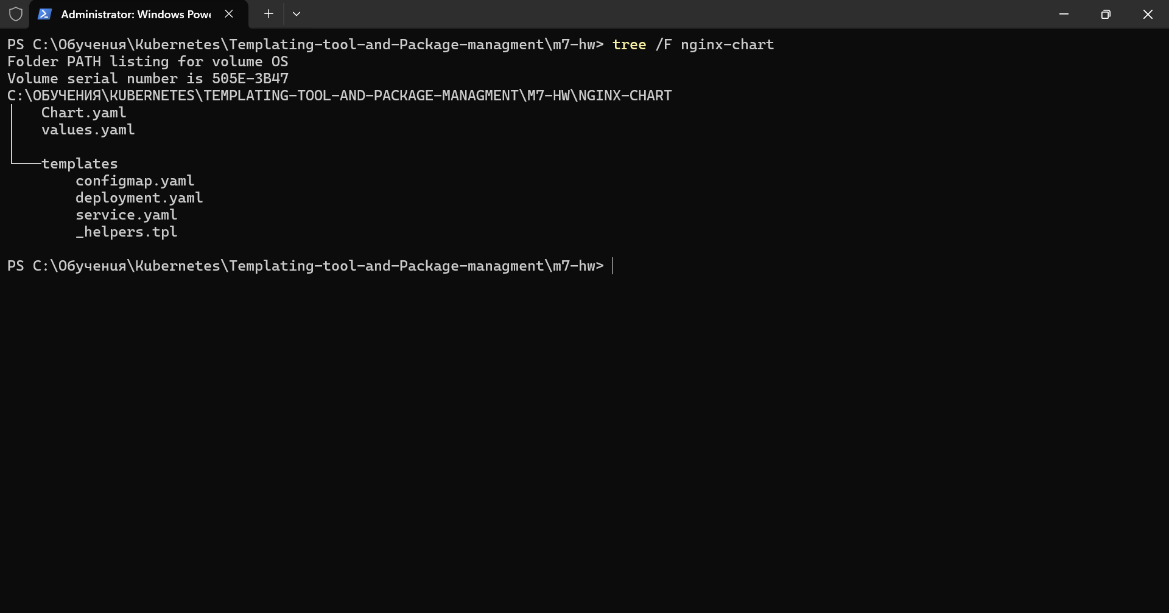
9.Preview and validate the created manifests
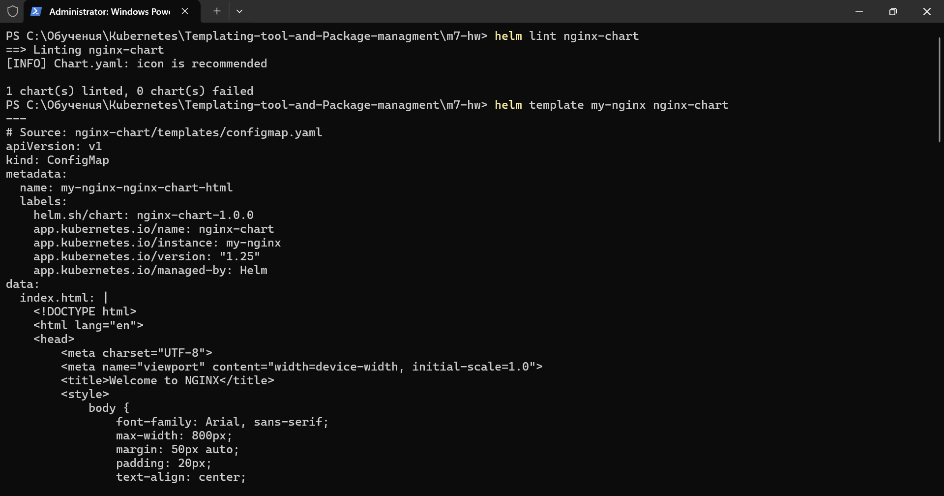
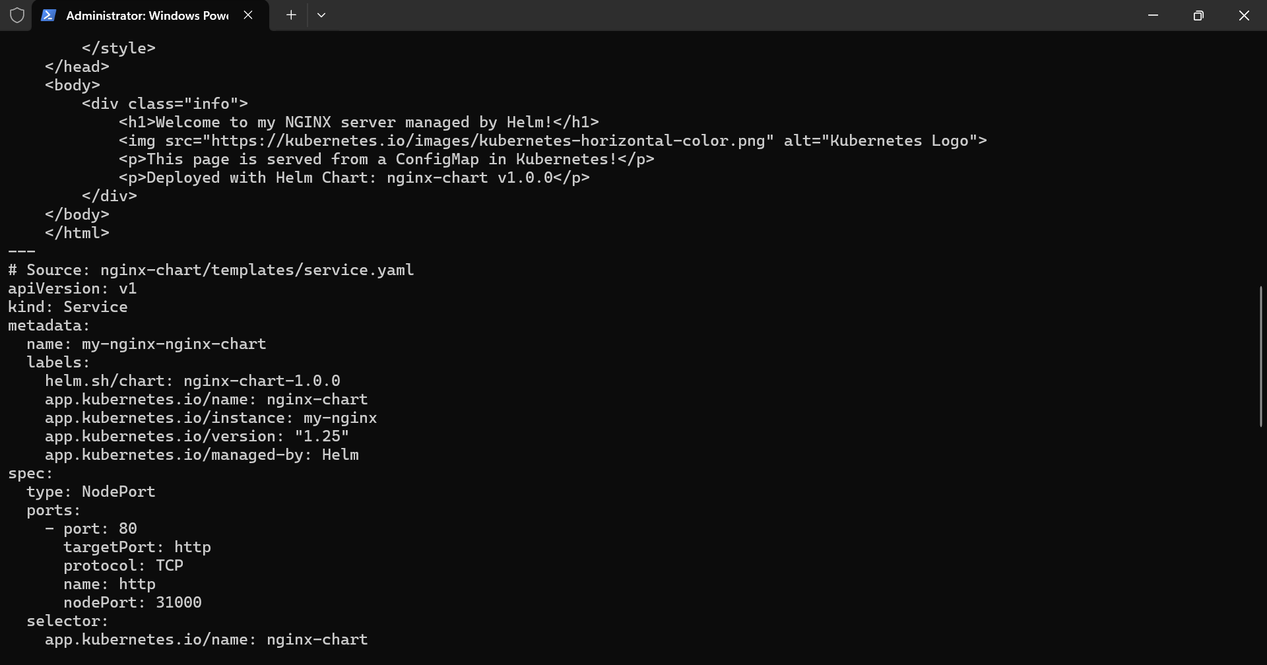
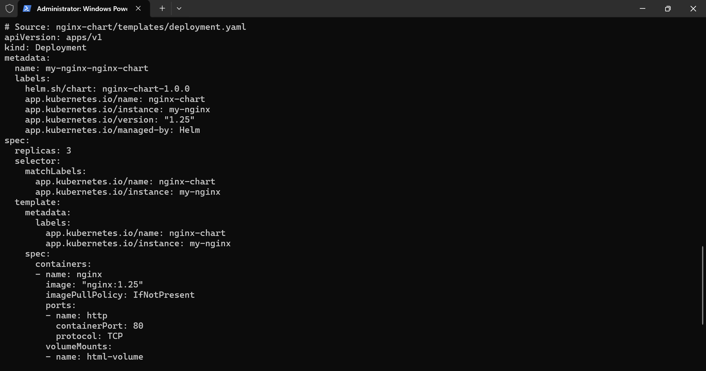
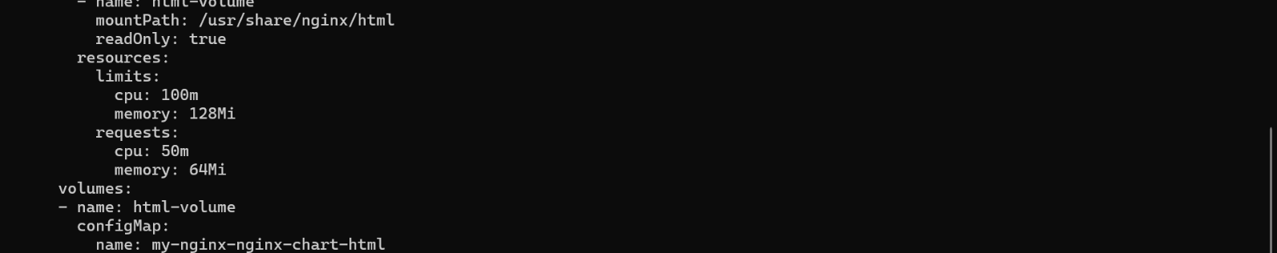
10. Install the chart with default values and verify both in terminal and in browser
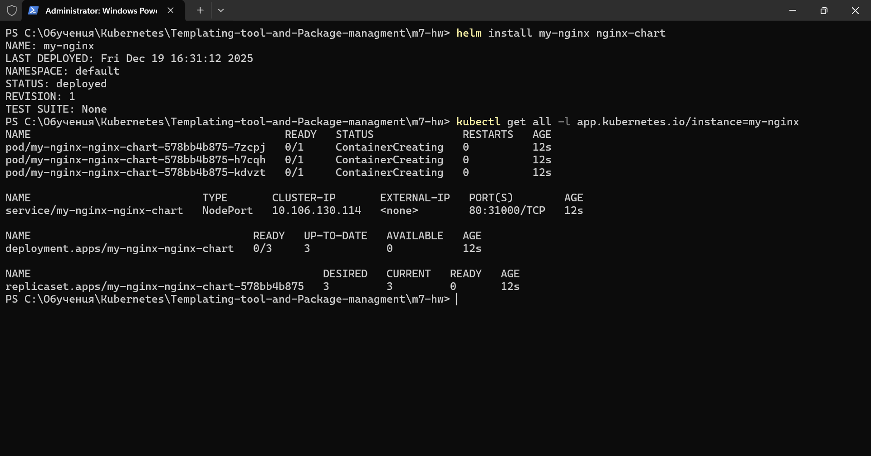
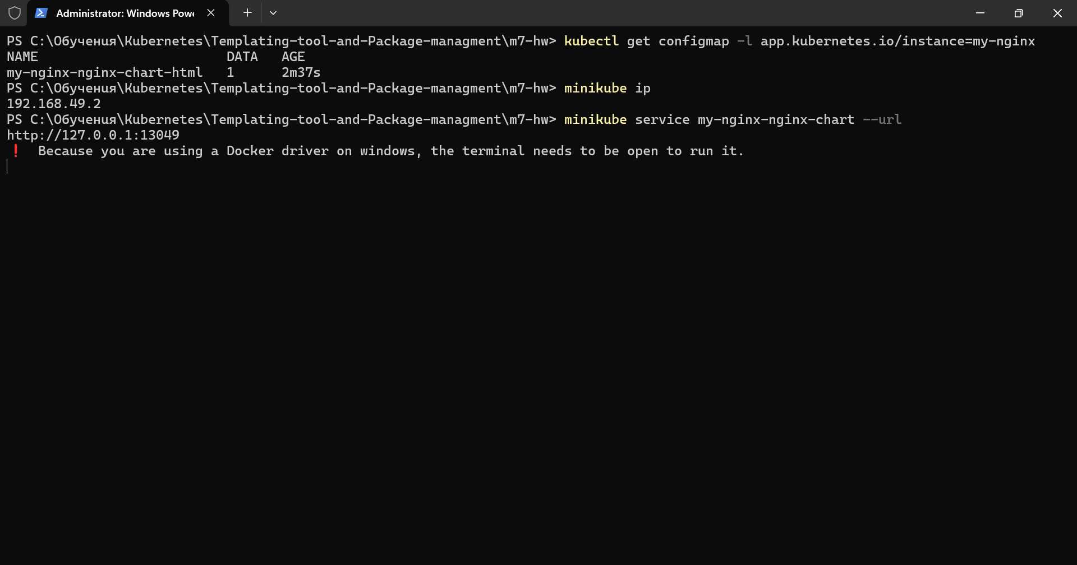
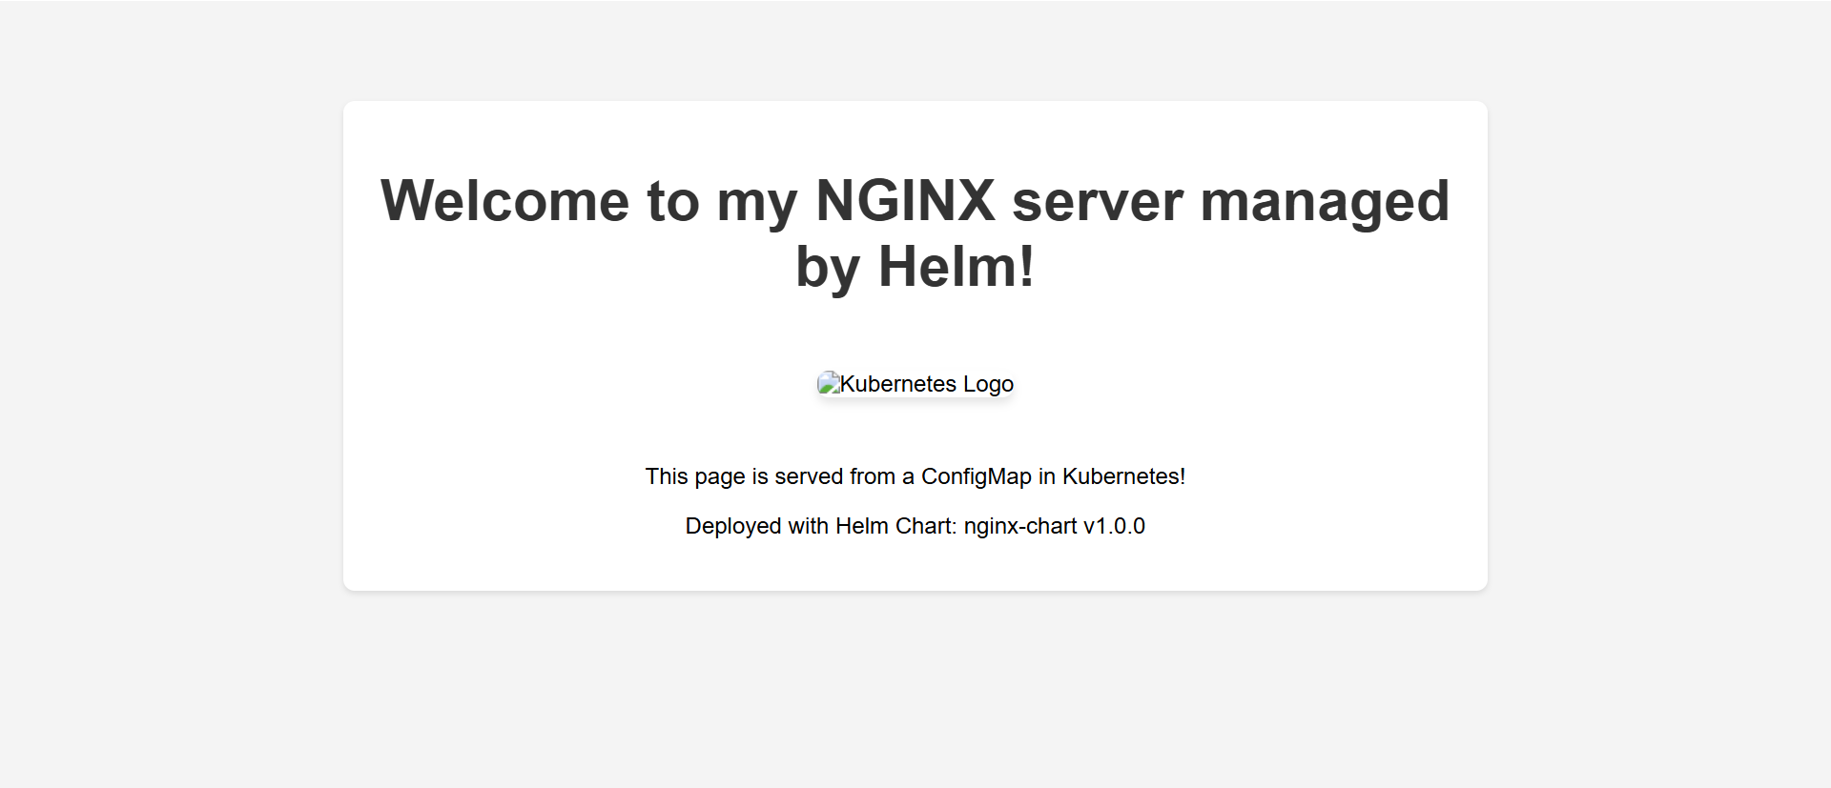
11. Testing different customizations, upgrading the chart and verification that it still works
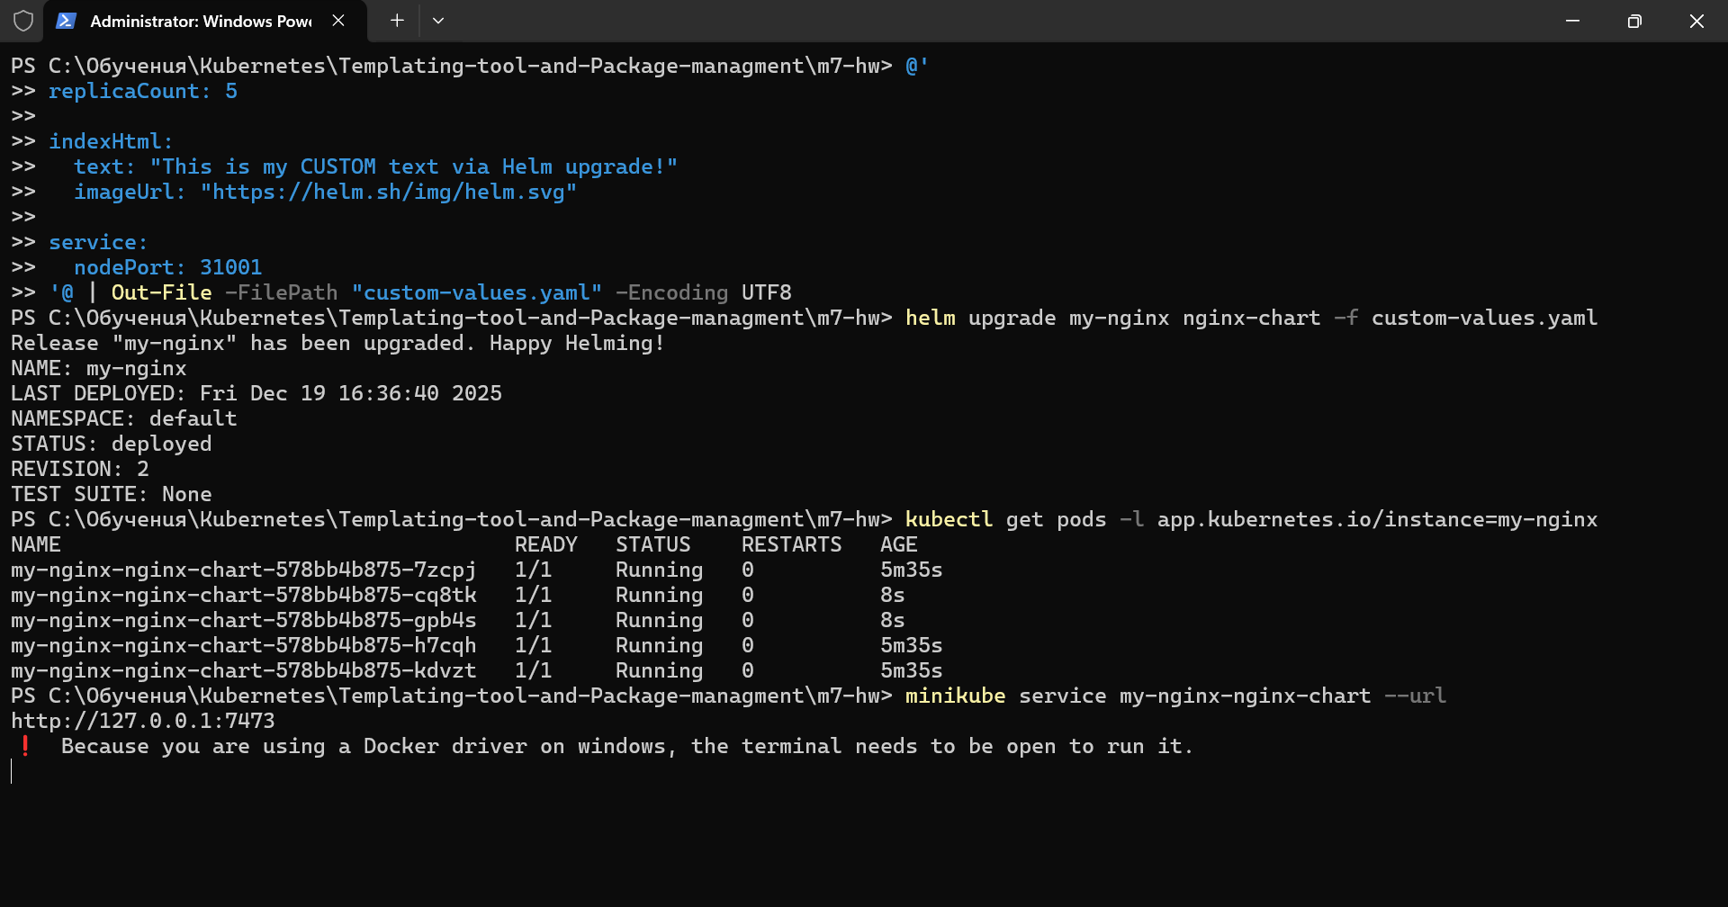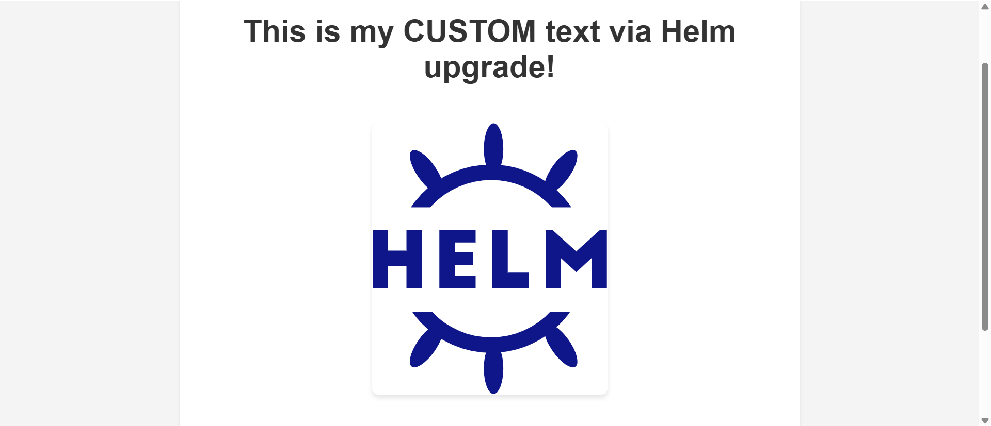

That was the most fun I had in a while. Thank You Бате Митко!!!

