Homework M3: Security and Policies
Main goal is to build further on what was demonstrated during the practice
For the successful completion of the tasks, you will need a simple (two or three node) cluster as the one used during the practice with the appropriate network plugin installed (one that supports Network Policies like Antrea, Calico, Weave Net, etc.)

Tasks *
You are expected to complete the following set of tasks:
- Create and register two Kubernetes uses – Ivan (ivan) and Mariana (mariana) who are part of the Gurus (gurus) group
- Create a namespace named projectx
- Create a LimitRange for the namespace to set defaults, minimum and maximum both for CPU and memory (use values that you consider suitable)
- Create a ResourceQuota for the namespace to set requests and limits both for CPU and memory (use values that you consider suitable). In addition, add limits for pods, services, deployments, and replicasets (again, use values that you find appropriate)
- Create a custom role (devguru) which will allow the one that has it to do anything with any of the following resources pods, services, deployments, and replicasets. Grant the role to ivan and mariana (or to the group they belong to) for the namespace created earlier
- Using one of the two users, deploy the producer-consumer application (use the attached files – you may need to modify them a bit). Deploy one additional pod that will act as a (curl) client
- Create one or more NetworkPolicy resources in order to
  - Allow communication to the producer only from the consumer
  - Allow communication to the consumer only from the client
As usual, you are not obliged to complete all the tasks but try to tackle as many as possible

Proof
Prepare a document that show what you accomplished and how you did it. It can include (not limited to):
- The commands you used to achieve the above tasks
- A few pictures showing intermediary steps or results
- Any configuration files and/or manifests

For this challenge I have decided to run simple cluster using minikube as installer
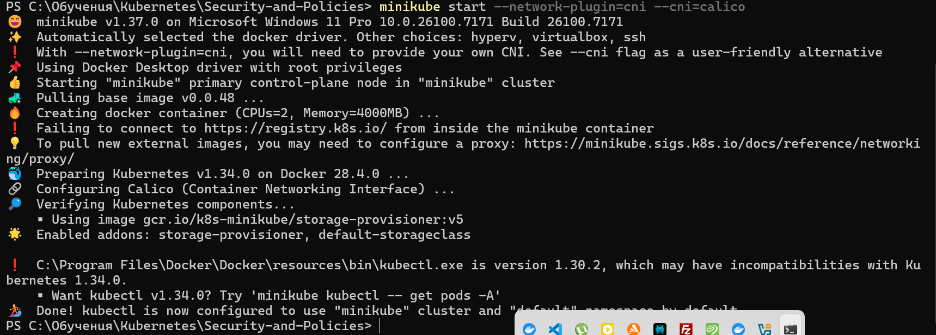
1.Creating two users Ivan and Mariana
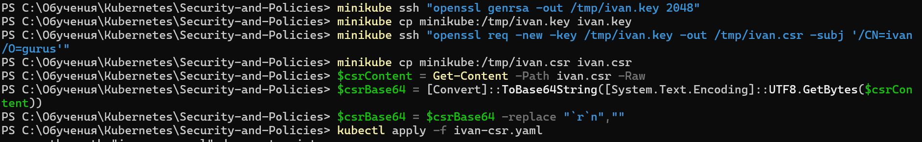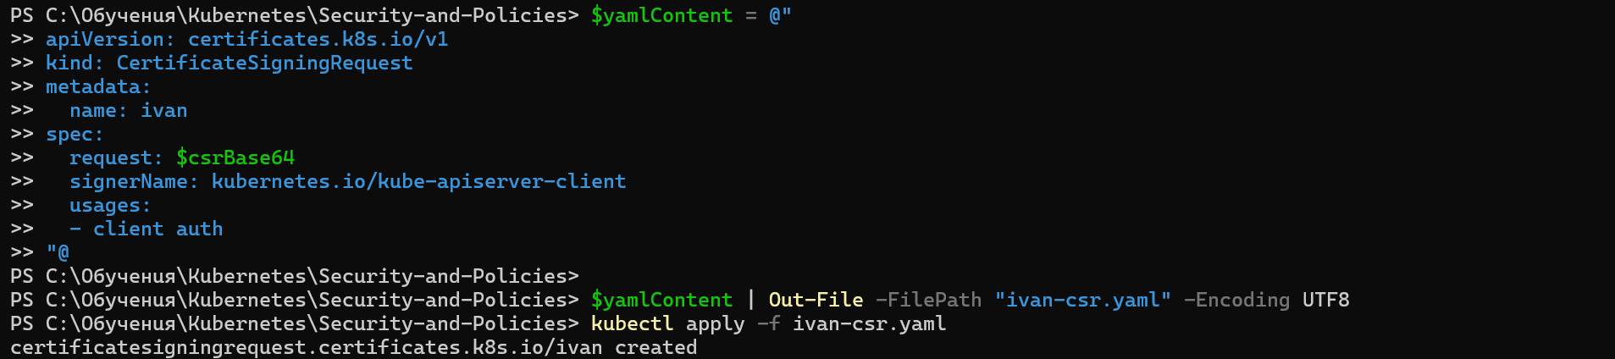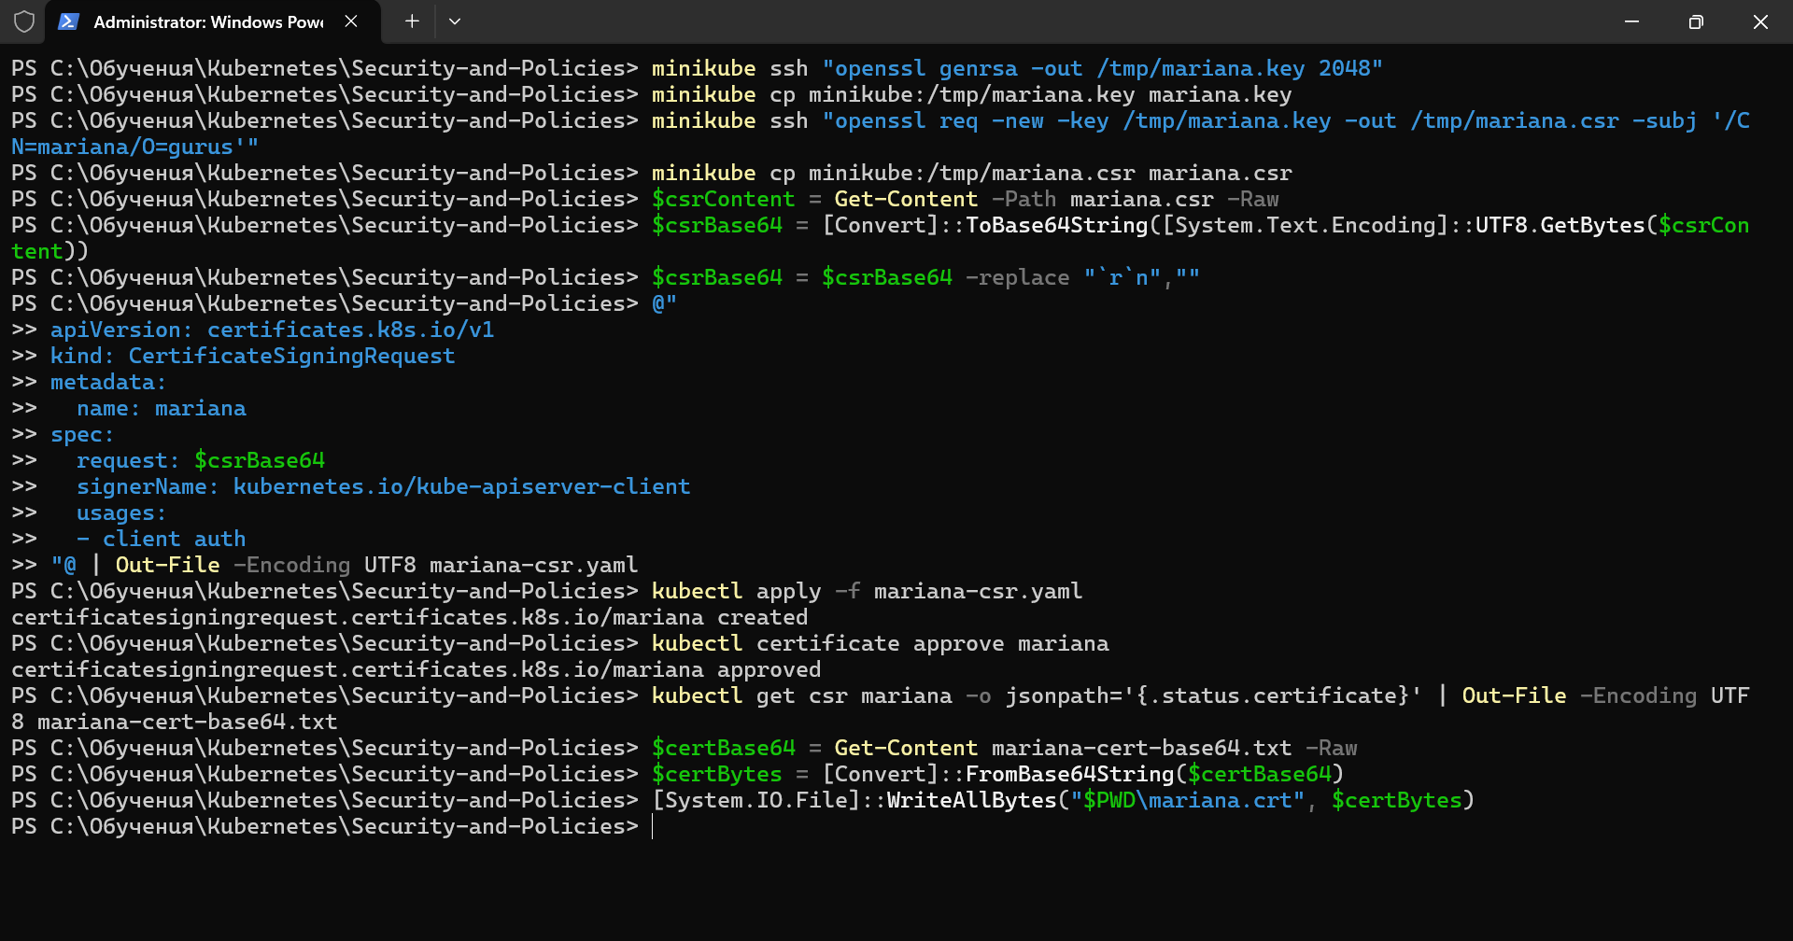
2.Creating namespace called project x
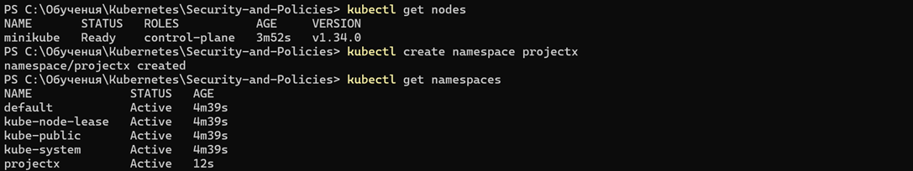
3.Creating a limit range
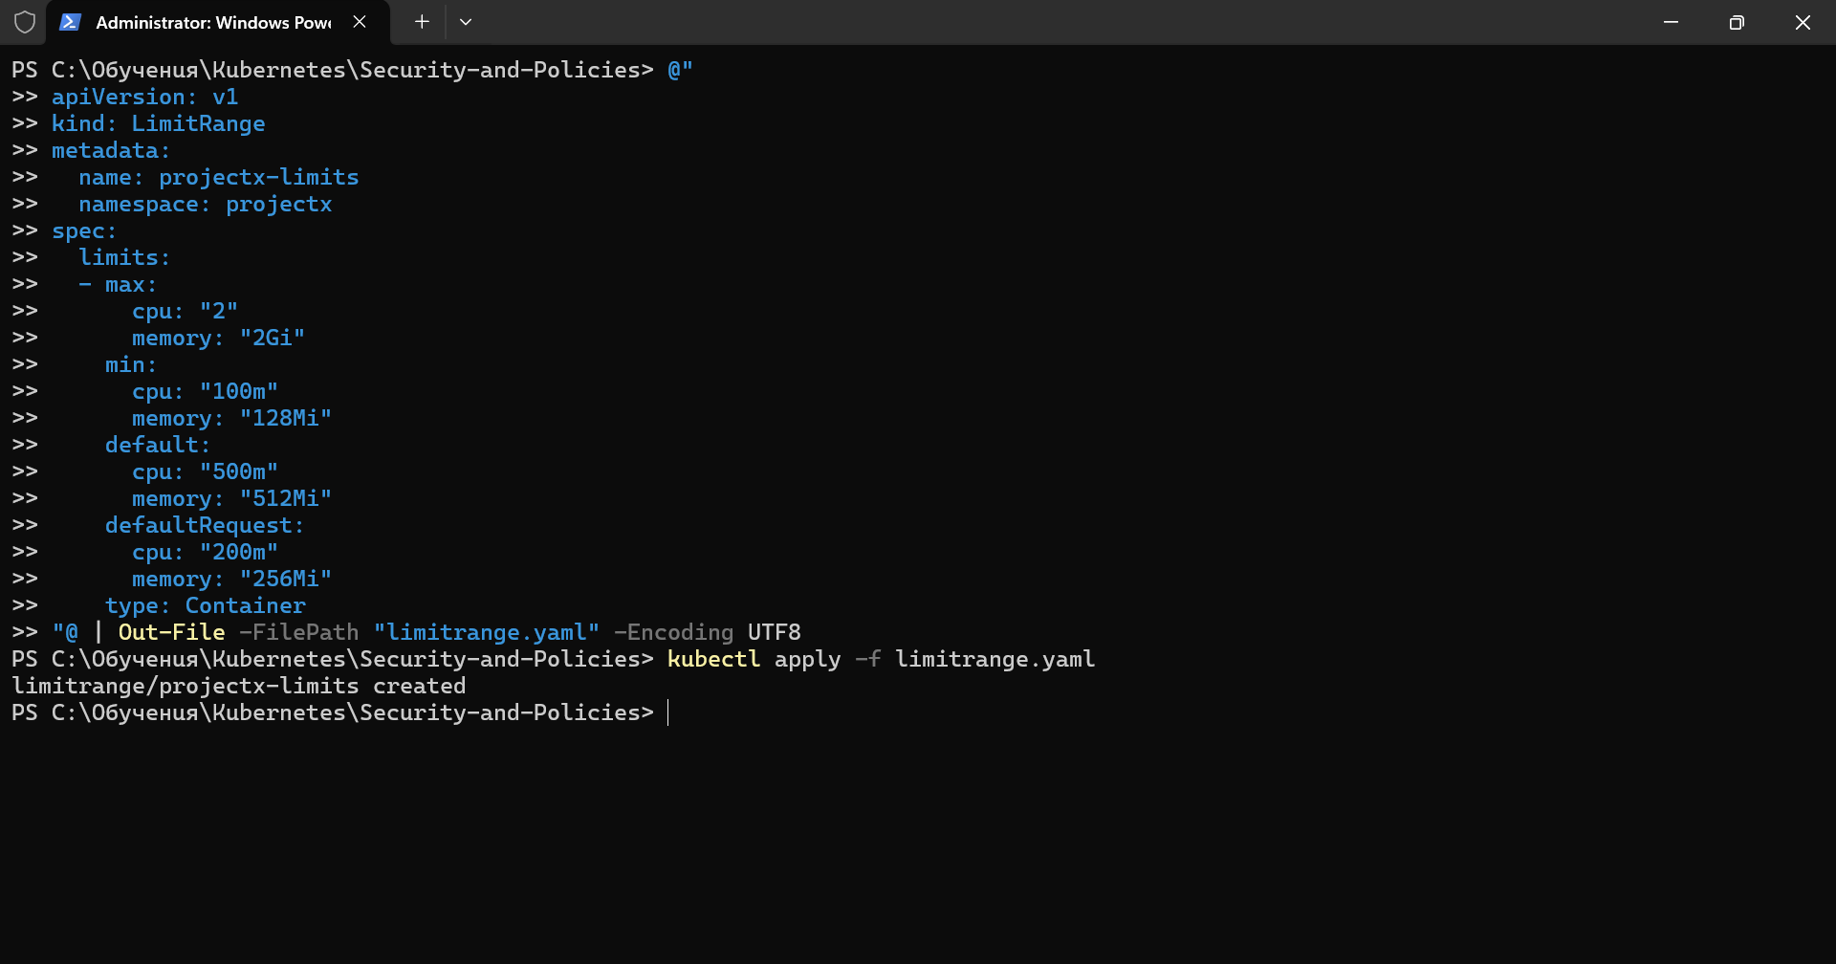
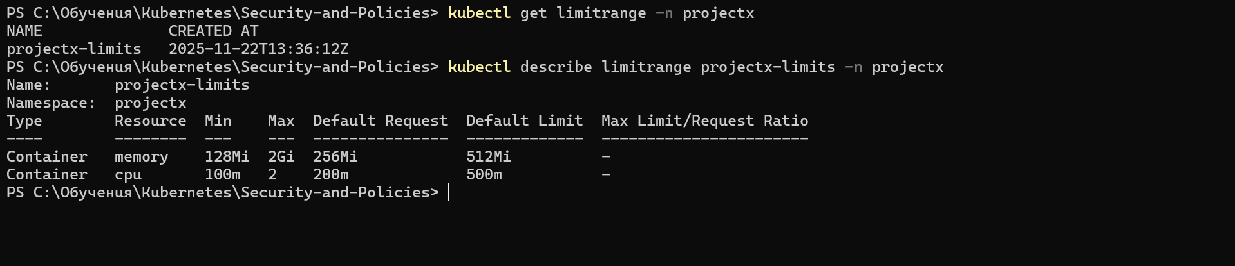
4.Creating a resource quota
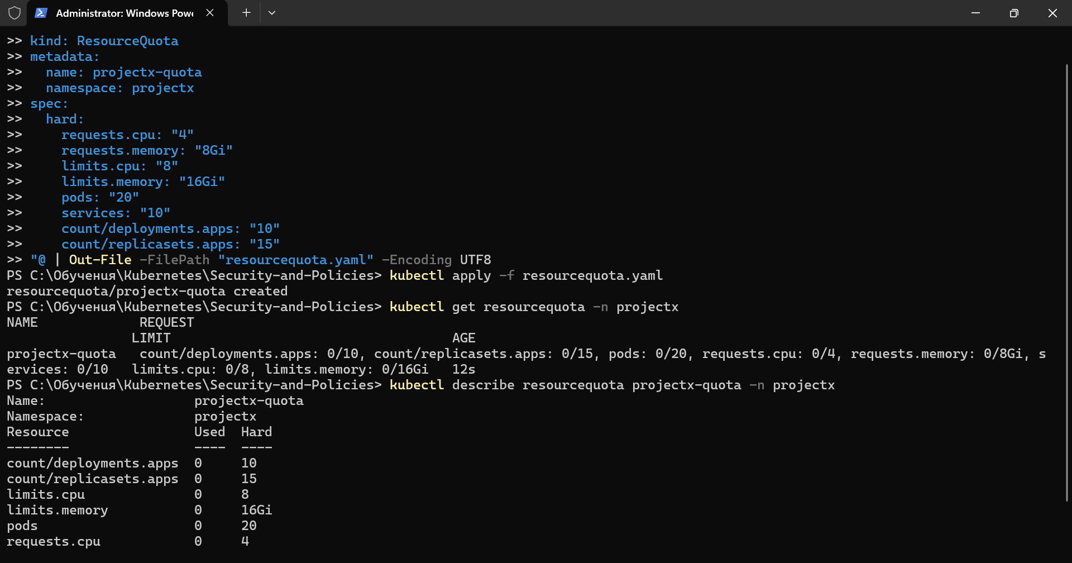
5.Creating a role Devguru
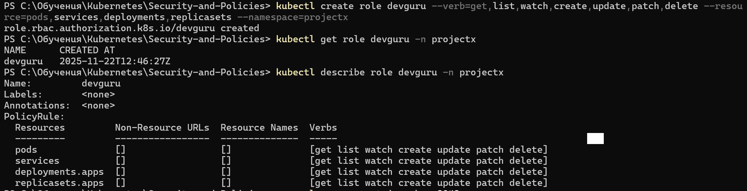
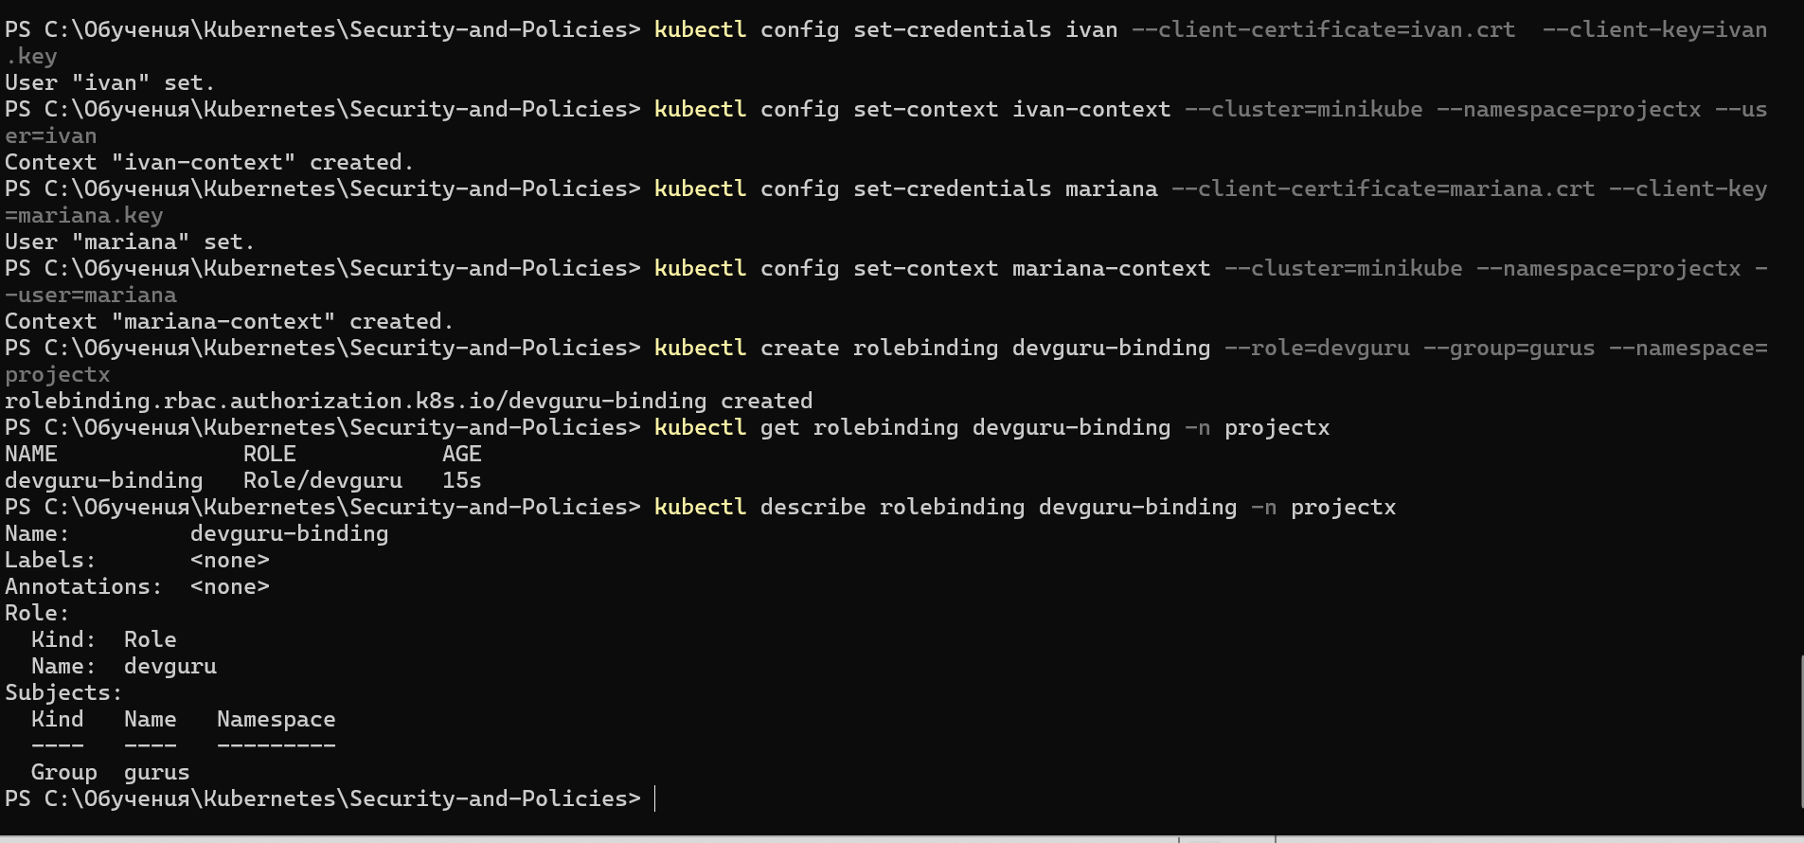
6.Editing the given manifests, deploying the app and creating a curl-client
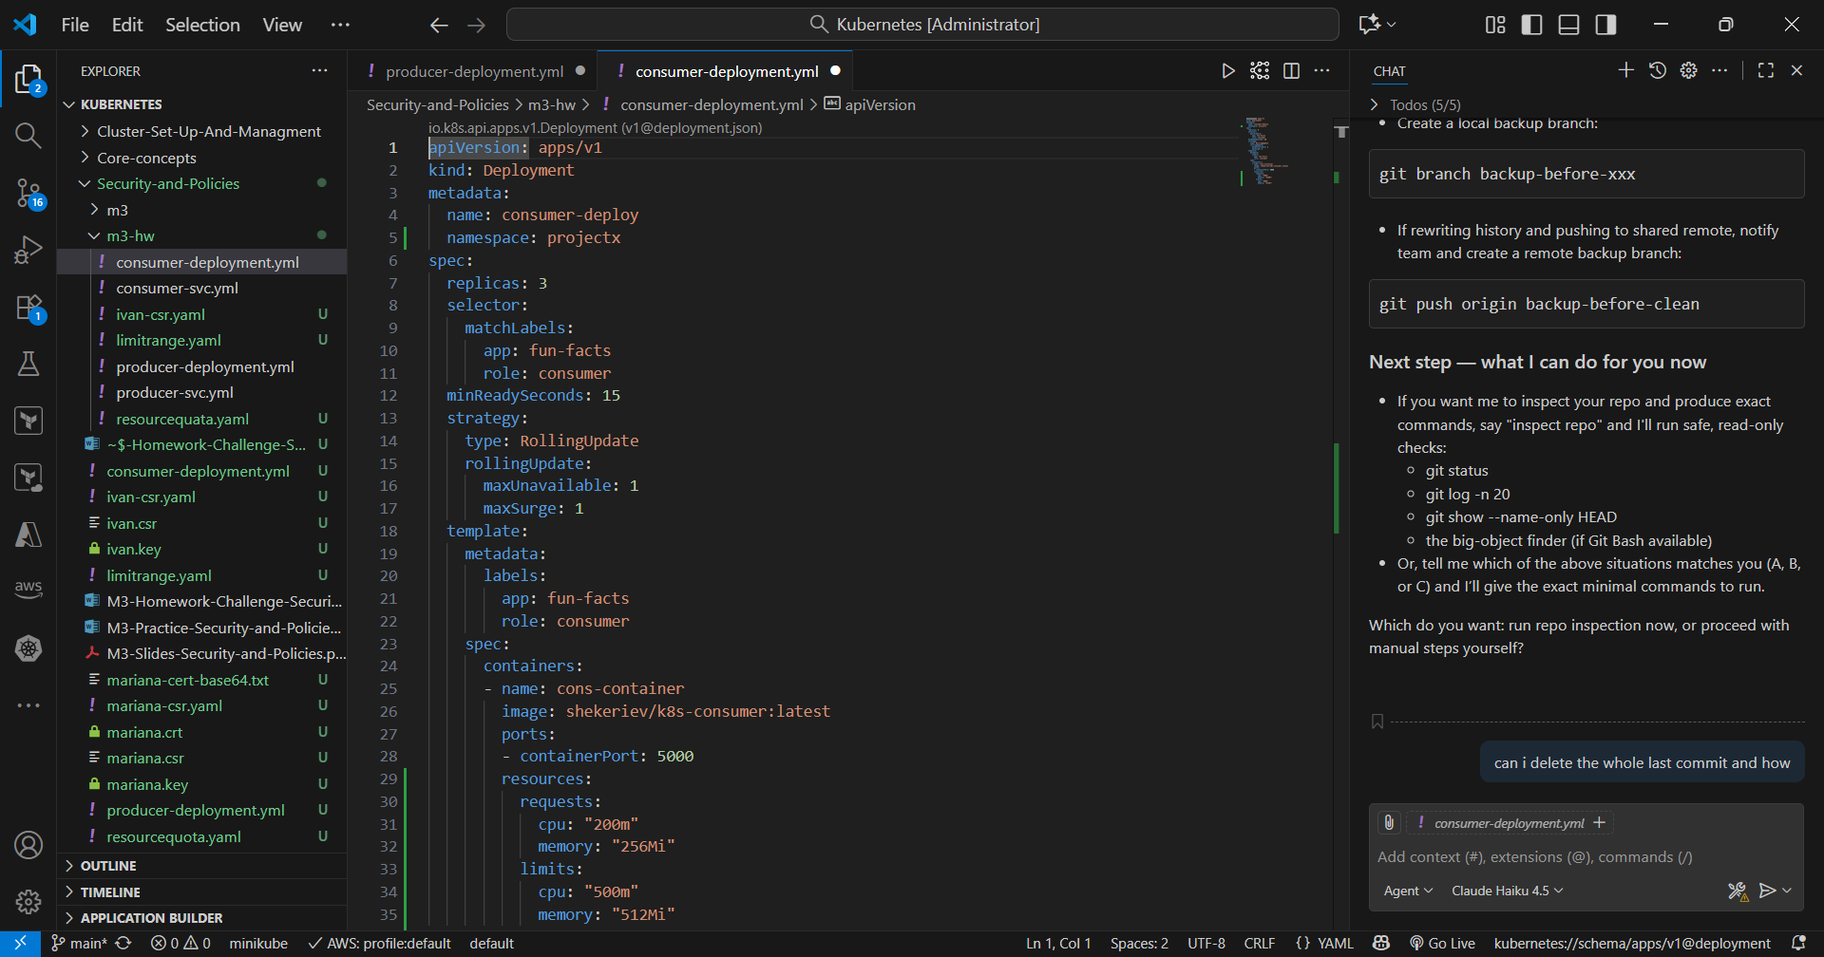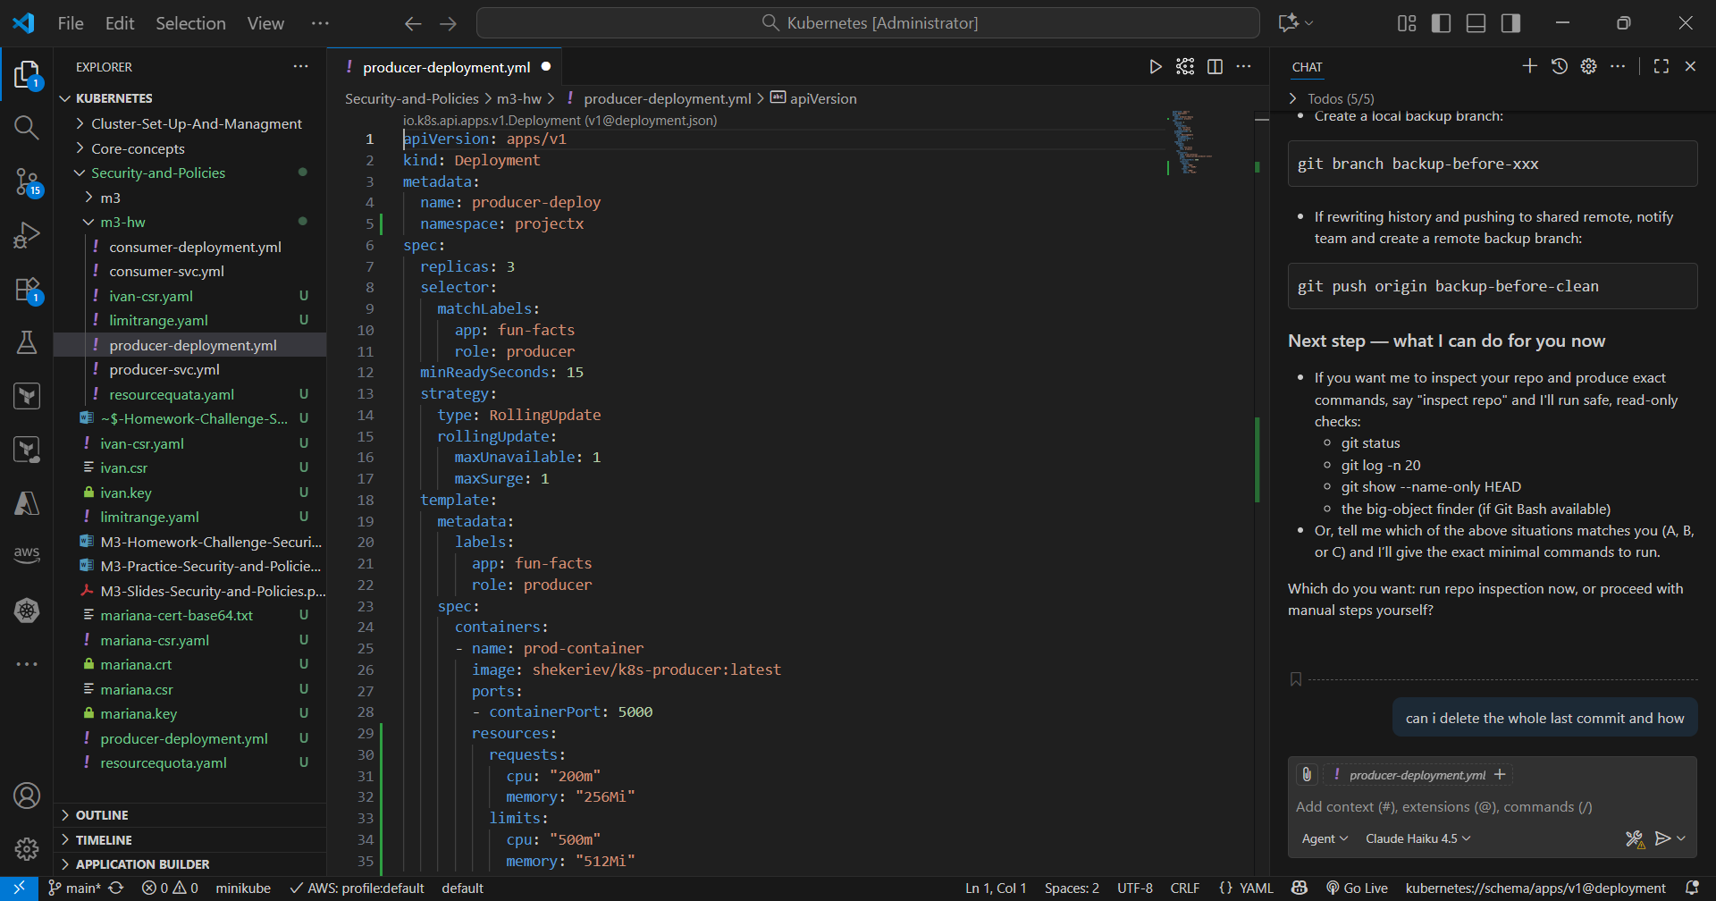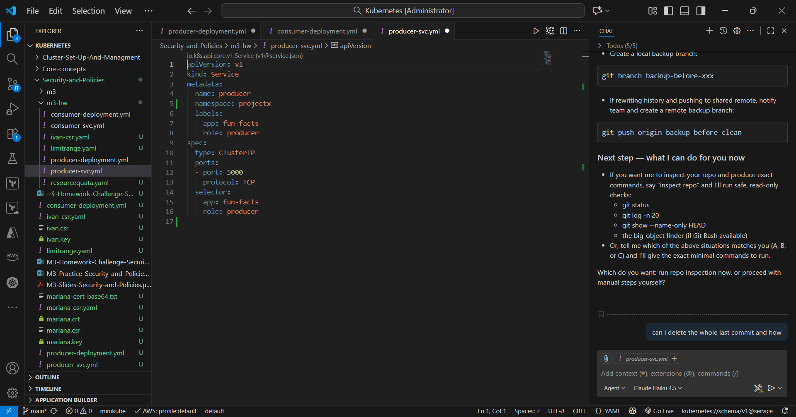
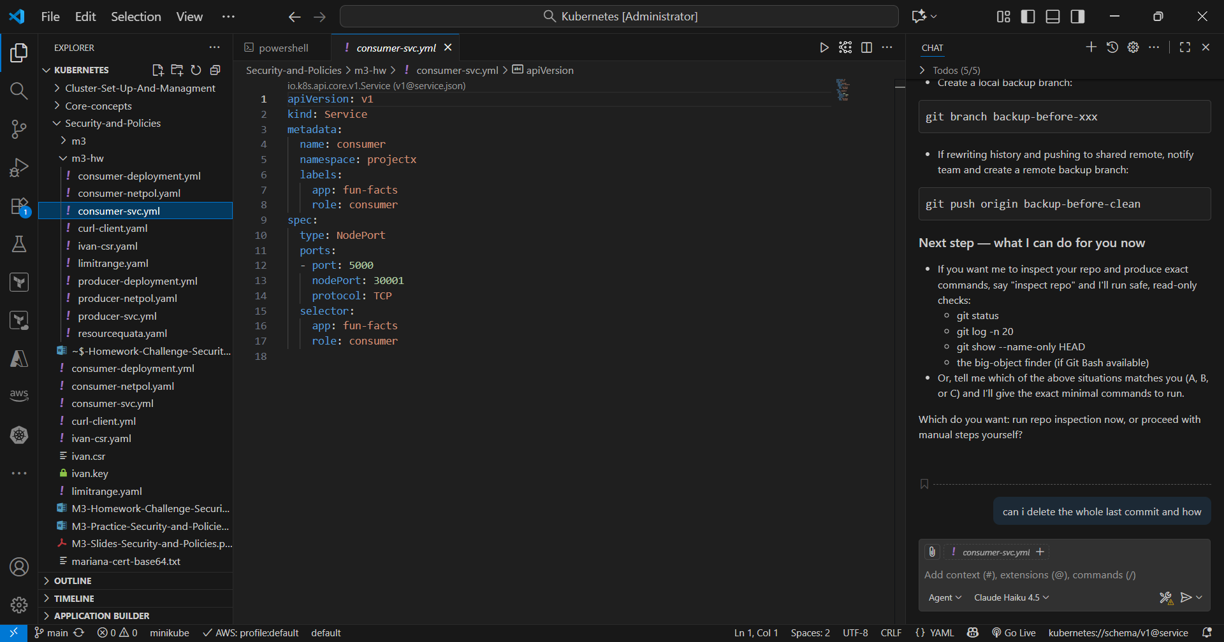
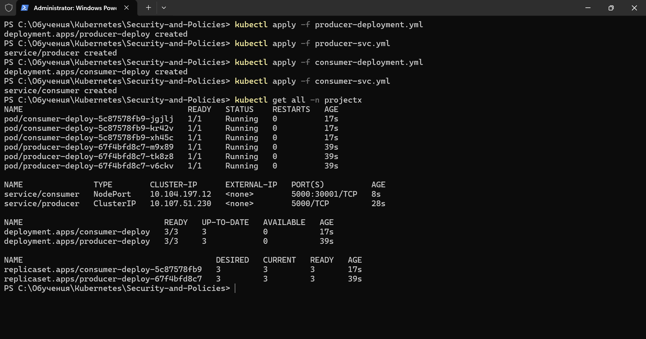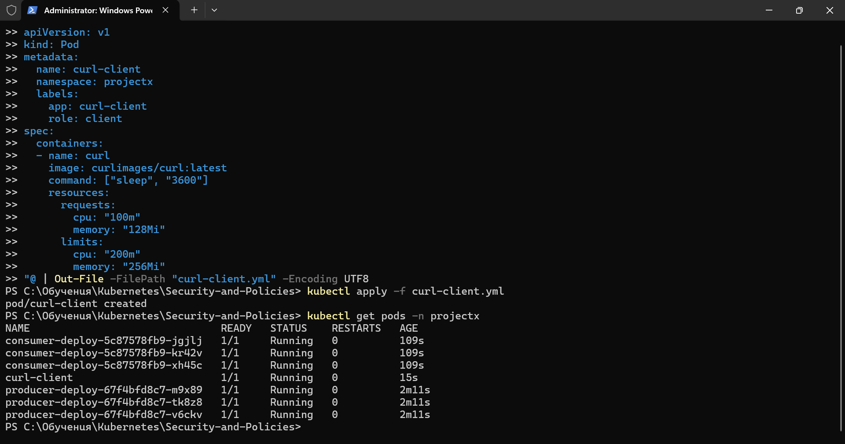
7.Creating network policy
