PostgreSQL Regular Exam

Online Electronics Store

A client operating a large online store specializing in electronic devices has reached out for your expertise in managing their database. Your task is to design and implement an efficient database structure, optimize the existing system for better performance, and conduct an analysis to guide the client in crafting a robust future management strategy for the shop.

Section 0: Database Overview
You are given an Entity/Relationship Diagram of the Online Electronics Store System. This diagram illustrates the connections among different entities within an Online Electronics Store, offering a visual depiction of the database structure:
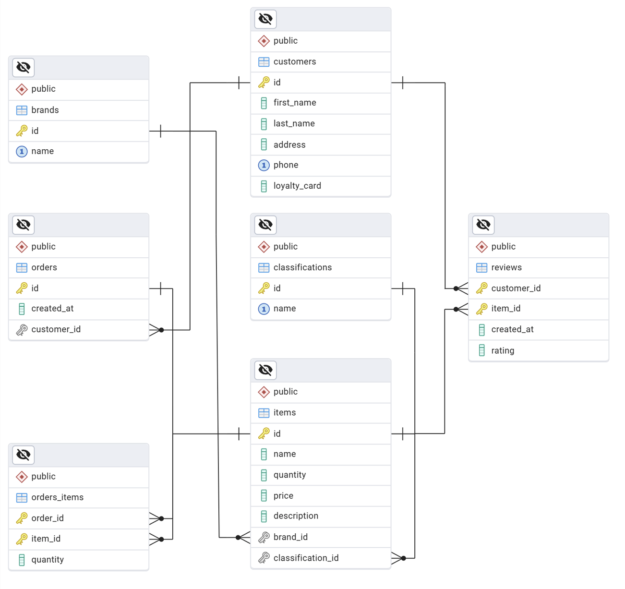
The Online Electronics Store must contain information about brands, classifications, customers, items, orders, and reviews.
Your task is to set up a database named electronics_store with the following tables:
- brands - contains information about the brands.
- classifications - contains information about the item types (classification).
- customers - contains information about the customers.
- items - contains information about the items.
  - Each item has a brand and a classification.
- orders - contains information about the orders.
  - Each order has a customer.
- reviews - contains information about the reviews.
  - Each review is related to an item and a customer.
- orders_items - a many-to-many mapping table between the orders and the items.

Section 1: Data Definition Language (DDL) - 30 Pts
Make sure you implement the database tables correctly.
Important Note: When working with dates, please adhere strictly to the specified data types in the model tables. For example, if a column is defined as type 'DATE,' ensure you utilize the 'DATE' data type. Similarly, if a column is designated as 'TIMESTAMP,' use the 'TIMESTAMP' data type. Failure to use the correct data type may result in your submission being rejected by the Judge system.

Table Design
You have been tasked to create the tables in the database by following the specified models.
Submit only your CREATE statements for all tables to the Judge System.

brands
Column Name | Data Type | Constraints
id | Integer, from 1 to 2,147,483,647 | Primary Key, Unique table identification, Auto-incremented
name | A string containing a maximum of 50 characters | NULL is NOT permitted,  UNIQUE values

classifications
Column Name | Data Type | Constraints
id | Integer, from 1 to 2,147,483,647 | Primary Key, Unique table identification, Auto-incremented
name | A string containing a maximum of 30 characters | NULL is NOT permitted,  UNIQUE values

customers
Column Name | Data Type | Constraints
id | Integer, from 1 to 2,147,483,647 | Primary Key, Unique table identification, Auto-incremented
first_name | A string containing a maximum of 30 characters | NULL is NOT permitted
last_name | A string containing a maximum of 30 characters | NULL is NOT permitted
address | A string containing a maximum of 150 characters | NULL is NOT permitted
phone | A string containing a maximum of 30 characters | NULL is NOT permitted, UNIQUE values
loyalty_card | A Boolean (TRUE or FALSE) | NULL is NOT permitted, DEFAULT FALSE

items
Column Name | Data Type | Constraints
id | Integer, from 1 to 2,147,483,647 | Primary Key, Unique table identification, Auto-incremented
name | A string containing a maximum of 50 characters | NULL is NOT permitted
quantity | Integer, from 0 to 2,147,483,647 | NULL is NOT permitted. The value must be greater than or equal to 0 (>= 0)
price | DECIMAL, up to 12 digits, 2 of which are after the decimal point | NULL is NOT permitted. The value must be greater than 0.00 (> 0.00)
description | An unlimited text | NULL is permitted
brand_id | Integer, from 1 to 2,147,483,647. | Relationship with table brands. Cascade operations. NULL is NOT permitted.
classification _id | Integer, from 1 to 2,147,483,647. | Relationship with table classifications. Cascade operations. NULL is NOT permitted.

orders
Column Name | Data Type | Constraints
id | Integer, from 1 to 2,147,483,647 | Primary Key, Unique table identification, Auto-incremented
created_at | A TIMESTAMP of the order | NULL is NOT permitted. DEFAULT NOW()
customer_id | Integer, from 1 to 2,147,483,647 | Relationship with table customers. Cascade operations. NULL is NOT permitted

reviews
Column Name | Data Type | Constraints
customer_id | Integer, from 1 to 2,147,483,647 | Relationship with table customers. Cascade operations. NULL is NOT permitted
item_id | Integer, from 1 to 2,147,483,647 | Relationship with table items. Cascade operations. NULL is NOT permitted
- | - | Composite Primary Key on both columns (customer_id and item_id). Unique table identification
created_at | A TIMESTAMP of the review | NULL is NOT permitted. DEFAULT NOW()
rating | A DECIMAL, up to 3 digits, 1 of which is after the decimal point. | NULL is NOT permitted. DEFAULT 0.0. The value must be less than or equal to 10.0 (<= 10.0)

orders_items
Column Name | Data Type | Constraints
order_id | Integer, from 1 to 2,147,483,647 | Relationship with table orders. Cascade operations. NULL is NOT permitted
item_id | Integer, from 1 to 2,147,483,647 | Relationship with table items. Cascade operations. NULL is NOT permitted
- | - | Composite Primary Key on both columns (order_id and item_id). Unique table identification
quantity | Integer, from 0 to 2,147,483,647 | NULL is NOT permitted. The value must be greater than or equal to 0 (>= 0)

Section 2: Data Manipulation Language (DML) - 10 Pts
Before starting, ensure to import the 'dataset.sql' file. Successful insertion of data is contingent upon the proper creation of the database structure.
This section entails executing various data manipulation tasks:

Insert
You must insert records with specific data into the items table using data derived from the first ten (10) rows of the reviews table, ordered by item_id in ascending order.
Insert the following data into the items table:
• name - concatenate the string 'Item' and the created_at value of the corresponding review.
• quantity - use the customer_id from the review.
• price – calculated as the rating multiplied by 5 (five).
• description - set it to NULL.
• brand_id - set it to the item_id from the review.
• classification_id - set it to the smallest item_id from the reviews table (ordered by item_id).
Do not hard-code values! Derive them dynamically from the reviews table using SQL queries.
Ensure you only insert data from the first ten (10) reviews based on their item_id.

Example
id | name | quantity | price | description | brand_id | classification_id
… | … | … | … | … | … | …
62 | Zathin++ | 87 | 1131.95 | It has three water levels: L/16L M/23L H/30L, and you can choose a suitable level according to the amount of clothes you need to wash | 7 | 7
63 | Cardguard SuperClean | 82 | 1063.16 | Do not hesitate to buy one | 7 | 7
64 | Item2019-02-11 21:33:00 | 9 | 11.00 | [null] | 1 | 1
… | … | … | … | … | … | …
70 | Item2018-11-12 22:24:00 | 8 | 24.50 | [null] | 1 | 1
71 | Item2018-12-13 10:21:00 | 14 | 16.00 | [null] | 2 | 1
72 | Item2018-07-27 23:49:00 | 24 | 23.50 | [null] | 3 | 1
73 | Item2020-12-12 18:34:00 | 3 | 22.50 | [null] | 4 | 1

Update
Update the rating column in the reviews table based on the item_id and customer_id:
- If the item_id and customer_id values are equal, set the rating to 10.0
- If the customer_id is greater than the item_id, set the rating to 5.5
- Otherwise, do not change the rating.

Example
customer_id | item_id | rating
… | … | …
4 | 6 | 2.7
5 | 6 | 3.0
6 | 6 | 10.0
7 | 7 | 10.0
8 | 1 | 5.5
9 | 1 | 5.5
… | … | …

Delete
As you may recall, during our initial work, data was inserted and updated. Now, there is a need to remove certain records from the database.
Delete all customers who have no orders placed.

Example
id | first_name | last_name
… | … | …
2 | Scott | Anderson
4 | Ronald | Lewis
5 | Brian | Williams
6 | Lauren | Johnson
8 | Karen | Harris
… | … | …

Section 3: Querying - 40 Pts
Important Note: Now, we'll conduct some data extraction tasks. Please ensure that the database is cleared of any manipulations from the previous operations in the Data Manipulation Language (DML) section. Insert the provided dataset again to maintain consistency with the examples in this section.

Customers
Extract information about customers with loyalty cards whose last name contains the letter 'm' or 'M'.
Sort the results by last_name in descending order and then by id ascending.

Required Columns
- id
- last_name
- loyalty_card

Example
id | last_name | loyalty_card
11 | Pomroy | true
1 | Martin | true

Orders by Date
Extract information about orders (id, created_at, customer_id).
Filter orders placed after 01-01-2025 that have customer_id between 15 and 30.
Format the creation date as 'DD-MM-YYYY'.
Order the results by creation date ascending (formatted one), then by customer_id descending, and finally by order id ascending.
Display the first 5 results.

Required Columns
- id
- created_at
- customer_id

Example
id | created_at | customer_id
11 | 02-01-2025 | 28
40 | 05-01-2025 | 27
43 | 05-01-2025 | 27
44 | 06-01-2025 | 16
14 | 11-01-2025 | 29

Items on Sale
Some items need to be put on sale. You must identify them and display the following data.
Write a query that returns the items' name, promotion, description, and quantity of all items not included in any orders.
Construct the promotion value using the item's brand name (upper case), a slash (/), and the classification name (lower case).
Display the description by prepending the 'On sale: ' string at the beginning (also applicable for NULL values).
Order the results by quantity in descending order then by name ascending.

Required Columns

- name
- promotion (a resulting string, according to the description above)
- description ('On sale: ' + current value)
- quantity

Example
name | promotion | description | quantity
Daltfresh | FUJITSU/air conditioners and heaters | On sale: With 10,000 BTUs this unit will save you energy and money while cooling a room. | 106
IronSDLight | ROWENTA/small domestic appliances | On sale: Patented Microsteam400 stainless steel soleplate technology creates perfect steam coverage through its 400 active micro-steam holes. | 88
Galaxy Z Fold3 5G | SAMSUNG/phones and tablets | On sale: | 68
Solarbreeze | DELL/laptops | On sale: With its small size, it can fit virtually anywhere that it is needed. | 55
… | … | … | …

Customers without Reviews
Write a query to identify customers who have placed at least one order but have not left any reviews. The query should include the following columns:
id as customer_id,
full_name - concatenate the customer's first_name and last_name, separated by a space,
total_orders - the total number of orders placed by the customer,
loyalty_status - return 'Loyal Customer' if the customer has a loyalty card, otherwise 'Regular Customer'.
Sort the results by total_orders in descending order, then by customer_id in ascending order.

Required Columns
- id as customer_id
- full_name
- total_orders
- loyalty_status

Example
customer_id | full_name | total_orders | loyalty_status
31 | Risa Goldsbrough | 4 | Regular Customer
28 | Selene Mateo | 3 | Regular Customer
26 | Cherilyn Bradane | 2 | Regular Customer
… | … | … | …
32 | Katlin Everitt | 1 | Regular Customer
33 | Lira Stickler | 1 | Loyal Customer

Top-rated Items
Write a query to extract the top 3 items with the highest average ratings from the reviews. For each item, display the following information:
The item's name, its average rating (rounded to 2 decimal places), the total number of reviews for the item, the item's brand name, the item's classification name
Include only items that have at least 3 reviews. Display the first 3 results.
Sort the results by the average rating in descending order and then by the item name in ascending order.

Required Columns
- item_name
- average_rating
- total_reviews
- brand_name
- classification_name

Example
item_name | average_rating | total_reviews | brand_name | classification_name
XPS 17 | 4.47 | 3 | Dell | Laptops
CLD washer | 4.33 | 3 | Beko | Home appliances
ACER Cromebook CB311 | 3.81 | 7 | Acer | Laptops

Section 4: Programmability - 20 Pts
Now it's time to showcase your database skills with some dynamic scripting. Write a series of functions and procedures to demonstrate your versatility.

Items by Classification
Create a user-defined function named udf_classification_items_count(classification_name VARCHAR(30)) that receives a classification name and returns the total number of associated items in a string format:
- "Found {count} items."
- If no items are found for the given classification name, the function should return "No items found."
Submit only your user-defined function to the Judge system.

Example
Test Query
SELECT udf_classification_items_count('Nonexistent') AS message_text;
Result
message_text
No items found.
Test Query
SELECT udf_classification_items_count('Laptops') AS message_text;
Result
message_text
Found 9 items.

Update Loyalty Status
Create a stored procedure udp_update_loyalty_status(min_orders INT) with the following parameters:
- min_orders - INTEGER
The procedure udp_update_loyalty_status(min_orders INT) receives a minimum count of orders as input and modifies the loyalty card status for all customers who have placed at least the same minimum number of orders.
- Set the loyalty card status for those customers to TRUE.
- Leave the loyalty card status of all other customers unchanged.
- The min_orders value will always be a positive integer greater than 0. You are not supposed to validate this condition.
Submit only your stored procedure to the Judge system.

Example
Test Query
CALL udp_update_loyalty_status(4);
Initial State of Customers
id | first_name | last_name | loyalty_card
… | … | … | …
30 | Maridel | Toller | false
31 | Risa | Goldsbrough | false
32 | Katlin | Everitt | false
33 | Lira | Stickler | true
34 | Barbie | Gandey | false
35 | Osborne | Sunderland | false
… | … | … | …

Resulting State
id | first_name | last_name | loyalty_card
… | … | … | …
30 | Maridel | Toller | false
31 | Risa | Goldsbrough | true
32 | Katlin | Everitt | false
33 | Lira | Stickler | true
34 | Barbie | Gandey | false
35 | Osborne | Sunderland | false
… | … | … | …

