### Experience

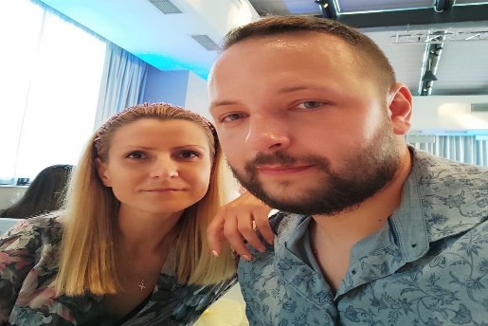

Plamen Stamenov

Front-End Developer

# Objective

I am a result-oriented Front-End Developer with almost 5 years of experience in the online betting/gambling industry.

## Skills & Abilities

HTML & CSS, React JS, SASS, JavaScript, Git, Node JS

## Vitals

Str. Pirin 59, Sofia, Bulgaria

**T** +359 883 361 570

**E** [plamen.stamenov.89@gmail.com](mailto:plamen.stamenov.89@gmail.com)

**L** [LinkedIn](https://www.linkedin.com/in/plamen-stamenov-256b71150/)

#### Draftkings INC, Lead Web content manager

##### november 2018 – march 2023

* Resolve a wide range of Front-End issues & incidents
* Initiate improvements and their execution to support the overall web content management strategy of the team
* Edit and coordinate the content for clients’ sites
* Perform trainings on CMS to company clients
* Assist in the onboarding process of new team members
* Develop and apply different Front-End customizations using HTML, CSS, JS

#### SOS Locksmith LTD, web Developer

##### November 2017 – october 2018

* Develop and create web sites based on a pre-set technical assignment
* Administer, maintain and update websites, SEO

#### Modo LTD, web administrator

##### August 2016 – July 2017

* Creation and development of graphic concepts for web site designs
* Design of logos and icons
* Create websites based on assignment
* Graphic design of websites

#### Freelancer, Web developer

##### January 2014 – july 2016

* Develop various websites for different clients
* Administer and update websites

### Education

#### React JS, Softuni

##### February 2023 – april 2023

* React and JSX
* Components
* Forms
* Routing
* React Hooks
* Authentication
* Advanced Techniques

#### HTML & CSS, Softuni

##### januari 2023 – february 2023

* HTML Structure
* CSS & Typography
* CSS Box Model
* Position & Grid
* Flexbox
* Media Queries

#### JavaScript, IT talents

##### April 2015 – June 2015

* Cycles, arrays, functions, IIFE, Closures, basic algorithms, and JavaScript data structures
* HTML, CSS, and Web Programming Basics and OOP

#### fundametals of C#, Telerik academy

##### september 2011 – january 2012

* Introduction to programming
* Primitive data types and variables
* Operators and expressions
* Input and output the console
* Conditional constructions
* Cycles

#### Computer technologies in engineering

##### university of mining and geology, sofia, bulgaria, september 2010 – june 2014

* Object oriented programming
* Data Structures and Algorithms
* Operating Systems
* Database management systems
* Web design
* Application software development
* Economy and Management
* Computer Graphics
* Microprocessor technology
* Computer modeling
* Administration of web systems
* Information security and security

### Tools & Technologies

* HTML
* CSS/SASS
* JavaScript
* React JS
* Node JS
* Git/GitHub
* Jira
* Confluence
* Slack

### INDUSTRY KNOWLEDGE

* Front-End Development
* Object-Oriented Programming (OOP)
* Search Engine Optimization (SEO)
* Content Management

### Protfolio

Are you head of the condo board, or a team lead for your favorite charity? This is the perfect place to let everyone know.

### REFERENCES

#### Gabriel Kanchev, Draftkings INC

##### Mobile: +359 888 104 049