Brazil: Detailed Usage Scenario
Douglas Aberdeen, Owen Thomas, Olivier Buffet

This scenario explores the use of the Brail Planning System for optimising the production of computers. This is a very simplistic example chosen to highlight the key features of the system. Figures are illustrative only, the precise graphical representations used may vary.

We begin with the task editor in Figure 1. The user successively populates this view with the tasks (interchangeably called actions) that might be useful for achieving the desired goal, in this case the production of a computer. While populating the system with tasks we do not consider which tasks, or in what order, will make up the final process or plan.

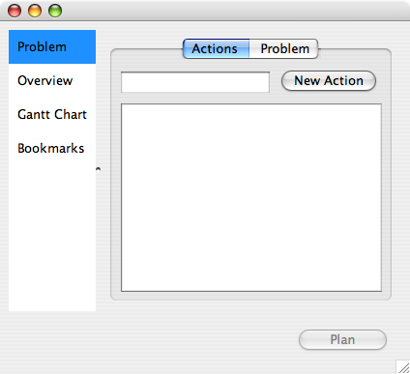
Figure 1: The empty task database view.

The first task we shall model is the use of an old process to produce a central processing unit (CPU) chip, the heart of any computer. By entering the task name “Make CPU at old factory” in the New Action space, we create a new task. We can then open the task modelling interface for this new task, shown in Figure 2.
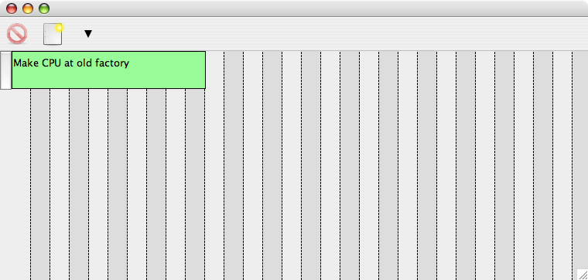
Figure 2: A newly created task for customisation

In this view time increases from left to right. The beginning of this task is at the leftmost side, regardless of how many other tasks currently populate the system. The horizontal length of the green bar represents the core duration of the task. Each vertical grey subdivision represents approximately one day for the purpose of this scenario.

The user now proceeds to modify this default view of the task to capture information about two fundamentally different forms of uncertainty, each producing different kinds of contingencies when performing this task:
- continuous uncertainty in how long the task takes;
- discrete uncertainty in the fundamental outcomes of the task.

Type 1 uncertainties are novelly modelled using an interactive process that uses two hot-spots on duration bar, show in Figure 3.
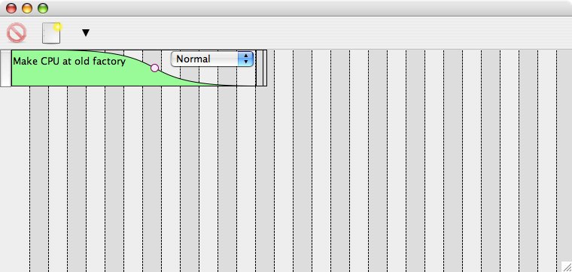
Figure 3: Interacting with a duration bar to model uncertainty in time.

An area at the end of the bar that is dragged to increase the maximum length, as shown in Figure 4. Clicking on the central hot-spot, here represented as a white dot, allow the user to change the shape of the curve. Thus the dot changes the duration variance, and the length changes the mean duration, and the height of colour represents the probability that the task is still continuing at that time. The user can also select from a range of shapes that represent different continuous probability distributions. Figure 4 shows a normal shape. The duration uncertainty in CPU production might come from the chemical process of making silicon wafers, or the process of photolithography for etching wires onto silicon. Overall, the user is relieved of the burden of needing to know anything about probability distributions, they interact with the representation until it shows approximately the correct likelihood of the task duration.

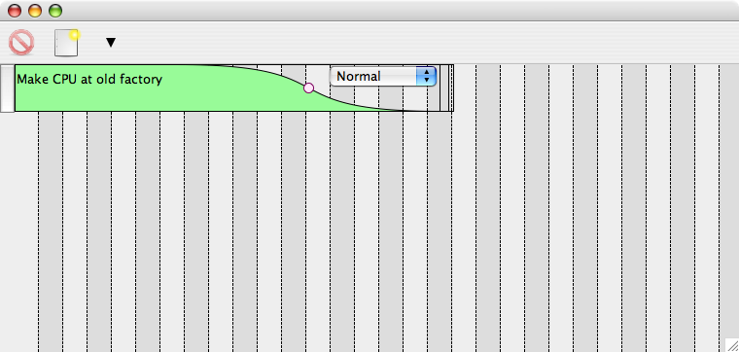
Figure 4: The duration of the task is extended
In the event that accurate information is available about the duration of the task --- perhaps because of a long history of the process, or automatic timing sensors --- the probabilistic information can be entered in a text form, or by directly editing/populating the XML database of task information.

The second major form of uncertainty is discrete outcomes. In the case of producing a CPU chip, all chips will be tested at the end of the process. The old CPU factory has a relatively high yield, 40% of chips pass the testing, shown in Figure 5. Note that the outcomes themselves extend the duration of the original task, and this extension for each outcome may itself be uncertain. In our scenario, the chip goes through a sequence of tests that take an effectively known amount of time. So we know exactly how long a good chip will take to get through the testing process. However, the task will be abandoned as soon as any single test fails. Thus the “CPU tests failure” outcome may terminate at any time through the testing process. Here we have used a Uniform distribution shape, indicating that we have no knowledge about how which tests will fail. If we were sensible, we would conduct the tests most likely to fail first. This would give an exponential shape of distribution. This mixture of continuous durations, and discrete outcomes, is a powerful and novel way of modelling uncertainty and contingencies in process engineering or planning.

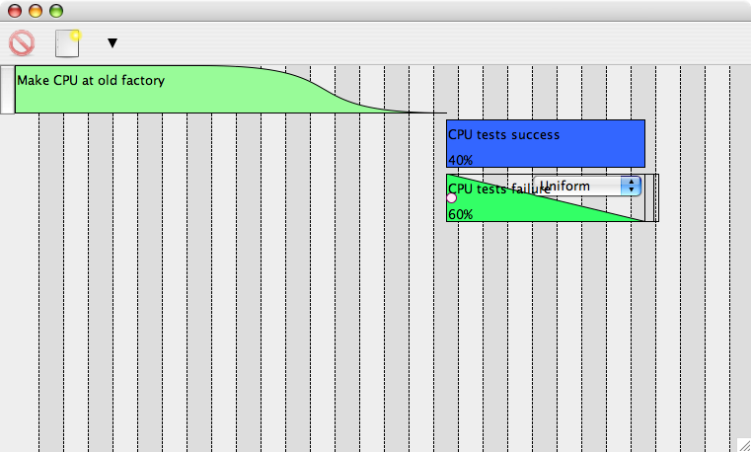
Figure 5: Two outcomes of making a CPU chip, success and failure

Once the uncertainties in a task are modelled we can add new tasks to the system. An important feature is that we can provide the system with multiple tasks that achieve the same end effects in different ways. The planning system will eventually recommend which is preferable. Here we provide the system with a second task that produces CPU chips, this time using a new process in a new factory. The completed task modelling is shown in Figure 6. By contrast with Figure 5, we see that the new process is similar, but with a much shorter duration but lower successful yield. It may not be clear even to a human expert whether the lower yield will be offset by the shorter production time. User chosen colours help keep different tasks and outcomes distinct; red always indicates a bad outcome.

We continue to add tasks to the database. This may be done over many years, may be done by an automated system based on the results of sensor logs for industrial processes, or done on the day for a particular plan based on guesstimates of the uncertainty. Figure 7 shows the complete set of 4 tasks that we may need to make a computer. In this scenario, all the tasks have a similar general format to the tasks shown in Figure 5 and Figure 6. The “Fabricate motherboard” task has a 10% probability of failing tests, but there is no alternative way to produced motherboards. The “Construct computer” task has a 5% probability of failure, and again no alternative.
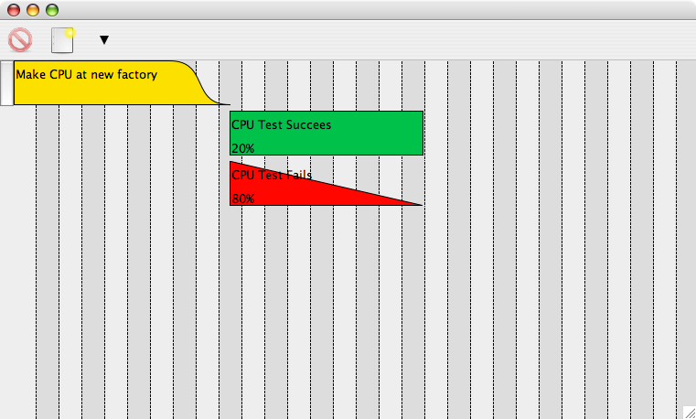
Figure 6: An alternative task for producing a CPU chip.

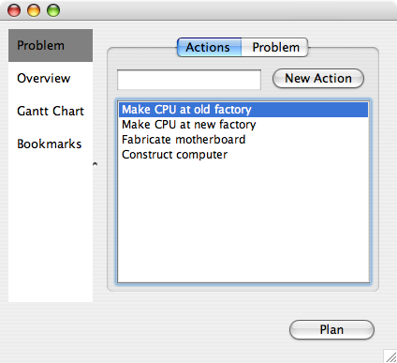
Figure 7: The completed database with 4 possible tasks.

The “Construct computer” task is special because it requires that a motherboard and CPU have been successfully produced. There’s only one way to produce a motherboard, but two ways to produce a CPU. It doesn’t matter which one is used. We need a way to specify these dependencies between tasks in a way that does not define an unnecessarily strict ordering between them. This can be done by returning to the task editor for the “Construct computer” task. Clicking on a hot-spot at the very beginning of the core duration opens a conditions editor, that allows specification of the rules under which “Construct computer” can commence, shown in Figure 8. Although not shown in this simple example, conditions can include tests on resource levels such as available workers, or money. Overall the condition editor allows construction of a complex logical formula for when a task is eligible to commence. The terms referred to, such as “Motherboard ok”, and “New CPU ok”, are called state variables. During planning every state variable has a value of true or false that can be tested as part of a condition. The values of these state-variables are set as effects of each discrete outcome. This is illustrated in Figure 9 where the effect of outcome “OK”. The condition in Figure 8, says that motherboard production must have succeeded, plus at least one of the CPU factories must have succeeded in producing a CPU. In this example we consider a single CPU, motherboard and computer at a time. In a more realistic example we would consider batches of CPUs and motherboards being produced as a resource.

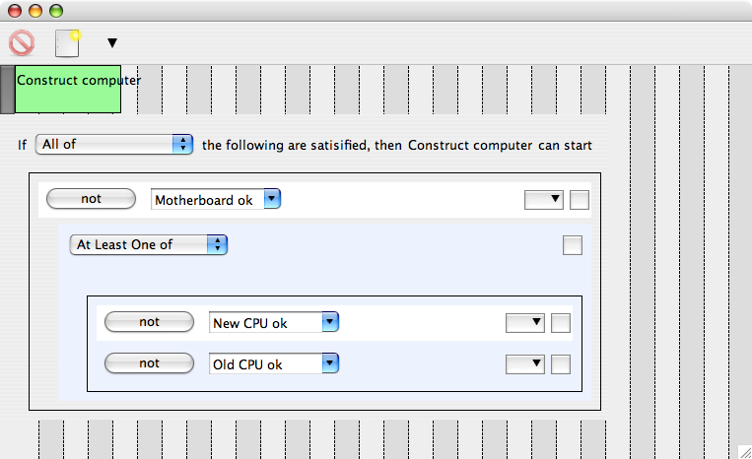
Figure 8: Specifying conditions under which we can "Construct Computer"

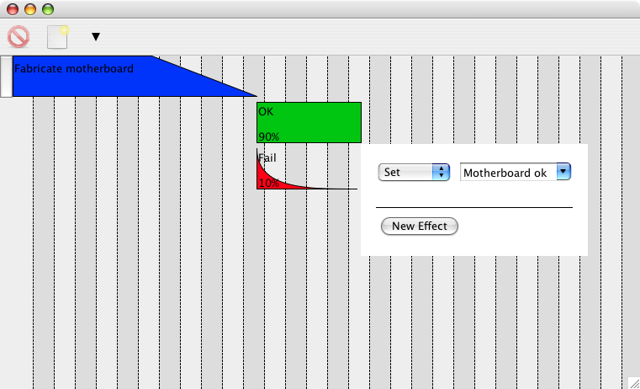
Figure 9: Setting state variables is an effect of tasks

Once all tasks are modelled, including effects and conditions, we can proceed to specifying the particular objective that we want to achieve through our final process or plan. This process begins by defining what state variables are true, and resource are available, prior to beginning the plan or process. This is done by ticking boxes to indicate what state variables are true, shown in Figure 10 (resources are not shown in this figure). In fact, in our example we assume nothing is initially true.

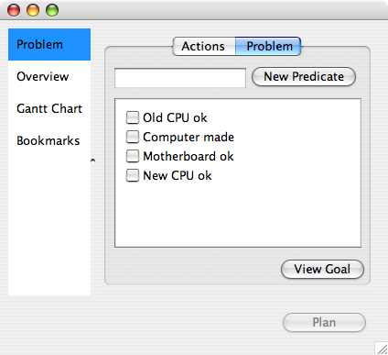
Figure 10: Specifying initially true state variables.

We then proceed to specify what objective wish to achieve. This is a condition for successful conclusion of the process or plan. In this case, Figure 11shows that we simply which to achieve “Computer made”.
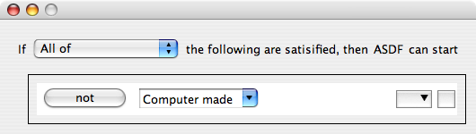
Figure 11: The condition for successful conclusion of the process or plan.

We now have a complete specification of a set of tasks with information about uncertain durations and outcomes, their interactions with other tasks via state variables and resources, plus the initial value of all state variables and resources, and finally a condition for successful conclusion of a process or plan. This constitutes the bulk of the information needed by any automatic planning software to produce a legal and “good” selection and sequencing of tasks to achieve the specified objective.

Our choice of Automatic planning system is the Factored Policy Gradient (FPG) Planner. This planning system requires additional information, such as a maximum time limit on the overall plan, and an indication of whether duration, probability of success, or resource consumption is the most important metric to optimise. The automatic planning system may be a remote super computer or cluster computer that communicates with the planning client via a network.

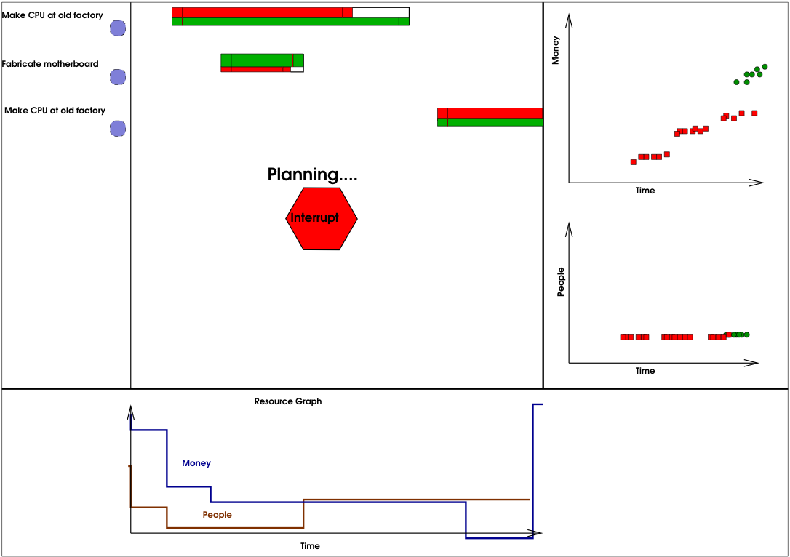
Figure 12: Feedback during automatic planning process

By selecting the Plan button, show in Figure 10, we begin the automatic planning phase. Immediately we see a view of the current proposed plan, shown in Figure 12.

While planning continues, which could take seconds to days depending the complexity of the modelled tasks, we see a continually updated representation of the most likely contingency under the current plan. The central view is a similar to a Gantt chart. Each task that is currently in the proposed plan is shown in a horizontal bar. However, this bar has a representation of all the possible outcomes and how long they take. To draw a static plan as shown, we must make assumptions about how long each task takes and which outcome actually occurred. Until overridden by user interaction, we assume the average duration for tasks, and the most likely outcome. In Figure 12 we see a poor plan because the first action starts late, and the “Fabricate motherboard” action has a further delay on its beginning. Furthermore the plan shown does not result in a successful conclusion of the plan because there is no “Construct computer” task in the plan. However, this is because the most likely outcome of the displayed plan is that the CPU fails to be produced because of low yield. This is naturally the most likely outcome of this process (CPU yields are surprisingly low in real factories), rather than a failure in the planning process.

The graphs to the right of Figure 12 are far more useful for getting a statistical picture of how the plan quality is improving. These graphs produce a point for every simulated trajectory of the plan. Old points are removed. These points are generated by the automatic planning system or by an independent local simulation of the plan being produced. In this example, red square points represent a simulated failure to reach the plan objective, and green circular points represent a successful plan. The horizontal axis is overall plan duration, and the vertical axis may represent any resource in the system, for example money. This is useful feedback on progress of the automatic planner. As the plan slowly improves, we see failure dots replaced by success dots, or the dots indicate generally shorter durations, or fewer resources consumed, or some or all of these features.

From either the updating static plan (Gantt chart), or the statistical representation of the plan, the user can at any time choose to interrupt the planning process and further explore the final plan and its contingencies.

After interrupting (or the planner may decide it has found the best plan and stop automatically), the user sees the final most likely contingency as the default view, shown in Figure 13. In fact, due to the low yield of CPU factories, the most likely outcome is a failure, although the statistical graphs on the right still indicate some successes. We see two bars for the “Make CPU at old factory” task, this indicates the automatic planner suggesting that, if at first the task fails, we try the same task again and again until time or resources run out. This behaviour can be adjusted my modelling the tasks in such a way that they can only run once, or only a finite number of times.

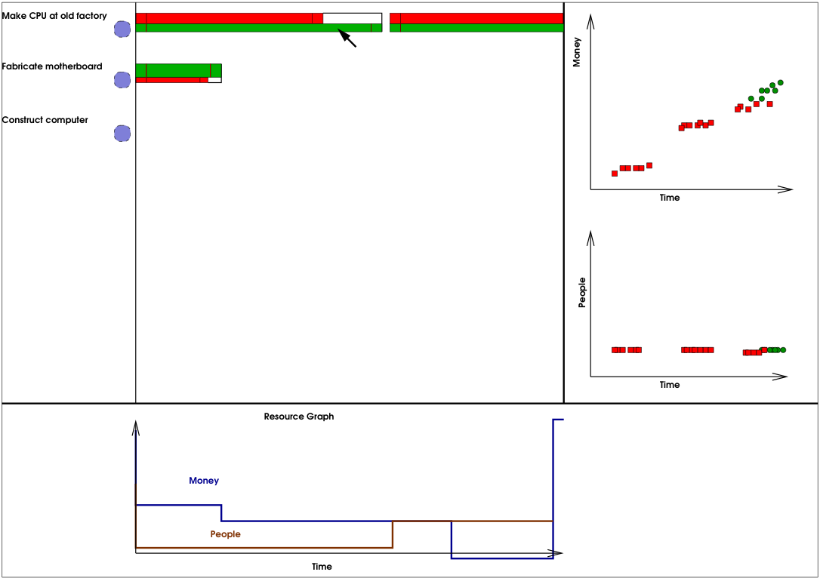
Figure 13: After planning the default plan is the most likely contingency.

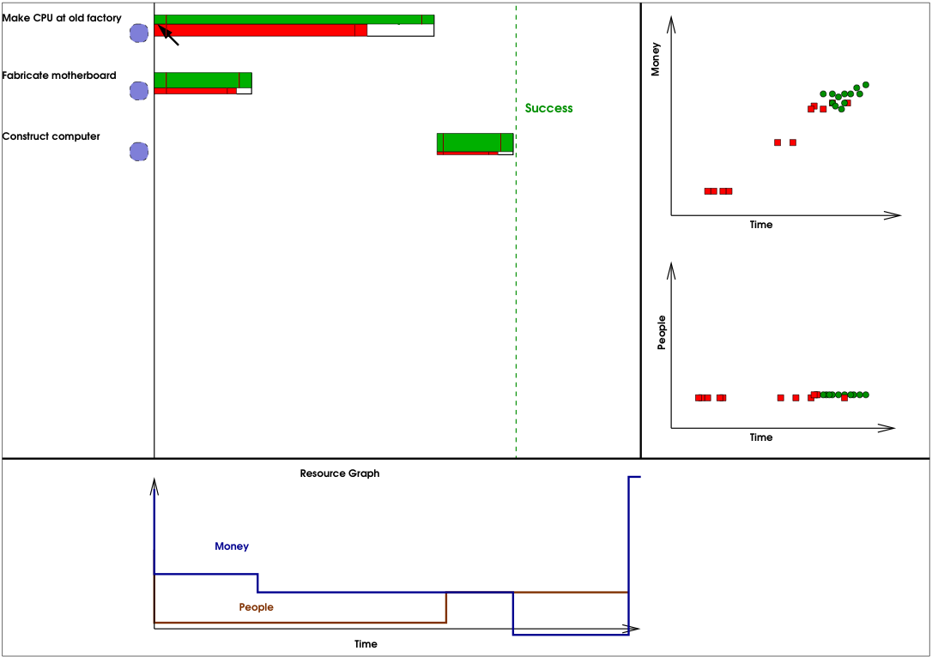
Figure 14: A successful most likely plan results after overriding the most likely outcome of "Make CPU at old factory".
The user now begins to interactively explore contingencies. The contingencies that can be explored are those that were modelled while populating the task database. The first contingency we explore is what happens if “Make CPU at old factory” actually succeeds? We can indicate this in a number of ways in an interface. In this example, the horizontal task bars have different colours, representing the different outcomes. Red is a failure outcome (the most likely and therefore on top), and then green represents success. If we click on the green part of the task bar we indicate that we wish to change the contingency from the most likely “fail” case to the less likely “success” case. This has a dramatic impact on the rest of the plan, which can now automatically unfolds to the new most likely plan, success, show in Figure 14.

Figure 14 shows from the uppermost green portion of the “Make CPU at old factory” that we are now assuming that the task succeeded. The remaining tasks have success as the most likely outcome anyway, resulting in the successful construction of a computer. The update of the plan is nearly instant after the user interaction. The statistical graphs to the right do not change in this case, because we have not actually change the proposed plan, just explored one contingency within that plan that was already captured by the statistical summary graphs.

We can, however, manually override the suggested plan. Suppose starting the task “Make CPU at old factory” was delayed due to delayed supply of raw silicon. The user can indicate this contingency by dragging the whole task to the right (Figure 15) to the true start time. When the use completes the update the planning system will be queried to replan given this selected contingency. The FPG planner we use permits near instantaneous replanning of this kind. The new plan is shown in Figure 16.

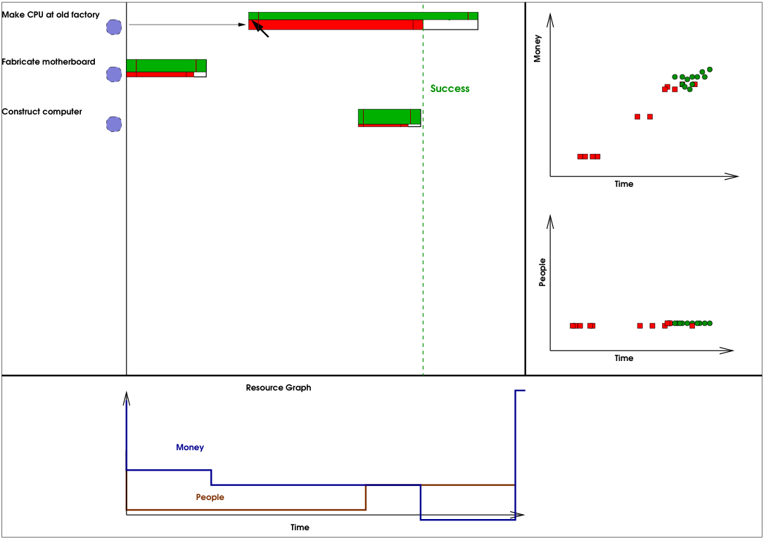
Figure 15: The user overrides the default plan by delaying task 1, reflecting the contingency observed in real life.

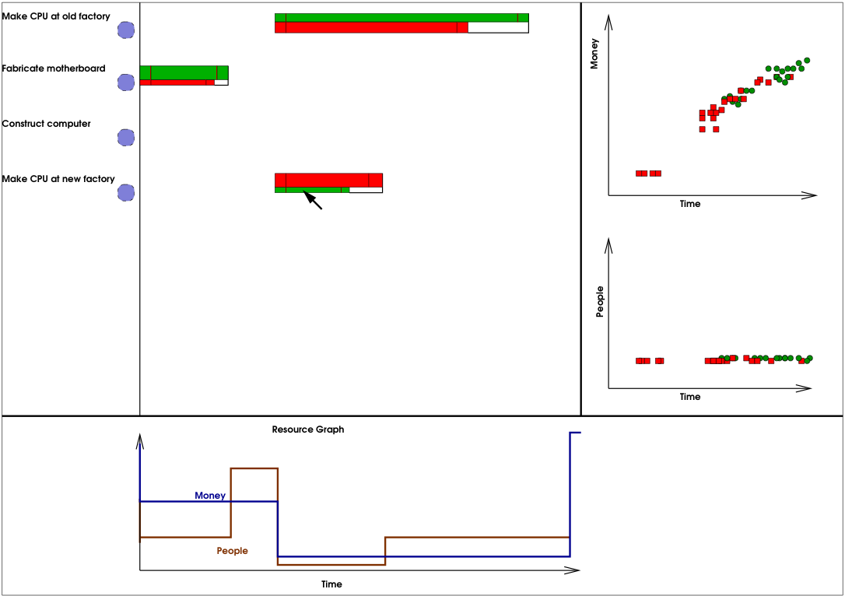
Figure 16: A new plan unfolds as a result of user exploring a delay to Task 1.

The updated plan shows a fairly radical change. The task “Construct Computer” has vanished, and the task “Make CPU at new factory” has been added, scheduled to start at the time the delay of the “Make CPU at old factory” was detected. This change is a response by the planner to mitigate the effects of the introduced delay. The planner reasons that, from our early model of old versus new CPU factories, the new factory can produce a CPU faster, but less reliably. Hence it has proposed “Make CPU at new factory” as a way to get the process or plan back on track. This will cost more overall, but the user may later suggest that this is too costly and ask for plans that prefer to spend more time rather than more money.

Since the plan has now changes, the statistical graphs to the right show invalid information. Over the next few minutes, in idle time as the user does not interact with the planner, the old points on the statistical graphs will be replaced with new ones from simulations on the updated plan. As a result, the user sees a higher than before percentage of green “success dots”, even though the successes are appearing later in time, and more spread out because we now have two independent tasks achieving the critical low probability step of making CPU.

However, we see that this new most likely plan still fails most of the time, due to yields of less than 50% for both CPU factories. Again the user manually updates the chosen outcome of “Make CPU at new factory” to produce Figure 17, revealing a successful new most likely plan.

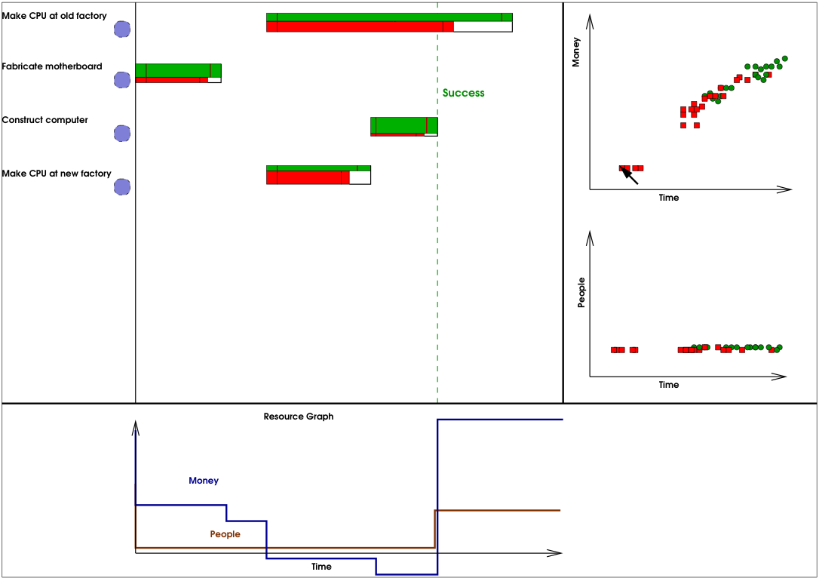
Figure 17: The result of overriding the outcome of "Make CPU at new factory".

For the final example of interactively exploring the probabilistic results of contingency planning, the user can interact with individual points on the statistics graphs. For example, suppose we want to find out why a small group of failure points exist early on in the plan. That is, we want to know how a small group of simulated planning executions failed so early. Clicking on this dot refreshes the Gantt-like plan view to represent exactly the simulated plan represented with that dot, shown in Figure 18.

The user can continue to explore this failed plan to find out how to make it succeed, or perhaps they can explore other simulated trajectories from the statistical summary graphs. We also keep a history of all project plans displayed so the user can browse backward and forward through their exploration of contingencies.

Note that the graph on the bottom of the display shows the resource use, and optionally the state variable values through the course of the displayed currently displayed plan. Although not demonstrated here we also permit the user to manually override resources and state variables at any time through the plan. This will also cause a new plan to be generated from the point in time where the resource or state variable override occurred. For example, if we manually overrode the value of state variable “Computer made” at any time, the planner would detect that the plan objective is immediately met and will not schedule any further tasks.

Note that the process decision that would be made as a result of this trivial example, would be to use the old factory for the majority of CPU’s, and use the new factory to make up for any variation in the expected yield from the old factory.
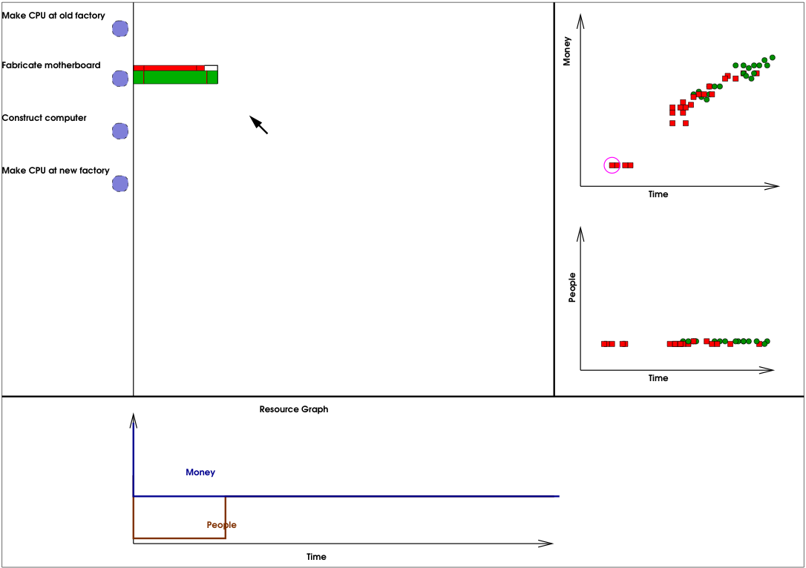
Figure 18: Plan that represents simulated execution that generated highlighted point in top-right graph.

Douglas Aberdeen. Policy-Gradient Methods for Planning. In Advances in Neural Information Processing Systems, The MIT Press, Cambridge, MA, 2006.

