# Week 7 – Group Activity Evidence

In this activity, we explored how an event-driven system can be applied to a driver-less smart car. The goal is to identify and design multiple event loops that allow the system to respond to environmental stimuli safely and in real time. Below is a visual framework based on the Sense–Think–Act model, followed by examples of three event loops using pseudo-code.

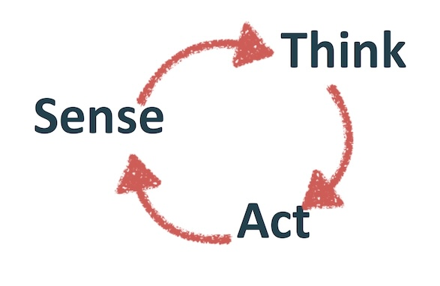

Figure: Sense–Think–Act loop for event-based system design

## Event Loop 1: Obstacle Avoidance

Sensors: Ultrasonic sensor, Lidar  
Input Services: Object detection  
State Updated: Car proximity state  
Output Actuation: Brake system, steering adjustment  
Actuation Services: Emergency brake, lane correction  
Processing: If an object is detected within unsafe distance, apply brake and/or steer away.  
  
Pseudocode:  
if detectObstacle():  
 if distanceToObstacle < safeThreshold:  
 applyBrake()  
 steerAway()

## Event Loop 2: Lane Following

Sensors: Camera, GPS  
Input Services: Lane detection  
State Updated: Car position within lane  
Output Actuation: Steering motor  
Actuation Services: Auto-steering  
Processing: Use camera to detect lane markings and adjust direction.  
  
Pseudocode:  
lanePosition = detectLane()  
if lanePosition != center:  
 adjustSteering(lanePosition)

## Event Loop 3: Speed Regulation

Sensors: Speed sensor, road sign reader  
Input Services: Speed limit detection  
State Updated: Current vs. allowed speed  
Output Actuation: Accelerator control  
Actuation Services: Cruise control adjustment  
Processing: Maintain speed within legal limits based on road signs.  
  
Pseudocode:  
speedLimit = readSpeedSign()  
currentSpeed = getCurrentSpeed()  
if currentSpeed > speedLimit:  
 decelerate()  
elif currentSpeed < speedLimit:  
 accelerate()