SIT314 – Week 8 Technical Task: Sense-Think-Act Loops with External APIs

# Objective

The aim of this task was to implement a complete sense-think-act loop using Node.js. This included:  
1. Visualizing data using the Plotly graphing library via nodeplotlib.  
2. Accessing real-time weather data using the weather-js API.  
3. Building a simple decision-based server that reacts to weather conditions (i.e., temperature) to simulate a smart heating control system.

# Part 1: Data Visualization with Plotly and Nodeplotlib

## Step 1: Setting Up the Project

A new folder named 'week8' was created and initialized using:  
npm init  
npm install nodeplotlib  
This setup allowed the use of Plotly’s plotting features in Node.js via the nodeplotlib wrapper.

## Step 2: Line Plot (Basic)

The first file, plot1.js, plotted a simple line graph.

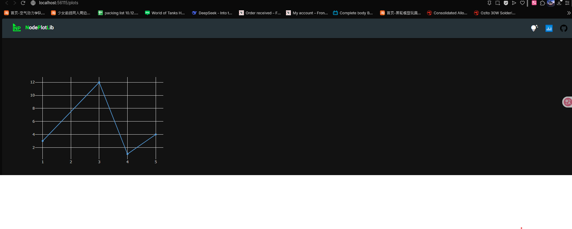

## Step 3: Two-Line Scatter Plot

A second file, plot2.js, was created to demonstrate two separate scatter plots on the same graph.

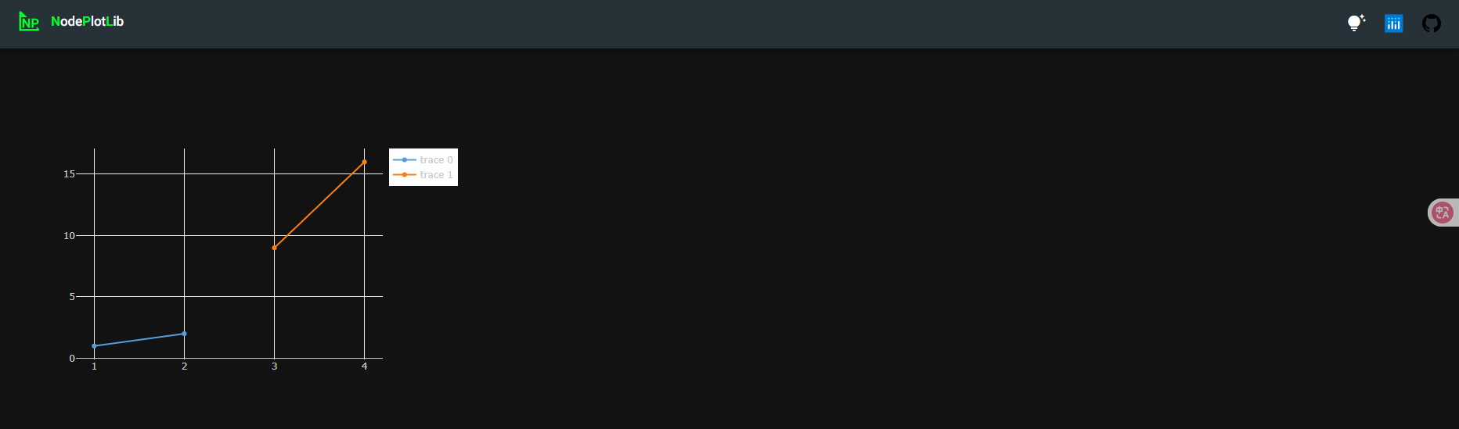

## Step 4: Bar Chart

Using plot3.js, a simple bar chart was created to demonstrate bar-based data visualization.

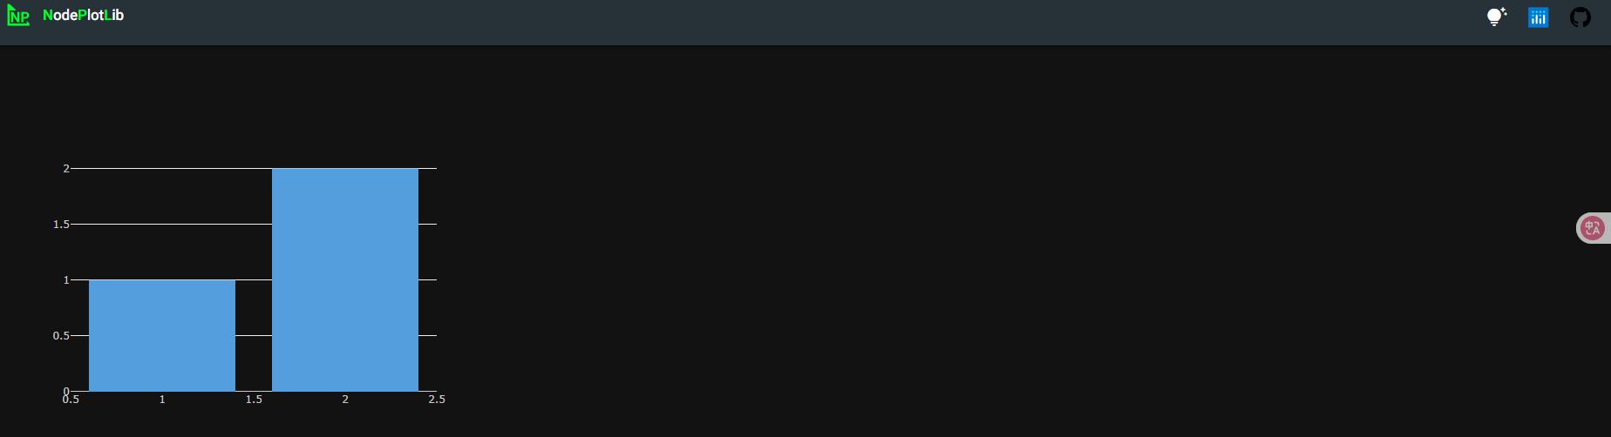

## Step 5: 3D Graph

The plot4.js file was used to produce a 3D scatter plot to showcase more advanced plotting capabilities.

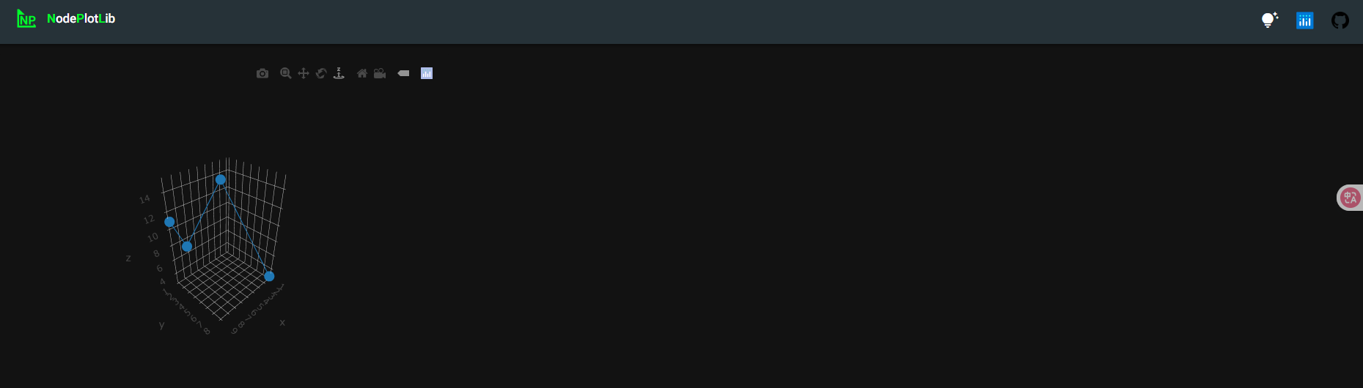

# Part 2: Accessing External Weather API

## Step 1: Installing Weather Module

npm install weather-js

## Step 2: Fetching Current Temperature

Using the weather1.js script, live temperature data for Melbourne, AU was retrieved via the weather-js API. The result was then simplified to display only the temperature reading.

# Part 3: Creating a Sense-Think-Act Loop (Smart Heating)

## Step 1: Developing server2.js

A small server was created using Express.js. The server fetches the current temperature via the weather-js API when accessed through a browser. Based on the temperature, it either 'turns heating off' or 'turns heating on'.

## Step 2: Launching Server

node server2.js

## Step 3: Output

The browser displays a message with the current temperature and action taken.

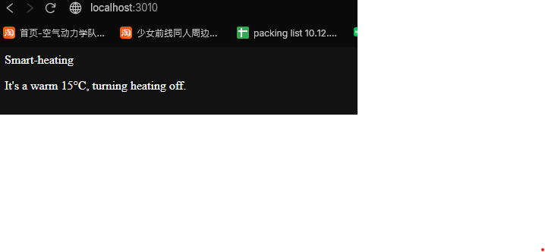

# Summary

This technical task successfully demonstrated:  
- Integration of real-time public data APIs.  
- Data visualization using nodeplotlib and Plotly.  
- Implementation of decision-based logic through a basic web interface (sense-think-act loop).  
- Fundamental understanding of combining APIs, data visualization, and control logic in IoT-related applications.