Data Grid Control Flash Tutorial

By: Ahmad Eissa
File Date: 22/01/2006

In this file, you will learn how to use the DBGrid control in easy steps with less code and more effectively. Simple, easy, and nice!
First, start a new project.
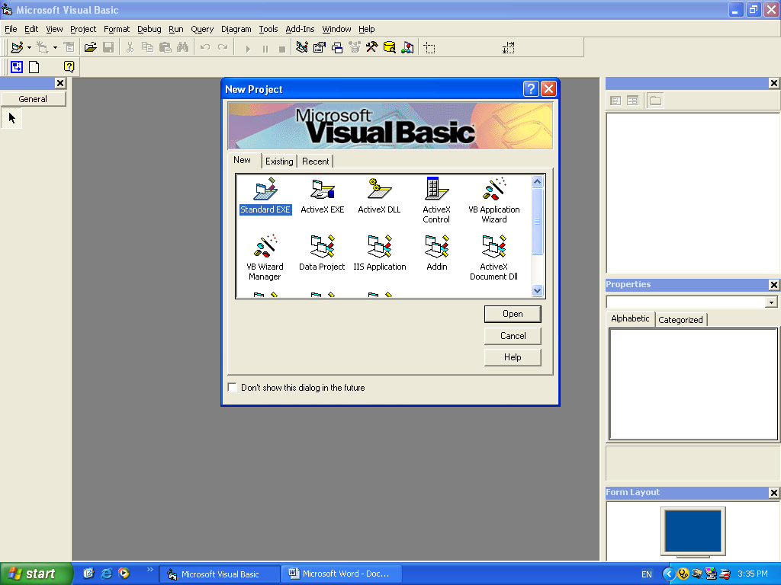

And then, right click on General Toolbar and select Components.
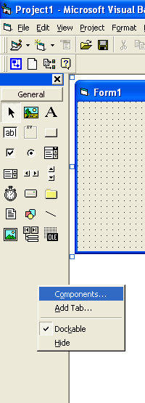

This box will appear, fine, just select "Microsoft DataGrid Control 6.0 (SP6)" from controls list and hit OK.
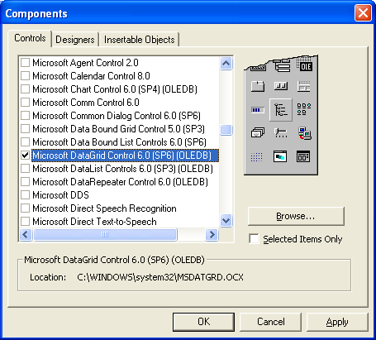

This icon will appear in your General Toolbar.

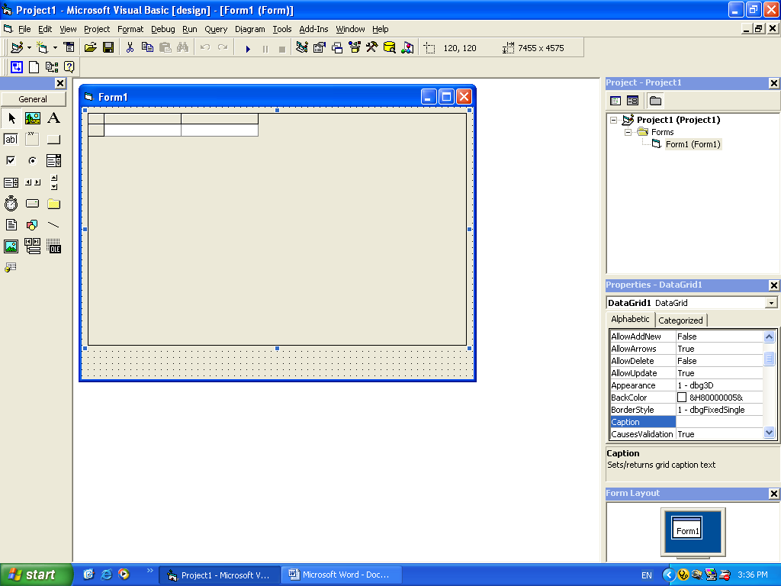

OK, after the Data Grid control icon is appeared in General Toolbar, just put this control in your application.

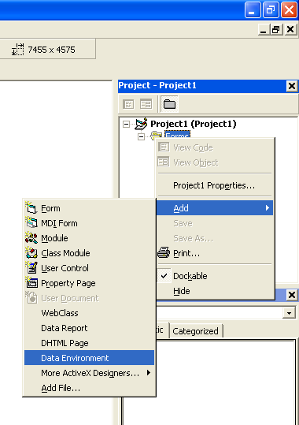
This control is used to view the data as a table (just like Excel) from an appropriate data engine. I used in this approach the DataEnvironment as a Data engine because it easy to deal with. Just add a DataEnvironment in your application.
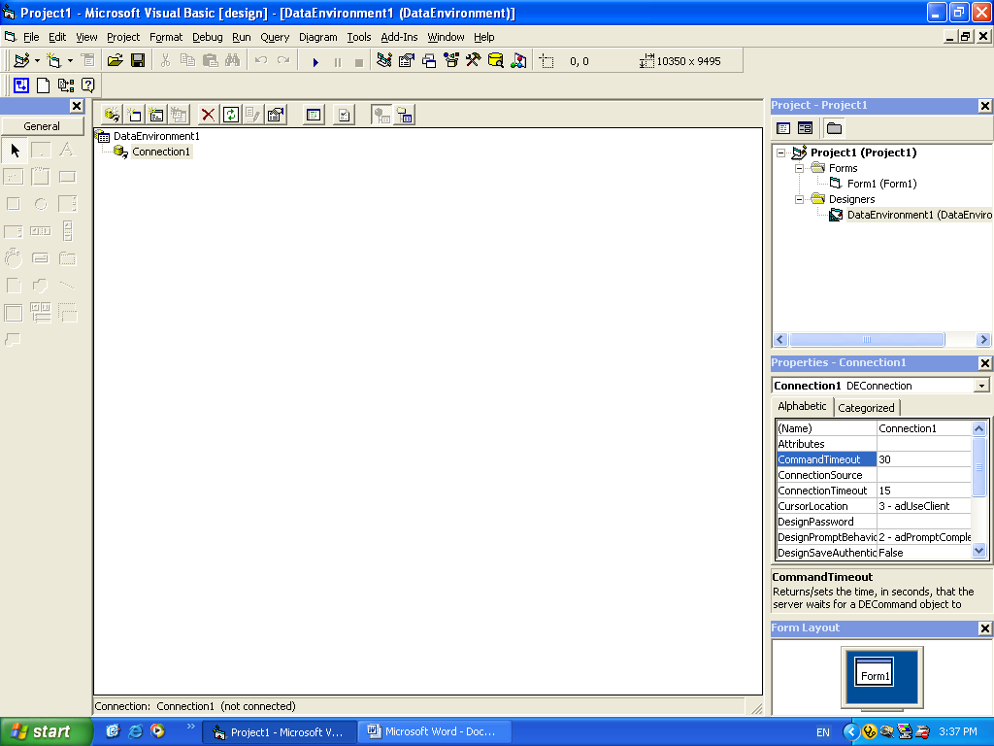

To add a database inside your DataEnvironmen, just right click n Connection1 and select Properties.

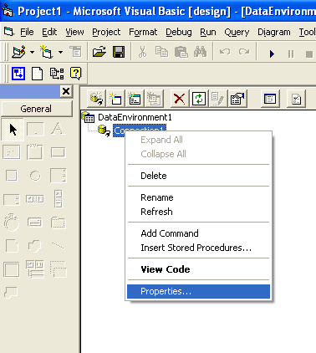
And then, you must adjust your data engine to work with your database, I used in this approach an Access 2000 Database, so I must select "Microsoft Jet 4.0 OLE DB Provider". If you use a deferent database, you must select your appropriate data provider.

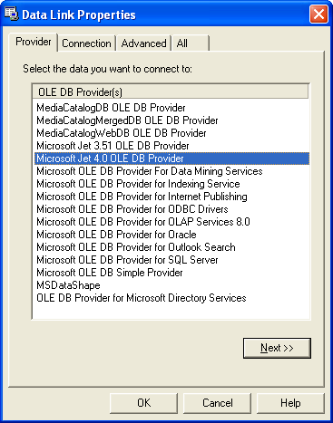

After that, go to connection tab to select or enter the database file name and path, and to test the connection.
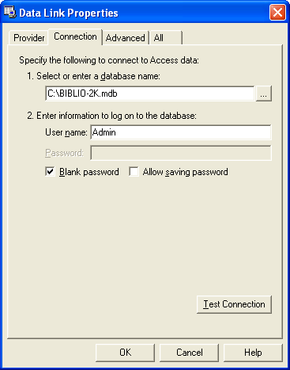

After testing the connection, this message box will appear.

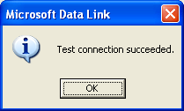
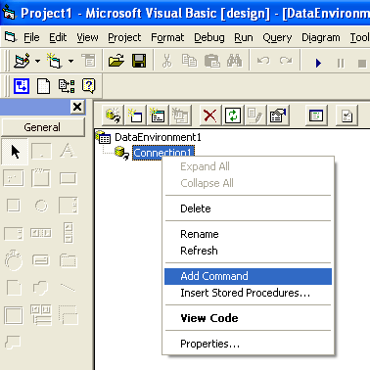

To insert the tables inside the DataEnvironment, right click the connection1 and select Add Command. This command will appear.

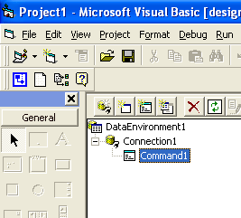

Now, right click the Command1, and select Properties.
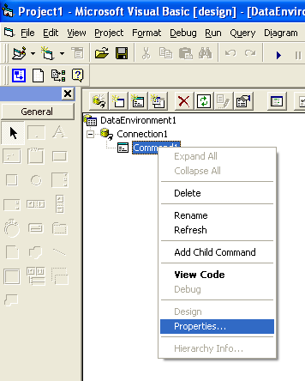

This window will appear.

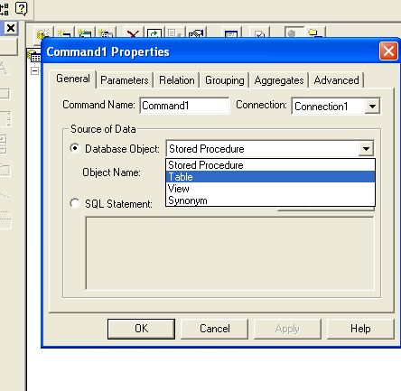
OK, from Database Object, select Table, and from Object Name select the table that you want to connect the Connection1 with it. Just to be like this pic.
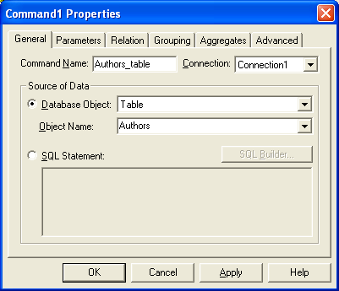

Then click OK.

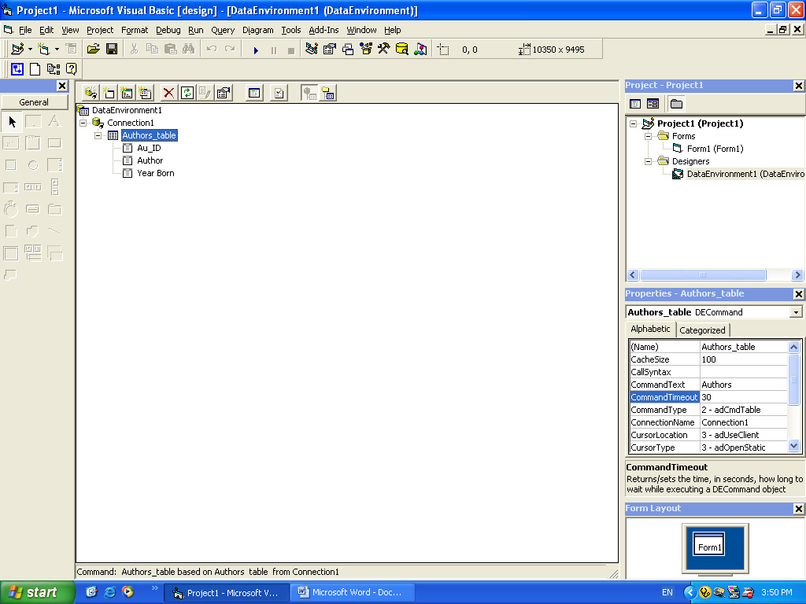

The connection will appear like that.
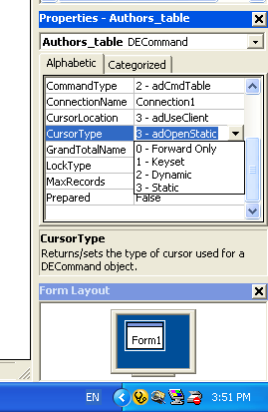

To make the DataEnvironment able to store data inside the database, change those two properties for the table command – here I name it Authors_table – to be in cursor Type = 2-Dynamic, and Lock Type = 3-Optimistic.

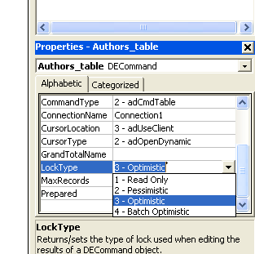

Just Like that.
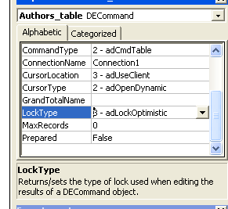

And write this code in the code side for the DataEnvironment:

Private Sub DataEnvironment_Initialize()
DataEnvironment1.Connection1.ConnectionString = "Provider=Microsoft.Jet.OLEDB.4.0;Data Source=" & App.Path & "\BIBLIO-2K.mdb;Persist Security Info=False"
End Sub

Like this picture.

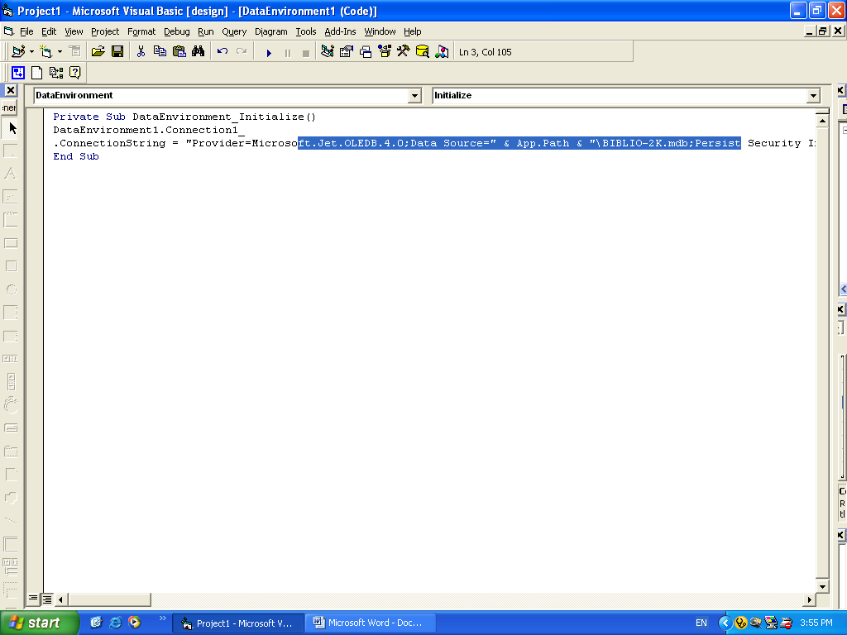
Now, back to the form, and prepare the DataGrid Control to receive the data. Just right click on the DataGrid control on the form and select Edit

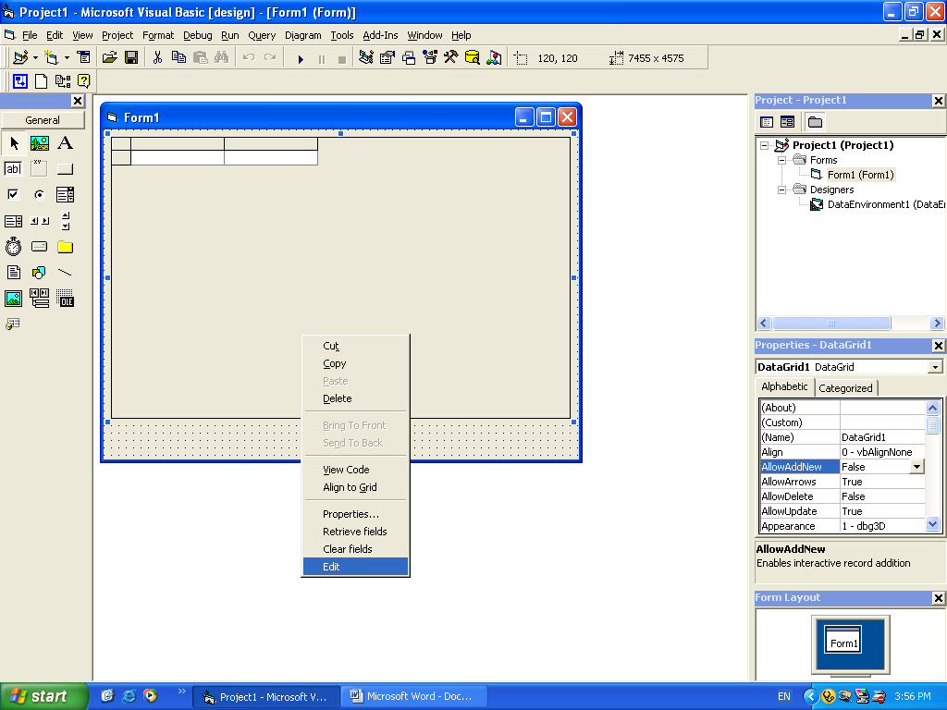

When the DataGrid control terns in edit status, right click again over the control and select Append to add a column as in the table in the database. Like this picture.
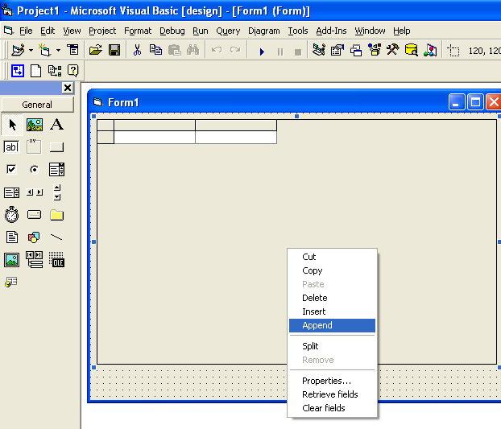

To be like this after adding a new column.

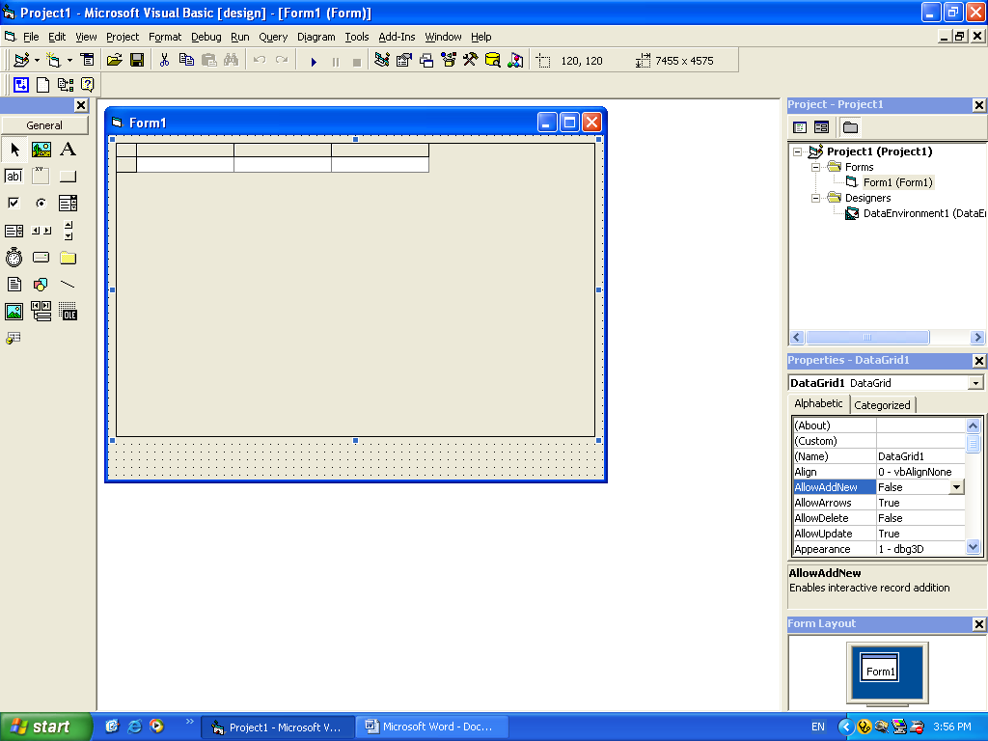

To connect the DataGrid control with the DataEnvironment, just go to the Data Source property for the DataGrid Control and change it to be DataEnvironment1 like the picture.

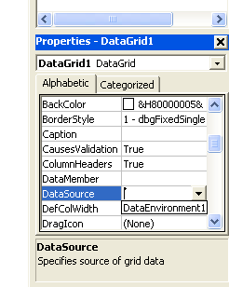

And the Data Member to be your table name which is placed in the DataEnvironment. Like the picture.

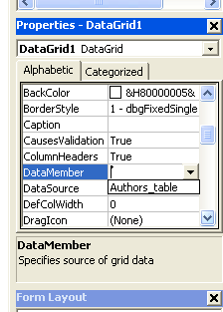

Now, you are ready to complete this approach! Only one step is left ☺ right click again over the DataGrid Control and select Properties.

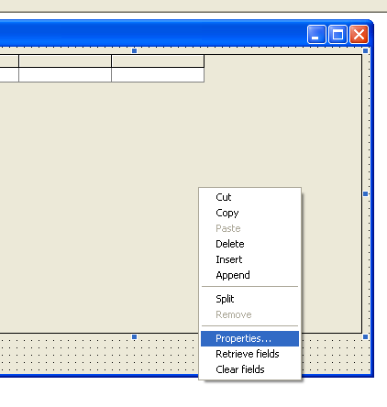
This window will appear.

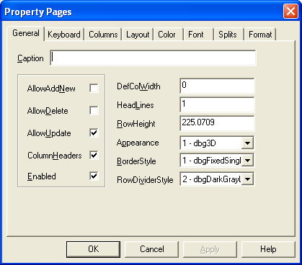

Just change the options like the followed picture.

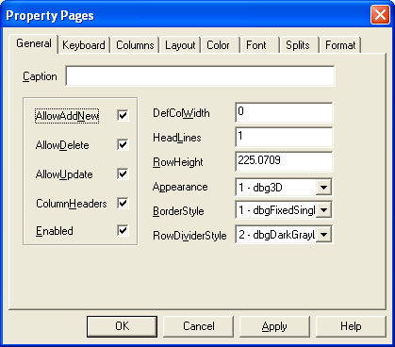

And then move to the Columns Tab. Like this picture.

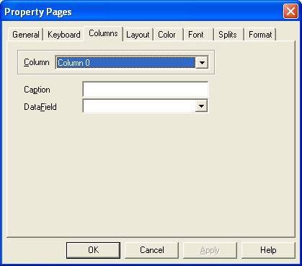

And start connect the grid columns with the database table columns. Like the followed five pictures.

One:
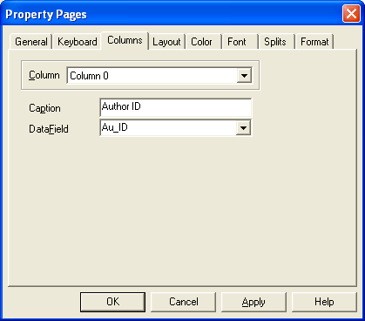
Two:
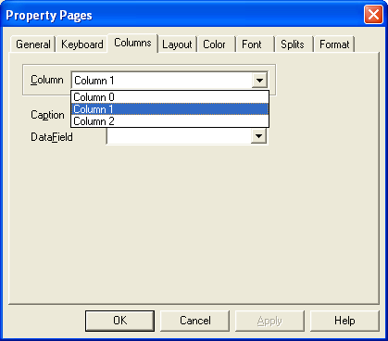

Three:
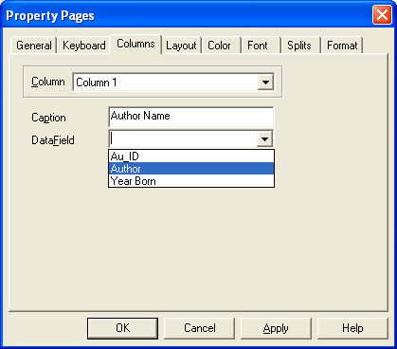
Fure:
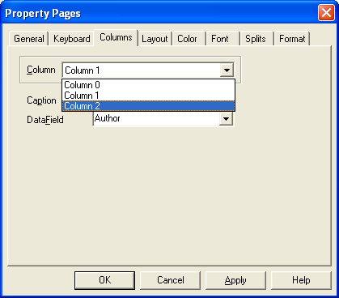

And five:
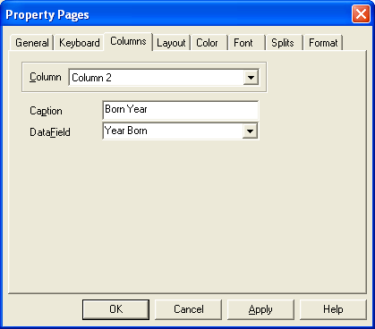

Your application should be finally like this:

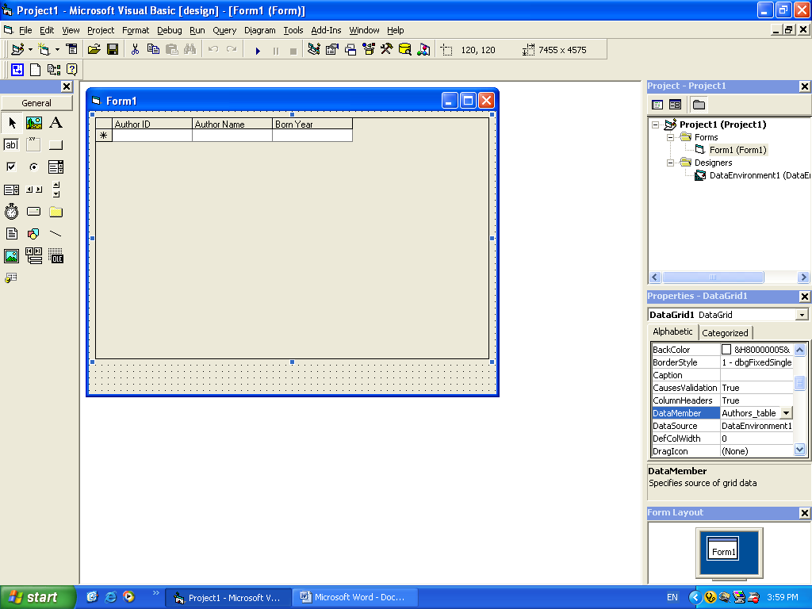

Enjoy starting your program and watch the data viewed through your DataGrid. Less code, more effectively, and Nice.

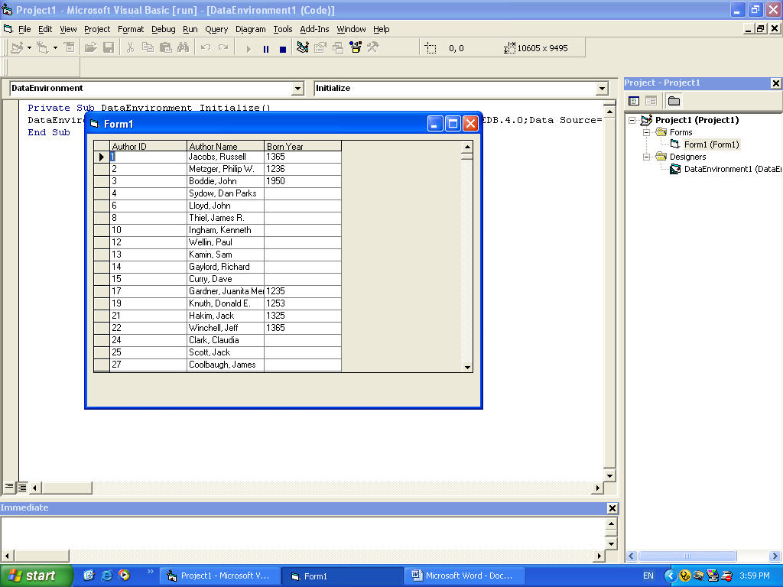

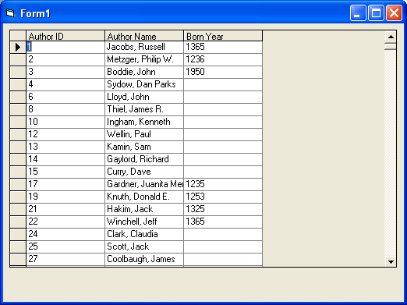

And you can edit the data inside the database simply lick Excel.

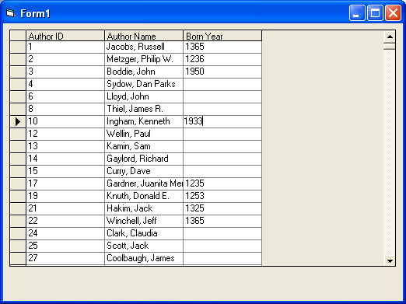

Thank you for your time… see you soon ☺

