HTML Help and Visual Basic 6 - Tutorial

By Almar Joling

Introduction
When you distribute an application, there should be some guidance for your customers and/or users how to work with it. You can simply add a few HTML pages, but this will not allow you to use the often appreciated "what's this help", in form of the small question mark in your applications form borders. Neither does it look professional.
The purpose of this document/tutorial is showing you how to use HTML Help for a very simple help file, and how to 'attach' it to your application. Note that by no means this document has been written to teach you everything about HTML Help. This document focuses more on the actual help file, combined with your Visual Basic 6 application.
Contents
Introduction.......................................................  Contents...........................................................  Requirements.......................................................  F1 Functionality...................................................  What's this help?..................................................  Context ID's.......................................................  Appendix A - Basic HTML Help usage.................................  Appendix B - "What's this?"........................................  Resources..........................................................  Copyright info..................................................... | 1  2  3  4  5  6  7  14  16  17
Requirements

When you are going to use this document, you will need:

- Visual Basic 6*
- Some knowledge of VB
- HTML Help Workshop
- Basic knowledge of HTML

HTML Help Workshop can be downloaded from the Microsoft Download Center. The exact URL for the "HTML Help 1.3 SDK" is currently:

http://msdn.microsoft.com/library/default.asp?url=/library/en-us/htmlhelp/html/hwMicrosoftHTMLHelpDownloads.asp

* Version 5 of VB can't be used for this tutorial. VB6 has native HTML Help file support and VB5 has not.
F1 functionality
Now, when we want to use a help file in our Visual Basic project, we have to add the following code, so the application knows where it can find the help file. Note that the extra function (AppDir) is not really needed. App.Path would work fine as well. But there are many people that install programs in their HD root, and then the path returned by App.Path isn't valid if you simply add the file with a slash before it.

Private Sub SetHelpFile()
App.HelpFile = AppDir & "myhelp.chm"
End Sub

Private Function AppDir() As String
'//If AppDir = NOT the root of the HD add "\", else don't add the slash
'//(This sub makes sure an "\" is added to the app.path)
If Right$(App.Path, 1) <> "\" Then
AppDir = App.Path & "\"
Else
AppDir = App.Path
End If
End Function

If you put this code in your VB project, and run the application, pressing F1 will show your help file!

Note: If you want to use "What's this help" (popup) functionality, please read Appendix B. The Help file path should be changed a little, this is explained in the Appendix B section.
What's this help?

"What's this help" is the small question mark at the right, in the control box of a window.

To get this small button on your form, you have to change a few properties. One important thing is that the question mark will only appear on forms that are fixed. So the borderstyle of your form has to be changed to "Fixed single" or "Fixed dialog". See Figure 1

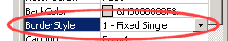
Figure 1: Borderstyle should be fixed

After you've set this property, you should also change two other properties "WhatsThisButton" and "WhatsThisHelp", as shown in Figure 2.
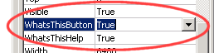
Figure 2: WhatsThisButton and WhatsThisHelp

Now you should see the small question mark on top of your form.
Next we will have to connect some controls to the help file, using ContextID's.

Important: After you've set WhatsThisButton, F1 won't work anymore, since the form's context ID is still 0 (meaning disabled). We'll get back to this later. F1 will now act like the question mark button!
Context ID's
When you have arrived at this point, you already should have made a simple HTML Help file. If you haven't yet, or only want to know how to add ContextID's to the help file, please check out Appendix A.
We know all our constants that we added to the HTML Help file. We've compiled the help project, and we're also setting the right filename in the code given earlier. So now it's time to actually link our help file to certain controls. This is done using the constants we added earlier in Appendix A/B. (Mapping/Aliases). These are ContextID's. You can simply set these constants in the properties of controls, as shown in Figure 3
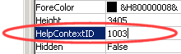
Figure 3: HelpContextID property

Now something very important, you should really read this to save some frustration =-).

When you turn on "WhatsThisButton", F1 won't work anymore. When off, F1 will open the help file and show directly the right page, for example if the textbox has the focus at the moment, it will show the "textbox" page directly.

There is another type of ContextID, called "WhatsThisHelpID". This works exactly the same. You should change the 0 to the constant you specified earlier for your pop-ups. How this is exactly done, step-by-step, can be read in Appendix B
Appendix A

Creating a new help file. When you start HTML Help Workshop, choose "new" in the File menu. Please follow the steps that will follow. We want a completely empty project. I saved my project under "myHelp.hhp"

When the new project has been created, you will see an empty window that should look something like Figure 4.
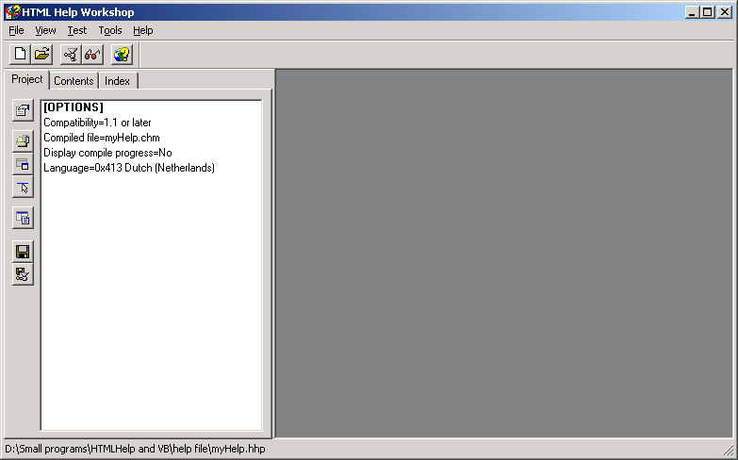
Figure 4: A new empty HTML Help project
Now choose the "Add/Remove topic files" button. I'm assuming here that you already made some nice documentation (in HTML format) for your application. I've created 3 empty files right now, just to show you how it works. You can do everything in the HTML files, as if you would put it online. All files (zip files, images, html files) will be compiled in the CHM file, that's the only big difference with "normal" HTML on the Internet.

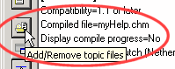
Figure 5: Add/Remove topic button

Now you will see a simple dialog where you can add/remove HTML files. When you're done with selecting files, press OK to continue. If you like you can double click on the files (under the [FILES] section) to modify them in the textbox right. But we'll leave that for now.
The following part is very important if you want to have "What's this help?" support in your application. So please read it carefully.
First we have to open the "HTML Help API Information" dialog, click the button shown in Figure 6.

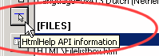
Figure 6: HtmlHelp API Information

Now you will see the following dialog (Figure 7):
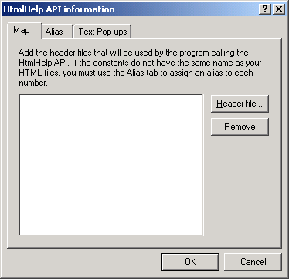
Figure 7: The mapping dialog

Now, it's going to be a little bit dirty. To map files we will have to create a "header" file, where we will map the numbers to a string version. Just like a constant in VB, something like:

Private myConstant as Long = 1000
But we have to do this in Notepad or WordPad, Word would probably work as well, but it's a bit bulky for something simple as what we are going to do right now. The constants we will add to the file are simple C/C++ constants. Have a look at Figure 8 for some basic example. Note that you can start with any value, but 1000 is recommended. After you've added some constants, save the file with an .h extension.
After you have saved the header file press "Header file..." in HTML help (see Figure 7) and select the file you just made. Press "OK" and the file will appear in the list. Now we are done with this.
One final note: The header file is only referenced! So moving it, deleting it will cause major problems. You can simply change the header (*.h) directly (Notepad/WordPad) if you want to change it.
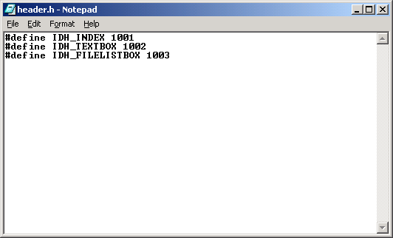
Figure 8: Some constants for our mapping, in Notepad

We've got the constants now. Next we need to "alias" them to the actual HTML files. This is done in the tab "Alias" (See Figure 7). Click on "Add..." in this dialog. In the dialog that popped up now, the constant strings (Like IDH_INDEX,IDH_TEXTBOX), should be used. After you have entered a constant, choose the file you want to alias. (See Figure 9)
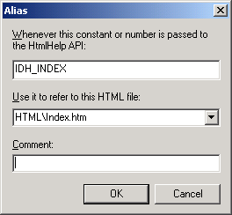
Figure 9: Adding a new alias
After adding some aliases, press "OK" in the HtmlHelp API Information dialog. Now we're done with the mapping part (Until you decide to modify the help file, adding/removing files, etc)
Table of contents

We need to add a Table of contents (TOC) to the project, so the user can browse through various items. It will look like Figure 10. Note that many things are customisable, but we'll leave those details for now.

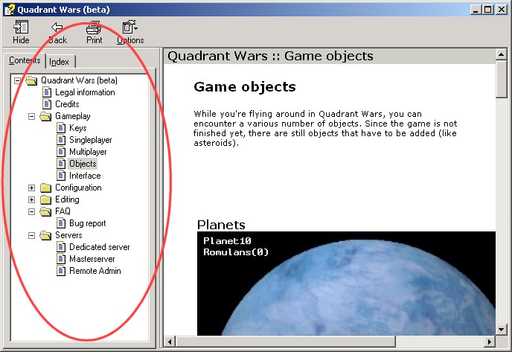
Figure 10: The TOC in the helpfile of Quadrant Wars

Let's get started. First select the "Contents" tab in the main window (Next to the "project" tab where we did many things before). The list at the left should still be empty. Now press the 3rd icon from above, the page icon (See Figure 11).

This means we will add a simple page. You could also add a topic (=folder) if you like. It doesn't really matter. Basically we only want to add all our HTML files to the help file, so it will show up in the application.

When you add a new page (or topic), you have to specify an "Entry title" (Figure 12). This is the title shown in the TOC.
Press "Add" to add a HTML file to this page/topic. Press "OK". Now you should see the item added to the list, in the main window, under the current tab (which should be contents).
Repeat the same with the remaining files: You could add a topic, and using the arrow buttons at the left (or simply adding new pages directly under topics using right mouse-click). Try to get something similar to Figure 13

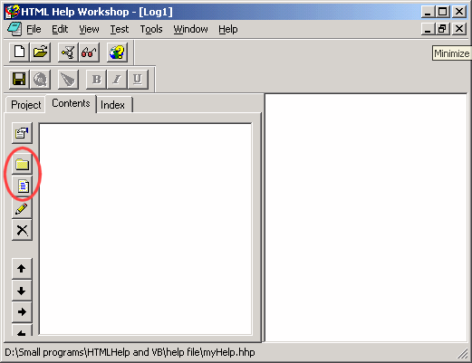
Figure 11: Icon on top is new topic, lowest icon is new page
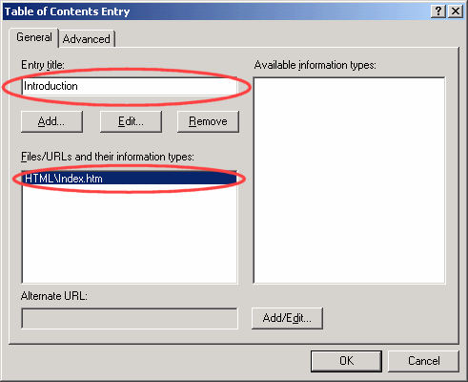
Figure 12: Name, and file(s) should be specified here
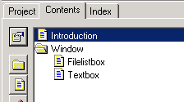
Figure 13: Try to make something like this

It doesn't really matter if you couldn't get something like above. It's more to show you how to work with HTML Help Workshop.

Now you need to compile the project. Choose "Compile..." in the File menu (or press the compile button on the toolbar).

Well, basically this is everything you should know about HTML Help, in my opinion. Of course there are many extra things in HTML Help Workshop. You should try them out yourself.
Appendix B - "What's this?"
If you start reading this, I assume you already read the mapping and aliasing part. If not, you really should.

"What's this" is the type of help that you see when you click on something with the question mark, it will popup a small "tooltip alike" message, giving you info about the item you clicked.

These text pop-ups are built using two files. One file defines all the constants, like with the mapping. This is exactly the same. And the other file specifies the text, which will be shown. See Figure 14 and 15 for an example
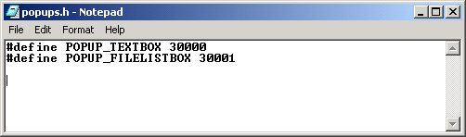
Figure 14: The constants used to associate the text
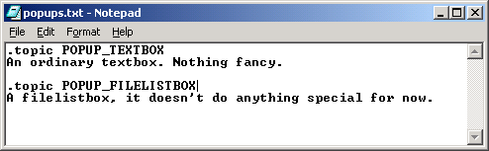
Figure 15: The pop-up text associated with the constant
After you have saved both files, go to the HtmlHelp API Information dialog, and click on the tab "Text-popups". Press the "Header file..." button to add a header file (the *.h file) and also press the "Text file..." button to attach the pop-up text to the project.

Note: Again, like with mapping, the files are only referenced. Deleting it or moving it will cause problems. You can modify the files without using the HTML Help Workshop (Using notepad/WordPad for example)

Now you're ready to enable the "WhatsThisHelp". You have to set the "WhatsThisHelpID" property for all your controls that you want to have this feature (Figure 16)
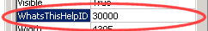
Figure 16: The "WhatsThis" property of a control

Now something important: It took me a while to figure it out: I could only find the answer on some newsgroups. If you want to use "WhatsThisHelp", you have to add something to the help file (see the code earlier given, above).

It should be in the form of:

Private Sub SetHelpFile()
App.HelpFile = AppDir & "myHelp.chm::popups.txt"
End Sub

You have to add the filename of the popup text file behind the chm file, and there should be two "::" between it as well.

Now you're done and you can simply use the question mark to get help about certain controls
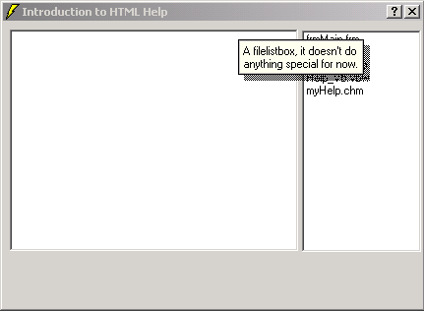
Figure 17: "What's this help" working like a charm!

Resources

Microsoft Most Valuable Professional - HTML Help Center
- http://www.mvps.org/htmlhelpcenter

Microsoft Knowledgebase
- http://support.microsoft.com/support/kb/articles/q192/1/18.asp

Almar's VB Fibre - Your speed guide to VB
http://vbfibre.digitalrice.com

Almar's Quadrant Wars - Massive multiplayer online game
http://www.quadrantwars.com
Copyright info

Visual Basic 6 copyright © Microsoft Corp. 1987 - 2000
HTML Help Workshop copyright © Microsoft Corp. 1996 - 1999

All rights reserved

