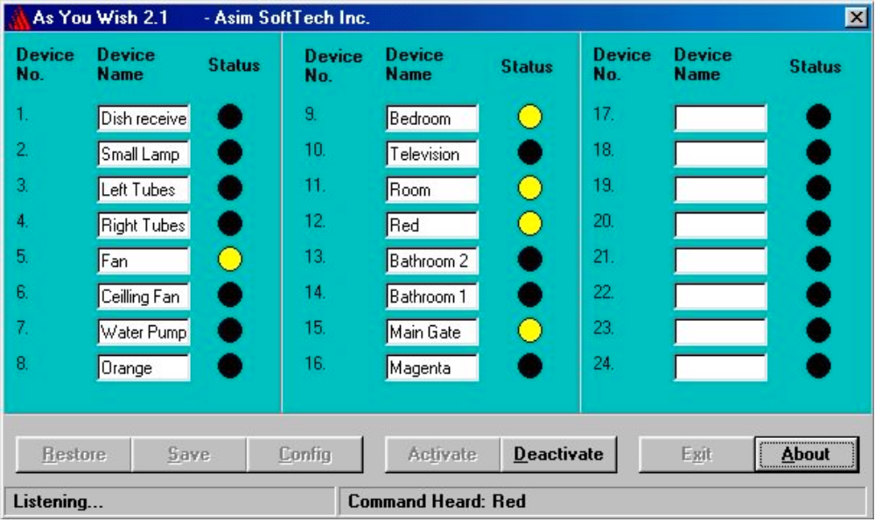

AS YOU WISH 2.1

Written by

SYED ASIM HUSSAIN ABBASI
Final Year Student of B.Sc. Elect. Engg. (Electronics),
University Of Engineering & Technology Lahore.
Microsoft Certified Professional.
Web site: http://i.am/asim_electro

Basics Of Voice Recognition:-

This project is one of the application of Voice Recognition. Voice Recogniton has its origin from DSP (Digital Signal Processing), the term with which most modern Electronic and Electrical Engineers are familiar.
Digital Signal Processing is one of the most powerful technologies that will shape science and engineering in the twenty-first century. Revolutionary changes have already been made in a broad range of fields: communications, medical imaging, radar & sonar, high fidelity music reproduction, and oil prospecting, to name just a few. Each of these areas has developed a deep DSP technology, with its own algorithms, mathematics, and specialized techniques.
Digital Signal Processing is distinguished from other areas in computer science by the unique type of data it uses: signals. In most cases, these signals originate as sensory data from the real world: seismic vibrations, visual images, sound waves, etc. DSP is the mathematics, the algorithms, and the chniques used to manipulate these signals after they have been converted into a digital form. This includes a wide variety of goals, such as: enhancement of visual images, recognition and generation of speech, compression of data for storage and transmission, etc.
Speech generation and recognition are used to communicate between humans and machines. Rather than using your hands and eyes, you use your mouth and ears. This is very convenient when your hands and eyes should be doing something else, such as: driving a car, performing surgery, or firing your weapons at the enemy.
Speech recognition is a classic example of things that the human brain does well, but digital computers do poorly. Digital Signal Processing generally approaches the problem of voice recognition in two steps: feature extraction followed by feature matching. Each word in the incoming audio signal is isolated and then analyzed to identify the type of excitation and resonate frequencies. These parameters are then compared with previous examples of spoken words to identify the closest match.

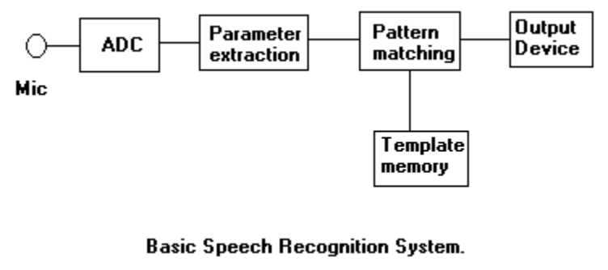

Purpose:-

The purpose of creating this project is to control all home equlipments e.g. Fans, Lights, Door motor, Electric Heater, TV, VCR, Water Pump etc through Voice. The user will no longer have to move from his seat, just to turn on the Fan. He will just call the Fan with its Name, rest will be done by "As You Wish".

Project Details:-

This project has two parts one is related to Software and other related to Hardware. Normally you have to plug the hardware to your system after that you have to install the software. First of all, connect the Microphone to the sound card and check whether it is working or not by using the Sound Recorder Utility in Windows.
You have to plug the Hardware to the Parallel Port of you PC. There are 24 sockets available on the Hardware, in which the devices to be controlled will be pluged in. There is also a AC supply Plug which you have to plug in the 220v~ supply. Now the Hardware setup is completed.
After the completion of hardware setup, start your computer and run the As You Wish software(it is assumed that the software has been previously installed). Now you can create the menu of devices names. The Device Numbers on the software and Hardware are the same. Click Save, when all the names have been entered.
Click Config button to set the configuration of the software. Write the address of Parallel Port on which you have connected the hardware. Click Ok.
Click Activate. Wait for the Listening status to appear. Now its ready to obey your previously entered commands.

